STATISTICAL APPENDICES SHOWING ANALYSIS OF RELATIONSHIP BETWEEN MEASURES OF PERSONAL RESPONSIBILITY AND MEASURES OF RED-STATE/BLUE-STATE POLITICS -- Jeffrey Frankel, Sept. 27, 2012

*** Thanks to Sarah Cannon and Jesse Schreger for econometric assistance. ***
I. The relationship between states’ ratio of Democratic/Republican votes and measures of personal responsibility
Figure 1a: Federal Taxes Paid minus Spending Received, among Blue vs. Red States
(Average of votes in 2000, 2004 and 2008 presidential elections)
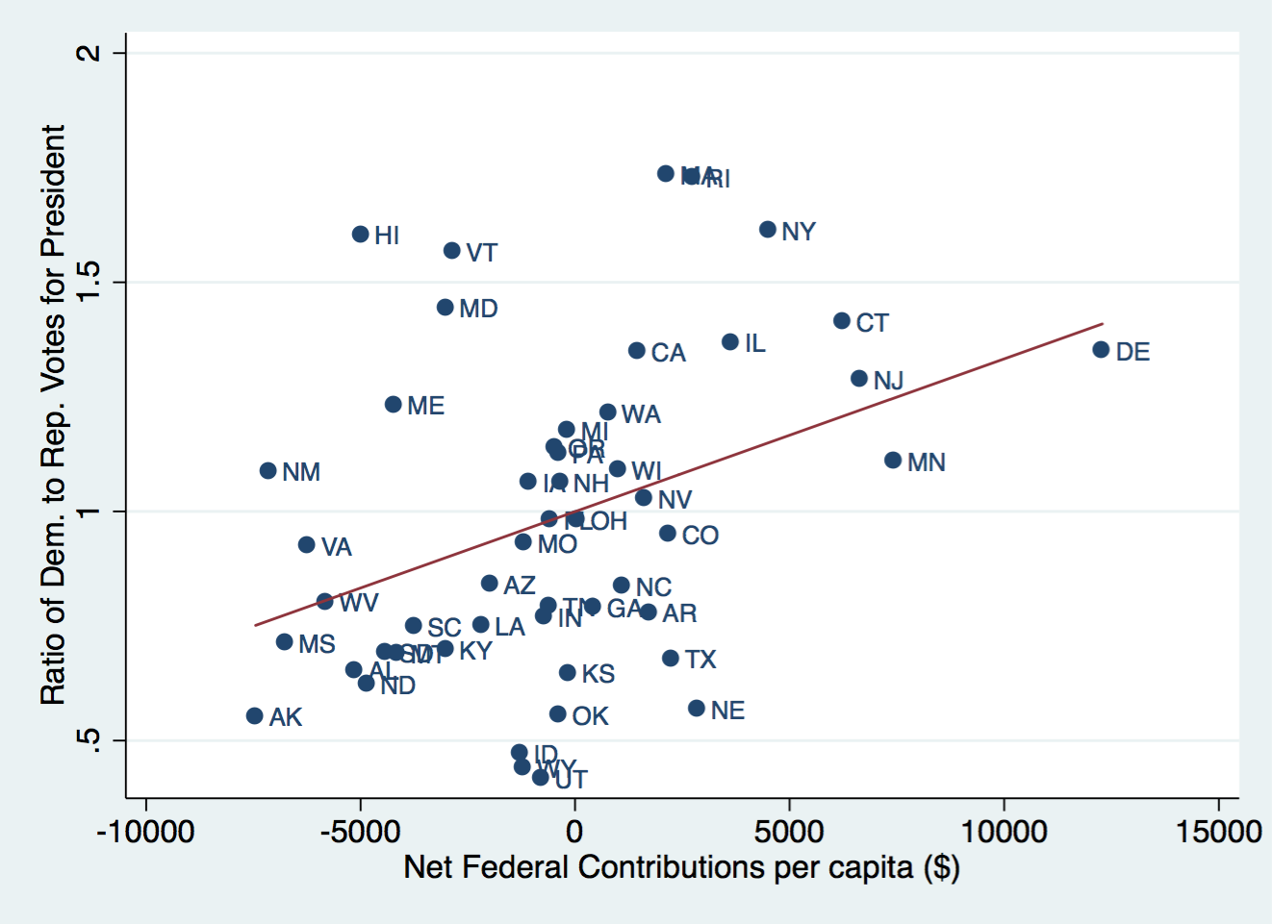

Figure 1b: Federal Taxes Paid minus Spending Received, among Blue vs. Red States (2008 presidential vote)
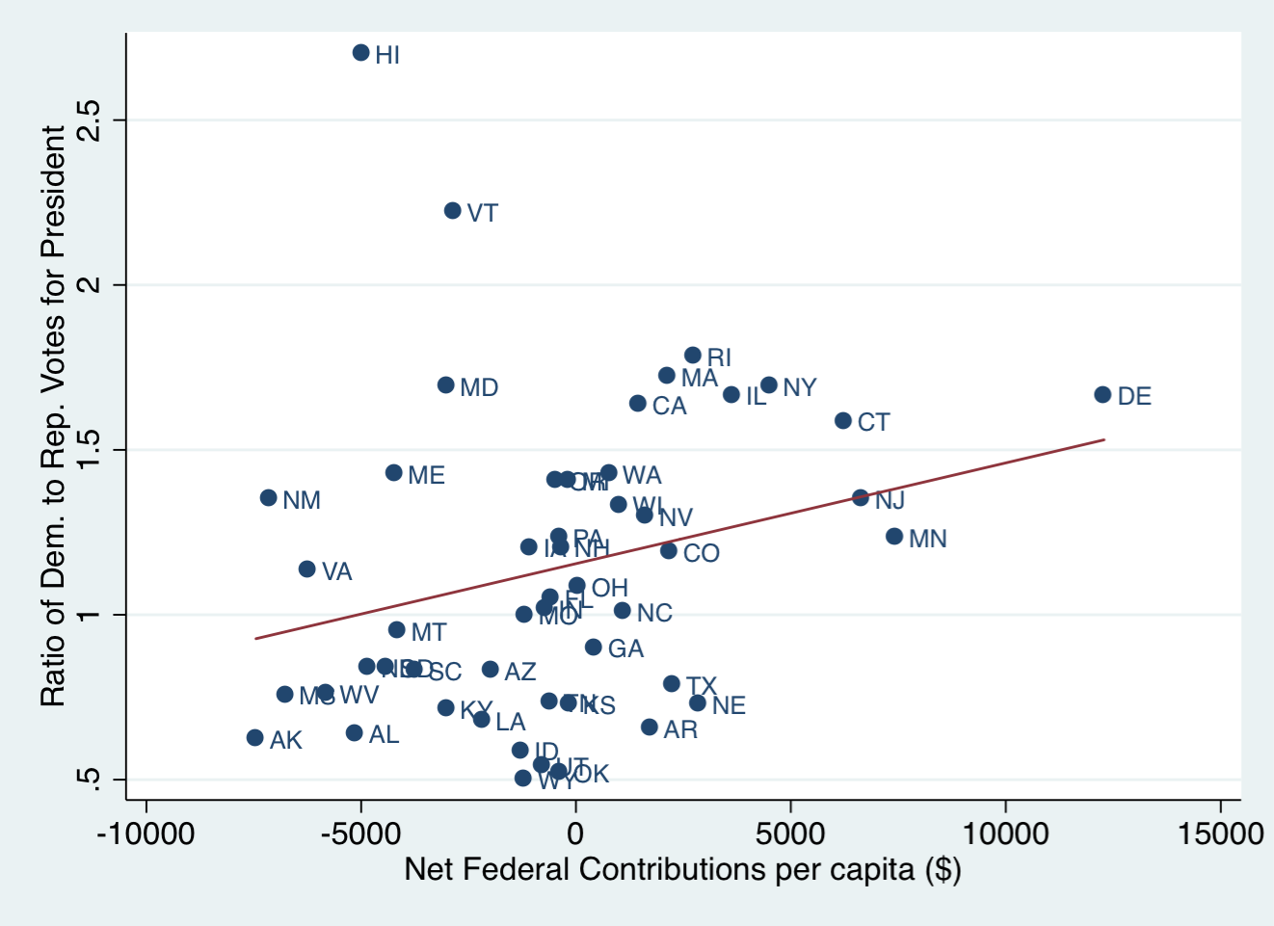

Figure 2a: Obesity (percentage of state population) among Red States and Blue States
(Average of votes in 2000, 2004 and 2008 presidential elections)
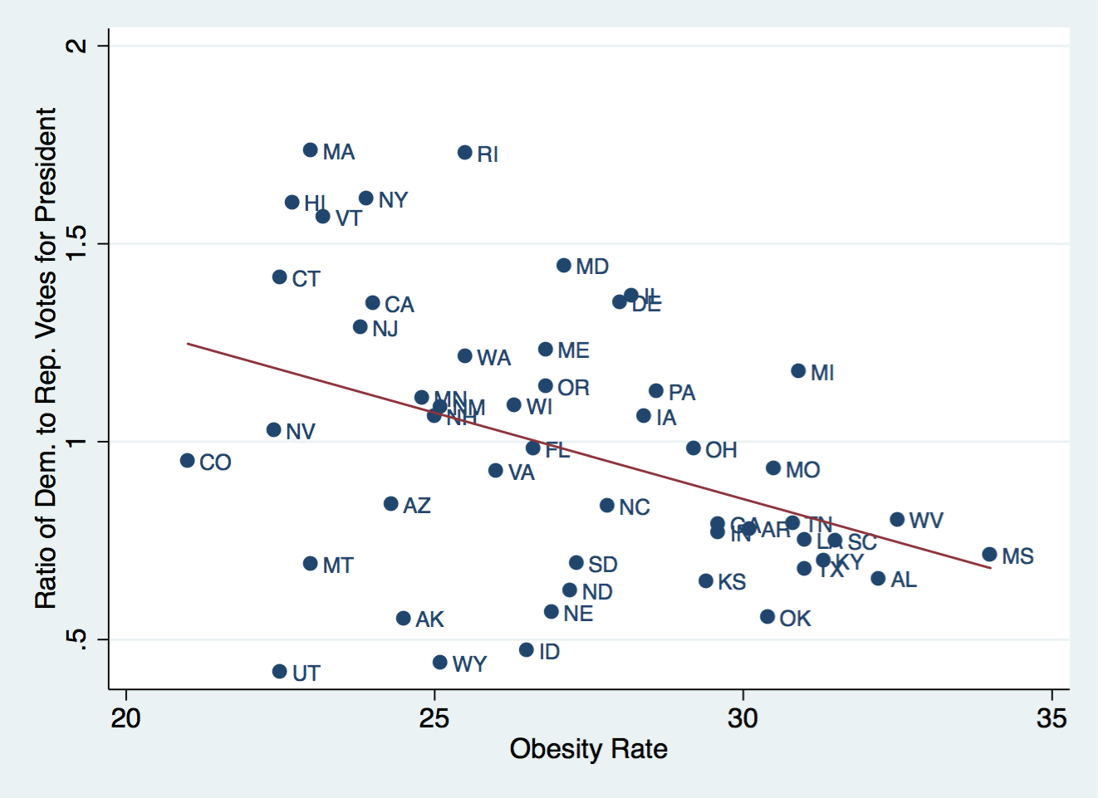

Figure 3a: Teen pregnancy rates (births among girls 15-17 years old) among Blue vs. Red States
(Average of votes in 2000, 2004 and 2008 presidential elections)
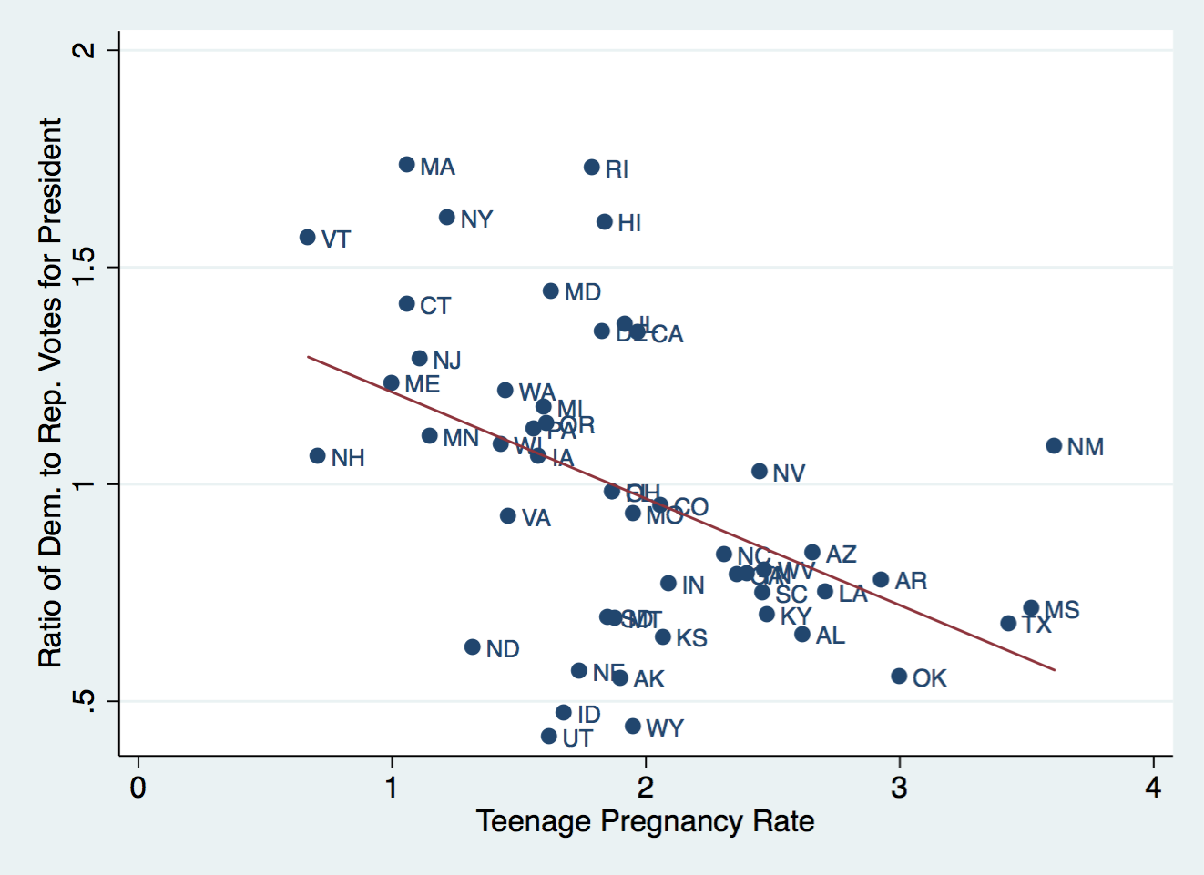

Figure 4a: Chlamydia rates among Blue vs. Red States
(Average of votes in 2000, 2004 and 2008 presidential elections)
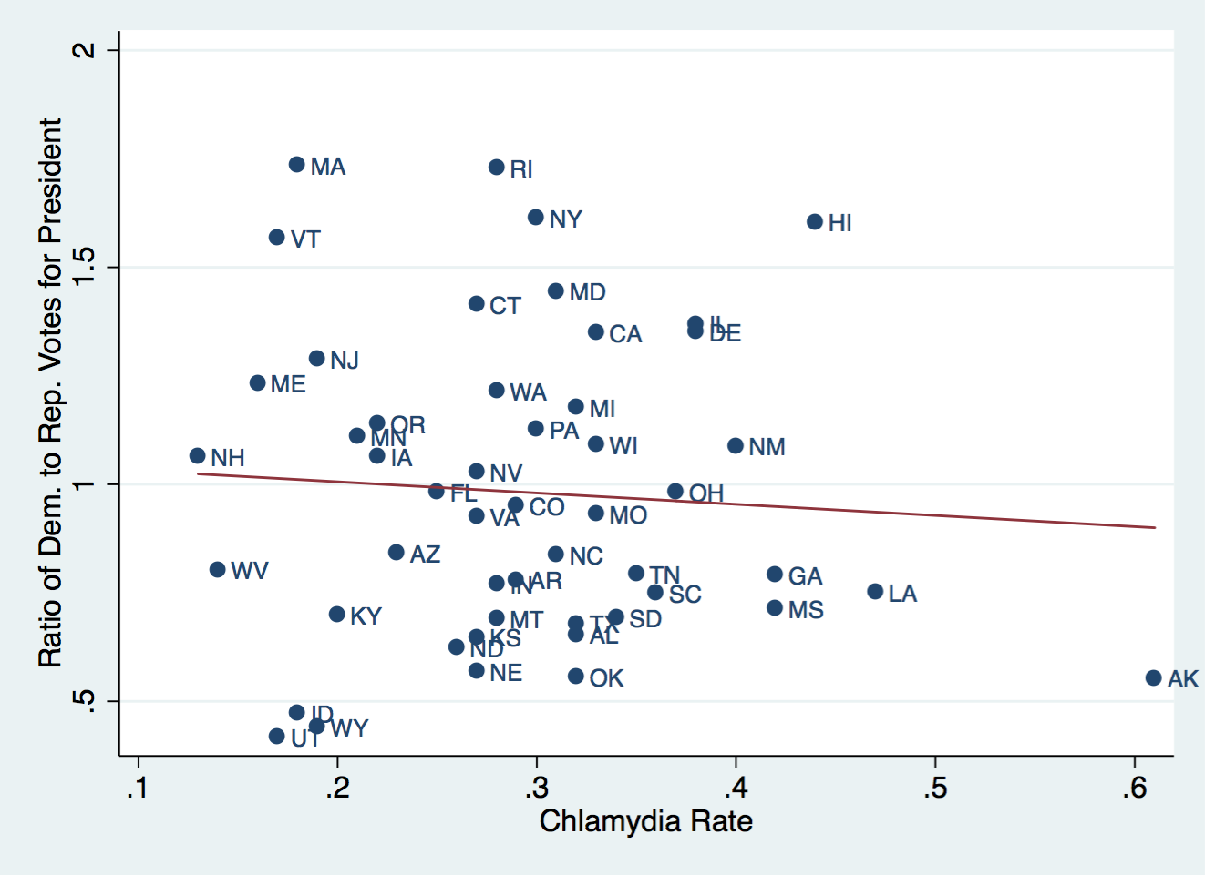

Figure 5a: Smoking (adult rates) among Blue vs. Red States
(Average of votes in 2000, 2004 and 2008 presidential elections)
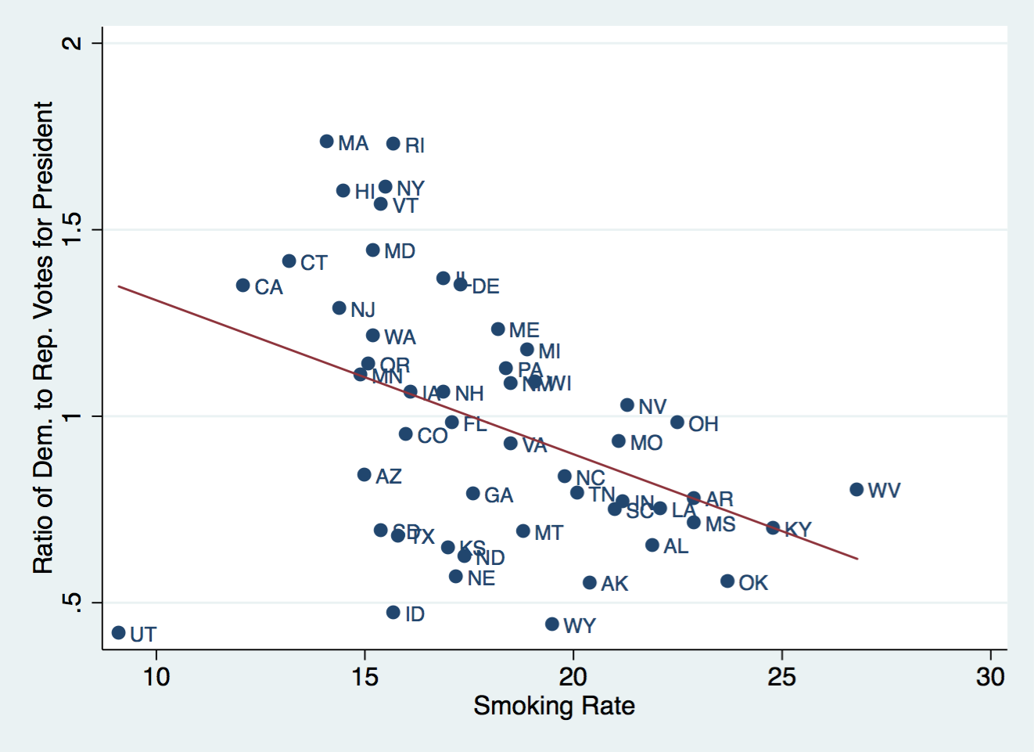

Figure 6a: Drunk driving fatalities among Blue vs. Red States
(Average of votes in 2000, 2004 and 2008 presidential elections)
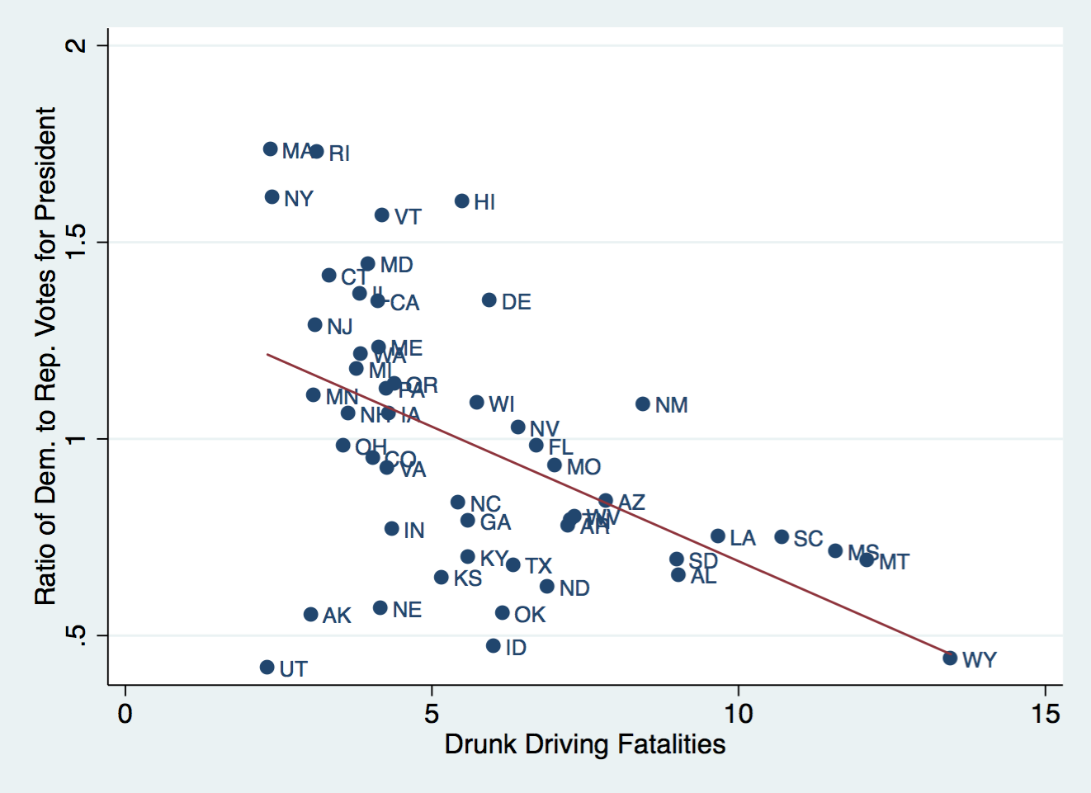

Figure 7a: Firearms assault rates among Blue vs. Red States
(Average of votes in 2000, 2004 and 2008 presidential elections)
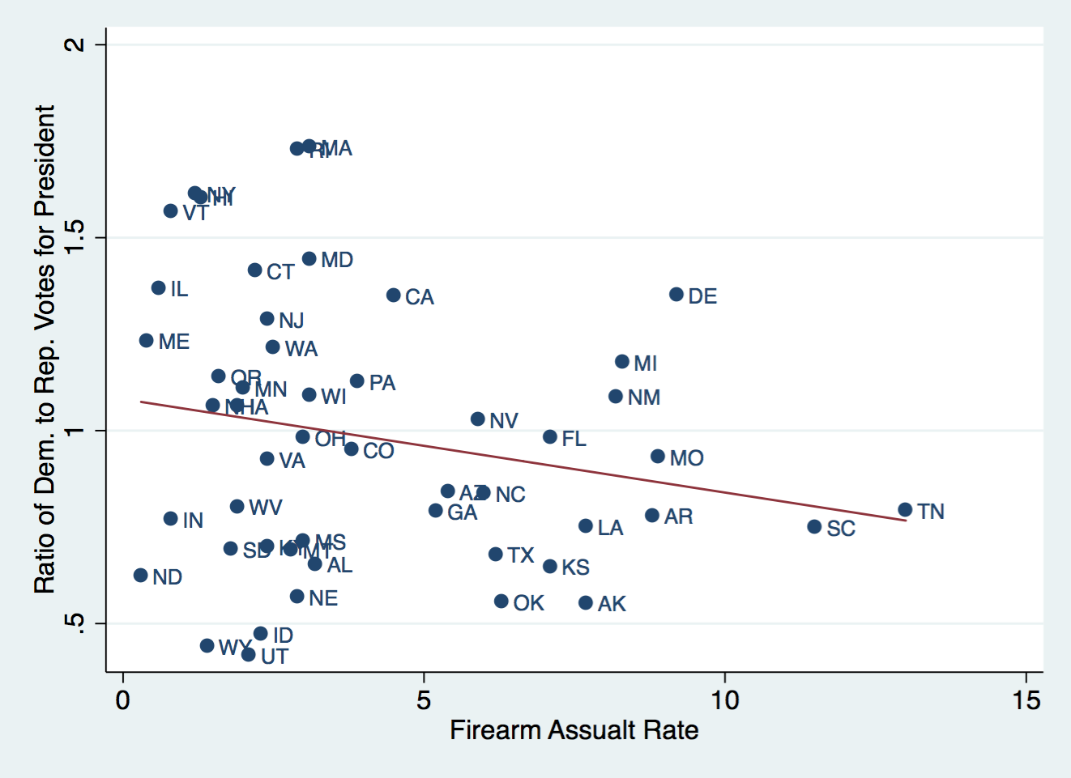

Figure 7b: Firearms assault rates among Blue vs. Red States (2008 presidential vote)
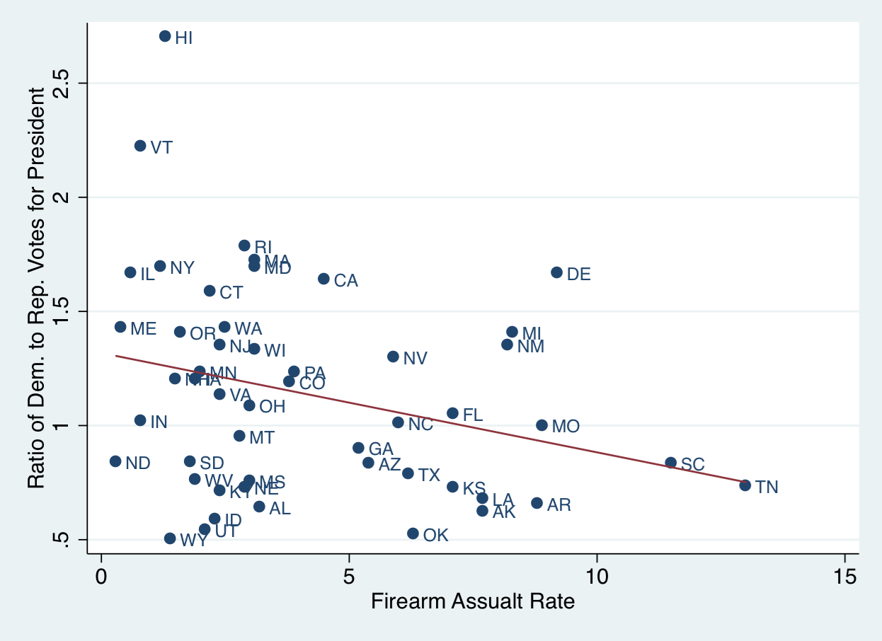

Table 1a: Regressions of Democratic/Republican vote ratio
(three-election average: 2000, 2004 & 2008)
against measures of personal responsibility
 | (1) | (2)
VARIABLES | Ratio D/R | RatioD/R_avg
Smoking (Adult Rate) |  | -0.0210
 |  | (0.0144)
Drunk Driving Deaths |  | -0.0541***
 |  | (0.0188)
Firearms Assault Rate |  | -0.00400
 |  | (0.0150)
Obesity Rate | -0.0532***
 | (0.0189)
Exercise Rate | -0.0118
 | (0.0147)
Constant | 3.333** | 1.684***
 | (1.526) | (0.228)
Observations | 50 | 50
R-squared | 0.168 | 0.301
*** p<0.01, ** p<0.05, * p<0.10. (Robust standard effors in parentheses.)

Table 1b: Regressions of Democratic/Republican vote ratio
(2008 presidential election)
against measures of personal responsibility

 | (1) | (2)
VARIABLES | RatioDR2008 | RatioDR2008
Smoking (Adult Rate) |  | -0.0382*
 |  | (0.0192)
Drunk Driving Deaths |  | -0.0516**
 |  | (0.0251)
Firearms Assault Rate |  | -0.0179
 |  | (0.0200)
ObesityRate | -0.0665***
 | (0.0229)
Exercise Rate | 0.00336
 | (0.0161)
Constant | 2.682 | 2.194***
 | (1.657) | (0.304)
Observations | 50 | 50
R-squared | 0.229 | 0.298

Figure 7a: Fitness Index (weighted average of Obesity rate and Exercise rate), among Blue vs. Red States
(Average of votes in 2000, 2004 and 2008 presidential elections)
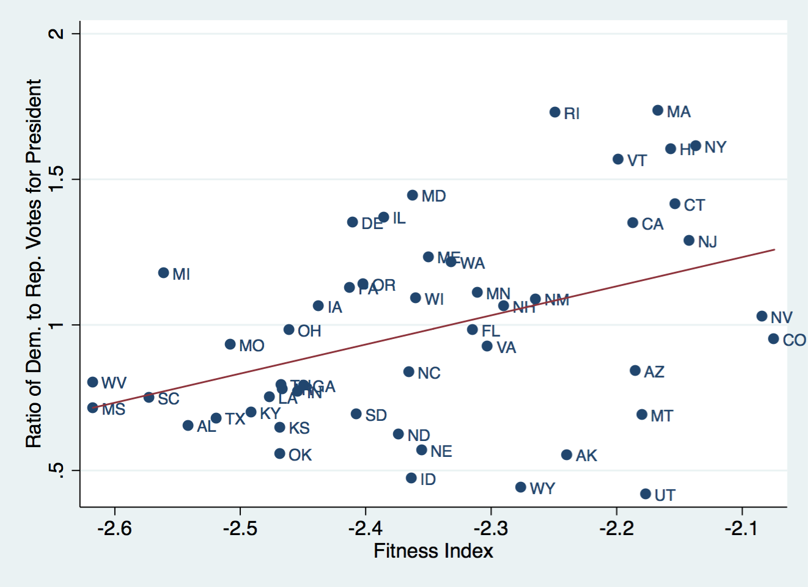

Figure 7b: Fitness Index (weighted average of Obesity rate and Exercise rate), among Blue vs. Red States
(2008 presidential vote)
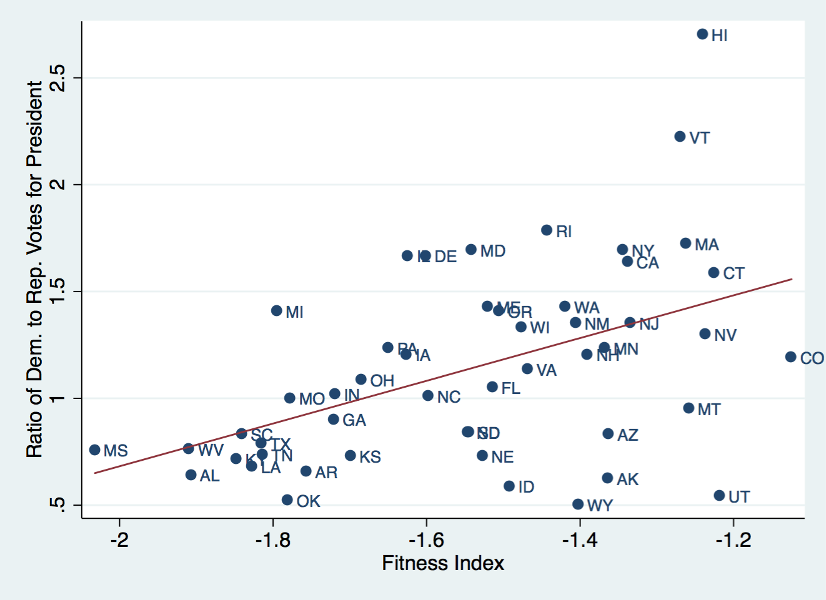

Figure 8a: Hazardous behavior Index (weighted average of smoking, drunk driving fatalities and firearms assaults), among Blue vs. Red States (Average of votes in 2000, 2004 and 2008 presidential elections)
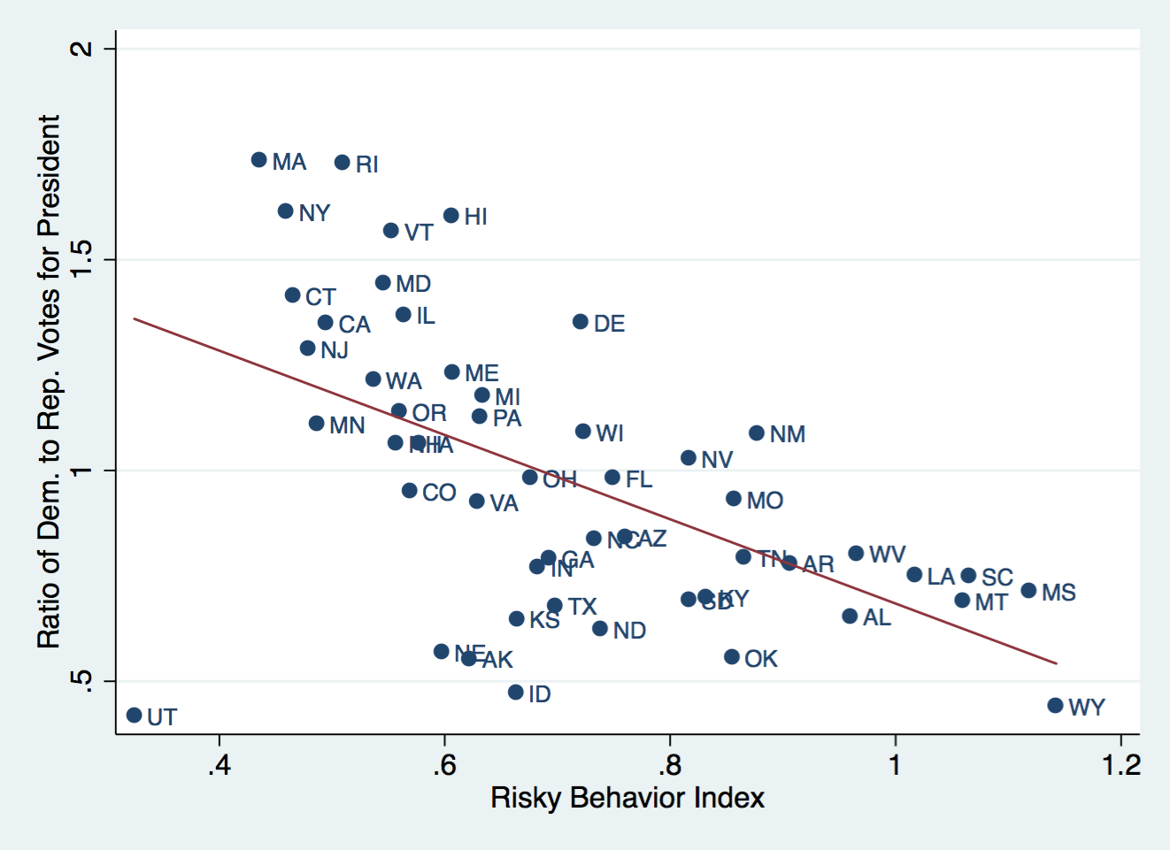

Figure 8b: Hazardous behavior Index (weighted average of smoking, drunk driving fatalities and firearms assaults), among Blue vs. Red States (2008 presidential vote)
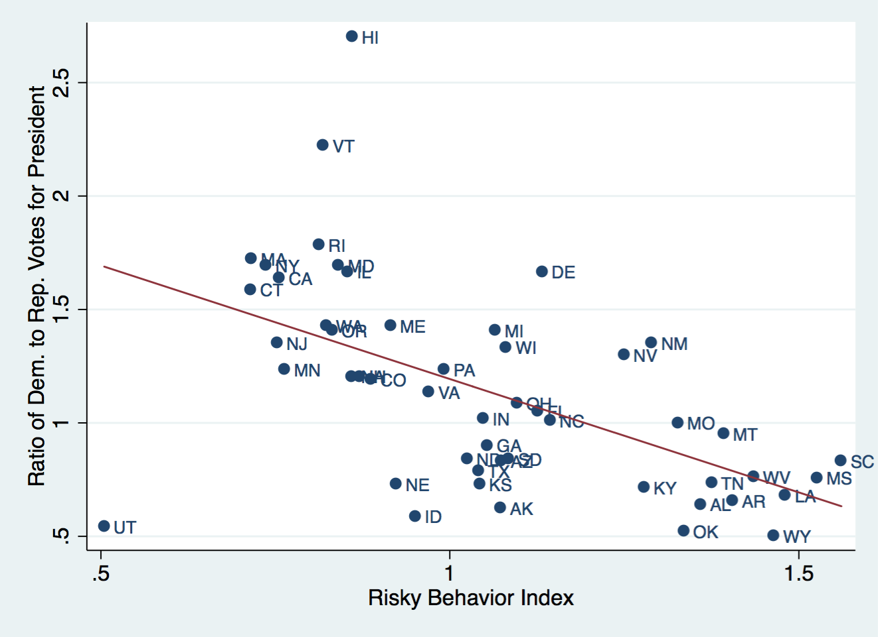

Table 2b: Univariate regressions of Democratic/Republican vote (2008) against measures of personal responsibility
 | (1) | (2) | (3) | (4) | (5)
VARIABLES | RatioDR2008 | RatioDR2008 | RatioDR2008 | RatioDR2008 | RatioDR2008
Personal Responsibility Index | 0.0876***
 | (0.0290)
Obesity Rate |  | -0.0693***
 |  | (0.0194)
Exercise |  |  | 0.0417***
 |  |  | (0.0153)
Drunk Driving Fatalities |  |  |  | -0.0811***
 |  |  |  | (0.0166)
Smoking rate |  |  |  |  | -0.0614***
 |  |  |  |  | (0.0218)
Constant | 1.715*** | 3.016*** | -2.082* | 1.603*** | 2.241***
 | (0.220) | (0.563) | (1.148) | (0.131) | (0.432)
Observations | 50 | 50 | 50 | 50 | 50
R-squared | 0.139 | 0.228 | 0.117 | 0.210 | 0.209
Robust standard errors in parentheses *** p<0.01, ** p<0.05, * p<0.10

Table 2b, continued: Regressions of Democratic/Republican vote against measures of personal responsibility
 | (1) | (2) | (3) | (4) | (5)
VARIABLES | RatioDR2008 | RatioDR2008 | RatioDR2008 | RatioDR2008 | RatioDR2008
Teenage Pregnancy rate  (15-17 yr olds.) | -0.328***  (0.0828)
Chlamydia Rate |  | -0.0334
 |  | (0.916)
Firearms Assault Rate |  |  | -0.0435**
 |  |  | (0.0194)
Overall Fitness Index |  |  |  | 0.0704***
 |  |  |  | (0.0198)
Overall Hazardous Behavior Index |  |  |  |  | -0.185***  (0.0364)
Constant | 1.776*** | 1.149*** | 1.318*** | 1.822*** | 1.777***
 | (0.175) | (0.262) | (0.120) | (0.234) | (0.154)
Observations | 50 | 50 | 50 | 50 | 50
R-squared | 0.228 | 0.000 | 0.082 | 0.226 | 0.270
Robust standard errors in parentheses *** p<0.01, ** p<0.05, * p<0.10
Figure 9a: Overall Personal Responsibility Index among red states and blue states
(Average of votes in 2000, 2004 & 2008 elections)
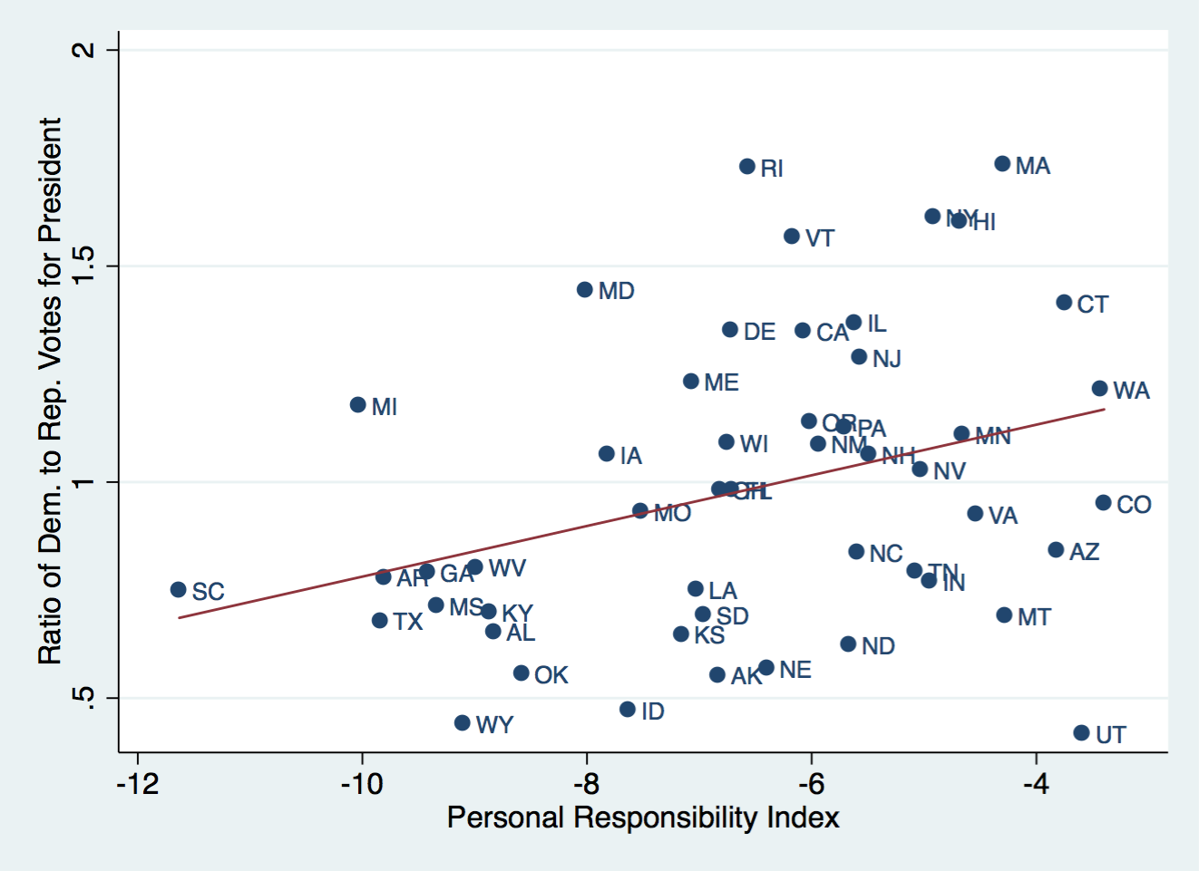

Table 3: Data for the 50 states
State | Repub/Dem | Obesity | Exercise | Drunk | Smoking | Teen | Chlamydia | Firearms | Personal
 | Vote 2008 |  |  | Driving Fatalities | (adult rate) | Pregnancy | rate | Assault rate | Responsibility  Index
Wyoming | 1.99 | 25.1 | 79.8 | 13.46 | 19.5 | 1.95 | 0.19 | 1.4 | -9.1
Oklahoma | 1.91 | 30.4 | 72.2 | 6.16 | 23.7 | 3 | 0.32 | 6.3 | -8.58
Utah | 1.84 | 22.5 | 83.1 | 2.32 | 9.1 | 1.62 | 0.17 | 2.1 | -3.59
Idaho | 1.7 | 26.5 | 80.9 | 6.01 | 15.7 | 1.68 | 0.18 | 2.3 | -7.63
Alaska | 1.6 | 24.5 | 79.4 | 3.03 | 20.4 | 1.9 | 0.61 | 7.7 | -6.83
TOP 5 AVE. | 1.808 | 25.8 | 79.08 | 6.196 | 17.68 | 2.03 | 0.294 | 3.96 | -7.146
Alabama | 1.56 | 32.2 | 70.3 | 9.03 | 21.9 | 2.62 | 0.32 | 3.2 | -8.83
Arkansas | 1.52 | 30.1 | 73.4 | 7.23 | 22.9 | 2.93 | 0.29 | 8.8 | -9.81
Louisiana | 1.47 | 31 | 70.2 | 9.67 | 22.1 | 2.71 | 0.47 | 7.7 | -7.03
Kentucky | 1.4 | 31.3 | 70.1 | 5.6 | 24.8 | 2.48 | 0.2 | 2.4 | -8.87
Kansas | 1.37 | 29.4 | 76.7 | 5.17 | 17 | 2.07 | 0.27 | 7.1 | -7.16
Nebraska | 1.37 | 26.9 | 78.4 | 4.17 | 17.2 | 1.74 | 0.27 | 2.9 | -6.4
Tennessee | 1.36 | 30.8 | 70.3 | 7.26 | 20.1 | 2.4 | 0.35 | 13 | -5.08
Mississippi | 1.32 | 34 | 68.6 | 11.59 | 22.9 | 3.52 | 0.42 | 3 | -9.34
W.Virginia | 1.31 | 32.5 | 75.4 | 7.33 | 26.8 | 2.47 | 0.14 | 1.9 | -8.99
Texas | 1.27 | 31 | 73.8 | 6.33 | 15.8 | 3.43 | 0.32 | 6.2 | -9.84
S.Carolina | 1.2 | 31.5 | 76.1 | 10.71 | 21 | 2.46 | 0.36 | 11.5 | -11.63
Arizona | 1.2 | 24.3 | 75.7 | 7.84 | 15 | 2.66 | 0.23 | 5.4 | -3.82
S.Dakota | 1.19 | 27.3 | 81 | 9 | 15.4 | 1.85 | 0.34 | 1.8 | -6.96
N.Dakota | 1.19 | 27.2 | 78.6 | 6.89 | 17.4 | 1.32 | 0.26 | 0.3 | -5.67
Georgia | 1.11 | 29.6 | 74.2 | 5.6 | 17.6 | 2.36 | 0.42 | 5.2 | -9.42
Montana | 1.05 | 23 | 81.1 | 12.1 | 18.8 | 1.88 | 0.28 | 2.8 | -4.28
Missouri | 1 | 30.5 | 75.1 | 7.01 | 21.1 | 1.95 | 0.33 | 8.9 | -7.52
N.Carolina | 0.99 | 27.8 | 75.2 | 5.44 | 19.8 | 2.31 | 0.31 | 6 | -5.6
Indiana | 0.98 | 29.6 | 74.6 | 4.35 | 21.2 | 2.09 | 0.28 | 0.8 | -4.95
Florida | 0.95 | 26.6 | 76.3 | 6.71 | 17.1 | 1.87 | 0.25 | 7.1 | -6.71
Ohio | 0.92 | 29.2 | 77 | 3.56 | 22.5 | 1.87 | 0.37 | 3 | -6.82
Virginia | 0.88 | 26 | 78 | 4.28 | 18.5 | 1.46 | 0.27 | 2.4 | -4.54
Colorado | 0.84 | 21 | 81.2 | 4.04 | 16 | 2.06 | 0.29 | 3.8 | -3.4
Iowa | 0.83 | 28.4 | 78.6 | 4.3 | 16.1 | 1.58 | 0.22 | 1.9 | -7.82
N.Hampshire | 0.83 | 25 | 81.4 | 3.64 | 16.9 | 0.71 | 0.13 | 1.5 | -5.49
Pennsylvania | 0.81 | 28.6 | 75.6 | 4.26 | 18.4 | 1.56 | 0.3 | 3.9 | -5.71
Minnesota | 0.81 | 24.8 | 84.1 | 3.08 | 14.9 | 1.15 | 0.21 | 2 | -4.66
Nevada | 0.77 | 22.4 | 75.7 | 6.41 | 21.3 | 2.45 | 0.27 | 5.9 | -5.03
Wisconsin | 0.75 | 26.3 | 81.5 | 5.74 | 19.1 | 1.43 | 0.33 | 3.1 | -6.75
New Mexico | 0.74 | 25.1 | 78.8 | 8.45 | 18.5 | 3.61 | 0.4 | 8.2 | -5.94
New Jersey | 0.74 | 23.8 | 74.3 | 3.1 | 14.4 | 1.11 | 0.19 | 2.4 | -5.57
Michigan | 0.71 | 30.9 | 77.8 | 3.78 | 18.9 | 1.6 | 0.32 | 8.3 | -10.03
Oregon | 0.71 | 26.8 | 82.8 | 4.39 | 15.1 | 1.61 | 0.22 | 1.6 | -6.02
Maine | 0.7 | 26.8 | 78.4 | 4.14 | 18.2 | 1 | 0.16 | 0.4 | -7.07
Washington | 0.7 | 25.5 | 82.7 | 3.85 | 15.2 | 1.45 | 0.28 | 2.5 | -3.43
Connecticut | 0.63 | 22.5 | 81.1 | 3.33 | 13.2 | 1.06 | 0.27 | 2.2 | -3.75
California | 0.61 | 24 | 77.2 | 4.13 | 12.1 | 1.97 | 0.33 | 4.5 | -6.07
Illinois | 0.6 | 28.2 | 75.1 | 3.83 | 16.9 | 1.92 | 0.38 | 0.6 | -5.62
Delaware | 0.6 | 28 | 78.1 | 5.95 | 17.3 | 1.83 | 0.38 | 9.2 | -6.72
Maryland | 0.59 | 27.1 | 78.1 | 3.97 | 15.2 | 1.63 | 0.31 | 3.1 | -8.01
New York | 0.59 | 23.9 | 73.4 | 2.4 | 15.5 | 1.22 | 0.3 | 1.2 | -4.92
Massachusetts | 0.58 | 23 | 80 | 2.37 | 14.1 | 1.06 | 0.18 | 3.1 | -4.3
Rhode Island | 0.56 | 25.5 | 75.7 | 3.13 | 15.7 | 1.79 | 0.28 | 2.9 | -6.57
Vermont | 0.45 | 23.2 | 81.8 | 4.2 | 15.4 | 0.67 | 0.17 | 0.8 | -6.17
Hawaii | 0.37 | 22.7 | 80.5 | 5.5 | 14.5 | 1.84 | 0.44 | 1.3 | -4.68
LAST 5 AVE. | 0.51 | 23.66 | 78.28 | 3.52 | 15.04 | 1.316 | 0.274 | 1.86 | -5.328

Data sources

Teenage pregnancy (15-17), 2009
Birth rate per 1,000 women in specified age group (divided by 10 to get % terms). Source: CDC.
Data Brief 58: U.S. birth rates for teenagers aged 15-17 and 18-19 by state, 2007 and 2009. Birth rate per 1,000 women in specified age group. [By place of residence. Data for 2009 are based on a continuous file of records received from the states.]

Chlamydia
Number of Reported Chlamydia Cases per 100,000 Population, 2003 (divided by 1,000 to get % rate)
SOURCE: statehealthfacts.org http://www.statemaster.com/graph/hea_chl_rat-health-chlamydia-rate

Shootings
Gun crime in the US, 2010. Firearms assaults per 100,000 population (divided by 1,000 to get rate)
Source: FBI, http://www.fbi.gov/about-us/cjis/ucr/crime-in-the-u.s/2010/crime-in-the-u.s.-2010
Source article: http://www.guardian.co.uk/news/datablog/2011/jan/10/gun-crime-us-state#data

drunk driving fatalities
NHSTA data, Department of Transportation

Thanks to Sarah Cannon and Jesse Schreger for econometric assistance.

Construction of composite indices:
Fitness index = [exercise - 5x(obesity)]/6.

Index of risky behavior
= (firearms assaults +5.0 drunk driving deaths + 8.0 teenage pregnancy)/ 14.0

Overall Index of personal responsibility
= average of fitness index and (-) risky behavior index.

Figure9b: Personal Responsibility Index & Democratic/Republican ratio (2008 election)
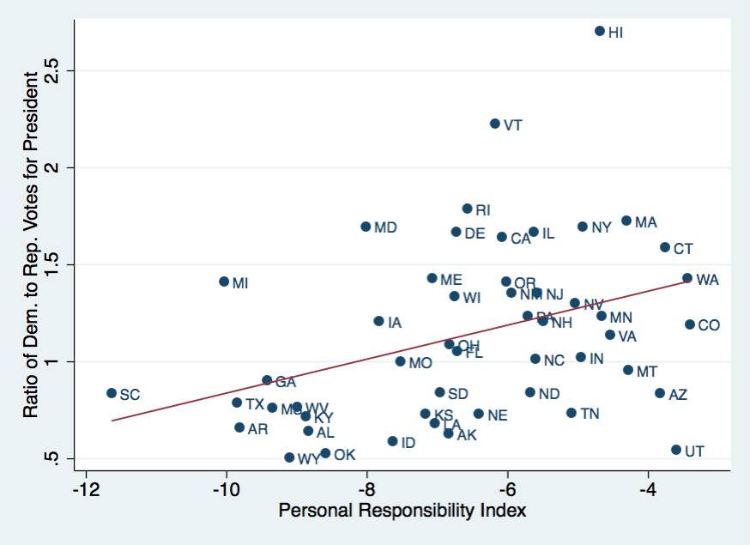

Appendix II: The relationship between states’ Ratio of Republican to Democrat votes and measures of personal responsibility

Figure 9c: Personal Responsibility Index
(averaging voting rates from 2000, 2004 and 2008 elections)

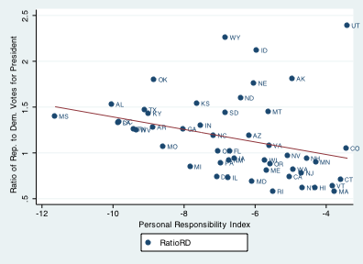

This is relationship is statistically significant at the 97% confidence level (3.0 % significance level).

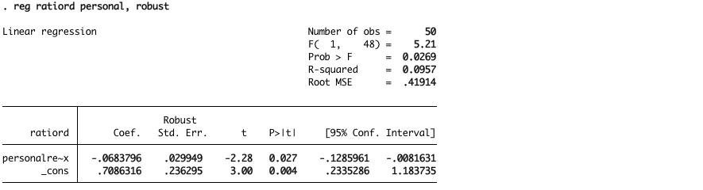

Figure 9d: Personal Responsibility Index Republican/Democratic ratio (2008 election)
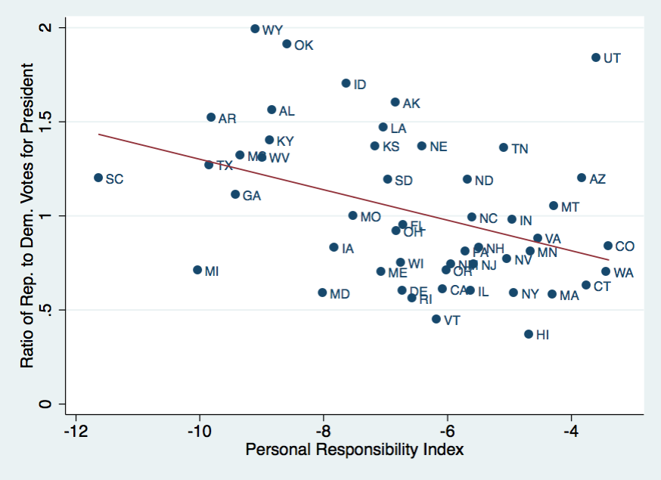

Obesity

Figure 2c: Obesity¹ and Republican vs. Democrat Popular Votes (2000, 2004, 2008 Elections)

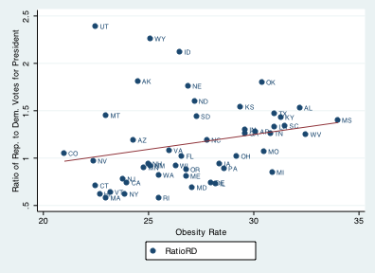
1 Source: CDC, http://www.cdc.gov/obesity/data/trends.html#State
This is a statistically significant relationship, at the 90 % confidence (10 % significance) level.

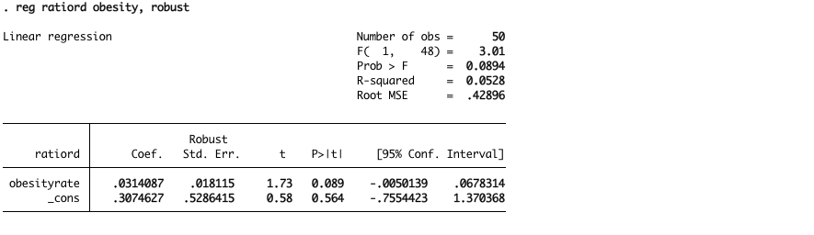

Figure 2d: Obesity¹ and Republican vs. Democrat Popular Votes (2008 Election)
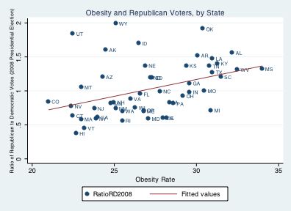
1 Source: CDC, http://www.cdc.gov/obesity/data/trends.html#State
This is a statistically significant relationship, at the 99.9 % confidence (0.1 % significance) level.

The relationship is significant at the 0.1% level. (Includes Washington, DC)
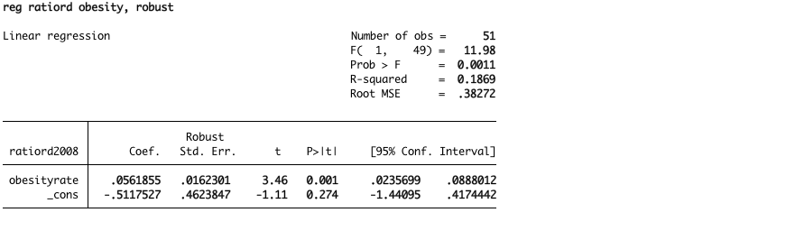

Figure 10d: Physical Exercise and Republican Voters (2008 election)

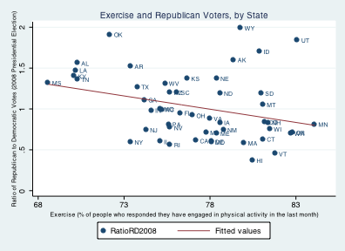
Note: CDC statistics on exercise pertain to 2004 (except for Hawaii, which pertains to 2005).
This relationship is statistically significant at the 97% confidence (3% significance) level.
Regression of Republican/Democratic voters against exercise is statistically significant.
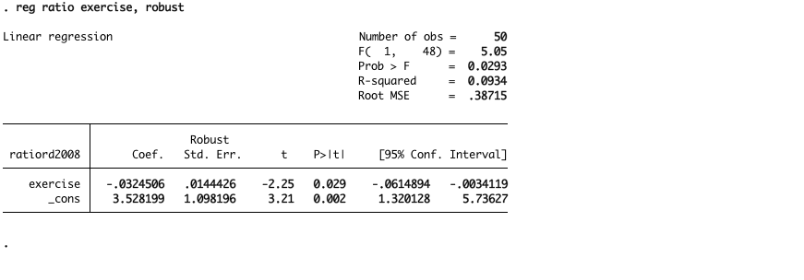

Figure 3d: Teenage Pregnancy² and Republican/Democrat Popular Votes (2008 Election)

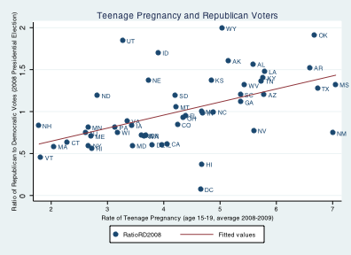

2 Source: CDC, Birth rates for teenagers aged 15-19 by state, annual average for 2007-2009. http://www.cdc.gov/obesity/data/trends.html#State (downloaded May 10, 2012)
This relationship is statistically significant at the 99.9 level of confidence (0.1 level of significance).
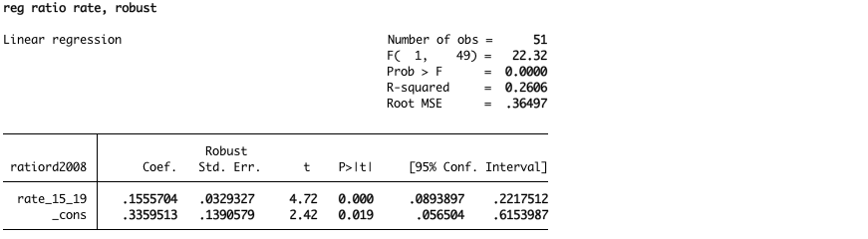

Table 2d: Univariate regressions of Republican/Democratic vote (2008) against measures of personal responsibility
 | (1) | (2) | (3) | (4) | (5)
VARIABLES | RatioRD2008 | RatioRD2008 | RatioRD2008 | RatioRD2008 | RatioRD2008
Personal Responsibility Index | -0.0811***
 | (0.0286)
ObesityRate |  | 0.0497***
 |  | (0.0157)
Exercise |  |  | -0.0325**
 |  |  | (0.0144)
DrunkDriving |  |  |  | 0.0737***
 |  |  |  | (0.0203)
SmokingAdultRate |  |  |  |  | 0.0461**
 |  |  |  |  | (0.0221)
Constant | 0.490** | -0.322 | 3.528*** | 0.602*** | 0.196
 | (0.194) | (0.448) | (1.098) | (0.134) | (0.420)
Observations | 50 | 50 | 50 | 50 | 50
R-squared | 0.158 | 0.155 | 0.093 | 0.229 | 0.156
*** p<0.01, ** p<0.05, * p<0.10 Robust standard errors in parentheses

Table 2d: Regressions of Republican/Democratic vote against measures of personal responsibility, continued
 | (1) | (2) | (3) | (4) | (5)
VARIABLES | RatioRD2008 | RatioRD2008 | RatioRD2008 | RatioRD2008 | RatioRD2008
Teenage Pregnancy | 0.282***
 | (0.0757)
ChlamydiaRate |  | 0.147
 |  | (0.745)
FirearmAssaultRate |  |  | 0.0294*
 |  |  | (0.0165)
FitnessIndex |  |  |  | -0.0511***
 |  |  |  | (0.0166)
RiskyBehaviorIndex |  |  |  |  | 0.162***
 |  |  |  |  | (0.0395)
Constant | 0.476*** | 0.981*** | 0.902*** | 0.527*** | 0.466***
 | (0.145) | (0.229) | (0.0957) | (0.189) | (0.145)
Observations | 50 | 50 | 50 | 50 | 50
R-squared | 0.223 | 0.001 | 0.050 | 0.158 | 0.272
*** p<0.01, ** p<0.05, * p<0.10 Robust standard errors in parentheses

= = = = = =

Appendix III: The relationship between states’ votes on Obamacare and measures of personal responsibility

Congressional vote:  Six states with highest share voting for Obamacare  (Affordable Care Act) |  | State’s ranking in measures of risky behavior vs. personal responsibility
 |  | Obesity | Lack of exer-cise | Teen-age preg-nancy | Chla-mydia | Drunk  Driving | Smo-king | Shoot-ings  (firearm assaults) | Average of  rank-ings
Vermont | VT | 43 | 46 | 50 | 47 | 32 | 39 | 47 | 43.4
Connecticut | CT | 48 | 42 | 46 | 34 | 43 | 48 | 35 | 42.3
Rhode I. | RI | 33 | 18 | 30 | 28 | 44 | 36 | 28 | 31.0
Hawaii | HI | 46 | 38 | 28 | 3 | 24 | 45 | 44 | 32.6
N.Dakota | ND | 23 | 33 | 42 | 35 | 14 | 25 | 50 | 31.7
Mass. | MA | 45 | 37 | 46 | 45 | 49 | 47 | 24 | 41.9
Average |  | 39.7 | 35.7 | 40.3 | 32.0 | 34.3 | 40 | 38 | 37.15
Six states with lowest votes for Obamacare
Louisiana | LA | 6 | 3 | 6 | 2 | 5 | 7 | 8 | 5.3
Wyoming | WY | 34 | 36 | 21 | 42 | 1 | 16 | 43 | 27.6
Idaho | ID | 29 | 39 | 32 | 44 | 19 | 35 | 34 | 33.1
Oklahoma | OK | 11 | 6 | 4 | 17 | 18 | 3 | 12 | 10.1
Utah | UT | 47 | 49 | 34 | 46 | 50 | 50 | 36 | 44.6
Alabama | AL | 3 | 5 | 8 | 18 | 6 | 8 | 21 | 9.9
Average |  | 21.7 | 23.0 | 17.5 | 28.2 | 16.5 | 19.8 | 25.7 | 21.77

Obesity
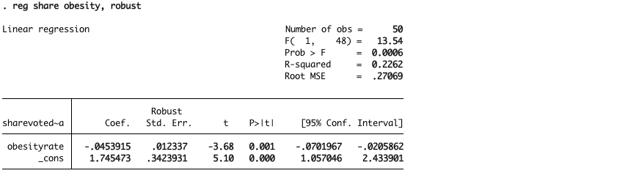
This relationship is statistically significant at the 99.9 % confidence level (0.1 % significance).

Exercise
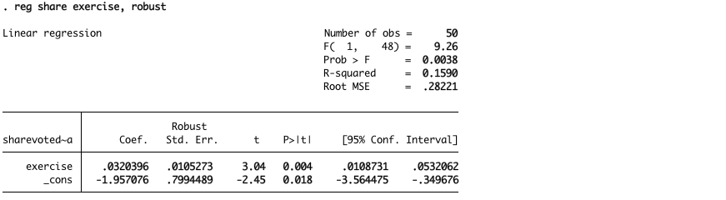
This relationship is statistically significant at the 99.5 % confidence level (0.5 % significance).

Drunk Driving
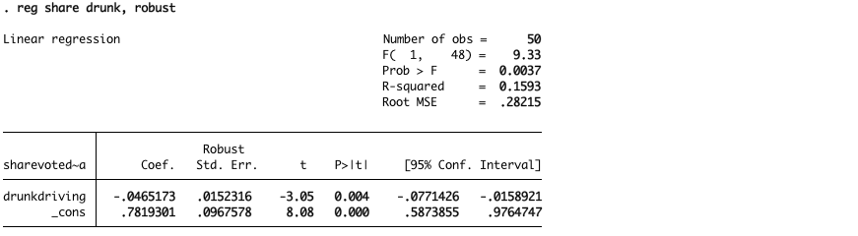
This relationship is statistically significant at the 99.5 % confidence level (0.5 % significance).

Smoking
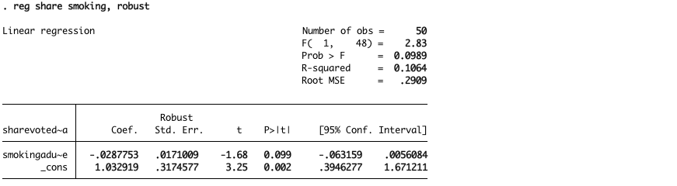
This relationship is statistically significant at the 90 % confidence level (10 % significance).

Teenage Pregnancy (15-17)
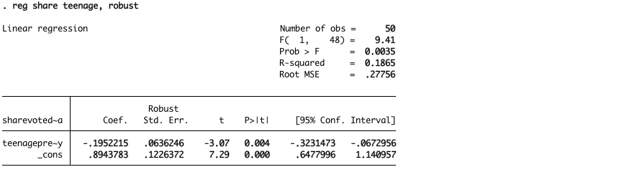
This relationship is statistically significant at the 99.5 % confidence level (0.5 % significance).

Chlamydia
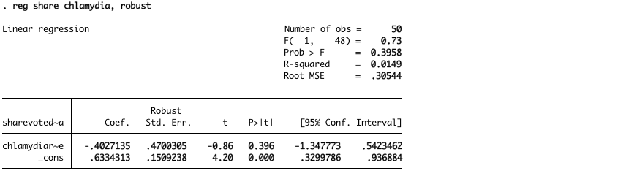
This relationship is not statistically significant at conventional confidence levels..

Firearm assaults
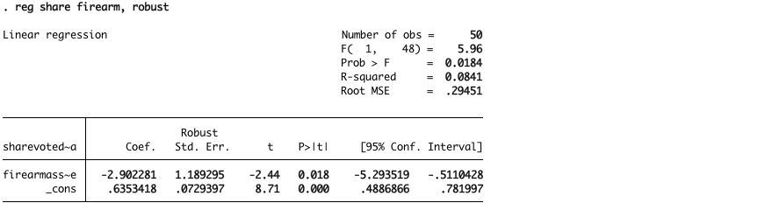
This relationship is statistically significant at the 98 % confidence level (2 % significance).

Fitness index = [exercise - 5x(obesity)]/6.

Index of risky behavior
= (firearms assaults +5.0 drunk driving deaths + 8.0 teenage pregnancy)/ 14.0

Overall Index of personal responsibility = average of fitness index and (-) risky behavior index.

Graph of States’ congressional votes on ACA (Affordable Care Act, i.e., Obamacare) against Index of Personal Responsibility
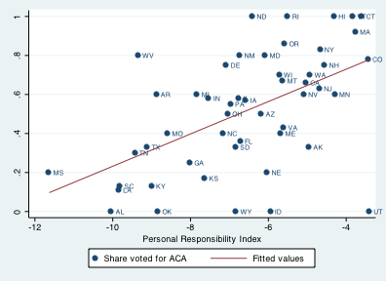

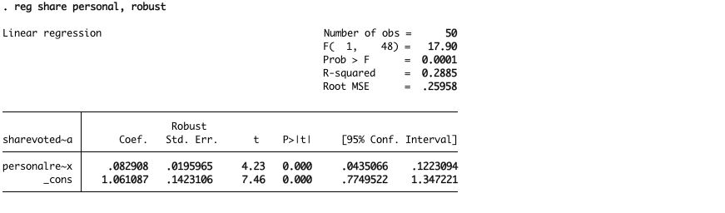
This relationship is statistically significant at the 99.9 % confidence level (0.1 % significance).

