Lay Theories of Effortful Honesty:
Does the Honesty-Effort Association Justify Making a Dishonest Decision?

Julia J. Lee
University of Michigan

Madeline Ong
Hong Kong University of Science and Technology

Bidhan Parmar
University of Virginia

Elinor Amit
Brown University

Acknowledgements
We thank Dasha Peppard, Roslina Yong and Thian Wen Li for their research assistance. This research was supported by the fellowship given to Julia Lee, Bobby Parmar, and Francesca Gino from the Edmond J. Safra Center for Ethics at Harvard University, and by research grants given to Madeline Ong from Singapore Management University and Julia Lee from Ross School of Business, University of Michigan. Correspondence concerning this article should be addressed to Julia Lee, profjlee@umich.edu.

Abstract
Are our moral decisions and actions influenced by our beliefs about how much effort it takes to do the right thing? We hypothesized that the belief that honesty is effortful predicts subsequent dishonest behavior because it facilitates one’s ability to justify such actions. In Study 1 (N=210), we developed an implicit measure of people’s beliefs about whether honesty is effortful or not, and we found that this lay theory predicts dishonesty. In Study 2 (N=339), we experimentally manipulated individuals’ lay theories about honesty and effort and found that an individual’s lay theory that honesty is effortful increased subsequent dishonesty. In Study 3, we manipulated (3a; N=294) and measured (3b; N=153) lay theories and the strength of situational force that encourages dishonesty and found that an individual’s lay theory influences subsequent dishonesty only in a weak situation, where individuals have more agency to interpret the situation. This research provides novel insights into how our lay theories linking honesty and effort can help us rationalize our dishonesty, independent of whether a particular moral decision requires effort or not.
Keywords: morality; effort; justifications; behavioral ethics; situational strength

Lay Theories of Effortful Honesty:
Does the Honesty-Effort Association Justify Making a Dishonest Decision?

Workplace dishonesty is prevalent in organizations and can be costly. According to estimates from the Association of Certified Fraud Examiners (2016), organizations worldwide lose 5% of their annual revenue, or up to $3.7 trillion, to employee fraud. In the United States, dishonest employees are responsible for about 30% of inventory losses, costing companies $1,922.80 per incident (National Retail Federation, 2017). The US Chamber of Commerce estimated that 75% of employees steal from their employers at least once and that roughly 30% of business failures are directly related to dishonest acts, such as employee theft (Soskil, 2017).
Individuals face many opportunities to make dishonest decisions in the course of their work. This paper argues that they may hold different lay theories about the nature of honesty as they face such decisions. A lay theory is a personally constructed set of foundational assumptions that an individual holds in relation to a social or physical situation (Molden & Dweck, 2006). We propose that in the context of moral decision making, individuals may develop lay theories about whether honesty is effortful or effortless. Drawing on the rich body of research on lay theories (e.g., Dweck, Chiu, & Hong, 1995), we first explore the possibility that individuals develop lay theories about whether honesty requires effort or not, and that these lay theories can influence their subsequent dishonest behavior. In addition, research on situational strength (e.g., Meyer, Dalal, & Hermida, 2010) suggests that individual differences, such as lay theories, are more pronounced in weak situations. In this paper, we also examine whether lay theories about honesty and effort have a stronger influence on subsequent dishonest behavior in the absence of a strong situation that encourages dishonesty.
Our work aims to make several theoretical contributions. First, moral psychologists have been primarily interested in investigating whether being honest is effortless (e.g., Haidt, 2001) or effortful (e.g., Kohlberg, 1981). We contribute to the moral psychology literature by moving beyond the dichotomous debate on whether honesty requires effort or not. Instead, we seek to answer the question of how lay people understand the relationship between morality and effort, thereby responding to the call for more research on lay morality (Monin, Pizarro, & Beer, 2007). Second, we extend prior research in behavioral ethics that has examined the role of implicit processes in behavioral ethics (e.g., Leavitt, Zhu, & Aquino, 2015; Reynolds, Leavitt, & DeCelles, 2010). In particular, we build a logic for why lay theories can be used to self-justify dishonest behavior. Finally, our work contributes to research on lay theories by identifying circumstances under which they have more or less influence on individuals’ decision making. Building on theory and research on situational strength (Judge & Zapata, 2015; Lee & Gino, 2018; Meyer, Dalal, & Hermida, 2010; Mischel, 1977; Treviño, 1986), we find that lay theories, such as those about honesty and effort, have a greater impact on moral decision making in the absence of a strong situational drive.

Theoretical Overview
A rich body of literature in moral psychology debates whether being honest closely resembles System I processes – fast, instinctual, and effortless – or System II processes – slower, deliberative, and effortful (Gilbert, Pelham, & Krull, 1988; Haidt, 2007; Kahneman, 2011). Researchers who endorsed the former emphasize the automaticity or intuitiveness of moral decisions (Haidt, 2001; Reynolds, 2006; Reynolds et al., 2010). Those who endorsed the latter, however, have long emphasized the role of deliberate reasoning and cognition in moral decision making (Kohlberg, 1981; Rest, 1986; Street, Douglas, Geiger, & Martinko, 2001; Turiel, 1983). Researchers’ strong emphasis on explaining honesty with either System I or System II thinking has limited the scope of moral psychology investigation to a particular subset of moral situations that bolsters either view (Monin, Pizarro, & Beer, 2007). As a result, scholars have narrowly focused on two prototypical situations: the camp that addresses complex moral dilemmas concludes that morality involves effort; the camp that addresses reactions to shocking moral violations concludes that morality involves not effort but rather automatic, affect-laden processes.
Instead of taking sides with either camp, we move beyond the debate and identify lay theories about morality and effort as an alternative lever of our moral decision making. Specifically, we ask where people actually stand on this debate. Drawing from research showing that people vary in their implicit theories about human attributes (e.g., Dweck et al., 1995), we argue that people may also hold different lay theories about how effortful it is to be honest. Critically, those beliefs may lead to different ethical outcomes, independent of whether a particular moral decision actually requires effort or not. We further argue that their implicit stance about the amount of effort that honesty requires influences their subsequent decision making.
How and why might one’s lay theories influence dishonesty? One possible mechanism we suggest is the availability of self-serving justifications, which allows people to (dishonestly) benefit themselves while appearing to be honest (Shalvi, Dana, Handgraaf, & De Dreu, 2011; Shalvi, Eldar, & Bereby-Meyer, 2012). In particular, under situations where the norms or rules of behavior are ambiguous, individuals can justify their unethical decisions more easily (Shalvi et al., 2011). One study found that participants were less likely to cheat in a die-roll task when the cheating involved inventing a number that had not been observed (i.e., inventing facts) and more likely to cheat in a die-roll task when the cheating involved reporting a higher number from an irrelevant die roll (i.e., shuffling facts). Along the same lines, it is therefore possible that the availability of individuals’ lay theories about honesty as an effortful decision may play a significant role in altering participants’ own judgment about the ethicality of their actions. We thus argue that such lay theories could serve as a justification for their dishonesty. In contrast, when individuals have lay theories that honesty does not require effort, they lack readily available justifications for their dishonesty and may behave honestly as a result.

Situational Strength as a Boundary Condition
Further, a lay theory that honesty is effortful is more likely to be used to justify dishonesty in the absence of a strong situation that is relevant to the context of moral decision making. Situational strength is defined as “implicit or explicit cues provided by external entities regarding the desirability of potential behaviors” (Meyer et al., 2010, p. 122). Mischel (1977) argued that strong situations can constrain the expression of a person, or an individual difference, whereas weak situations create more ambiguity in terms of behavioral expectations, thereby allowing the person to influence behavior. Thus, the person (i.e., individual dispositions and traits) is theorized to have more influence over the activation of his or her behavior in weak, as opposed to strong, situations. Judge and Zapata (2015) developed an interactionist model to demonstrate how situational strength of job contexts and activation of personality traits influence job performance. Supporting this model, they found that personality traits predict job performance when the job context represents weak situations (e.g., unstructured work environment, more employee discretion for decision making).
Drawing from these perspectives that view ethics as the interplay between the personal and situational forces (Lee & Gino, 2018; Treviño, 1986), we specify the individual’s lay beliefs about honesty and effort as one possible personal force. Such lay beliefs can be viewed as an individual difference or a cognitive schema that can be manipulated. We conceptualize the situational force as the extent to which the context of one’s moral decision making provides a clear incentive or normative expectation for dishonesty. We predict that one’s lay theories about honesty and effort are more likely to influence subsequent decision making when there is a lack of situational force. For example, when there is a strong situation (e.g., a situation that creates a strong incentive and temptation to behave dishonestly and that provides a clear situational attribution for unethical behavior), one’s lay theories of effortful honesty are less likely to be used as justification, thus attenuating the relationship between lay theories and dishonesty. Instead, we theorize that such a situation would inhibit the expression of implicit beliefs that individuals endorse, following the logic that a strong situation could constrain individuals’ freedom of decision and action by forces outside their control (Peters et al., 1982). In contrast, in the absence of a strong situation (e.g., a situation that does not create a strong incentive or temptation to behave dishonestly), individuals may have difficulty attributing their temptation to situational factors. One’s lay theories are therefore more likely to be used as a justification, resulting in dishonesty.
In sum, we propose that holding the lay theory that honesty is effortful is positively associated with, and can lead to, subsequent dishonesty. Furthermore, the strength of a situation should moderate the relationship between one’s lay theories and subsequent dishonesty. Specifically, the effect of holding such a belief would be more pronounced in the absence of a strong situation than in the presence of a strong situation.
Hypothesis 1: The lay theory that honesty is effortful will be positively associated with, and will increase, the likelihood of subsequent dishonesty.
Hypothesis 2: The strength of a situation will moderate the relationship between lay
theories about honesty and effort and subsequent dishonesty. Specifically, the effect of lay theories will be more pronounced in the absence of a strong situation than in the presence of a strong situation.

Overview of Studies
We tested these hypotheses in three studies using three different tasks to measure dishonesty. In Study 1, we developed a new implicit-association test (IAT) to measure individual difference in people’s lay theories about honesty as an effortful decision and tested whether this implicit measure predicts dishonest behavior (e.g., the extent to which participants over-claim their earnings). In Study 2, we experimentally manipulated individuals’ lay theories to establish causality. Finally, we examined the possibility that situational strength moderates the relationship between lay beliefs about honesty and effort and dishonest behavior in Studies 3a and 3b. In Study 3a, we manipulated not only lay theories but also the strength of the situation to motivate dishonesty. In Study 3b, we measured implicit lay theories and manipulated the strength of the situation.

Study 1: Implicit Association between Honesty and Effort
We tested the hypothesis that the more individuals implicitly associate honesty with effort, the more likely they are to engage in dishonest behavior (Hypothesis 1). Implicit associations inform one’s judgments and behavior outside of conscious awareness and deliberation (Greenwald et al., 2002). Implicit measures are less likely to be controlled by conscious thoughts (Greenwald et al., 2002) and therefore are less susceptible to one’s effort to manage impressions (Greenwald, Poehlman, Uhlmann, & Banaji, 2009). We thus developed an implicit measure of the individual difference in making associations between two concepts – honesty and effort.

Method
Participants completed an IAT (implicit-association test) that measured their lay theories about the relationship between effort and honesty, and then they were given an opportunity to cheat. Given the novelty of our hypotheses, we did not conduct a power analysis for this study but planned to stop recruiting once we had 200 participants. A total of 210 individuals (M_{age} = 35.19, SD_{age} = 12.10; 54% male) from Amazon Mechanical Turk participated in a short online survey for monetary incentive. This study used two supposedly unrelated tasks. First, participants were redirected to complete an “online categorization task” on an external website (millisecond.org) for an IAT (Greenwald & Draine, 1998; Nosek, Banaji, & Greenwald, 2002). Then they completed the puzzle Boggle to measure dishonesty on Qualtrics (adapted from Marsh & Bower, 1993), which was designed to measure one’s willingness to cross ethical boundaries. Participants received a bonus payment of up to $1.20 from the Boggle task.
Measure of implicit association. The IAT is a reaction-time task that requires participants to sort words into provided categories. This test is based on the assumption that reaction times for categories that participants closely associate or find compatible are shorter than for categories that are not easily associated. We first created our word dictionary using first-order synonyms of the target categories from a thesaurus and used two pilot tests (n=34 and n=74) to narrow the range of vocabularies in order to include only words that participants would understand with clarity. As is standard practice, we then administered a total of seven blocks in random order but used data from four blocks to calculate d scores as recommended by Greenwald, Nosek, and Banaji (2003). In the first block, participants pressed a computer key on the left side of the keyboard (e.g., “e”) if they saw an honesty-related word (e.g., good) appear, and a key on the right side of the keyboard (e.g., “i”) if they saw a dishonesty-related word (e.g., corrupt) appear. In the second block, participants repeated this process for the effortful (e.g., difficult) and effortless (e.g., easy) words. In the third block, participants pressed the left key when any word from either the effortful or honest categories appeared on the screen, and the right key when any word from the effortless or dishonesty categories appeared. Block 4 was a repeat of block 3. In block 5, participants pressed the left key for effortless and the right key for effortful words, reversing the key assignments from block 2. In blocks 6 and 7, participants pressed the left key when any word from either the effortful or dishonest categories appeared, and the right key when words from either the effortless or honest categories appeared, reversing the pairings in blocks 3 and 4 (See Appendix A). The implicit association between honesty and effort was indexed by the amount of time it took participants to respond to the target words when honesty and effortful words shared the same key, relative to the amount of time it took to respond to the same words when honesty and effortless words shared the same key (Lane, Banaji, Nosek & Greenwald, 2007).
Using the d algorithm (Greenwald et al., 2003), we scored the measure of implicit association as a standardized difference score between the strength of association between the honesty and effortful words, and between honesty and effortless words. Positive scores indicate a stronger association between honesty and effortful words (or dishonesty and effortless words), while negative scores indicate a stronger association between honesty and effortless words (or dishonesty and effortful words). The d score varied from −1.68 to 0.99 with an average of −0.74 in our sample, suggesting that there is an individual difference in implicitly associating honesty/dishonesty with more effort. The full list of words used in this test is in Table 1.
Subsequent dishonesty. We instructed participants to find as many four-letter words as they could from a letter matrix (see Appendix B for the visual depiction of the rules in this task, as well as the actual matrix used in this study) and told them that they would be paid $0.10 for each word reported. We also asked participants to follow three rules when constructing their four-letter English words: (1) do not re-use letters in the matrix, (2) all letters must be adjacent, and (3) no proper names are allowed. To help participants count the number of correctly identified words, we encouraged them to write down the words they found on a piece of paper. They were given 60 seconds to solve the Boggle puzzle. They then reported how many they had solved and wrote down the actual words on a separate page for verification. We counted the number of words participants reported that violated the rules of the game: words consisting of more or less than four letters, words that could not be created using our three specified rules, and words that cannot be found in an English dictionary.
Demographics and exploratory variables. We asked participants to provide standard demographic information (age, gender, level of education, and income) and to describe their political orientation and religiosity. For exploratory purposes, we included a measure of moral identity (α = .78; Aquino & Reed, 2002).

Results
Table 2 shows the descriptive statistics of the main variables and their zero-order correlations. Given that our dependent measure is a count variable (e.g., number of times the participant entered an illegitimate word; range = 0–9; 29.5% entered at least one illegitimate word) and is not overdispersed, we used Poisson regression for all our analyses. First, we found that the implicit association between honesty and effort predicted more dishonesty as measured by the number of illegitimate words, b = .69, SE = .15, p < .001, 95% C.I. = [.40, .98], Likelihood-ratio χ²(1, N=209) = 20.02, Pseudo R² = .035 (Model 1 in Table 3). In Model 2, we show that this positive relationship between the implicit association and dishonesty is robust after controlling for actual performance on the Boggle task and demographics (age and gender), b = .69, SE = .15, p < .001, 95% C.I. = [.39, .97], Likelihood-ratio χ²(4, N=208) = 25.31, Pseudo R² = .045.
Although examining the role of moral identity is beyond the scope of our research, prior research suggests that moral identity is related to moral decision making and behavior (e.g., Detert, Treviño, & Sweitzer, 2008; Jennings, Mitchell, & Hannah, 2015). Thus, we wondered how individuals’ moral identity might influence our results. We explored this question using our measure of moral identity as a control variable and then a moderator variable.
Importantly, the positive relationship between the implicit association and dishonesty is robust after controlling for moral identity, as well as for our previous control variables (actual performance, age, and gender), b = .56, SE = .15, p < .001, 95% C.I. = [.26, .86]. However, moral identity had significant, albeit weak relationships with the implicit association between honesty and effort (r = −.14, p = .04) and with dishonesty (r = −.19, p = .01). This suggests that individuals with high levels of moral identity were less likely to implicitly associate honesty and effort and were less likely to be dishonest.
Finally, we examined an interaction term between the implicit association and moral identity. We found a significant interaction, after controlling for performance, age, and gender, b = –.34, SE = .16, p = .03, 95% C.I. = [–.66, –.03]. Specifically, the positive relationship between the implicit association and dishonesty was stronger at lower levels of moral identity than at higher levels of moral identity, suggesting that moral identity plays a role as an important individual difference (see Figure 1).
In sum, Study 1 provides initial support for Hypothesis 1 that individuals indeed vary in their lay theories about the relationship between effort and honesty and that those lay theories are related to their subsequent dishonest behavior. Specifically, the more the individual associated honesty with effort, the more likely they were to cheat in an unrelated task. Additionally, we show that the influence of these lay theories on dishonesty was robust after controlling for standard demographic differences and, more importantly, moral identity.

Study 2: Manipulating Lay Theories about the Link between Honesty and Effort
Study 1 provided compelling evidence that the way individuals think about the two concepts – honesty and effort – can play an important role in moral decision making, above and beyond the role of moral identity. However, we cannot determine the causal direction of this relationship. It is possible that honest individuals are more likely to believe that honesty does not require effort (Greene & Paxton, 2009). Using an experimental design, in Study 2 we attempted to establish the causal effect of holding an implicit belief that honesty requires effort (vs. does not require effort) on subsequent dishonesty (Hypothesis 1).

Method
Participants. A total of 392 students (M_{age} = 21.14, SD_{age} = 1.54; 41% male) from two universities located in the midwestern United States and Southeast Asia were recruited for academic credit, and 379 individuals completed the study. In this study, we did not predetermine the sample size but instead collected data until a stopping point that is naturally associated with the academic calendar. This stopping rule allowed us to achieve good statistical power. In addition, we excluded participants whose English is not their first language, as good comprehension of English would be necessary to understanding the manipulation materials and decision-making-task instructions. Forty participants were excluded, leaving 339 participants total (M_{age} = 21.19, SD_{age} = 1.53; 41% male).
Experimental procedure. To experimentally induce participants’ lay theories about honesty and effort and to reduce demand characteristics, we had participants first read an article that was ostensibly being pilot tested for a future study to be conducted with high school students. Following prior research that manipulated participants’ lay theories (Chiu, Hong, & Dweck, 1997), we assigned participants randomly to read either an article arguing that honest decisions require effort (honesty-is-effortful condition) or an article arguing that honest decisions do not require effort (honesty-is-effortless condition). For the honesty-is-effortful condition, participants read: “It is difficult to be an ethical person. People often find that figuring out the right thing to do involves making hard choices.” For the honesty-is-effortless condition, participants read: “It is easy to be an ethical person. People often find that figuring out the right thing to do involves making simple decisions.” The full-length articles that participants read for the two conditions are provided in Appendix C (see Articles 1 and 2). After reading their article, participants answered questions about whether it was appropriate for high school students’ reading level (e.g., “Do you think most 10th and 11th graders will be able to understand the ideas expressed in this article?”). This procedure was used for both the pretest and the main study.
Measure of dishonesty. The final stage of the main experiment included a measure of dishonesty. We asked participants to play a social game (Gneezy, 2005; see Appendix D for more details) and to decide whether to lie to another participant to earn a $2.00 bonus (vs. earning only a $.50 bonus). In this game, all participants were told that they were paired randomly with another anonymous player (Player 2). In fact, all were assigned to the role of Player 1 and were not actually paired with another participant (Player 2). Instead, all participants reacted to preprogrammed information presented on Qualtrics.com. They were given information about two possible monetary payoffs that they were told Player 2 would not be aware of: (1) Option A, which would give $2.00 to Player 1 and $.50 to Player 2; and (2) Option B, which would give $.50 to Player 1 and $2.00 to Player 2. They were then asked to send one of two messages to Player 2: a truthful message (“Option B will earn Player 2 more money than Option A”) or a lie (“Option A will earn Player 2 more money than Option B”). We used this decision to measure their willingness to engage in dishonesty to benefit themselves.

Result
Manipulation check. Instead of including a manipulation check in the main study, we ran a pretest on a separate sample of participants, which allowed us to minimize concerns that the manipulation check might increase awareness of the study’s true purpose. For the pretest, we planned to recruit at least 160 participants, and over-recruited to achieve this sample size, for a final sample of 174 participants (M_{age} = 37.78, SD_{age} = 12.34; 50% males) from Amazon Mechanical Turk. We first tested whether manipulating implicit lay theories influences the participants’ explicit beliefs about honesty and effort. Participants responded to 15 statements about their beliefs about honesty and effort, which we created based on our theorizing about lay beliefs and using words from the dictionaries we created for the IAT in Study 1. Sample items include “Doing the right thing is effortful,” “Making an ethical decision is challenging,” and “Being honest can be a struggle” (1 = strongly disagree, 7 = strongly agree). Based on our exploratory factor analysis, we selected eight items that loaded strongly onto a single factor (see Appendix E for the factor analysis and item loadings). The eight-item measure showed high reliability (α = .95).
Consistent with Hypothesis 1, our manipulation had a significant effect. Participants in the honesty-is-effortful condition (M = 4.86, SD = 1.34) were significantly more likely to explicitly report that honesty requires effort than participants in the honesty-is-effortless condition (M = 3.37, SD = 1.44), t(172) = 7.05, p < .001, 95% C.I. for the difference between the means in two conditions = [1.08, 1.91], d = 1.07. Overall, these results confirm that our manipulation of lay theories governing the link between honesty and effort influenced individuals’ explicit assumption about the two concepts.
Main study. In this study, we directly manipulated implicit beliefs to test the causal effect of implicit beliefs on subsequent dishonesty (Hypothesis 1). As our dependent measure was binary, we used logistic regressions to examine whether our manipulation influenced the likelihood of making a dishonest decision by lying to one’s counterpart. Accounting for location fixed effects, which were not significant, p > 0.45, participants in the honesty-is-effortful condition (M_{probability of lying} = .45, SD = .50) were marginally more likely to lie to their counterpart than those in the honesty-is-effortless condition (M_{probability of lying} = .35, SD = .48), Odds Ratio = 1.54, SE = .35, p = .054, 95% C.I. for Odds Ratio = [0.99, 2.40].
In sum, Study 2 experimentally manipulated one’s lay theories about honesty and effort and found that holding a belief that honesty is effortful (vs. effortless) increased the tendency to make unethical decisions.

Study 3: Exploring the Interplay between Person and Situation
Study 2 provided experimental evidence that individuals’ lay theories have ethical consequences. In Studies 3a and 3b, we test Hypothesis 2, that the strength of the situation will moderate the relationship between individuals’ lay theories and subsequent dishonesty. We predicted that the effect of lay theories will be more pronounced in the absence of a strong situation than in the presence of a strong situation. Specifically, in Study 3a, we extended our findings from Study 2 by examining the effect of lay theories relative to a new control condition. In doing so, we further predicted and tested whether it is the honesty-is-effortful condition that increases dishonesty but not the honesty-is-effortless condition that decreases dishonesty, relative to the control condition. In Study 3b, we aimed to conceptually replicate findings from Study 3a with a non-overlapping sample. Instead of manipulating lay theories, we adopted the same implicit measure from Study 1 to assess individuals’ lay theories.

Method for Study 3a
Participants and experimental procedure. To operationalize the strength of the situation in the moral-decision context, we used two types of tasks for the strong versus weak situation. In the strong-situation task, there was a stronger temptation to dishonestly benefit oneself, thus creating a strong incentive to justify one’s dishonesty. In the weak-situation task, there was less temptation to cheat, thus making an honest decision feel less costly. Here we predicted that the effect of experimentally manipulated lay theories about honesty and effort will be more pronounced for the task that presents a weak situation than for a task that presents a strong situation.
We used a 3 (Lay theories: honesty-is-effortful, honesty-is-effortless, control) × 2 (Situational strength: strong vs. weak situation) between-subjects design. In accordance with statistical guidelines that advise at least 50 participants per focal condition (see Simmons, Nelson, & Simonsohn, 2013), we aimed to have 300 participants. A total of 301 adults (M_{age} = 38.34, SD_{age} = 12.70; 40% males) from Amazon Mechanical Turk completed our study in exchange for $0.80. As in Study 2, we excluded participants whose English is not their first language, which left 294 participants (M_{age} = 38.23, SD_{age} = 12.78; 40% males). We used the same procedure as in Study 2 to experimentally induce participants’ lay theories. In addition, we included a control condition to examine whether it is beliefs about honesty requiring effort that drive more cheating, or whether it is beliefs about honesty being effortless that drive less cheating. The article for the control condition was unrelated to honesty or effort but included a neutral topic on how weather is related to productivity (see Appendix C for all three articles).
Measure of dishonesty. Participants were instructed to answer eight sequentially presented multiple-choice quantitative reasoning questions for an ostensibly unrelated study by selecting one of the options presented. The instructions explained that a $.15 bonus would be awarded for each correct answer and that participants would have 40 seconds to answer each question. We intentionally chose math questions that are challenging for most participants to solve within 40 seconds to incentivize participants’ cheating. Importantly, we varied the extent to which honesty requires conscious effort to refrain from violating moral rules by adopting two versions of the same problem-solving task (see Appendix F for more details).
In the strong situation condition, the instructions stated that because the questions were adapted from SAT preparation software, participants had to remember to press the spacebar within five seconds of seeing each question; otherwise the correct answer would appear (Vohs & Schooler, 2008; von Hippel, Lakin, & Shakarchi, 2005). Participants were told that although the website cannot record spacebar keystrokes, they should answer all the questions on their own. In this situation, cheating occurred by default, and the setup provided a clear situational attribution for cheating (e.g., “The program made me cheat”). This task presents a strong situation because there is a strong temptation for participants to not do anything (i.e., not press the spacebar) and to allow the right answer to appear on screen. In other words, the strong situation serves as a justification for participants to remain passive and make a dishonest decision through inaction or omission.
In contrast, instructions in the weak situation condition stated that the answer would appear only if participants pressed the spacebar within the first five seconds of seeing each question. This task presents a weak situation because there is less temptation to intentionally press the spacebar to make the right answer appear and the situation does not readily provide a situational attribution for cheating. In this case, participants would need additional internal justification to actively make a dishonest decision or cheat via commission. This variation of the cheating task allowed us to test our prediction that the effect of holding a lay theory that honesty requires effort on dishonesty would be stronger in the weak situation than in the strong situation.
In both conditions, the number of times each participant failed to solve the problems on their own (either by pressing the spacebar or by failing to press the spacebar within five seconds of seeing each question) was counted as our dependent measure of dishonest behavior. Extensions of our manipulation of situational strength can be found in many real world situations; employees can behave dishonestly by actively committing a fraud or telling a lie (i.e., commission), but they can also behave dishonestly by failing to report unethical behavior that they have witnessed or simply not correcting the error that benefited themselves (i.e., omission).

Results for Study 3a
Consistent with Study 1, we used Poisson regressions for our analyses to model cheating as a function of all manipulations. On average, out of eight questions, participants cheated 2.5 times (SD = 2.9). Their actual performance (the number of times they provided the correct answers without the answers appearing on screen) was 0.67 questions (SD = 1.02) on average.
We entered lay theories (honesty-is-effortful, honesty-is-effortless, control) and situational strength (strong situation vs. weak situation) as predictors in the regression model, Likelihood-ratio χ²(5, N=288) = 268.20, p < .001, Pseudo R² = .17. There was a main effect of situational strength: participants in the strong situation condition (M = 3.90, SD = 2.93) cheated significantly more than those in the weak situation condition (M = 1.13, SD = 2.15), b = –1.52, SE = .17, p < .001, 95% C.I. = [–1.86, –1.18]. There were no main effects of lay theories, ps > .16.
More importantly, and as predicted, there was a significant interaction effect between lay theories and situational strength, χ²(2, N=288) = 34.40, p < .001 (see Figure 2). In particular, for the strong situation, there were no significant differences in cheating between the honesty-is-effortful (M = 3.60, SD = 2.84), honesty-is-effortless (M = 4.17, SD = 2.99), and control conditions (M = 4.11, SD = 3.03), ps > .17, indicating that our manipulation of lay theories did not influence dishonesty in the task where dishonesty is made easy and encouraged. For the weak situation, however, those in the honesty-is-effortful condition (M = 1.89, SD = 2.73) cheated significantly more than those in the control condition (M = .65, SD = 1.78), p < .001, 95% C.I. = [.79, 1.70] and significantly more than those in the honesty-is-effortless condition (M = .88, SD = 1.65), p < .001, 95% C.I. = [.49, 1.46]. Those in the control condition and honesty-is-effortless condition did not significantly differ in their cheating, p > .14, 95% C.I. = [–.08, .62], suggesting that it is the honesty-is-effortful condition that increases cheating but that the honesty-is-effortless condition does not reduce cheating. This confirmed that Hypothesis 2 was supported; holding a belief that honesty is effortful in particular increased the tendency to make dishonest decisions, while holding a belief that honesty is effortless did not reduce cheating.

Method for Study 3b
The goal of Study 3b was to test whether our measure of the lay beliefs as an individual difference and situational strength jointly influence subsequent dishonesty. We thus used the same procedure as in Study 1 to assess participants’ implicit lay theories. Then, we used the same cheating tasks (quantitative reasoning questions) as in Study 3a to experimentally induce situational strength. A total of 201 students (M_{age} = 20.93, SD_{age} = 1.41; 43% male) from a university in Southeast Asia completed the study for academic credit. We did not predetermine the sample size but collected data until a stopping point that is naturally associated with the academic calendar, as in Study 2. We excluded international students, which left 173 participants (M_{age} = 20.97, SD_{age} = 1.40; 43% male). Last, we asked participants two additional questions: “How much temptation did you experience to look at the correct answers? (1 = no temptation at all, 7 = very high level of temptation)” and “How challenging was it to stop yourself from looking at the correct answers? (1 = not challenging at all, 7 = extremely challenging)” to ensure that our manipulation of situational strength was successful.
Results for Study 3b
On average, participants in the strong situation condition experienced more temptation, t(171)= –5.43, p < .000, 95% C.I. = [–2.00, –.93], d = .83, and found it to be more challenging to refrain from cheating, t(170) = –5.58, p < .000, 95% C.I. = [–2.19, –1.04], d = .85, than participants in the weak situation condition.
Consistent with Study 3a, we used Poisson regressions for our analyses to model cheating as a function of lay theories and situational strength. On average, out of eight questions, participants cheated 2.64 times (SD = 2.85). Their actual performance was 0.87 questions (SD = 1.12) on average. We entered lay theories (i.e., d algorithm from IAT) and situational strength (strong situation vs. weak situation) as predictors in the regression model, Likelihood-ratio χ²(3, N=152) = 238.98, p < .001, Pseudo R² = .28. There was a main effect of situational strength: participants in the strong situation condition (M = 4.67, SD = 2.52) cheated significantly more than those in the weak situation condition (M = .79, SD = 1.69), b = –1.33, SE = .29, p < .001, 95% C.I. = [.15, .47]. There were no main effects of lay theories, ps > .23.
There was a significant interaction effect between lay theories and cheating task, b = .75, SE = .36, p = .037, 95% C.I. = [1.05, 4.29]. As predicted, and consistent with Study 3a, for the strong situation, lay theories did not have a significant relationship with cheating, ps > .23. For the weak situation, however, lay theories had a significant positive relationship with cheating, b = .94, SE = .33, p = .004, 95% C.I. = [1.36, 4.84]. These findings show additional support for Hypothesis 2, that the effect of the lay belief that honesty is effortful will be more pronounced in weak situations than in strong situations.
Taken together, our results thus support our hypothesis that the effect of the lay belief that honesty is effortful on dishonesty is more pronounced when there is a weak situational force. However, in the presence of a strong situation, such a lay belief has no clear effect on dishonesty.

General Discussion
How hard is it to do the right thing? While the question about whether honesty requires effort has received much scientific attention in the past decades (Monin, Pizarro, & Beer, 2007), surprisingly little research has addressed individuals’ lay theories about whether honesty is effortful or not, and whether holding such lay theories influences our ethicality. This paper provides converging evidence that how an individual answers this fundamental question can have important consequences for how they make moral decisions.
Our research is the first to examine lay theories regarding how effortful it is to do the right thing. Importantly, we developed a new IAT, which is less susceptible to self-presentational biases, and demonstrated the presence of an implicit association between two concepts: honesty and effort. Study 1 showed that the more participants associated honesty with effort, the more likely they were to behave dishonestly. Study 2 demonstrated that believing that honesty is effortful increased dishonesty compared with believing that honesty is effortless. Finally, in Studies 3a and 3b, we explored how such lay theories interact with the strength of the situational forces at hand. Notably, the results from these studies showed that the lay theory that honesty requires effort increased dishonesty only when the situation did not present a strong temptation to cheat. This suggests that the lay theories about honesty as an effortful decision may provide a form of justification, especially when the situation itself does not present ample opportunities to justify one’s dishonesty (i.e., a weak situation). Thus, our work not only confirms that lay theories can be used to justify dishonesty but also provides new empirical evidence on the interplay between the situational and dispositional forces that govern one’s dishonesty.

Theoretical Contributions
Our work contributes to the literatures on moral psychology, behavioral ethics, and lay theories. First, our research offers a novel perspective on the debate in moral psychology on whether honesty is driven by effortless System I or effortful System II processes (e.g., Haidt, 2007; Kahneman, 2011). While this debate has generated decades of empirical research, Monin, Pizarro, and Beer (2007) advocated for moving beyond this dichotomy between reason and emotion. This approach has limited the scope of investigation in moral psychology around the prototypical moral decision making that pits deliberative reasoning against affect-laden intuitions. We challenged this view by deepening our understanding of lay morality; that is, that individuals vary in how they think about the relationship between morality and effort, which may significantly influence how they make moral decisions.
Second, by integrating the literatures on implicit theories and behavioral ethics, we shed light on when and why one’s lay theories about effortful honesty can have consequences for one’s moral decision making. Our research deepened our understanding of how such lay theories can be used to justify one’s dishonest actions. We thus contribute to the growing literature on self-justification in behavioral ethics, in which individuals are shown to engage in mental gymnastics to rationalize their dishonest behavior while striving to maintain their positive self-concept (e.g., Shalvi, Gino, Barkan, & Ayal, 2015). That is, self-justification allows people to resolve their internal conflict between profiting from dishonest actions and feeling sufficiently moral. In this research, we provided a new way of thinking about how lay theories can contribute to self-justification, specifically by construing moral actions as effortful behavior.
Last, our work adds to our current understanding of lay theories by drawing from the literature on situational strength (Judge & Zapata, 2015; Lee & Gino, 2018; Meyer et al., 2010; Mischel, 1977; Treviño, 1986). Here we identified a specific situational strength – the presence (vs. absence) of strong temptation to cheat for a financial gain – as an important boundary condition for the relationship between lay theories and dishonesty. By specifically theorizing the interactive role of both situational and dispositional forces, our work provides a more nuanced view on the effect of lay theories, suggesting that they influence moral behavior, especially in the absence of a strong situational pull.

Limitations and Future Directions
Our investigation has some limitations. First, we examined the influence of lay theories in the context of specific decision-making tasks that provide immediate reward to the decision maker and involve clear violations of moral expectations. However, the extent to which an honest decision involves deliberate effort may vary across different circumstances (Monin, Pizarro, & Beer, 2007). Some everyday decisions (e.g., filing expense reports honestly) may be relatively easy and feel effortless, while complex others (e.g., right vs. right ethical dilemmas that pit utilitarian beliefs against deontological beliefs, in particular) may require more effort and deliberation. Future research could explore how the dynamics we uncovered play out with other types of moral decisions, for instance, complex moral dilemmas where the right thing to do is more ambiguous. Similarly, future research could also examine whether lay theories of effortful honesty could generalize and influence the occurrence of dishonest behaviors in the workplace, beyond the confines of a lab session.
Second, there may be critical individual differences that modulate the relationship between one’s lay theories and dishonesty. Indeed, we measured moral identity in Study 1 and found that for people who have higher levels of moral identity, the relationship between their implicit beliefs connecting morality with effort no longer predicted more dishonesty, compared with those who have lower levels of moral identity (see Figure 1). In the same vein, some individuals may differ in how likely they are to rely on self-justifications. In particular, propensity to morally disengage (Bandura, 1999) may be a critical personality trait that predicts lay beliefs and allows people to detach themselves from dishonest actions. Similarly, conscientiousness may also influence the impact of lay beliefs such that for those who are highly conscientiousness, the lay belief that honesty is effortful might actually drive them to be honest rather than dishonest. In addition to examining theoretically relevant individual differences, we note that lay theories about effortful honesty are just one type of lay theory that we identified as critical in moral decision making. Future research should explore other types of lay theories that are beyond the scope of this paper (e.g., how do people understand the relationship between morality and emotions/intuitions?).
Third, our proposed mechanism -- using the idea that honesty is effortful as self-serving justifications -- was not explicitly tested, out of concern that asking participants about whether they used particular mental gymnastics to be able to behave dishonestly may invoke suspicion about the study’s purpose. Importantly, we believe such self-serving justifications would stem from egocentric biases, which may arise from unconscious and automatic psychological mechanisms (Epley & Caruso, 2004). For this reason, the role of self-justification in behavioral ethics has been studied rather implicitly. For instance, Shalvi et al. (2011) studied how people use desired counterfactuals as a self-justification that is available to them. In their die-under-cup paradigm, they asked participants to report the outcome of a private die roll for a financial gain. When participants were allowed to roll the die three times but only the first roll was supposed to count, they were likely to report the highest outcome of the three rolls, rather than reporting honestly. But when they were to roll the die just once, the likelihood of cheating was reduced, because lying without justification made them feel more unethical. They argued that additional die rolls (as counterfactuals) provided justifications for dishonesty. Following the same logic, we argued that the availability of one’s lay theories about morality and effort could serve as a possible justification for one’s dishonesty. Future studies, however, could utilize a measure of moral disengagement to test the extent to which participants justified their moral transgressions (Detert, Treviño, & Sweitzer, 2007).
Lastly, the results of our studies involving the IAT should be interpreted carefully, given the recent debates on the construct validity of the IAT as well as metric meaningfulness (Arkes & Tetlock, 2004; Blanton & Jaccard, 2006; Greenwald, Nosek, & Sriram, 2006). These debates often stem from the use of IATs to measure attitudes in isolation. To further conversations about the IAT’s validity and usefulness, scholars have called for using the IAT to predict socially relevant behavior (Greenwald, Poehlman, Uhlmann, & Banaji, 2009). We contribute to that goal in finding that the relative strength of one’s implicit association between honesty and effort when compared with honesty and effortless words predicted dishonest behavior. Future research could further validate our measure with variations of the IAT, including the single-category IAT (Karpinski & Steinman, 2006) or the go/no-go association test (Nosek & Banaji, 2001), and correlate them with the frequency of dishonest behavior in the workplace.
Finally, although our studies operationalize situational strength as the distinction between cheating by omission versus commission, there are many other features of strong situations that could justify one’s unethical behavior, such as peer influence, authority, incentives, and framing effects. One particular situation that would be conceptually relevant is when organizations have a strong norm around the prevalence of unethical behavior (Cialdini, 2003), as well as how easily justifiable these behaviors are if doing so allows employees to meet their performance goals (Schweitzer, Ordóñez, & Douma, 2004). As we have witnessed in the case of Wells Fargo account fraud scandal (Lynch & Cutro, 2017), such a norm could solidify the idea that doing the right thing comes with a cost to one’s performance, while dishonesty appears to be an “easy” choice.

Practical Implications
Our research has important implications for future research and for organizational practices in curbing dishonesty at work. We found that a brief exposure to an article arguing that honesty requires effort increased dishonesty; this raises concerns that advocating a view that conceptualizes honesty as an effortful act could have unintended ethical consequences. To reduce the occurrence of workplace dishonesty, leaders and organizations may wish to promote the mindset among employees that honesty can be achieved with relatively less effort. We have not directly examined the possibility that our manipulation in Study 2 influences the occurrence of dishonest behaviors beyond the limited duration of the lab study session. However, much of the relevant evidence from longitudinal studies using workshops and field interventions supports that lay beliefs can be fostered in children and adults (e.g., lay beliefs about whether one’s intelligence and ability are malleable vs. fixed; Blackwell, Trzesniewski, & Dweck, 2007; Heslin, Vandewalle, & Latham., 2006). Future research may thus adopt a similar paradigm and examine whether an ethics training focusing on the agent whose honest decision was made rather effortlessly (e.g., “I was simply doing the right thing” as opposed to “It was extremely difficult to resist the temptation”) could lead to better ethical outcomes.

Conclusion
Every day, we face a range of moral decisions: doing the right thing may be easier than crossing ethical boundaries under certain circumstances, but this may not always be the case. Our research suggests that where individuals stand on the debate about whether morality is effortful (vs. effortless) can have direct consequences for their subsequent dishonesty. Importantly, our manipulation of lay theories about honesty and effort suggests a malleability of implicit assumptions that people hold. Thus, our research inspires future researchers to develop ways in which one could implicitly associate honesty with less effort (e.g., by building self-efficacy around solving everyday moral dilemmas).

References
Aquino, K., & Reed II, A. (2002). The self-importance of moral identity. Journal of Personality and Social Psychology, 83(6), 1423–1440.
Arkes, H. R., Hirshleifer, D., Jiang, D., & Lim, S. S. (2010). A cross-cultural study of reference point adaptation: Evidence from China, Korea, and the US. Organizational Behavior and Human Decision Processes, 112(2), 99-111.
Arkes, H. R., & Tetlock, P. E. (2004). Attributions of implicit prejudice, or” would Jesse Jackson ‘fail’ the Implicit Association Test?”. Psychological Inquiry, 15(4), 257-278.
Association of Certified Fraud Examiners. (2016). Report to the nations on occupational fraud
and abuse. Retrieved from: https://s3-us-west-2.amazonaws.com/acfepublic/2016-report-to-the-nations.pdf
Blackwell, L. S., Trzesniewski, K. H., & Dweck, C. S. (2007). Implicit theories of intelligence predict achievement across an adolescent transition: A longitudinal study and an intervention. Child Development, 78(1), 246-263.
Blanton, H., & Jaccard, J. (2006). Arbitrary metrics in psychology. American Psychologist, 61(1), 27-41.
Chen, H., Ng, S., & Rao, A. R. (2005). Cultural differences in consumer impatience. Journal of Marketing Research, 42(3), 291-301.
Chiu, C.-y., Hong, Y.-y., & Dweck, C. S. (1997). Lay dispositionism and implicit theories of personality. Journal of Personality and Social Psychology, 73(1), 19–30.
Cialdini, R. B. (2003). Crafting normative messages to protect the environment. Current Directions in Psychological Science, 12(4), 105-109.
Detert, J. R., Treviño, L. K., & Sweitzer, V. L. (2008). Moral disengagement in ethical
decision making: A study of antecedents and outcomes. Journal of Applied Psychology, 93, 374-391.
Dweck, C. S., Chiu, C.-y., & Hong, Y.-y. (1995). Implicit theories and their role in judgments and reactions: a word from two perspectives. Psychological Inquiry, 6(4), 267–285.
Epley, N., & Caruso, E. M. (2004). Egocentric ethics. Social Justice Research, 17(2), 171-187.
Gilbert, D. T., Pelham, B. W., & Krull, D. S. (1988). On cognitive busyness: when person perceivers meet persons perceived. Journal of Personality and Social Psychology, 54(5), 733–740.
Gneezy, U. (2005). Deception: The role of consequences. The American Economic Review, 95(1), 384–394.
Greene, J. D., & Paxton, J. M. (2009). Patterns of neural activity associated with honest and dishonest moral decisions. Proceedings of the National Academy of Sciences, 106(30), 12506–12511.
Greenwald, A. G., & Draine, S. C. (1998). Distinguishing unconscious from conscious cognition - reasonable assumptions and replicable findings: Reply to Merikle and Reingold (1998) and Doshler (1998). Journal of Experimental Psychology: General, 127(3), 320–324.
Greenwald, A. G., Banaji, M. R., Rudman, L. A., Farnham, S. D., Nosek, B. A., & Mellot, D. S. (2002). A unified theory of implicit attitudes, stereotypes, self-esteem, and self-concept. Psychological Review, 109(1), 3–25.
Greenwald, A. G., Nosek, B. A., & Banaji, M. R. (2003). Understanding and using the implicit association test: I. An improved scoring algorithm. Journal of Personality and Social Psychology, 85(2), 197–216.
Greenwald, A. G., Poehlman, T. A., Uhlmann, E. L., & Banaji, M. R. (2009). Understanding and using the implicit association test: III. Meta-analysis of predictive validity. Journal of Personality and Social Psychology, 97(1), 17–41.
Haidt, J. (2001). The emotional dog and its rational tail: A social intuitionist approach to moral judgment. Psychological Review, 108(4), 814–834.
Haidt, J. (2007). The new synthesis in moral psychology. Science, 316(5827), 998–1002.
Heslin, P. A., Vandewalle, D., & Latham, G. P. (2006). Keen to help? Managers’ implicit person theories and their subsequent employee coaching. Personnel Psychology, 59(4), 871-902.
Jennings, P. L., Mitchell, M. S., & Hannah, S. T. (2015). The moral self: A review and
integration of the literature. Journal of Organizational Behavior, 36, S104-S168.
Judge, T. A., & Zapata, C. P. (2015). The person–situation debate revisited: Effect of situation strength and trait activation on the validity of the Big Five personality traits in predicting job performance. Academy of Management Journal, 58(4), 1149-1179.
Kahneman, D. (2011). Thinking, fast and slow. New York City, NY: Farrar, Straus and Giroux.
Karpinski, A., & Steinman, R. B. (2006). The single category implicit association test as a measure of implicit social cognition. Journal of Personality and Social Psychology, 91(1), 16-32.
Kohlberg, L. (1981). The Meaning and Measurement of Moral Development (volume 13). Worchester, MA: Clark University Heinz Werner Institute.
Leavitt, K., Zhu, L., & Aquino, K. (2016). Good without knowing it: subtle contextual cues can activate moral identity and reshape moral intuition. Journal of Business Ethics, 137, 785–800.
Lee, J. J., & Gino, F. (2018). In search of moral equilibrium: Person, situation, and their interplay in behavioral ethics. In K. Gray, & J. Graham (Eds.), The Atlas of Moral Psychology: Mapping Good and Evil in the Mind. New York: Guilford Press, 475-484.
Lynch, L. J., & Cutro, C. (2017). The Wells Fargo Commercial Banking Scandal. Darden Case No. UVA-C-2394.
MacCallum, R. C., Zhang, S., Preacher, K. J., & Rucker, D. D. (2002). On the practice of dichotomization of quantitative variables. Psychological Methods, 7(1), 19.
Marsh, R. L., & Bower, G. H. (1993). Eliciting cryptomnesia: Unconscious plagiarism in a puzzle task. Journal of Experimental Psychology, 19(3), 673–688.
Meyer, R. D., Dalal, R. S., & Hermida, R. (2010). A review and synthesis of situational strength in the organizational sciences. Journal of Management, 36(1), 121-140
Mischel, W. (1977). The interaction of person and situation. In D. Magnusson, & N. Endler (Eds.), Personality at the Crossroads: Current Issues in Interactional Psychology (pp. 333–352). Hillsdale, NJ: Lawrence Erlbaum Associates.
Molden, D. C., & Dweck, C. S. (2006). Finding” meaning” in psychology: a lay theories approach to self-regulation, social perception, and social development. American Psychologist, 61(3), 192-203.
Monin, B., Pizarro, D. A., & Beer, J. S. (2007). Deciding versus reacting: Conceptions of moral judgment and the reason-affect debate. Review of General Psychology, 11(2), 99–111.
Murdock, T. B., & Anderman, E. M. (2006). Motivational perspectives on student cheating: Toward an integrated model of academic dishonesty. Educational Psychologist, 41(3), 129-145.
National Retail Federation. (2017). National retail security survey 2017. Retrieved from: https://nrf.com/resources/retail-library/national-retail-security-survey-2017
Ng, S., Kim, H., & Rao, A. R. (2015). Sins of omission versus commission: Cross‐cultural differences in brand‐switching due to dissatisfaction induced by individual versus group action and inaction. Journal of Consumer Psychology, 25(1), 89-100.
Nosek, B. A., & Banaji, M. R. (2001). The go/no-go association task. Social Cognition, 19(6), 625-666.
Nosek, B. A., & Sriram, N. (2007). Faulty assumptions: a comment on Blanton, Jaccard, Gonzales, and Christie (2006). Journal of Experimental Social Psychology, 43(3), 393-398.
Nosek, B. A., Banaji, M. R., & Greenwald, A. G. (2002). Math = male, me = female, therefore math ≠ me. Journal of Personality and Social Psychology, 83(1), 44–59.
Rest, J. R. (1986). Moral Development: Advances in Research and Theory. New York City, NY: Praeger.
Reynolds, S. J. (2006). A neurocognitive model of the ethical decision-making process: Implications for study and practice. Journal of Applied Psychology, 91(4), 737–748.
Reynolds, S. J., Leavitt, K., & DeCelles, K. A. (2010). Automatic ethics: The effects of implicit assumptions and contextual cues on moral behavior. Journal of Applied Psychology, 95(4), 752–760.
Schweitzer, M. E., Ordóñez, L., & Douma, B. (2004). Goal setting as a motivator of unethical behavior. Academy of Management Journal, 47(3), 422-432
Shalvi, S., Dana, J., Handgraaf, M. J., & Dreu, C. K. (2011). Justified ethicality: Observing desired counterfactuals modifies ethical perceptions and behavior. Organizational Behavior and Human Decision Processes, 115, 181–190.
Shalvi, S., Eldar, O., & Bereby-Meyer, Y. (2012). Honesty requires time (and lack of justifications). Psychological Science, 23(10), 1264–1270.
Shalvi, S., Gino, F., Barkan, R., & Ayal, S. (2015). Self-serving justifications: Doing wrong and feeling moral. Current Directions in Psychological Science, 24(2), 125–130.
Simmons, J. P., Nelson, L. D., & Simonsohn, U. (2013). Life after p-hacking. Meeting of the Society for Personality and Social Psychology, New Orleans, LA, 17-19 January 2013. Available at http://dx.doi.org/ 10.2139/ssrn.2205186.
Soskil, M. (2017). Integrity…when no one’s looking. New York, NY: Page Publishing.
Street, M. D., Douglas, S. C., Geiger, S. W., & Martinko, M. J. (2001). The impact of cognitive expenditure on the ethical decision-making process: The cognitive elaboration model. Organizational Behavior and Human Decision Processes, 86(2), 256–277.
Treviño, L. K. (1986). Ethical decision making in organizations: A person-situation interactionist model. Academy of management Review, 11(3), 601-617.
Turiel, E. (1983). The Development of Social Knowledge: Morality and Convention. Cambridge, UK: Cambridge University Press.
Vohs, K. D., & Schooler, J. W. (2008). The value of believing in free will. Psychological Science, 19(1), 49–54.
von Hippel, W., Lakin, J. L., & Shakarchi, R. J. (2005). Individual differences in motivated social cognition: The case of self-serving information processing. Personality and Social Psychology Bulletin, 31(10), 1347–1357.
Tables

Table 1

IAT Categories and Terms, Study 1

 | Categories
Terms | Honest | Dishonest | Effortful | Effortless
 | Good | Bad | Effortful | Easy
 | Honest | Dishonest | Complicated | Intuitive
 | Virtuous | Corrupt | Struggle | Simple
 | Moral | Unacceptable | Difficult | Painless
 | Fair | Unfair | Hard | Uncomplicated
 | Ethical | Evil | Tough | Basic
 | Decent | Illegal | Challenging | Effortless
 | Right | Immoral | Demanding | Straightforward

Note. Honest words were paired with either effortful or effortless words, and dishonest words were paired with either effortful or effortless words.

Table 2

Means, Standard Deviations, and Zero-order Correlations, Study 1

 | Variables | Mean | SD | 1 | 2 | 3 | 4 | 5
1 | Implicit Association | –0.74 | 0.5
2 | Dishonesty | 0.65 | 1.49 | 0.17*
3 | Actual Performance | 0.64 | 0.96 | –0.06 | 0.04
4 | Moral Identity | 5.09 | 0.9 | –0.14* | –0.19** | 0.15*
5 | Age | 35.19 | 12.1 | –0.01 | 0.07 | 0.04 | 0.06
6 | Female | 1.45 | 0.5 | –0.02 | –0.02 | 0.11 | 0.26*** | 0.05

Note. N = 339; Implicit association refers to the d score from the IAT. Female is 0 if male, 1 if female. *p < 0.05, **p < 0.01, ***p < 0.001.

Table 3

Poisson Regression Analyses for Dishonesty in the Boggle Task, Study 1

 |  | Dishonesty
Predictor Variables |  | Model 1 |  |  | Model 2
 |  | b | SE |  | b | SE
Implicit Association |  | 0.69* | 0.15 |  | 0.68** | 0.15
Actual Performance |  |  |  |  | 0.11 | 0.08
Age |  |  |  |  | 0.01 | 0.01
Female |  |  |  |  | –0.11 | 0.17
N |  | 209 |  |  | 208
Likelihood-ratio χ² |  | 20.02** |  |  | 25.31**
Pseudo R² |  | 0.035 |  |  | 0.045

Note. Implicit association refers to the d score from the IAT. Female is 0 if male, 1 if female. **p < 0.01, *p < 0.05.

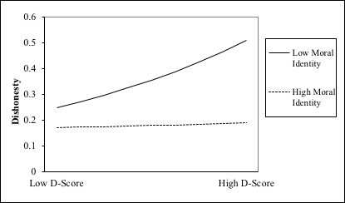

Figure 1. Dishonesty as a function of implicit beliefs and moral identity. The dependent variable is the number of times that the participant entered an illegitimate word in the Boggle task.

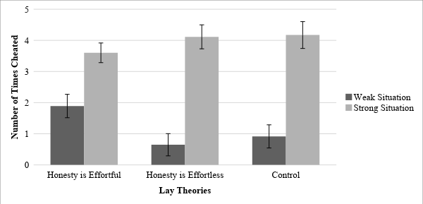

Figure 2. Dishonesty as a function of lay theories and strength of situation. The dependent variable is the number of times the participants used the answer provided by the programming glitch after five seconds have passed.

Appendices
Appendix A. Sequence of Blocks in Implicit Association Task in Studies 1 and 3b

Block Number | Press Left Key When a Word from the Following Category Appears | Press Right Key When a Word from the Following Category Appears
1 | Honest | Dishonest
2 | Effortful | Effortless
3 | Effortful or Honest | Effortless or Dishonest
4 | Effortful or Honest | Effortless or Dishonest
5 | Effortless | Effortful
6 | Effortful or Dishonest | Effortless or Honest
7 | Effortful or Dishonest | Effortless or Honest

Note: Words appear on the screen one by one and participants either press the left or right key to sort that word into the correct category. The words that appear on the screen will belong to either one of the four categories: honest, dishonest, effortful or effortless.

Appendix B. Depiction of the Rules and Actual 9-letter Matrix Used in Study 1

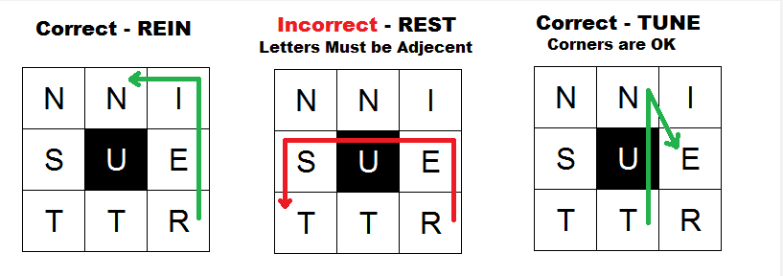

Appendix C. Articles Used to Manipulate Lay Theories about Honesty and Effort in Studies 2 and 3a

1) Honesty-is-effortful Condition (Study 2 and Study 3a)

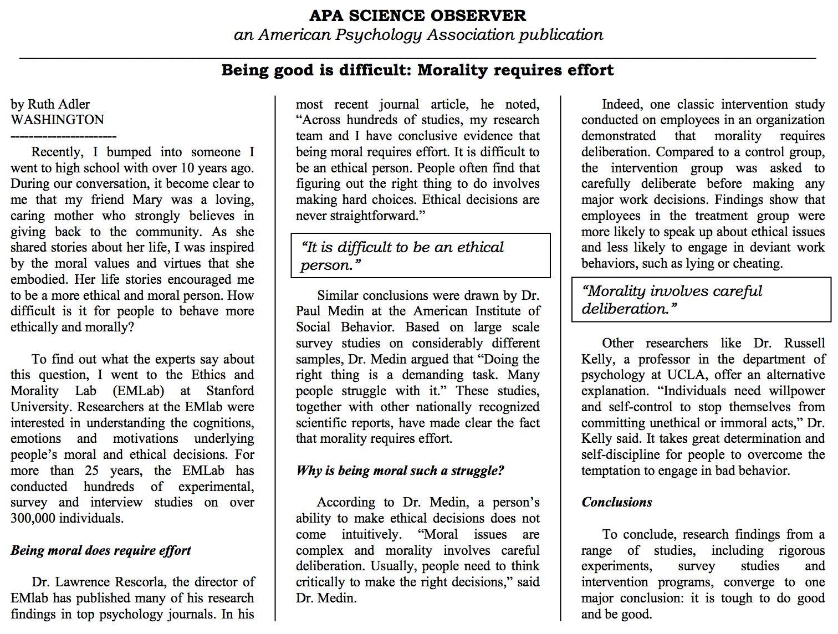

2) Honesty-is-effortless Condition (Study 2 and Study 3a)

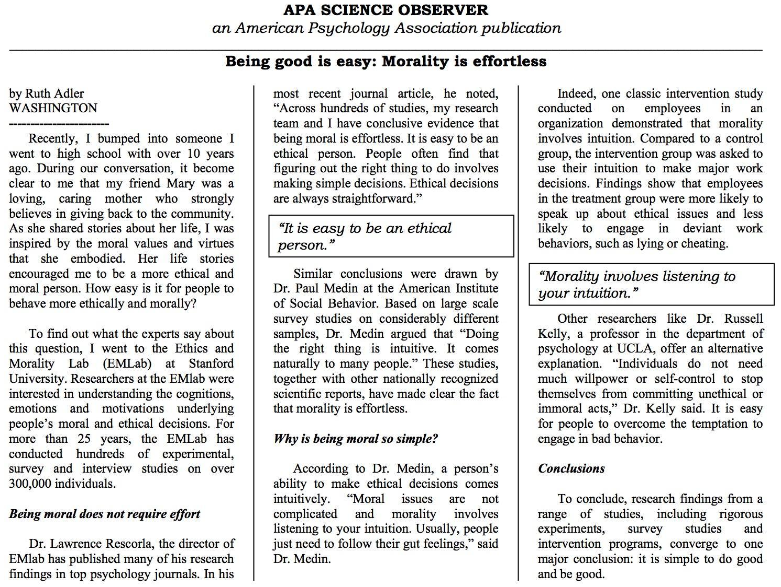

3) Control Condition (Study 3a only)

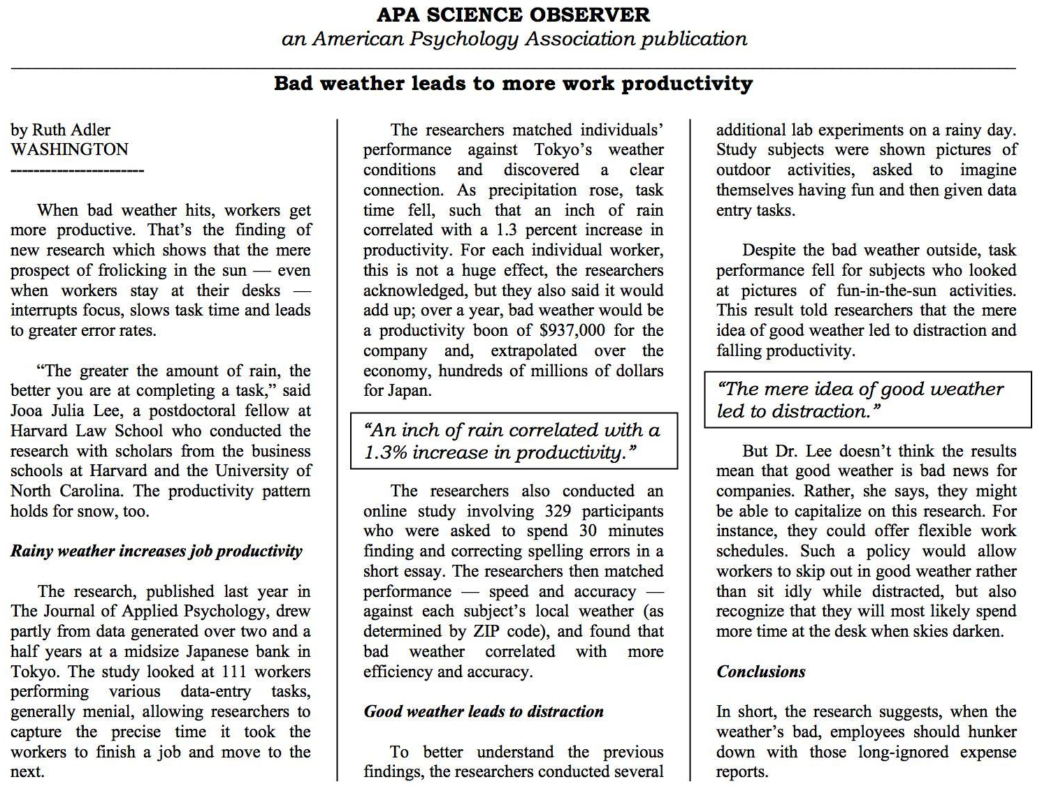

Appendix D. Measure of Lying in Study 2

Please complete the following decision-making task. Read the instructions carefully to ensure that you understand how the task works.

You will be given the opportunity to receive an extra cash bonus on top of the subject pool credit you will receive for your participation.

The amount of cash bonus you will receive is based on the decisions that you and another randomly assigned player will make. You will be randomly, and virtually, paired with another participant.

One of you will be assigned to the role of “message sender” and one of you will be assigned to the “decision-maker”. Please continue to be randomly assigned to a role.

Please be patient while the computer system randomly assigns you to a role. This may take a few seconds.

Participants were not actually paired with anyone else. They were shown a loading circle for five seconds and then received the following instructions:

You have been assigned to the role of a “message sender”. The other participant has been assigned to the role of “decision maker”. There are two possible monetary payments available in this task:

Option A: $2.00 to the message sender (YOU) and $0.50 to the decision maker (YOUR PARTNER).

Option B: $0.50 dollar to the message sender (YOU) and $2.00 dollars to the decision maker (YOUR PARTNER).

First, the message sender (YOU) will choose between one of two messages (which will be provided to you later) to send to the decision maker. The decision maker will then make a choice between option A and B. However, the decision maker will not know what the actual payments are for each option; the only information the decision maker will have is the information sent by you, the message sender.

Again, the decision maker will not know the monetary payments associated with each choice. Only you, the message sender, will ever see the monetary payment options. Please note that roughly 75% of the decision makers will follow your advice. The identities of the sender and the decision maker will be kept confidential, and the money all participants earned would be paid to each participant at the end of the study.

Participants advanced to the next page where they were given the following instructions:

The table below displays the payment options. Remember, only the message sender (YOU) will be able to see what the actual payment options are. The decision maker will simply be asked to select Option A or Option B after receiving your message. The option they select will determine your own payment.

Payment Options | Option A | Option B
Message sender (YOU) receives | $2.00 | $0.50
Decision make will receive | $0.05 | $2.00

Here are the possible messages that you as the message sender can send to the decision maker.

Message 1: I advise you that you choose Option A since you (the “decision maker”) earn more money than choosing Option B.

Message 2: I advise you that you choose Option B since you (the “decision maker”) earn more money than choosing Option A.

Which message would you like to send to the decision maker?
- Message 1
- Message 2

After choosing a message, participants received the following message:

Thank you. Your message has been delivered to the decision maker.

Please be patient while the decision maker makes a decision.

Participants were shown another loading circle for five seconds before being shown the following message:

The decision maker chose Option A. You receive $2.00!

Please click the button to view the debriefing information and then collect your payment.

Appendix E. Items of Measure of Beliefs about Honesty and Effort and Factor Loading in Study 2 (pretest)

Item No. | Item | Factor Loading
1. | Being honest is hard. | .94
2. | Doing the right thing is difficult. | .94
3. | Being honest can be a struggle. | .92
4. | Being ethical is a demanding task. | .91
5. | Making an ethical decision is challenging. | .84
6. | Doing the right thing is complicated. | .80
7. | Being honest can be tough. | .78
8. | Doing the right thing is effortful. | .77
9. | Being ethical requires willpower. | .58
10. | Making an ethical decision requires cognitive processing. | .53
11. | Making an ethical decision requires contemplation. | .50
12. | Making an ethical decision takes time. | .49
13. | Being honest requires self-control. | .46
14. | Being ethical requires reason. | .18
15. | Morality can be achieved through careful deliberation. | -.13

Note: Standardized factor loadings from exploratory factor analysis are reported. An exploratory factor analysis of the 15 items suggested a two-factor structure, with eight items loading on one factor (eigenvalue = 8.97 and explaining 59.79% of variance) and the remaining seven items (italicized) loading on the second factor (eigenvalue = 1.13 and explaining 7.5% of variance). Upon further examination, we decided to retain the eight items associated with the first factor since they explained a greater proportion of the variance. When we ran a separate exploratory factor analysis on the eight items in bold, the results suggest that the eight items load onto a single factor and all items had factor loadings of .70 and above.

Appendix F. The Spacebar Task in Study 3a and Study 3b

Participants were randomly assigned to two conditions: the strong situation condition and the weak situation condition. In each condition, participants were asked to answer eight quantitative reasoning questions but were warned that there was a glitch with the software that enabled the correct answers to be viewed. They received the same instructions and the same questions, but two different warning messages. The warnings appeared with the instructions and with each question before the answer was revealed. Participants were given 40 seconds to solve each question and were able to monitor the remaining time for each question with a timer that appeared onscreen.

== Instructions ==
The following screens contain a series of quantitative reasoning questions. Please answer the questions to the best of your ability. You will have 40 seconds to answer each question and will earn $0.15 for each question answered correctly. That means that you have a chance to earn up to an additional $1.20 for this study.

[Strong situation condition]
WARNING: Because these questions were adapted from SAT preparation software, the answer to each question will appear automatically if you do not press the spacebar in the first 5 seconds of viewing that question. Please answer the questions on your own.

[Weak situation condition]
WARNING: Because these questions were adapted from SAT preparation software, the answer to each question will appear if you press the spacebar within the first 5 seconds of viewing that question. Please answer the questions on your own.

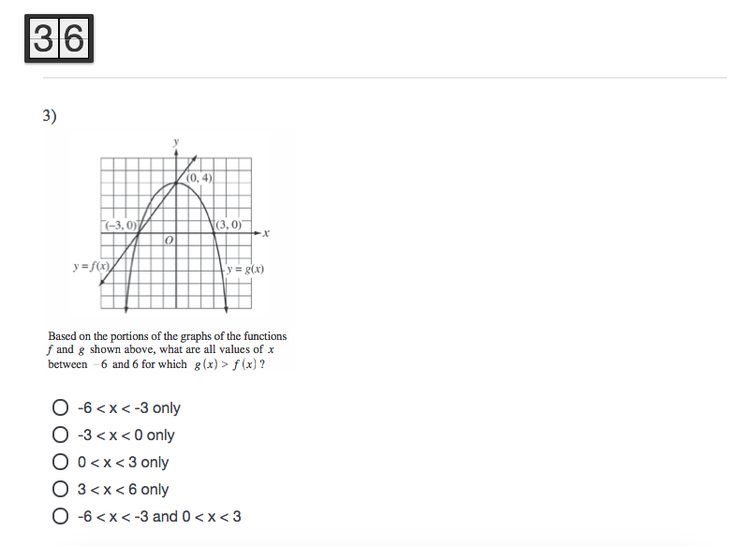

All studies reported in this paper have been approved by the institutional review boards of the universities that the authors are affiliated with.
We note that the d algorithm is not a simple calculation of the difference between IAT conditions but an effect-size calculation which accounts for the interdependency between IAT conditions by taking the difference between the IAT conditions and dividing it by the pooled standard deviation (Nosek & Siriam, 2007).
As a robustness check, we created a new dichotomous variable for our dependent measure (1 = created one or more illegitimate words, 0 = created no illegitimate words) and ran logistic analyses. First, we found that the implicit association between honesty and effort predicted a higher likelihood of cheating, Odds Ratio = 1.92, SE = .57, p = .028, 95% C.I. = [1.07, 3.46]. Second, the direction and magnitude of our effect did not change after controlling for actual performance and demographics, Odds Ratio = 1.96, SE = .59, p = .025, 95% C.I. = [1.08, 3.53]. In addition, we repeated our analyses after excluding the possible outliers (four individuals who created more than five illegitimate words) and found consistent results. That is, we found that the implicit association between honesty and effort predicted more dishonesty as measured by the number of illegitimate words, b = .40, SE = .19, p = .028, 95% C.I. = [.04, .75]. Mirroring the results from Model 2, we also show that this positive relationship between the implicit association and dishonesty is robust after controlling for actual performance on the Boggle task and demographics (age and gender), b = .38, SE = .18, p = .034, 95% C.I. = [.03, .74].
The 40 participants who were excluded from the study did not differ significantly from the included participants in terms of age, t(376)= 1.54, p = .13, gender, χ²(2, N = 378) = .74, p = .69, or probability of cheating, t(376) = –.42, p = .68.
In response to a reviewer’s suggestion, we also conducted the same analyses using the full 15-item measure (α = .95). Mirroring our results with eight items, our manipulation had a significant effect on the 15-item composite; participants in the honesty-is-effortful condition (M = 5.08, SD = 1.06) were significantly more likely to explicitly report that honesty requires effort than participants in the honesty-is-effortless condition (M = 3.72, SD = 1.28), t(172) = 7.57, p < .001, 95% C.I. = [1.01, 1.72], d = 1.15.
We note that our effect size in this study was particularly small, and our effect did not reach statistical significance at the 5% significance level, which warrants further investigation. In addition, we also ran an analysis without excluding any participants. Participants in the honesty-is-effortful condition (M_{probability of lying} = .44, SD = .50) were more likely to lie than those in the honesty-is-effortless condition (M_{probability of lying} = .37, SD = .48), but the difference was not statistically significant, Odds Ratio = 1.34, SE = .28, p = .163, 95% C.I. for Odds Ratio = [0.89, 2.03]. We suspect that this result might be due to the way we measured dishonesty (i.e., our binary dependent measure was either lying to the other player or not). Although our binary measure offers simplicity and ease of interpretation, it is crude, and considerable variability may be subsumed within cheaters and non-cheaters, thereby underestimating the extent of variation in our dependent measure. Indeed, scholars have suggested that dichotomous variables are limited because they suppress effect sizes and statistical significance (MacCullum, Zhang, Preacher, & Rucker, 2002).
We also had a measure of whether participants were born in the United States or Canada, and identified five participants who were not born in the United States or Canada. Excluding these participants did not change the direction or significance of our results.
There was a significant main effect of situational strength on actual performance; participants in the strong situation condition (M = .35, SD = .71) performed worse than those in the weak situation condition (M = 1.01, SD = 1.18), p < .001, while participants cheated more in the strong situation (M = 3.46, SD = 2.88) than in the weak situation condition (M = 1.1, SD = 2.12), p < .001. This result corresponds to the significant negative correlation between participants’ actual performance and dishonesty, r = –.40, p < .001, suggesting that under the time limit, participants in the strong situation ended up choosing to cheat instead of trying to solve the problem on their own.
Unlike Study 3a, this study was conducted in Southeast Asia. We believed that excluding international students would make a difference because without exposure to the same pre-university curriculum, international students may not be answering the quantitative reasoning questions with the same level of mathematical knowledge as local students. This might influence their probability of cheating on the task (Murdock & Anderman, 2006). More importantly, research shows cross-cultural differences in loss aversion and attitudes toward acts of commission versus omission (e.g., Arkes, Hirshleifer, Jiang, & Lim, 2010; Chen, Ng, & Rao, 2005; Ng, Kim, & Rao, 2015). Given that our study design involves manipulating cheating by omission versus commission, we excluded international students in order to minimize such cross-cultural differences.
If we include international students back in, the effect of our interaction term becomes not statistically significant, p = .167. Although not statistically significant, our results were directionally consistent in that the effect of lay theories on dishonesty was stronger in the weak situation (p = .017) than in the strong situation (p = .144). If we were to exclude both international students and non-native English speakers, the effect of our interaction term also becomes not statistically significant, p = .10. However, the pattern of our results remain similar. The effect of lay theories on dishonesty was stronger in the weak situation (p = .018) than in the strong situation (p = .268).

