Multiwell plate-based CycIF (p-CycIF)
Connor Jacobson, Zoltan Maliga, Clarence Yapp, and Jia-Ren Lin

Written for 96-well (Nunc 165305) plates; volumes can be adjusted for 384-well plates

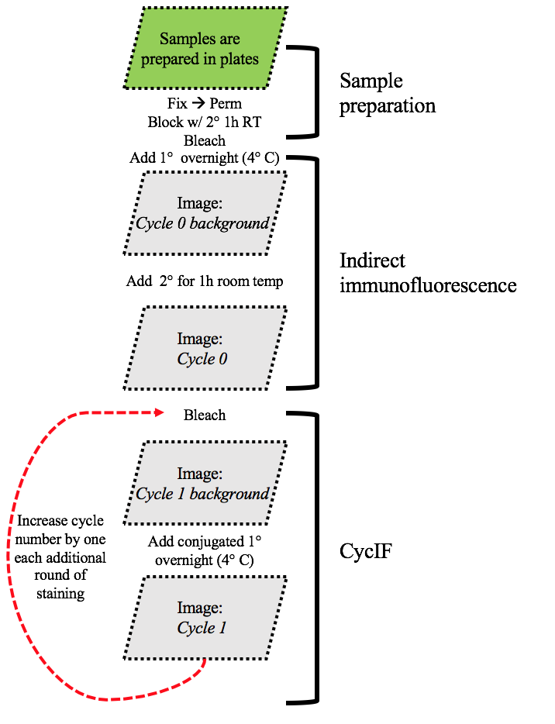
Cyclic immunofluorescence in a multi-well plate format permits reimaging the same field of fixed cells with a large number of antibodies to measure protein or phospho-peptide abundance at sub-cellular resolution. The protocol below describes a workflow to fix, stain, and iteratively image cells in a 96 well plate to produce a dataset with background and signal images in each staining cycle for reliable cell quantification.

Sample preparation: Plates are prepared by the experimentalist with proper drug treatments and controls – plate maps outlining conditions should be provided. An exploratory CycIF biomarker panel should be selected beforehand, and stocks of antibodies should be checked.

Note: For image acquisition, all users will need to attend a training session on the INCell 6000 with Clarence Yapp before becoming an independent user. Jerry Lin and Clarence will help with image processing after it has been acquired. Computationalists can help with heavy-quant data analysis.

Protocol

1. Fixation:
- Add 140 uL 4% PFA to all wells
- Incubate for 30 minutes at room temperature (RT)
- Wash plates 4x with PBS using plate washer (or manually for poorly adherent cells)
Sealed plates can be stored at 4°C for weeks to months, depending on cell line

2. Permeabilization (of membranes and for antigen retrieval):
a. Add 140 uL of ice-cold methanol to all wells
- Incubate for 10 minutes at RT
- Wash plates 4x with PBS

3. Blocking (inhibit non-specific binding):
- Add 140 uL of Odyssey blocking buffer (OBB) to all wells
- Incubate for 1hr at RT
- Wash plates 4x with PBS
- Add 140 uL of OBB + secondaries* (1:2000) + Hoechst (1:5000) to all wells
- Incubate overnight (block from light) at 4°C
- The next morning, wash plates 4x with PBS
4. Fluorophore inactivation (photo-bleaching):
- Add 140 uL bleaching solution to all wells
- Place plates on LED light for 60 minutes
- Wash plates 4x with PBS

5. Quantifying background:
- Stain plates overnight (block from light) at 4°C with first round of primaries (can be unlabeled)
If using Zenon-labeling Technologies see “Reagents”
- The next morning, wash plates 4x with PBS
- Plate are now ready to be imaged for background quantification
Name file “Cycle 0 background”
6. Image acquisition with GE INCell 6000 Analyzer:
- In the instrument software and under the ‘Setup’ tab, create a new protocol or open an existing one. Can use Connor’s protocol: “Nunc_” with pre-loaded layout as a starting point.
- Plate/Slide tab: select plate type and highlight the wells to be imaged. With the 10x/0.45NA lens selected, click on ‘Verify LAF’ to confirm the thickness of the plate bottom. Apply changes if necessary.
- Objective Lens tab: select an appropriate objective lens for image acquisition that gives sufficient resolution and field-of-view. A 40x/0.95NA will give better resolution, but a 20x/0.75NA will allow more cells to be imaged per unit time.
- Fields tab: select the number of fields per well to be imaged. Use an overlap of 5-10% to maximize accuracy of stitching using Ashlar (if required). The number of fields imaged is experiment and biomarker specific. Aim for 300-500 cells/well depending on the conditions.
- Channel Settings tab: select the number of channels to be imaged. Available channels include DAPI (ex 405nm/ em 455/50nm), FITC (ex 488nm/ em 525/20nm), dsRed2 (ex 561nm/em 605/52nm), and Cy5 (ex 642nm/ em 706.5/72nm). For each channel, ensure that the exposure time and laser power provide sufficient signal-to-background but avoid saturation (max gray level value is 65536). Use a binning of 2x2. If needed, untick ‘Open aperture’ to use line confocal mode3 for each channel. Start with an aperture size of 1 airy unit and increase if signal-to-background ratio and mean intensity is too low.
- Focus options: Click on the Focus Finder (FF) button and use the mouse wheel to bring the sample into focus. Click on the green pencil button to set ‘Initial Focus’. Tick ‘Laser Autofocus’ to use laser autofocusing. Click the ‘Autofocus Offset’ button to determine the offset of each channel. Due to chromatic aberration, the channels will have different offsets, usually within 10 microns of each other.
- Acquisition options: Select ‘horizontal serpentine’.
- Save your protocol. Click on the ‘Scanning’ tab and click on the ‘Scan’ button to run your image acquisition protocol.

7. Indirect IF (Cycle 0 of CycIF):
Up until this point, the cells have been prepared and imaged for background subtraction. The subsequent steps collect true stains of your biomarkers of interest.
a. Add appropriate secondaries to corresponding wells based on species, isotype, and fluorophore
b. Incubate for 1hr (block from light) at RT
c. Wash plates 4x with PBS
d. Image plates as “Cycle 0”
e. Repeat steps 4a-4c for photobleaching
f. Re-image plates as “Cycle 0 bleached” to determine if fluorophore was successfully inactivated/removed4
This step will be valuable for background subtraction
8. p-CycIF staining:
- Stain plates overnight (block from light) at 4°C with Cycle 1 conjugated antibodies
- Wash plates 4x with PBS
- Image plates as “Cycle 1”
- Repeat Steps 4a-4c for however many cycles are in your CycIF panel
Name each imaging session file as “Cycle n (bleached)”

Reagents
Name Vendor Cat. No. Lot No.
16% Paraformaldehyde Electron Microscopy Sciences 15710 160108
Methanol (99.9%) Arcos Organics 61009-0040 B0533428
Hoechst 33342 Thermo H3570 1840439
Odyssey blocking buffer (OBB) Li-Cor 927-40000 --
*Goat anti-Rabbit as 488/FITC Thermo A11070 1812158
*Donkey anti-Goat 555/Cy3 Thermo A21432 1750277
*Goat anti-Mouse 647/Cy5 Thermo A21237 1843705

Zenon antibody labeling
adapted from the Thermo-Fisher reagent manual: https://www.thermofisher.com/us/en/home/life-science/cell-analysis/labeling-chemistry/protein-and-antibody-chemical-labeling/antibody-protein-labeling-kits/zenon-antibody-labeling-kits.html

With this technology, one can add fluorescent labels to unlabeled antibodies. By using Thermo’s species/isotype-specific regents, one can label rabbit and mouse antibodies at the 488, 555, and 647 wavelengths (among others) enhancing the incorporation of additional antibodies into our CycIF biomarker panel selection. The protocol is as simple as a subsequent CycIF cycle:

- Add 7 uL PBS to 1 uL antibody of interest.
- Add 2 uL isotype-specific Zenon-label. Incubate for 5-10 min (block from light) at RT.
- Add 2 uL matching Zenon-block to mix. Incubate for 5-10 min (block from light) at RT.
- Add mix to cells and stain overnight (block from light) at 4°C
- The next morning, wash plates 4x with PBS using plate washer.
Plates are now ready for the next round of imaging

Appendix

Additional reading: Lin, Jia‐Ren, et al. "Cyclic Immunofluorescence (CycIF), A Highly Multiplexed Method for Single‐cell Imaging." Current protocols in chemical biology (2016): 251-264.

If you would like to perform p-CycIF on your own samples, please contact the individuals below to set up a meeting to discuss experimental design, timeline, and a plan of execution:

Laura Maliszewski: laura_maliszewski@hms.harvard.edu
Jerry Lin: Jia-Ren_Lin@hms.harvard.edu
Zoltan Maliga: zoltan_maliga@hms.harvard.edu
Connor Jacobson: connor_jacobson@hms.harvard.edu
Clarence Yapp: clarence@hms.harvard.edu

3% H₂O₂ in PBS plus 20mM NaOH: 35.2 mL PBS + 4 mL H₂O₂ (30% stock) + 800 uL NaOH (1M stock)
2 Although the dsRed filter for the INCell 6000 is compatible with Alexafluor 555, it is better optimized for Alexafluor 568. Consider using AF568 if your images suffer from poor signal-to-background and are dim. If an antibody is not available with the AF568 fluorophore, it is possible to add a 568-label using Zenon labeling (see “Reagents”). 3 Line confocal mode reduces out-of-focus blurring which would otherwise obfuscate details (such as punctate or filamentous structures) in your image. Contrast and resolution will improve at the detriment of light sensitivity, which will therefore increase exposure time, total acquisition time, and rate of photobleaching. Confocal mode can be used for just one or as many channels of any cycle desired.
.
4 If 3% H₂O₂ does not inactive a fluorophore entirely, one can increase the concentration of beaching solution to 4.5% or the plates can be left on the light for up to 90 minutes.

