Appendix Figures and Tables

Appendix Figure 1. Data source description. (a) shows the same or similar posts may be published by different authors, (b) shows the same post may be published in both groups, (c) shows a real post in the full size (c-1) and in brief (c-2) that was crawled and processed through a data cleaning step (c-3), and (d) and (e) are the descriptions of the two groups as of December 2019.

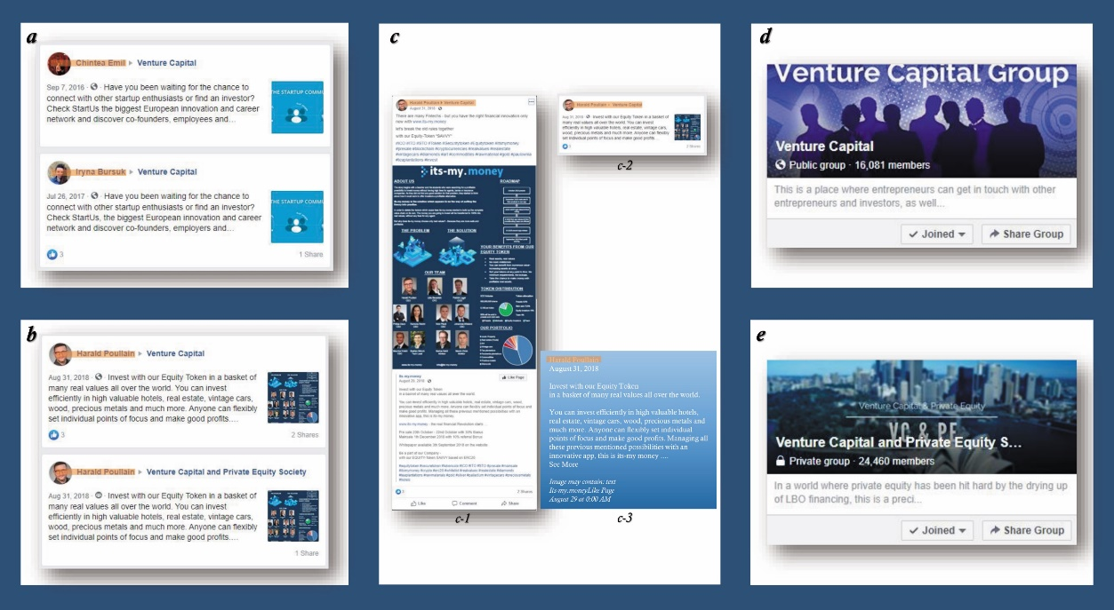

Appendix Figure 2. Understanding of methods. (a) is an illustration of the force-directed layout network, (b) illustrates a stream graph (x-axis = time, y-axis = number of identified topics.

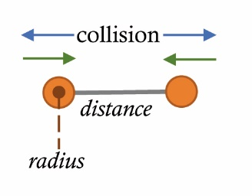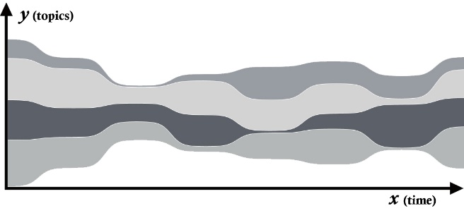
(a) (b)

Appendix Table 1. Moderator information for the two groups to indicate the sparsity of raw post data. Note that the colored name is the same person.

The Private group |  |  |  |  | The Public group
Moderators | As an inviter | Posts | Followers | Got Likes | Moderators | As an Inviter | Posts | Followers | Got Likes
SB |  |  |  |  | 3SiMV | 204 |  | 1,370 | 1,331
TWB |  |  |  |  | CF | 6,188
MHC |  |  |  |  | JF | 2,567 | 512 | 1,239
KC
PD |  |  | 204
YE
JF | 2,453 |  | 1,239 | 2,453
SG |  |  | 62
AG |  |  | 62
WAH | 11 | 1 |  | 11
GH
MK
JLDL | 20 |  | 1,032 | 20
JL
GL
AM | 2 |  |  | 2
KM
RM
SGKN
AN
MP
PS
LNT
AT |  |  | 96
AZ

Appendix Table 2. Example subgroups in two venture-capital groups. Note that the same colored name means the same person.
Serial Number | The Private group | The Public group
1 | JF, NJ, AJ | JF, WJDW, AP
2 | JCR, AB, SJ | CF, AS, NH
3 |  | CF, KA, VK
4 |  | CF, CFF, NE
5 |  | CF, PG, AM
6 |  | CF, PG, VKl
7 |  | CF, SLV, RS
8 |  | CF, SK, MK
9 |  | CF, DY, RK
10 |  | CF, RP, AA
11 |  | CF, SB, MS
12 |  | CF, VK, PPP
13 |  | CF, PS, AG
14 |  | CF, PS, NA
15 |  | CF, JC, SKh
16 |  | CF, SJ, AA
17 |  | CF, HK, AG
18 |  | CF, SA, AK
19 |  | CF, RJ, SS
20 |  | CF, RS, DK
21 |  | CF, NM, RS
22 |  | CF, SS, PK
23 |  | CF, AS, AK
24 |  | CF, RT, SC
25 |  | CF, YR, CCP
26 |  | CF, SM, AG

