Session on Trade Deficits and the Trump Administration, Friday, September 15,
from 10:00 am to noon at AEI, 1789 Massachusetts Ave. NW, Washington DC

Trade Fallacies – Jeffrey Frankel, Harvard Kennedy School.

- “US trade negotiators have been out-negotiated by those from other countries.” Wrong.
  - In most trade negotiations, such as TPP, NAFTA, and the Uruguay Round that culminated in the founding of the WTO, the US has been able to get most of what it asked for – in large part because it has been the leader of the international order. Up until now.
  - Most of the trade agreements have required high-tariff trading partners to reduce barriers against US goods, while the US already had relatively low tariffs and so has conceded less.
  - US demands have also driven agreements on deeper integration -- in such areas as labor rights, the environment, investor-state dispute settlement, and intellectual property rights.
  - The Administration is trying to renegotiate NAFTA. How could NAFTA usefully be modernized and expanded? TPP. Six ways
    - Updating for some new issues that did not exist when NAFTA was originally negotiated, such as e-commerce and data localization.
    - Greater protections for labor, such as guaranteeing throughout the region that workers can form independent unions, banning child labor, and strengthening enforcement against human trafficking.
    - Greater protections for the environment, such as steps to protect the oceans and provisions to enforce bans on trade in endangered species and illegal logging.
    - The backing up of environmental and labor provisions by a dispute settlement process and threats of economic penalties that are as serious as those that back up regular mercantile disputes.
    - Some protection against corporate abuse of Investor-State Dispute Settlement. There should be provision for summary dismissal of frivolous suits, such as when a MNC challenges a new regulation simply on the grounds that it diminishes its ability to earn profits.
    - The inclusion of more countries in the agreement. Good candidates would be some in South America, including Peru and Chile, and others in Asia and the Pacific.
  - One of the funniest things that Trump has said is "The negotiators for Germany have done a far better job than the negotiators for the United States."
    - He is under the impression that there is an occupation called German trade negotiator, apparently unaware that Germany long along outsourced this responsibility to the customs union called the European Union.
    - Evidently he was referring to the fact that Germany runs a large trade surplus, including bilaterally with the US.
- “Bilateral trade imbalances reflect bad trade agreements.” Wrong.
  - If country A currently runs a bilateral trade deficit with country B, it generally signifies some combination of the following three causes: (i) A currently has a trade deficit overall, (ii) B has a trade surplus overall, (iii) B needs to earn a structural surplus with countries like A, to pay for a structural deficit from, for example, OPEC countries.
  - If the US stops importing steel from China, we will import that much more from Europe. If we stop importing consumer electronics from China, we will import them from other Asian countries.
  - The guy who cuts my hair insists that I pay him with money. He refuses to accept as payment a lecture in economics, which is what I have to offer. But that’s okay, because I earn my income giving lectures at Harvard.
- “A trade deficit indicates the absence of a level playing field.” Wrong.
  - There is no (positive) correlation between countries’ tariff rates and their trade balances.
  - Trade deficits are macroeconomic phenomena, influenced by national incomes and exchange rates, and determined in a deeper sense by national saving and investment.
  - The United States has run current account deficits since 1982 because national saving (as a share of GDP) has been low,
    - taking the form of both low private saving and low public saving
    - The famous twin deficits: exogenous increase in the budget deficit leads to an increase in the trade deficit (e.g., 2001-07).
  - China, Germany, Japan, and South Korea run current account surpluses because they have high national saving rates.
Average applied tariffs and average trade balances from 2012 to 2015 for 183 countries

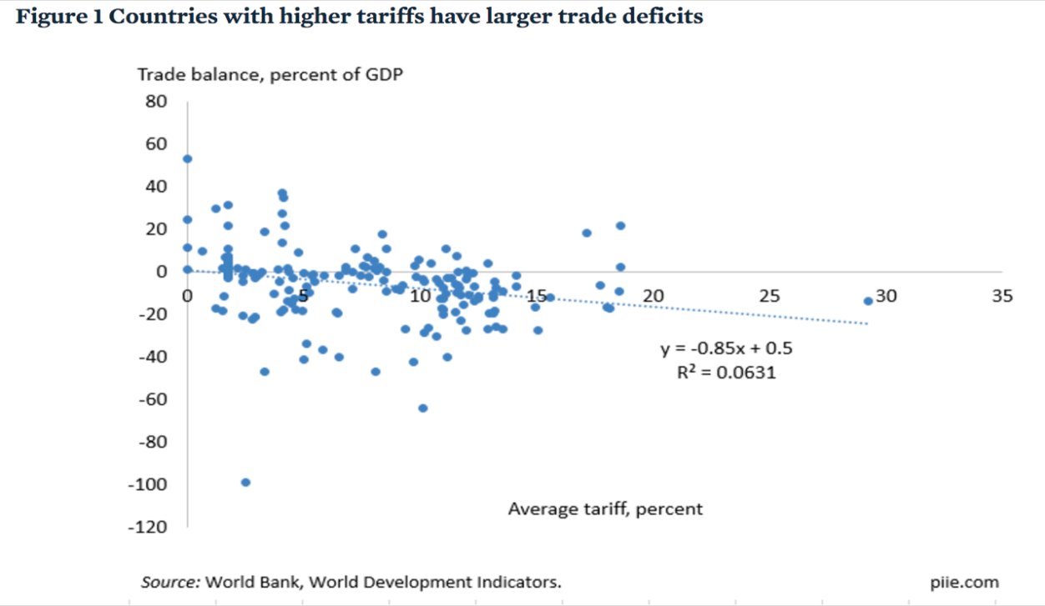

Caroline Freund, PIIE, May 8, 2017 “Public Comment on Trump Administration Report on Significant Trade Deficits.”

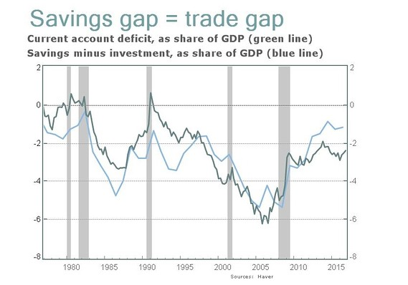
Jeff Sachs, “Opinion: What Trump doesn’t get about the link between U.S. savings and trade deficits,“ Marketwatch, April 21, 2017.

- “Trade deficits are bad, subtracting from GDP. Eliminating a trade deficit adds to growth and creates jobs.” Wrong.
  - Well, not always wrong.
    - An export boom when there is excess capacity in the economy – as there was for most countries after the Great Recession of 2008-09 – would have been a way to add nicely to output and employment. But we are now at the natural rate of unemployment.
    - Also chronic current account deficits imply rising international indebtedness which, for normal countries, eventually brings costs such as impaired creditworthiness.
  - But trade deficits are not always bad news and trade surpluses are not always good news:
    - E.g., the rise in the trade deficit in the late 1990s (the half-decade after NAFTA went into effect accompanied the longest US economic expansion on record
      - It originated in an investment boom rather than a budget deficit.
      - It brought unemployment as low as 3.8% by 2000 and rising real wages
      - and real incomes for the median family.
      - Imports rose even more rapidly than exports, but that was a useful safety valve that prevented the economy from over-heating.
    - Conversely, sudden improvements in the trade balance are usually attributable to recession (because lower income means lower imports). E.g., the US deficit fell by half in 2009.

The trade balance does not add to growth. Indeed the balance “improves” in recessions like 2007-09.
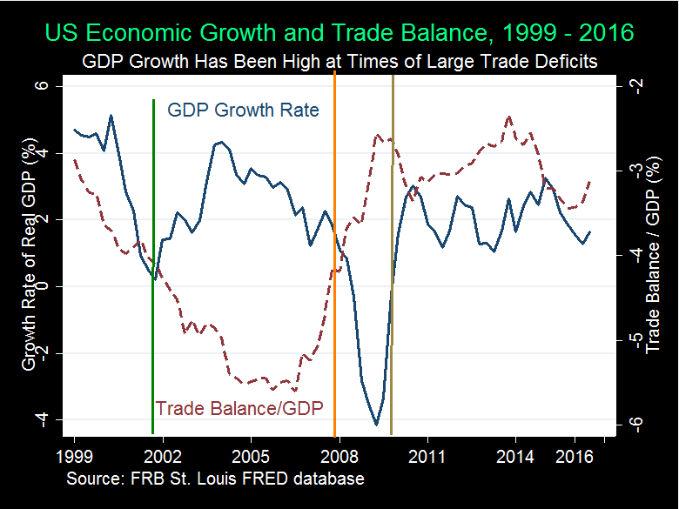
From: Menzie Chinn & Michael Klein, “Is the Trade Deficit a Drag on Growth?” Econofact, Jan.20, 2017

- “Free trade agreements are generally bad for income distribution; they explain much of the stagnation in median family income in the US since 2001. An aggressive trade policy would reduce inequality.” Probably wrong.
  - It should not be news that letting in more imports creates both winners and losers.
    - So do all changes, e.g., keeping out imports.
    - To take the example of Trump White House moves against imports of steel and aluminum – even if one ignores the lack of a legal basis for the national security claim (under Section 232) – a loss of steel imports would raise costs of US manufacturers that use these products as inputs (such as autos). This would both raise the cost of living at home and make US exports less competitive abroad. And that is before we get to loss of exports through (1) foreign loss of dollar earnings with which to buy goods from us, (2) dollar appreciation, and (3) foreign retaliation against US products.
  - It is true that recent research has shown that some specific industries and localities suffer more and longer from import competition than some analysts were previously aware. But this does answer the question of the overall implications for median workers. The negative effect of imports on jobs leaves out two big factors on the “plus“ side of the balance sheet:
    - trade creates export jobs, which tend to pay higher wages than other jobs; and
    - trade lowers the price of importable consumer goods, which are disproportionately bought by lower-income households.
  - It is hard to say whether or how much increased trade has contributed to rising inequality. Probably less than such other factors as technological progress, slowed education rates, winner-take-all markets, assortative mating, and increased monopoly power in some industries.
  - We do not need to know the relative importance of causes of higher inequality to know some of the policies to address it. Here are ten:
    - Expand, don’t reduce, the health-insured population.
    - Strengthen, don’t weaken, US financial regulation.
    - Address the long-term rise in household debt.
    - Reform the tax system (staying revenue-neutral)
      - Expand the EITC; don’t eliminate the estate tax.
      - Make the payroll tax more progressive.
      - Corporate: lower the tax rate, but offset by eliminating deductions
    - Put social security on a sound footing.
    - Increase infrastructure spending.
    - Don’t subsidize fossil fuels, but allow fracking (regulated). Start a carbon tax.
    - Improve education, esp. universal pre-school education.
    - Keep US global economic leadership, including abiding by trade agreements.
    - Consider wage insurance.
- “Trade policy threats against China (or South Korea!) can serve as ‘bargaining chips’ to help resolve the North Korean nuclear threat.”
  - Folly (not fallacy).
  - A deal-maker should know fundamental principles of bargaining:
    - One needs to think of what the other country wants.
    - Threats and promises require credibility.
Trump has already squandered his many times over.

