Presentation to Seminar on Business Cycle Dating
Panel on “International Experiences from the USA & Canada,”
Mexico City, Oct. 30-31, 2019
CIDE (Centro de Investigación y Docencia Económicas,
or Center for Research and Teaching in Economics).

Jeffrey Frankel

Harpel Professor of Capital Formation and Growth

Harvard Kennedy School, Harvard University
Outline
- “Why are business cycle committees needed?” The question is one that I have been called upon to answer more often than you might think over my 25-year period of membership on the US NBER BCDC. The question might even be the one that is asked most frequently by the media each time we declare a turning point, that is, a peak or trough.
  - Typically the journalist in question had not covered the preceding recession, [and often he or she has only just discovered the existence of the committee or the fact that it has the official responsibility for declaring recessions].
  - I will elaborate later on how and why this question is asked,
    - I think as long-time member of the NBER committee I may have a unique perspective, that is hard to figure out if one has not actually done it.
- Despite the frequency of the question, the turning points declared by the BCDC lead to newspaper and news-site headlines whenever announced; and the dates are in turn accepted in chronologies – virtually universally.
  - Whether it is an econometric scholar doing macroeconomic research or a politician giving a speech that tries to assign credit or blame for a recession, they use the NBER dates.
  - I think it is useful that everyone is working off of a common officially designated chronology.
  - The official status of the NBER dates is confirmed on the website of the Bureau of Economic Analysis of the US Department of Commerce.
    - “The designation of a recession is the province of a committee of experts at the National Bureau of Economic Research (NBER), a private non-profit research organization.”
    - E.g., the dates are used by the US government, as the basis for the shaded-in recession areas on graphs.

Fig. 1 The NBER BCDC has declared 5 US recessions
(10 turning points) since 1978
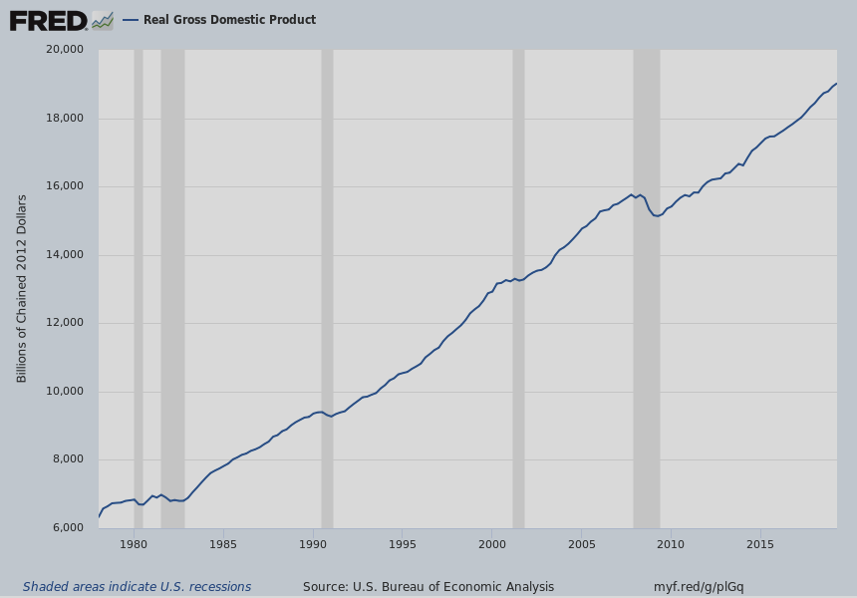
  - For example, nobody questions the declaration that there was a recession in 2001, even though the two quarters of negative growth that year were not consecutive. [Either at the time or now, though I seem to recall that there was a period subsequently when GDP revisions showed 3 consecutive negative quarters in 2001].
    - Everyone accepts that the longest US expansion on record until now was the 10-year period (120 months) from March 1991 to March 2001. Nobody tries to claim what would be a corollary of the disappearing 2001 recession, that the record length of a US expansion is, instead of 10 years, the period of 16 ½ years (201 months) from March 1991 to December 2007.
      - Someone wishing to push back against Donald Trump would have an incentive to make such a claim, because it would imply that the current expansion -- 2009-2019 -- is not after all the longest on record in the US.
  - Similarly, at the time when we announced that the 2008 recession had begun with a peak in December 2007, the government estimates still reported that the official GDP measure of output was actually higher in both the first and second quarters of 2008 than the last quarter of 2007.
    - We based our call on other indicators, such as job loss and the national income measure of output.
    - Much later, the Commerce Department revised its statistics: The current estimates reassuringly show that GDP was in fact lower in both of the first two quarters of 2008 than in the last quarter of 2007.
    - Even though our announcement of the beginning of the recession was greeted as long overdue when we made it, we would have had to wait another year and a half to get that crucial revision from the Commerce Department if we had stuck with the “two quarters of negative growth” rule.

- Some background
  - Although the NBER’s chronology goes back to 1854, it was Martin Feldstein who established a committee of NBER scholars and gave it responsibility for business cycle dating when he took over the institution in 1978.
  - The first press release dates from July 27, 1979. (It said the committee was not ready to declare a recession. Even though GDP had fallen, other indicators like employment were still rising.)
  - Designation of the membership on the committee is the prerogative of the President of the NBER, currently Jim Poterba.
  - The membership of the committee has fluctuated, between 6 and 10 if I remember right.
  - Bob Hall has been chairman of the committee the whole time since 1978.
- The US system is fundamentally different from that used by almost all other countries.
  - Most countries use the simple rule of two consecutive negative quarters, with no committee to make the decisions.
  - The background memo for the CIDE conference lists a few other committees in other countries:
    - the CEPR’s BCDC for the euro area;
    - CD Howe Institute in Canada;
    - also Spain and Brazil.
  - If there is not some degree of official buy-in, it is a different exercise. I salute these committees; and I won’t go so far as to call their work a purely academic exercise. But it is my impression that the findings receive little attention in the media or recognition from their national governments. I would be happy to be corrected on this if I am wrong [by Steve Ambler for the case of Canada, or others].

- Japan is one of the very few other countries that departs from a mechanical rule of two consecutive quarters of negative GDP in official chronology.
  - The Japanese government is the arbiter, but the government departs from the automatic two-quarter rule and considers other indicators.
  - As mentioned, some other countries have committees that look at other variables but their decisions receive relatively little attention from the media or official government bodies.
    - Perhaps their rulings will gradually gain more public and official recognition in the future, as the NBER BCDC has.
- Why not follow the rule of two consecutive quarters of negative GDP? Examples illustrate.
  - That rule says that Italy has had 3 or 4 recessions since 2007. But GDP has remained far below the 2009 peak. Looking at the graph of GDP, I would call it one big recession. So, I believe, would the NBER if applying its methods.
Fig.2: Italy has had at least 3 separate recessions since 2008, by the 2-quarter rule. 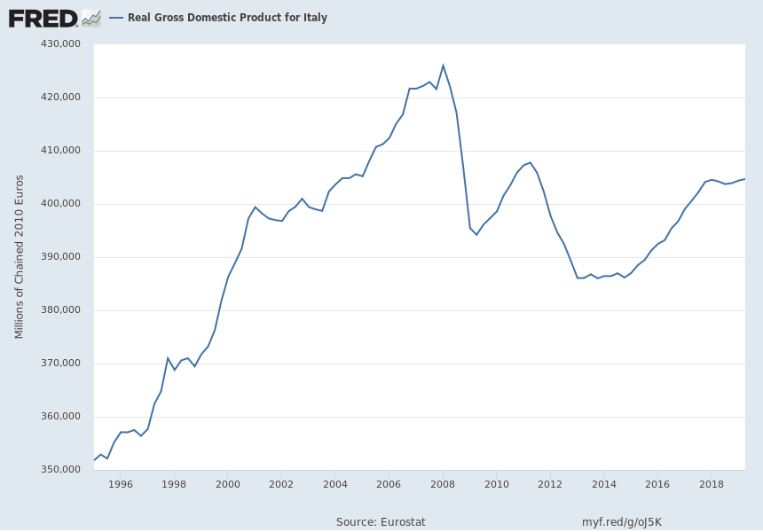
  - A similar story holds for the recent history of some other euro members, such as Ireland [a misleading “recession” in 2013].
- Further, the NBER Committee does not look only at GDP.
  - The second most important indicator, which is critical when working in real time, is employment. (I personally am fond of total hours worked, because it seems to me that changes in the demand for labor show up in the length of the workweek before firms starting firing or hiring.)
  - Also on the list of indicators at which the Committee looks are industrial production and real personal income.
  - Other indicators have also been taken into account. (E.g., retail sales).
- GDP does has special significance.
  - But even the GDP concept has ambiguities. By the time of the Great Recession, the committee had come to the view that it is a mistake to rely solely on the product side measure of GDP, that is, C+I+G+X-M. The US evidence suggests that the income-side measure (labor compensation+ capital income + taxes) is at least as informative, perhaps more so, even though it receives virtually no public attention.
    - The two in theory should be identical but in practice are not.
    - In 2015, the Commerce Department’s BEA finally started publishing a series called “the average of GDP and GDI”, which the President’s Council of Economic Advisers christened GDO.
    - This is the number that the NBER BCDC had been computing for itself and using in its deliberations regarding the 2007-09 recession.
  - A major reason why employment and the other indicators receive weight in real time is that GDP numbers are revised repeatedly [including in the US case the subsequent July and every July for five years.]
  - In countries that rely on the rule of two consecutive quarters of negative growth, a revision in GDP may mean that a turning point that was declared in the past must now be revised. Examples in a moment.
  - But GDP or GDO does have special significance, especially in the decision to call a trough.
- Allow me a digression, an illustration of how important GDP or GDO can be in deciding to call a trough.
  - You might have noticed from the Table that the lag has been especially long when declaring that the economy has reached a trough and that a recovery is therefore underway – an average of 19 months in the last three recoveries. You may wonder why.
  - Even when it seems clear that a trough has occurred, we ask ourselves the question: hypothetically, if the economy were to crash tomorrow, would we call this a new separate recession (as in 1981), or a continuation of the same one. In the latter case, we try to hold off calling the trough, because we don’t want to have to revise a date that has already been called.
  - If GDP or GDO has come close to re-attaining its preceding peak -- say it has climbed more than 2/3 of the way back to the previous peak -- the answer to the hypothetical question is “a sudden reversal would count as a new recession.” In this case the Committee would feel confident enough to call the trough.
    - That Italy’s GDP has not yet re-attained its 2007 peak is the reason why I say that if the NBER were applying its approach, it would probably have waited many years to declare an end to the 2008-09 recession, and perhaps still would not have done so.
- Now, why, each time there is an announcement, does the Committee get asked “Why do we need the BCDC?”
  - The first variant of the question is “You geniuses just trumpeted a recession that everybody else figured out a long time ago. Why are you only now getting around to declaring it? Your committee is useless.” Indeed, the average lag between a turning point and the announcement is 12 months. [see table].
Table: Dates of the 5 business cycles declared by the NBER BCDC
Turning Point Date | Peak or Trough | Announcement Date | Lag (months)
June 2009 | Trough | Sept. 20, 2010 | 15
December 2007 | Peak | Dec. 1, 2008 | 12
November 2001 | Trough | July 17, 2003 | 20
March 2001 | Peak | Nov. 26, 2001 | 8
March 1991 | Trough | Dec. 22, 1992 | 21
July 1990 | Peak | April 25, 1991 | 9
November 1982 | Trough | July 8, 1983 | 8
July 1981 | Peak | Jan. 6, 1982 | 6
July 1980 | Trough | July 8, 1981 | 12
January 1980 | Peak | June 3, 1980 | 6
AVERAGE LAG |  |  | 11.7
Note: A peak is the start of recession; a trough is the start of a recovery.

  - The second variant of the question is “Why shouldn’t the US do what virtually everybody else does, and just follow the rule of two consecutive quarters of negative growth? Who needs a bureaucratic committee?”
  - These two critiques often unknowingly contradict each other. The recession that “everybody knows” we are in, often would not pass the two-quarter rule according to the initial GDP statistics.
  - Clearly, the two-quarter rule has both pros and cons compared to the NBER committee’s less mechanical approach. One advantage is that it appears more objective. Another is that the public learns of a cyclical turning point with a lag of only a few months – that is, as quickly as the GDP statistics are compiled,
    - rather than waiting a year or so after the fact, until all the data are in, before announcing a turning point.
  - One major disadvantage of the two-quarter rule is that when the GDP statistics are revised subsequently, they may require a retroactive revision of the cyclical turning points.
    - For example, a 2011-12 recession in the UK was subsequently erased from the record when the GDP numbers were revised in June 2013. Claims that in 2012 had appeared in the speeches of UK politicians and in the writings of researchers, made in good faith at the time, were subsequently rendered false.
    - I believe France also in 2013 had to erase a recession due to revisions in the GDP data.
    - The reason the NBER waits so long before dating a trough or peak is so that it can be reasonably sure it will not have to revise the call in the future, after the dates have already entered the official chronology.
      - Likewise, the Japanese government waits for a year or so before making such announcements.
      - The NBER BCDC would revise a date if it had to, and has occasionally considered it.
      - But a revision of dates would be confusing. And the Committee has never done it.
      - The goal of the NBER is not to be quick. Hundreds of other observers see that as their job. The NBER BCDC sees its job as being definitive.
- There is another, more fundamental argument for abandoning the two-quarter rule in many countries. Some countries experience sharp slowdowns or periods of diminished economic activity and yet their long-term trend growth rates are either so high or so low that the negative-growth rule does not capture what is needed to describe the state of the economy.
  - Consider first a country where the rule would yield excessively frequent “recessions”. In Japan, the population is shrinking and productivity growth is far below what it used to be, so the country’s output growth has averaged only 1% per year in recent decades. As a result, even small fluctuations can turn GDP growth negative. The two-quarter rule would suggest that Japan had seven recessions between 1993 and 2015, or one every three to four years.
Fig. 3 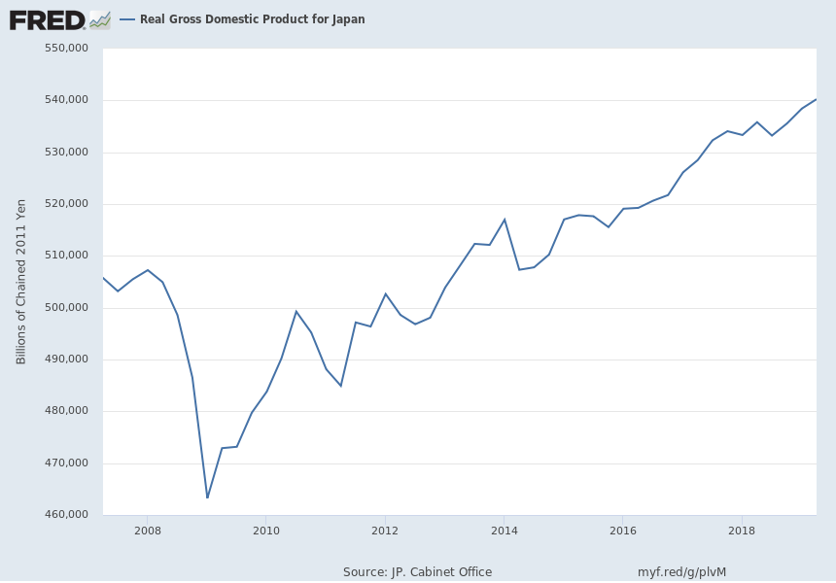
  - Now consider the opposite problem, when the two-quarter rule yields infrequent recessions. Australia is said to have the world-record for the length of its current expansion, at 28 years.
    - To be sure, Australia has earned much of its success: attributable to its adoption of structural reforms since the 1980s, its openness to trade and a switch to a floating exchange rate.
    - Still, one reason why Australia’s GDP shows no downturns in the past 28 years is that the country’s population and labor force are growing substantially faster than those in other advanced economies, especially in Europe and East Asia.
  - Similarly, China has not had an outright recession in 26 years (since 1993). Although its economy has of course experienced remarkably strong growth, China, too, suffered in the Great Recession. But even an 8-percentage-point decrease in GDP growth (from 14% in 2007 to 6% at one point in 2009) was not enough to cause Chinese output to shrink in absolute terms. The reason, of course, is that its trend growth rate has been very high, owing to rapid growth in labor productivity.
- There are unquestionably substantial advantages in having an automatic procedure that is simple and transparent, if the alternative is delegating the job to a committee of unelected unaccountable ivory-tower economists. But I hope I have shed some light on the arguments in favor of having such a committee nonetheless.

Current Members of the NBER Business Cycle Dating Committee
Robert Hall, Stanford University, Chair, 1978-
Robert J. Gordon, Northwestern University, 1978-
James Poterba, MIT, 2008-
Valerie Ramey, University of California, San Diego, 2017-
Christina Romer, University of California, Berkeley, 2003-2008, 2010-
David Romer, University of California, Berkeley, 2003-2009, 2010-
James Stock, Harvard University, 2009-2012, 2016-
Mark W. Watson, Princeton University, 2009-

Past Members of the NBER Business Cycle Dating Committee
Ben Bernanke, Princeton University, 2000-2002
William Branson, Princeton Univesity, 1978-1991
Martin Feldstein, Harvard University, 1978-1982, 1984-2019
Jeffrey Frankel, Harvard University, 1993-1996, 1999-2019
Benjamin Friedman, Harvard University, 1978-1991
N. Gregory Mankiw, Harvard University, 1991-2000
Geoffrey Moore, Rutgers University, 1978-2000
Eli Shapiro, MIT, 1982-1984
Victor Zarnowitz, University of Chicago, 1978-2009

Frankel, "Become an Economist, See the World," in Eminent Economists II, Lall Ramrattan & Michael Szenberg, eds. (Cambridge University Press, 2014).
Frankel, "Italian Growth: New Recession of 6-Year Decline?" VoxEU, Aug.11, 2014.

