Jeffrey Frankel

China Is Not yet Number One

Abstract Many claim that China will soon overtake the US. I argue that this claim is based on a misuse of statistics. The International Comparison Program (ICP) price data is necessary to compare living standards, since a dollar’s worth of yuan buys more in China than a dollar buys in the US. But the fact that rice and clothes are cheap in rural China does not make the Chinese economy larger. What matters for size in the world economy is how much a yuan can buy on world markets. Using the correct prices, the US remains the world’s largest economic power by a substantial margin.

Keywords China, US, PPP, GDP, exchange rate
JEL Classification E01, F41

1 Introduction
Widespread recent reports have trumpeted: “China to overtake the US as top economic power this year.” The claim is basically wrong. The US remains the world’s largest economic power by a substantial margin.
The story was based on the 29 April release of a report from the International Comparison Program (ICP) project of the World Bank (World Bank, 2014). The work of the ICP is extremely valuable. I await eagerly their latest estimates every six years or so and I use them, including to look at China (Frankel, 2006, 2010). (Before 2005, the data collection exercise used to appear in the Penn World Tables.)
The ICP numbers compare countries’ GDPs using PPP rates, rather than actual exchange rates (see Figure 1). This is the right thing to do if you are interested in individual living standards. It is the wrong thing to do if you are interested in measuring a country’s weight in the global economy, I would argue. When thinking about a country’s size in the world economy, it is how much the yuan can buy on world markets that is of interest. PPP tells you how many haircuts and other local goods it can buy in China.

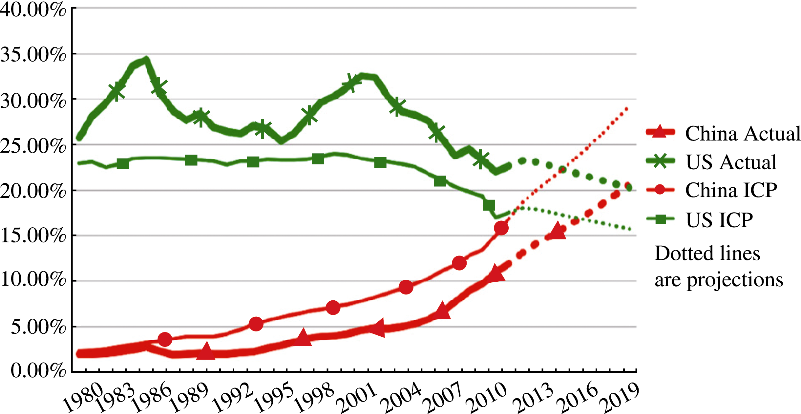
Figure 1 World GDP Shares, Based on Actual Exchange Rates and ICP Rates (estimated cost of living), Both Converted to Dollars

The bottom line for China is that it has a ways to go before it surpasses the US by either criterion—income of the average Chinese (correctly measured with PPP rates), or aggregate size of the Chinese economy (GDP correctly measured at actual exchange rates). This in no respect detracts from the country’s impressive growth record, which at about 10% per annum for three decades constitutes a historical miracle (Prasad, 2009).
At current exchange rates, the American economy is still almost double China’s—83% bigger to be precise. But the day is not far off. If we assume, aggressively, that the Chinese real growth rate continues to exceed US growth by 5% per annum and the yuan to appreciate at 3% a year in real terms, then China will pass the US by 2021—soon, but not imminent.

2 Use and Misuse of PPP Adjustments
The PPP-versus-exchange rate issue is familiar to international economists. This annoying but unavoidable technical problem arises because China’s output is measured in its currency, the yuan, while US income is measured in dollars. How should you translate the numbers so that they are comparable? The obvious solution is to use the contemporaneous exchange rate (multiply China’s yuan-measured GDP by the dollar-per-yuan exchange rate, so that is expressed in dollars).
Someone then points out, however, that if you want to measure the standard of living of Chinese citizens, you have to take into account that many goods and services are cheaper there. A yuan goes further if it is spent in China than if it is spent abroad. Some internationally traded goods have similar prices. T-shirts are virtually as cheap in the US as in China, in part because we can buy them from there. (Oil is almost as cheap in China as abroad, because it can import it). But haircuts—a service that cannot readily be traded internationally—are much cheaper in China than in the US. For this reason, if you want to compare income per capita across countries, you need to measure local purchasing power, as the ICP does.

3 Proper Uses of PPP
The PPP measure is useful for many purposes, like knowing which governments have been successful at raising their citizens’ standard of living. A second application is estimating whether the country’s currency is “undervalued,” controlling for its productivity (Cheung, 2012, Cheung et al., 2010, Subramanian, 2010). A third is judging whether it is reasonable to expect that they have the means to start cutting pollution. The turning point for sulphur dioxide in international data has been estimated at roughly $10,000 per capita in today’s dollars (Frankel and Rose, 2005). China is now there.
Looking at income per capita, China is still a relatively poor country, even by the PPP measure and even though it has come very far in a short time (Pethokoukis, 2014). Its income per capita has now passed Albania’s, and is approximately even with the Dominican Republic, which is in the middle of the distribution of 195 countries (97th).
But Albania and the Dominican Republic do not often get headlines. Why are we so much more interested in China? Partly because it is such a dynamic economy, but not just that. China has the world’s largest population. When you multiply a medium income per capita by a billion “capita,” you get a large number. The combination of a very large population and a medium income gives it economic power, and also political power.
Why do we consider the US the incumbent number 1 power? Partly because it is rich, but not just that. If income per capita were the criterion, then Monaco, Qatar, Luxembourg, Brunei, Liechtenstein, Kuwait, Norway, and Singapore would all rank ahead of the US.
For the purposes of that comparison, it does not much matter whether you use actual exchange rates to make the comparison or PPP rates. Relative rankings for income per capita do not depend on this technical choice as much as rankings of size do. The reason is that the PPP rates are highly correlated with income per capita, the phenomenon known as the Balassa-Samuelson relationship (Balassa, 1964; Samuelson, 1964).
If you are choosing which country to be a citizen of, you might want to consider one of these richest countries. But we do not consider Monaco, Brunei and Liechtenstein to be among the world’s “leading economic powers,” because they are so small. What makes the US the number one economic power is the combination of having one of the highest populations together with having one of the higher levels of income per capita.

4 Misuse of PPP
So there is a widespread fascination with the question how China’s economic size or power compares to America’s, and especially whether the challenger has now displaced the reigning champ as number one (Subramanian, 2011a). It seems to me that PPP rates are not the best ones for making this comparison. Why?
When we talk about size or power we are talking about such questions as the following:
From the viewpoint of multinational corporations, how big is the Chinese market?
From the standpoint of global financial markets, will the RMB challenge the dollar as an international currency (Frankel, 2012; Subramanian, 2011b)?
From the viewpoint of the IMF and other multilateral agencies, how much money can China contribute and how much voting power should it get in return (Frankel, 2014)?
From the viewpoint of countries with rival claims in the South China Sea, how many ships can its military buy?
For these questions, and most others where the issue is total economic heft, you want to use GDP evaluated at current exchange rates.
It is sometimes objected that using the current exchange rate subjects the comparison to the substantial fluctuations that exchange rates often exhibit. This is true. But the large measurement errors in the PPP adjustment are considerably worse. There is a good case for using a five-year average of the exchange rate instead of the exchange rate in one particular year. It does not make much difference for the US-China comparison during this period. But even when exchange-rate fluctuations seem large, the difference is relatively small compared to the other statistical issues at stake here.

References
Balassa B (1964). The Purchasing-Power Parity doctrine: A reappraisal. Journal of Political Economy, 72(6): 584–596
Cheung Y-W (2012). Exchange rate misalignment: The case of the Chinese Renminbi. CESifo Working Paper: Monetary Policy and International Finance 3797
Cheung Y-W, Chinn M D, Fujii E (2010). Measuring misalignment: Latest estimates for the Chinese yuan. In: Simon Evenett (ed), The US-Sino Currency Dispute: New Insights from Economics, Politics and Law. A VoxEU.org Publication, April
Frankel J (2006). On the yuan: The choice between adjustment under a fixed exchange rate and adjustment under a flexible rate. CESifo Economic Studies, 52(2): 246–275
Frankel J (2010). On the yuan: The choice between adjustment under a fixed exchange rate and adjustment under a flexible rate. In: Simon Evenett (ed), The US-Sino Currency Dispute: New Insights from Economics, Politics and Law. A VoxEU.org Publication, April: 51–60
Frankel J (2012). Internationalization of the RMB and historical precedents. Journal of Economic Integration, 27: 329–365
Frankel J (2014). IMF reform and isolationism in the US Congress. East Asia Forum, 29 January
Frankel J, A Rose (2005). Is trade good or bad for the environment? Sorting out the causality. Review of Economics and Statistics, 87(1)
Pethokoukis J (2014). Sorry, China, the US is still the world’s leading economic power. AEIdeas, 30 April
Prasad E S (2009). Is the Chinese growth miracle built to last? China Economic Review, 20(1): 103–123
Samuelson P A (1964). Theoretical notes on trade problems. Review of Economics and Statistics, 46(2): 145–154
Subramanian A (2010). New PPP-based estimates of Renminbi undervaluation and policy implications. Peterson Institute for International Economics, Policy Brief, No. 10–8
Subramanian A (2011a). Eclipse: Living in the shadow of China’s economic dominance. Peterson Institute for International Economics
Subramanian A (2011b). Renminbi rules: The conditional imminence of the reserve currency transition. Peterson Institute for International Economics, Working Paper, 11–14
The Economist (2014). Measuring GDP: The dragon takes wing. 3 May
World Bank (2014). 2011 International Comparison Program Summary Results Release Compares the Real Size of the World Economies. 29 April

Editor’s note: This article was originally posted at the website www.VoxEU.org. To stimulate discussions and research, the FEC periodically publishes opinions written by economists on issues related to China and other transition or emerging economies. The views expressed here are those of the author and do not represent those of the FEC.

