June 2008
Comments by JEFFREY FRANKEL
on “Credibility, Commitment and Regulation,by Dieter Helm”
Conference on Populism and Natural Resources,
Harvard University, Nov. 1-2, 2007.

Organized by Bill Hogan and Federico Sturzenegger.
Procedings forthcoming, MIT Press.

FRANKEL: Let me begin by saying I think this is a great theme for a conference. It goes far beyond the point that natural resources are once again back in the limelight, that ten years ago mineral commodities were neglected, and that in this decade we've rediscovered that economies do run on energy and raw materials, that everything can't be done over the Ethernet. But what makes this conference especially interesting is that it is focusing, in a very nitty-gritty way, on what are desirable institutions to deal with commodity booms -- what's state-of-the-art, what's best practice -- that resource-rich countries can adopt to avoid the mistakes of the past.

A number of us here teach classes on aspects of development, in which we talk about the role of “institutions” determining whether some countries perform better than others. Our students almost tease us, in that we talk about institutions so much but sometimes are not specific enough about how to determine what are good institutions. The design of contracts or wealth funds to deal with natural resource cycles is a good example what we mean.

The central theme seems to be the conflict between the incentives that exist ex-ante, which is for a government to offer attractive terms so that -- whether it's an outside multi-national coming in or a domestic firm -- it will invest and develop the resources, vs. the incentives that exist ex-post, which is often to renege on the contract. In particular, if the price subsequently goes up, “why let the company get all the gains?”

This is an area where better design of mechanisms and incentives and institutions can make a huge bit of difference. As the conference organizers point out, the formulation of the problem goes back at least to Ray Vernon. I, as Dieter Helm, like the term “time inconsistency.” In fact, in monetary theory we get even fancier and call it “dynamic inconsistency” -- just to reduce the chance that the uninitiated will know what we're talking about. But it's just a simple idea that the incentive you have to promise ahead of time is different from the incentive you have after the investment has already been made.

I have an illustration, Ulysses tied to the mast; I took it from the cover of the Harvard Magazine where it appeared awhile ago.
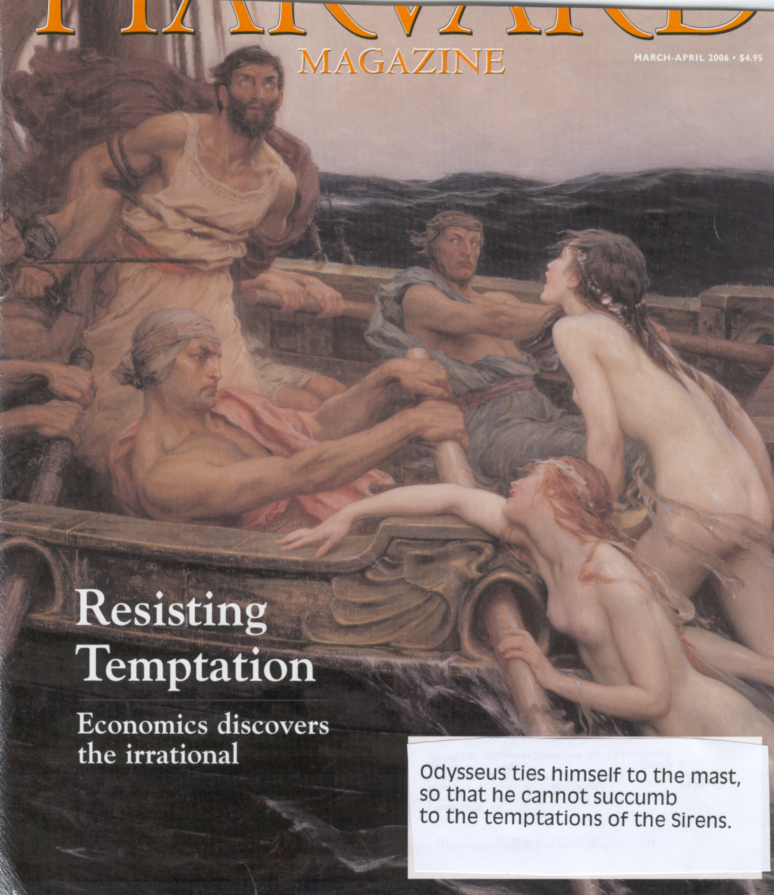

The story, of course, is Ulysses, or Odysseus in the Greek, was told that his ship was going to sail past the Sirens and they sing so sweetly that the sailors would always dive into the water and be drowned. So he gave orders to his men that they stop up their ears, but he wanted to listen, so he ordered them to tie him to the mast and no matter how much he begged to be let go they should not let him go. And so the painting shows him hearing the Sirens and telling his men to let him go, but they didn't because it was the ex-ante commitment was successful.

It's a bit ironic that this has become best known and best established in monetary theory where the analogy is that it's a monetary authority. Central banks have the inventive to say ahead of time, “oh no, we're not going to print a lot of money, we're not going to be inflationary,” in order to get price expectations down and wages down. And then after the fact, they have an incentive to do precisely that, an irresistible temptation to be more expansionary. The lessons are, you need institutions to tie your hands, such as a constitutionally independent central bank, or a currency board, or a fixed exchange rate, or nominal inflation targeting, or whatever.

I think time inconsistency actually applies better to some areas of micro-economics. Dieter Helm, in footnote 2, mentions a reference on global climate change. This is a connection that I share very much with him, an idea that in existing analysis of global climate change, with all the complications that are in typical models, the one thing that has been largely missing, for example, in the design of the optimal path, is the idea that governments have an incentive to promise ex-ante, “oh yes, we're going to start off slowly, but we're going to cut emissions very sharply in the second half of the 21st century”. But it's not very credible because this set of policymakers are not going to be around in the second half of the 21st century. When the time comes it's going to be expensive for the new crop of policy makers to do it then.

Furthermore, here's the point: everybody knows that. Nobody believes the century-long commitment path to begin with. That's a big problem with the economic modeling of the climate change.

To get to the subject here, it's a great application. The pattern has been repeated so many times in so many countries: the price goes up, and then the government wants to renege. They don't want to give the company all the profits and, in a sense, why should they? Certainly the political pressures are typically very strong. But it's become such a familiar pattern that it seems, by now, there ought to have been contracts designed that are robust with respect to this inconsistency, contracts where you write in ahead of time, “if the price goes up so much, then the gains are split between the company and the government,” or whatever.

Looking at the U.K. example is very useful and very interesting. This paper is an excellent review of the British case. It's very clearly written. It's a subject I knew very little about; I feel that I learned a tremendous amount on every page. One of the reasons to look to the U.K. is, when it's Bolivia one might think that they could write any contract in the world and people still wouldn't believe it because of past history and the institutional roots are not be deep enough, and that they would end up reneging.

So it is useful to start off with a country where the regulators are supposed to be gentlemen and keep their word, and where they rank high in the indices of Transparency International and the other rankings the political scientists have come up with to quantify the quality of institutions. Here the institution is the RPIX mechanism, which is a fixed price contract, but only for four or five years, after which it is to be revised or renegotiated.

I won't go through and repeat the points that are well presented by Dieter Helm. But the overall conclusion is that it hasn't really worked that well. He specifically says it hasn't worked as well as perceived. First the regulator and then the government reneged on the ex-ante contracts; he goes through the two examples of 1994 and 1995 distribution prices and windfall profits taxes, which is something we can all relate to. I think that's probably true in any country; when there are huge profits, there is political pressure from the public to claw back a share of them.

We read about some unintended side effects. He says the company violated the implicit contract in shifting its financing composition towards debt. I don't know if that's an implicit contract. I would call it, maybe, an unintended consequence. Can you really blame a company -- given its incentives, given a rate of return determined by the weighted average cost of capital, and given its responsibility to its shareholders, -- if it shifts towards debt when that's more profitable. I don't know if I'd call that breaking an implicit contract unless there was some discussion around it ahead of time and the only sense in which it wasn’t explicit is that it wasn’t written down.

One of the reasons that he gives for why the RPIX mechanism hasn't worked as well as one might hope or expect, is that the U.K. system is less rule-based than the U.S. system. If we're talking along the lines “we're going to write down a contract ahead of time and stick to it,” maybe that is a system in which the U.S. approach works better. We're beginning to have doubts about that when it comes to financial regulation, accounting practices. Maybe the European system's got some advantages. But in this case, where it is apparently left up to some “good chaps”, on the one hand keeping your word is a nice British attribute, but on the other hand doing what's in the interest of your citizens is also a good attribute. If you've got the discretion it's hard not to use it. And in some sense you're just as negligent not to use it as the company would be negligent not to do something in the interest of the shareholders. The whole point is to bind people ex-anti so that they don't have that option. Now that would be the whole advantage.

Where I come out is: it's not clear to me that anything approximating optimal contract design was really tried in Britain. The mechanism is very crude. The author explains its origins, that it was not designed to do some theoretically optimal contract, but arose by historical happenstance.

So my question, for everyone at the conference, is: what about some attempts at contracts that build in contingencies? If the price goes up so much, the company gets to keep some of it but some of it goes back to the government. And symmetrically if it goes down.

I know what a few of the answers to this question are going to be. One is: there are just a lot of contingencies. It's not only the price going up and down, but there are various other contingencies and it's very hard to write them all in ex-ante.

Another part of it has got to be that in a situation where the government does already have a lot of credibility and that is ranked high by Transparency International or the Political Scientists' indices of governance and rule of law, that they can withstand a bit of moral hazard more, and it's not going to kill off investment.

Whereas, if it's a country with not as good a history of institutions and property rights and rule of law and all that, it's the other way around. You could do a great job writing the contingent contract and yet that wouldn't right away make your reputation and bring in all the investment you wanted.

I want to know if the U.K. or other countries have experimented, have learned from this mistake. What I get from this paper is: here's are some things that didn't work. Let's hear some optimally designed contracts -- not just in theory, but informed by practice -- optimally designed contracts that could be robust and could have some hope of holding up ex-post.

