Version for publication; 3/2/ +ed +JF 4/7- + Jul20,2009:p7;.11J;12-13;logs,Aus,ACES; 25;28;p35-6Eu;+allGDP->y. +4refsAug27

An Elaborated Proposal for a Global Climate Policy Architecture:
Specific Formulas and Emission Targets for All Countries in All Decades

Jeffrey Frankel, Harpel Professor, Harvard University

For the Harvard Project on International Climate Agreements.
Forthcoming in Post-Kyoto International Climate Policy,
edited by Joe Aldy and Rob Stavins (Cambridge University Press, 2009).

The author would like especially to thank Valentina Bosetti of FEEM who produced, by means of the WITCH model, all the simulations of the effects of my formula-based proposals, thereby bringing hitherto-abstract ideas to life. This paper literally could not have been written without her. He would like to thank Joe Aldy and Robert Stavins of the Harvard Project on International Climate Agreements for encouraging and supporting this line of research. For comments and suggestions on the outcome he would like to thank Valentina Bosetti, John Deutch, Robert Keohane, Warwick McKibben, Oyebola Olabisi, Rob Stavins, Jonathan Weiner, and an anonymous reviewer. The author would further like to thank for partial support the Sustainability Science Program, funded by the Italian Ministry for Environment, Land and Sea, at the Center for International Development at Harvard University.

Abstract

This paper offers a detailed plan to set quantitative national limits on emissions of greenhouse gases, building on the foundation of the Kyoto Protocol. It attempts to fill in the most serious gaps: the absence of targets extending as far as 2100, the absence of participation by the United States and developing countries, and the absence of reason to think that countries will abide by commitments. The plan elaborates on the idea of a framework of formulas that can assign quantitative limits across countries, one budget period at a time. Unlike other proposals for century-long paths of emission targets that are based purely on science (concentration goals) or ethics (equal rights per capita) or economics (cost-benefit optimization), this plan is based partly on politics. Three political constraints are particularly important. (1) Developing countries are not asked to bear any cost in the early years. (2) Thereafter, they are not asked to make any sacrifice that is different in kind or degree than was made by those countries that went before them, with due allowance for differences in incomes. (3) No country is asked to accept an ex ante target that costs it more than, say, 1% of income in present value, or more than, say, 5% of income in any single budget period. They would not agree to ex ante targets that turned out to have such high costs, nor abide by them ex post. An announced target path that implies a future violation of these constraints will not be credible, and thus will not provide the necessary signals to firms today.
The proposal is that (i) China and other developing countries are asked to accept targets at BAU in the coming budget period, the same in which the US first agrees to cuts below BAU; and (ii) all countries are asked to make further cuts in the future in accordance with a formula which sums up a Progressive Reductions Factor, a Latecomer Catch-up Factor, and a Gradual Equalization Factor. The paper tries out specific values for the parameters in the formulas (parameters that govern the extent of progressivity and equity, and the speed with which latecomers must eventually catch up). The resulting target paths for emissions are run through the WITCH model. The outcome is reasonable, in terms of both carbon abatement (achieving concentrations of 500 PPM in 2100) and economic cost (no country suffers a disproportionate burden).
An Elaborated Proposal for a Global Climate Policy Architecture:
Specific Formulas and Emission Targets for All Countries in All Decades

This paper offers a framework of formulas that produce precise numerical targets for emissions of carbon dioxide (CO₂) in all regions of the world in all decades of this century. The formulas are based on pragmatic judgments about what is possible politically. The reason for this approach is the author’s belief that many of the usual science-based, ethics-based, and economics-based paths are not dynamically consistent: That is, it is not credible that successor governments will be able to abide by the commitments that today’s leaders make.
The formulas proposed here are driven by seven political axioms:
- The United States will not commit to quantitative targets if China and other major developing countries do not commit to quantitative targets at the same time, because of concerns about economic competitiveness and carbon leakage.
- China and other developing countries in the very short run will not make economic sacrifices, especially because the United States has not done so.
- China and other developing countries, even in the longer run, will not make sacrifices different in character from those made by richer countries that have gone before them.
- In the long run, no country can be rewarded for having “ramped up” its emissions well above 1990 levels before joining.
- No country will agree to participate if its expected cost during the course of the 21st century (in present discounted value) is more than Y, where Y is for now set at 1 percent of gross domestic product (income) per year.
- No country will abide by targets that cost it more than X in any individual budget period, where X is for now set at 5 percent of income.
- If one major country drops out, others will become discouraged and the system may unravel.

The proposed targets are formulated assuming the following framework. Between now and 2050, the European Union follows the path laid out in the January 2008 European Commission Directive; the United States follows the path in 2008 legislative proposals associated with Senator Joseph Lieberman; and Japan, Australia and Korea follow statements that their own leaders have recently made. China, India and other countries agree immediately to quantitative greenhouse gas (GHG) emission targets, which in the first decades merely copy their business-as-usual (BAU) paths, thereby precluding leakage. These countries are not initially expected to cut emissions below their BAU trajectory.
When the time comes for these countries to join mitigation efforts—perhaps when they cross certain thresholds—their emission targets are determined using a formula that incorporates three elements: a Progressive Reductions Factor, a Latecomer Catch-up Factor, and a Gradual Equalization Factor. These factors are designed to persuade the developing countries that they are only being asked to do what is fair in light of actions already taken by others. In the second half of the century, the formula that determines the emissions path for industrialized countries is dominated by the Gradual Equalization Factor. But developing countries, which will still be in earlier stages of participation and thus will have departed from their BAU paths only relatively recently, will still follow in the footsteps of those who have gone before. This means that their emission targets will be set using the Progressive Reductions Factor and the Latecomer Catch-up Factor, in addition to the Gradual Equalization Factor. The glue that holds the agreement together is that every country has reason to feel that it is only doing its fair share.

We use the WITCH model to analyze the results of this approach in terms of projected paths for emissions targets, permit trading, the price of carbon, lost income, and environmental effects. Overall economic costs, discounted (at 5 percent), average 0.24 percent of Gross Product. No country suffers a discounted loss of more than 1 percent of income overall from the agreement, nor more than 5 percent of income in any given period. Atmospheric CO₂ concentrations level off at 500 parts per million (ppm) in the latter part of the century. (The next phase of this research will aim for a target of 450 ppm.)

The problem

There are by now many proposals for a post-Kyoto climate change regime, even if one considers only proposals that accept the basic Kyoto approach of quantitative, national-level limits on GHG emissions accompanied by international trade in emissions permits. The Kyoto targets applied only to the budget period 2008–2012, which is now upon us, and only to a minority of countries (in theory, the industrialized countries). The big task is to extend quantitative emissions targets through the remainder of the century and to other countries—especially the United States, China, and other developing countries.

Virtually all the existing proposals for a post-Kyoto agreement are either based on scientific environmental objectives (e.g., stabilizing atmospheric CO₂ concentrations at 450 ppm in 2100), ethical or philosophical considerations (e.g., the principle that every individual on earth has equal emission rights), or economic cost-benefit analyses (weighing the economic costs of abatement against the long-term environmental benefits). This paper proposes a path of emission targets for all countries and for the remainder of the century that is intended to be more practical in that it is also based on political considerations, rather than on science or ethics or economics alone.

The industrialized countries did, in 1997, agree to quantitative emissions targets for the Kyoto Protocol’s first budget period, so in some sense we know that it can be done. But the obstacles are enormous. For starters, most of the Kyoto signers will probably miss their 2008–2012 targets, and of course the United States never even ratified. At multilateral venues such as the United Nations Framework Convention on Climate Change (UNFCCC) meeting in Bali (2007) and the Group of Eight (G8) meeting in Hokkaido (July 2008), world leaders have (just barely) been able to agree on a broad long-term goal of cutting total global emissions in half by 2050. But these meetings did not come close to producing agreement on who will cut how much, not to mention agreement on multilateral targets within a near-enough time horizon that the same national leaders are likely to still be alive when the abatement commitment comes due. To quote Al Gore (1993, p.353), “politicians are often tempted to mke a promise that is not binding and hpe for some unexpectedly easy way to keep the promise.” For this reason, the aggregate targets endorsed so far cannot be viewed as anything more than aspirational.

Moreover, nobody has ever come up with an enforcement mechanism that simultaneously has sufficient teeth and is acceptable to member countries. Given the importance countries place on national sovereignty it is unlikely that this will change. Hopes must instead rest on weak enforcement mechanisms such as the power of moral suasion and international opprobrium. It is safe to say that in the event of a clash between such weak enforcement mechanisms and the prospect of a large economic loss to a particular country, aversion to the latter would win out.

Necessary aspects of a workable successor to Kyoto

I have suggested six desirable attributes that any proposed successor-agreement to the Kyoto Protocol should deliver:

- More comprehensive participation—specifically, getting the United States, China, and other developing counties to join the system of quantitative emission targets.
- Efficiency—incorporating market-flexibility mechanisms such as international permit trading and providing advance signals to allow the private sector to plan ahead, to the extent compatible with the credibility of the signals.
- Dynamic consistency—addressing the problem that announcements about steep cuts in 2050 are not credible. The lack of credibility stems from two sources. First, it is known that today’s leaders cannot bind their successors. Second, the projected failure of most Kyoto signatories to meet their first-period emission targets makes the lack of seriousness at a global level painfully obvious.
- Equity—taking account of the point made by developing countries that industrialized countries created the problem of global climate change, while poor countries are responsible for only about 20 percent of the CO₂ that has accumulated in the atmosphere from industrial activity over the past 150 years (though admittedly this is changing rapidly). From an equity standpoint, developing countries argue they should not be asked to limit their economic development to pay for a climate-change solution; moreover, they do not have the capacity to pay for emissions abatement that richer countries do. Finally, many developing countries place greater priority on raising their people’s current standard of living (including reducing local air and water pollution). These countries might reasonably demand quantitative targets that reflect an equal per capita allotment of emissions, on equity grounds, even waiving any claims to reparations for the disproportionate environmental damages that can be expected to fall on them.
- Compliance —recognizing that no country will join a treaty if it entails tremendous economic sacrifice and that therefore compliance cannot be reasonably expected if costs are too high. Similarly, no country, if it has already joined the treaty, will continue to stay in during any given period if staying in means huge economic sacrifice, relative to dropping out, in that period.
- Robustness under uncertainty—recognizing that the relationship between cost and compliance applies not just to ex ante calculations based on current expectations, but also ex post, when future growth rates and other uncertain economic and technological variables become known.

Unlike the Kyoto Protocol, the proposal outlined in this chapter seeks to bring all countries into an international policy regime on a realistic basis and to look far into the future. But we cannot pretend to see with as fine a degree of resolution at a century-long horizon as we can at a five- or ten-year horizon. Fixing precise numerical targets a century ahead is impractical. Rather, we need a century-long sequence of negotiations, fitting within a common institutional framework that builds confidence as it goes along. The framework must have enough continuity so that success in the early phases builds members’ confidence in each other’s compliance commitments and in the fairness, viability, and credibility of the process. Yet the framework must be flexible enough that it can accommodate the unpredictable fluctuations in economic growth, technology development, climate, and political sentiment that will inevitably occur. Only by striking the right balance between continuity and flexibility can we hope that a framework for addressing climate change would last a century or more.

An example of such a framework in another policy area is the General Agreement on Tariffs and Trade, which emerged after World War II and provided the basis for 50 years of successful multilateral negotiations to liberalize international trade, culminating in the founding of the World Trade Organization. Nobody at the beginning could have predicted the precise magnitude or sequence of reforms to various trade barriers, or what sectors or countries would be included. But the early stages of negotiation worked, and so confidence in the process built, more and more countries joined the club, and progressively more ambitious rounds of liberalization were achieved.
Another analogy would be with the process of European economic integration, culminating in the formation of the European Economic and Monetary Union. Despite ambitions for more comprehensive integration, nobody at the time of the founding of the European Coal and Steel Community, or the subsequent European Economic Community, could have forecast the speed, scope, magnitude, or country membership that this path of integration would eventually take. The aim should be to do the same with the UNFCCC.

Political constraints

Let us restate the claims regarding political feasibility to be taken as axiomatic.
- The United States will not commit to quantitative targets if China and other major developing countries do not commit to quantitative targets at the same time, though this leaves completely open the initial level and future path of the targets. Any plan will be found unacceptable if it leaves the less developed countries free to exploit their lack of GHG regulation for “competitive” advantage at the expense of the participating countries’ economies and leads to emissions leakage at the expense of the environmental goal.
- China, India, and other developing countries will not make sacrifices they view as
  - fully contemporaneous with rich countries,
  - different in character from those made by richer countries who have gone before them,
  - preventing them from industrializing,
  - failing to recognize that richer countries should be prepared to make greater economic sacrifices than poor countries to address the problem (all the more so because rich countries’ past emissions have created the problem), or
  - failing to recognize that the rich countries have benefited from an “unfair advantage” in being allowed to achieve levels of per capita emissions that are far above those of the poor countries.
- In the short run, emission targets for developing countries must be computed relative to current levels or BAU paths; otherwise the economic costs will be too great for the countries in question to accept. But in the longer run, no country can be rewarded for having "ramped up” emissions far above 1990 levels, the reference year agreed to at Rio and Kyoto. Fairness considerations aside, if post-1990 increases are permanently “grandfathered,” then countries that have not yet agreed to cuts will have a strong incentive to ramp up emissions in the interval before they join. Of course there was nothing magic about 1990 but, for better or worse, it is the year on which Annex I countries have long based planning.
- No country will accept a path of targets that is expected to cost it more than Y percent of income throughout the 21st century (in present discounted value), where Y is for now set at 1 percent.
- No country will accept targets in any period that are expected to cost more than X percent of income to achieve during that period; alternatively, even if targets were already in place, no country would in the future actually abide by them if it found the cost to doing so would exceed X percent of income. In this paper, income losses are defined relative to what would happen if the country in question had never joined. An alternative would be to define income losses in a future period relative to what would happen if the country were to drop out in that period, after decades of participation. For now, we set X at 5 percent.
- If one major country drops out, others will become discouraged and may also fail to meet their own targets, and the framework may unravel. If such unraveling in a future decade is foreseeable at the time that long-run commitments are made, then those commitments will not be credible from the start. Firms, consumers, and researchers base their current decisions to invest in plant and equipment, consumer durables, or new technological possibilities on the expected future price of carbon: If government commitments are not credible from the start, then they will not raise the expected future carbon price. The reason for this political approach is the belief that many emissions pathways proposed on the basis of scientific or economic analyses are not dynamically consistent: That is, it is not credible that successor governments will be able to abide by the commitments that today’s leaders make.

Squaring the circle

Of the above propositions, even the first and second alone seem to add up to a hopeless “Catch-22”: Nothing much can happen without the United States, the United States will not proceed unless China and other developing countries start at the same time, and China will not start until after the rich countries have gone first.
There is only one possible solution, only one knife-edge position that satisfies the constraints. At the same time that the United States agrees to binding emission cuts in the manner of Kyoto, China and other developing countries agree to a path that immediately imposes on them binding emission targets—but these targets in their early years simply follow the BAU path. The idea of committing to only BAU targets in the early decades will provoke outrage from both environmentalists and business interests in advanced countries. But both sides might come to realize that this commitment is far more important than it sounds: It precludes the carbon leakage which, absent such an agreement, will undermine the environmental goal and it moderates the competitiveness concerns of carbon-intensive industries in the rich countries. This approach recognizes that it would be irrational for China to agree to substantial actual cuts in the short term. Indeed China might well react with outrage at being asked to take on binding targets of any kind at the same time as the United States. But China may also come to realize that it would actually gain from such an agreement, by acquiring the ability to sell emission permits at the same world market price as developed countries. (China currently receives lower prices for lower-quality project credits under the Kyoto Protocol’s Clean Development Mechanism [CDM] or joint implementation [JI] provisions.).

In later decades, the formulas I propose do ask substantially more of the developing countries. But these formulas also obey basic notions of fairness, by (1) asking for cuts that are analogous in magnitude to the cuts made by others who began abatement earlier and (2) making due allowance for developing countries’ low per capita income and emissions and for their baseline of rapid growth. These ideas were developed in earlier papers (see Frankel 1999, 2005, and 2007 and Aldy and Frankel 2004) which suggested that the formulas used to develop emissions targets incorporate four or five variables: 1990 emissions, emissions in the year of the negotiation, population, and income. One might perhaps also include a few other special variables such as whether the country in question has coal or hydroelectric power, though the 1990 level of emissions conditional on per capita income can largely capture these special variables.

Here we narrow down the broad family of formulas to a more manageable set, and then put them into operation to produce specific numerical targets for all countries, for all five-year budget periods of the 21st century. The formulas are made precise through the development of three factors: a short-term Progressive Reductions Factor, a medium-term Latecomer Catch-up Factor, and a long-run Gradual Equalization Factor. The result is a set of actual numerical targets for all countries for the remainder of the century (presented in Table 1). These are then fed into the WITCH model, by Valentina Bosetti, a co-author of that model, to see the economic and environmental consequences. International trading plays an important role. The framework is flexible enough that one can tinker with a parameter here or there—for example if the economic cost borne by a particular country is deemed too high or the environmental progress deemed too low—without having to abandon the entire formulas framework.

Emission targets for all countries: rules to guide the formulas

All developing countries that have any ability to measure emissions would be asked to agree immediately to emission targets that do not exceed their projected BAU baseline trajectory going forward. The objective of getting developing countries committed to these targets would be to forestall emissions leakage and to limit the extent to which their firms enjoy a competitive advantage over carbon-constrained competitors in the countries that have already agreed to targets below BAU under the Kyoto Protocol. (We expect that the developing countries would, in most cases, receive payments for permits and thus emit less than their BAU baseline.) Most countries in Africa would probably be exempted for some years from any kind of commitment, even to BAU targets, until they had better capacity to monitor emissions.

One must acknowledge that BAU paths are neither easily ascertained nor immutable. Countries may “high-ball” their BAU estimates in order to get more generous targets. Even assuming that estimates are unbiased, important unforeseen economic and technological developments could occur between 2010 and 2020 that will shift the BAU trajectory for the 2020s, for example. Any number of unpredictable events have already occurred in the years since 1990; they include German reunification, the 1997–1998 East Asia crisis, the boom in the BRIC countries (Brazil, Russia, India, and China), the sharp rise in world oil prices up until 2008, and the world financial crisis of 2007–2009. A first measure to deal with the practical difficulty of setting the BAU path is to specify in the Kyoto-successor treaty that estimates must be generated by an independent international expert body, not by national authorities. A second measure, once the first has been assured, is to provide for updates of the BAU paths every decade. To omit such a provision—that is, to hold countries for the rest of the century to the paths that had been estimated in 2010—would in practice virtually guarantee that any country that achieves very high economic growth rates in the future will eventually drop out of the agreement, because staying in would mean incurring costs far in excess of 5 percent of income. Allowing for periodic adjustments to the BAU baseline does risk undermining the incentive for carbon-saving investments, on the logic that such investments would reduce future BAU paths and thus reduce future target allocations. This risk is the same as the risk of encouraging countries to ramp up their emissions, which we specified above to be axiomatically ruled out by any viable proposal. That is why the formula gives decreasing weight to BAU in later budget periods and why we introduce a Latecomer Catch-up Factor (explained below), which tethers all countries to their 1990 emission levels in the medium run.

Countries are expected to agree to the next step, quantitative targets that entail specific cuts below BAU, at a time determined by their circumstances. In our initial simulations, the choice of year for introducing an obligation actually to cut emissions was generally guided by two thresholds: when a country’s average per capita income exceeds $3000 per year and/or when its per capita annual emissions approach 1 ton or more. But we found that starting dates had to be further modified in order to satisfy our constraints regarding the distribution of economic losses.

As already noted, this approach assigns emission targets in a way that is more sensitive to political realities than is typical of other proposed target paths, which are constructed either on the basis of a cost-benefit optimization or to deliver a particular environmental and/or ethical goal. Specifically, numerical targets are based (a) on commitments that political leaders in various key countries have already proposed or adopted, as of early 2009, and (b) on formulas designed to assure latecomer countries that the emission cuts they are being asked to make represent no more than their fair share, in that they correspond to the sacrifices that other countries before them have already made.
Finally comes the other important concession to practical political realities: If the simulation in any period turns out to impose on any country an economic cost of more than X% of income (where X is for the purposes of this analysis is taken to be 5 percent), we assume that this country drops out. Dropping out could involve either explicit renunciation of the treaty or massive failure to meet the quantitative targets. For now, our assumption is that in any such scenario, other countries would follow by dropping out one by one, and the whole scheme would eventually unravel. This unraveling would occur much earlier if private actors rationally perceived that at some point in the future major players will face such high economic costs that compliance will break down. In this case, the future carbon prices that are built into most models’ compliance trajectories will lack credibility, private actors will not make investment decisions that reflect those prices today, based on them, and the effort will fail in the first period. Therefore, our approach to any scenario in which any major player suffers economic losses greater than X% would be to go back and adjust some of the parameters of the emission formulas, so that costs are lower and this is no longer the case.
We hope by these mechanisms to achieve political viability: non-negative economic gains in the early years for developing countries, average costs over the course of the century below 1 percent of income per annum, and protection for every country against losses in any period as large, or larger than, 5 percent of income. Only if they achieve political viability are announcements of future cuts credible. And only credible announcements of future cuts will send firms the long-term price signals and incentives needed to guide investment decisions today.

Guidelines from policies and goals already announced by national leaders

Our model produces country-specific numeric emission targets for every fifth year: 2012, 2017, 2022, etc. For each five-year budget period, such as the Kyoto period 2008–2012, computations are based on the average of the starting year and ending year.

The European Union. The EU emissions target for 2008–2012 was agreed at Kyoto: 8 percent below 1990 levels. In the second 2015–2020 period (for simplicity we choose the year 2017), the EU target is the one that Brussels announced in January 2008 and confirmed in December 2008: namely, 20 percent below 1990 levels. On the one hand, as with other targets publicly supported by politicians in Europe and elsewhere, skepticism is appropriate regarding EU member countries’ willingness to make the sacrifices necessary to achieve this target. On the other hand, however, the European Union’s commitment to this number was not conditional on other countries joining in. Indeed the European Union has said it would cut emissions 30 percent below 1990 levels if other countries joined in. So in this sense we are being conservative in choosing the 20 percent target.
For the third period (2022–2027), and thereafter up to the eighth period (2048–2052), the EU targets progress in equal increments to a 50 percent cut below 1990 levels: In other words, targets relative to 1990 emissions start at 25 percent below, and then progress to 30 percent, 35 percent, 40 percent, 45 percent, and 50 percent below.

Japan, Canada, and New Zealand. These three Pacific countries are assigned the Kyoto goal of a 6 percent reduction below 1990 levels. Of all ratifiers, Canada is probably the farthest from achieving its Kyoto goal. But Japan dominates this country grouping in size. We assume that by 2010 the United States has taken genuine measures, which helps motivate these three countries to get more serious than they have been to date. In a small concession to realism, we assume that they do not hit the numerical target until 2012 (versus hitting it on average over the 2008–2012 budget period).
Japan’s then-Prime Minister, Yasuo Fukuda, on June 9, 2008, announced a decision to cut Japanese emissions 60–80 percent by mid-century and successor Taro Aso on June 10, 2009, announced a plan to cut 15 per cent by 2020. We interpret these targets as cuts of 10 percent every five years between 2010 and 2050, computed logarithmically. The cumulative cuts are 80 percent in logarithmic terms, or 51 percent in absolute terms (i.e., to 49 percent of the year–2010 emissions level).

The United States. A series of bills to cap US GHG emissions were proposed in Congress in 2007 and early 2008. It is possible that some version of such legislation might pass by 2010.
The Bingaman–Specter bill would have reduced emissions to 2006 levels by 2020 and to 1990 levels by 2030, but with a cap or “safety valve” on the price of carbon. The Lieberman–Warner bill was more aggressive. It would have begun by reducing emissions in 2012 to below 2005 levels and would have tightened the emissions cap gradually each year thereafter, such that by the year 2050, total emissions would be held to 30 percent of 2012 levels—in other words, a 70 percent reduction from emissions levels at the start date of the policy. If such a bill were not passed until 2010 or so, the goal of achieving 2005 levels by 2012 (let alone a 4 percent reduction) would for all practical purposes be impossible to achieve. The bill’s sponsors would have to adjust 2012 to BAU levels, which are projected to be 39 percent above 1990 levels, or 33 percent logarithmically (i.e., 1990 emissions were 28 percent below current 2012 BAU projections), so the 2050 target would be 42 percent below 1990 levels. A slightly revised “manager’s” version of the Lieberman–Warner bill earned significant congressional support in June 2008: Though it did not garner a large enough majority to become law, the vote was widely considered an important step forward politically for the activist camp. It was presumed that a new bill in the next session would probably look similar and, with a new president, would have better chances of success.
If taken at face value, with 2012 emissions returned to 2005 levels or lower, then the Lieberman–Warner targets would shave off another 13 percent from the target path, so that emissions in 2050 would be 55 percent below 1990 levels. There are three respects in which it might be naïve to accept these political aspirations at face value. First, it is not realistic to think that the United States could go from the steady emission growth rates of 1990–2007 (when emissions increased, on average, by 1.4 percent per year) to immediate rapid cuts, without passing through an intermediate phase of slowing, and then peaking or plateauing, before reversing (a trajectory some have called “slow-stop-reverse”). Second is the point that many voters and politicians who have supported recent legislative proposals will be unlikely to support the measures that would be needed to attain the targets contained in those proposals in an economically efficient way—that is, by raising the price of fossil fuels through such measures as a carbon tax or tradable permits. Third, the Lieberman–Warner target is somewhat more aggressive than Europe’s goal, measured relative to 1990 emissions, and implies a much more aggressive rate of emissions decline than Europe’s over the period 2012–2050. So far, American support for serious action has lagged behind Europe’s.
On the other hand, if China and other developing countries accept quantitative targets, as foreseen under this plan, this will boost domestic American support for tough action. In addition, one could argue that there is more “fat” in US emissions, so it should be easier to achieve reductions than in Europe or Japan. The terminal level of emissions in 2050 under the formula would still probably be substantially higher than Europe’s, relative to population or GDP.
We assume that the average annual emissions growth rate is cut in half during the period 2008–2012, to 0.7 percent per year or 3.5 percent cumulatively, so that emissions in 2012 are 31.5 percent above 1990 levels. At that point, we assume emissions plateau (growth is held to zero) for the period 2012–2017. These near-term targets are substantially more aggressive than those in the American Clean-Energy and Security Act of 2009 (ACES Act), which was passed by the House of Representatives in June 2009, before consideration by the Senate. The ACES Act specifies that US emission allowances continue to grow at 3 per cent per year from 2012 to 2017.

Then we implement the rest of the Lieberman–Warner formula, such that emissions in 2050 reach a level that is 67 percent below 1990 levels. Using our postponed base this is 98.5 percent below 2012 levels, logarithmically. Spread over 38 years, this implies sustained reductions of 2.6 percent per year on average, or 13 percent every five years. This rate of reduction over 2017-2050 is more aggressive than was Lieberman–Warner, but substantially less aggressive than the ACES Act -- 5 per cent per year -- unless the price ceiling specified by an escape clause kicks in. This is the reverse ranking of the stringency in the plans’ pre-2017 target paths.

Australia. Canberra has been reluctant to take strong actions because the country is so dependent on coal. In July of 2008, however, Australian Prime Minister Kevin Rudd announced plans to cut emissions to 60 percent below 2000 levels by 2050. In the regional groupings of our model, Australia is classified together with South Korea and South Africa.

Korea and South Africa. Until recently it looked unlikely that any “non-Annex I” countries would consider taking on serious cuts below a BAU growth path within the next decade. But in March 2008, the new president of South Korea, Myung-bak Lee, “tabled a plan to cap emissions at current levels over the first Kyoto period.” This was an extraordinarily ambitious target in light of Korea’s economic growth rate. He also “vowed his country would slash emissions in half by 2050,” like the industrialized countries—of which Korea is now one. Emissions have risen 90 percent since 1990 and it is hard to imagine any country applying the brakes so sharply as to switch instantly from 5 percent annual growth in emissions to zero. Perhaps President Lee thinks he can offset growth in South Korean emissions by paying North Korea to reforest. We choose to interpret the Korean plan to flatten emissions as covering a period that stretches out over the next fourteen years, so that in 2022 the level of emissions is the same as in 2007.
Meanwhile, South Africa has evidently proposed that its emissions would peak by 2025 and begin declining by 2030.

China. Getting China to agree to binding commitments is the sine qua non of any successful post-Kyoto plan. Evidently China has announced plans to start cutting GHG emissions in 2030. Presumably that means relative to BAU, rather than in absolute terms. Of course 2030 is later than industrialized countries would like. The country is expected to cross the threshold of 1 ton of emissions per capita around 2014 and the threshold of $3000 in annual per capita income by 2022. A standard five- or ten-year lag between treaty signing and budget period would point to a first-cuts budget period around 2024–2027. But persuading Beijing to move the 2030 date up by five years is not as critical as persuading it to accept some quantitative target in 2010, even if that target only reflects BAU. The reason is that if China does not adopt some binding target in the near term, the United States and most developing countries won’t join, and then the entire enterprise will be undone.

The key questions thus become (1) how to determine the magnitude of China’s cuts in its first budget period—that is, for the first period in which it is asked to make cuts below BAU; (2) how to determine Korea’s cuts in its second budget period; and (3) how to set targets for everyone else. (The other regions are Latin America—which logically should act after Korea but before China in light of its stage of development—Russia, Middle East/North Africa, Southeast Asia, India/South Asia, and Africa.) Our general guiding principle is to ask countries only to do what is analogous to what has been done by others who have gone before them. To put this general principle into practice, we apply three factors.

Guidelines for formulas that ask developing countries to accept “fair” targets, analogous to those who have gone before

This section discusses the three factors for determining “fair” emissions targets for developing countries. The three factors are additive (logarithmically).
We call the first the Progressive Reductions Factor. It is based on the pattern of emission reductions (relative to BAU) assigned to countries under the Kyoto Protocol, as a function of income per capita. This pattern is illustrated in Figure 1, which comes from the data as they were reported at that time. Other things equal, richer countries are asked to make more severe cuts relative to BAU, the status quo from which they are departing in the first period. Specifically, each 1 percent difference in income per capita, measured relative to EU income in 1997, increases the abatement obligation by 0.14 percent, where the abatement obligation is measured in terms of reductions from BAU relative to the EU cuts agreed at Kyoto. Normally, at least in their early budget periods, most countries’ incomes will be below what the Europeans had in 1997, so that this factor dictates milder cuts relative to BAU than Europe made at Kyoto. In fact the resulting targets are likely to reflect a “growth path”—that is, they will allow for actual emission increases relative to the preceding periods. The formula is:
PRF expressed as country cuts vs. BAU
= EU's Kyoto commitment for 2008 relative to its BAU + .14 * (gap between the country’s income per capita and the EU’s 2007 income per capita).
The parameter (0.14) was suggested by ordinary least squares (OLS) regression estimates on the data shown in Figure 1. Other parameters could be chosen instead, if the parties to a new agreement wanted to increase or decrease the degree of progressivity.

Figure 1: The Emissions Cuts Agreed at Kyoto Were
Progressive with Respect to Income, when Expressed Relative to BAU

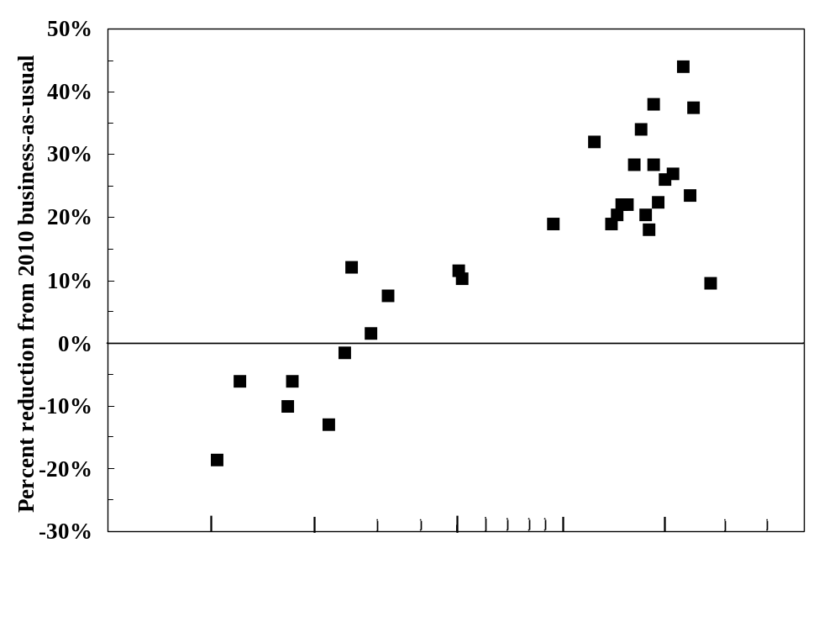
Sources: The World Bank, the U.S. Energy Information Administration, and national communications to the UNFCCC

The Latecomer Catch-up Factor is the second element in the formula. Latecomers are defined as those countries that have not ratified Kyoto or for which Kyoto did not set quantitative targets. (Perhaps it should also include those like Canada that ratified the treaty but, based on current trends, are not expected to meet the goal.) These countries should not be rewarded by permanently readjusting their targets to a higher baseline. Aside from notions of fairness, such re-basing would give all latecomers an incentive to ramp up their emissions before signing on to binding targets, or at a minimum would undercut any socially-conscious incentives they might otherwise introduce to reduce emissions unilaterally in the time period before they join the system. Thus the Latecomer Catch-up factor is designed to close gradually the gap between the starting point of the latecomers and their 1990 emission levels. It is parameterized according to the numbers implicit in the Lieberman proposal to bring US emissions to 70 percent below 1990 levels by 2050 and the Lee proposal to flatten South Korea’s emissions over a period beginning in 2008. In other words, countries are asked to move gradually in the direction of 1990 emissions in the same way that the United States and Korea under current proposals will have done before them.
The formula for a country’s Latecomer Catch-up Factor (LCF) is as follows. Further percentage cuts (relative to BAU plus a Progressive Reductions Factor) are proportional to how far emissions have been allowed to rise above 1990 levels by the time the country joins in. That is, it is given by:
LCF = α + λ (percentage gap between country’s lagged emissions and 1990 emissions).
The parameter λ represents the firmness with which latecomers are pulled back toward their 1990 emission levels. The value of λ implicit for Europe at the time the Kyoto Protocol was negotiated was sufficient to pull the EU-average below its 1990 level. But to calibrate this formula, the most relevant countries are not European (since the Europeans are not latecomers), but rather the United States and Korea, since these are the only countries among those that did not commit themselves to Kyoto targets whose political leaders have said explicitly what targets they are willing to accept in the second budget period. The parameters α and λ were chosen as the unique solutions to two simultaneous equations representing the US target in bills sponsored by Senator Lieberman and the Korean target (a flattening of emissions being interpreted here as holding absolute emissions in 2022 equal to 2007 levels). The parameters then work out to
α = 0.2115 and λ = -0.3400
Thus:
LCF = 0 .2115 -0 .3400 log(country’s current emissions / country’s 1990 emissions)

The third element is the Gradual Equalization Factor (GEF). Even though developing countries under the proposal benefit from not being asked for abatement efforts until after the rich countries have begun to act, and face milder reduction requirements, they will still complain that it is the rich countries that originally created an environmental problem for which the poor will disproportionately bear the costs, rather than the other way around. Such complaints are not unreasonable. If we stopped with the first two factors, the richer countries would be left with the permanent right to emit more GHGs, every year in perpetuity. This seems unfair.
In the short run, pointing out the gap in per capita targets is simply not going to alter the outcome. The poor countries will have to live with it. Calls for the rich countries to cut per capita emissions rapidly, in the direction of poor-country levels, ignore the fact that the economic costs of such a requirement would be so astronomical that no rich country would ever agree to it. The same goes for calls for massive transfer payments from the rich to the poor (as in a proposal by the Group of 77 developing countries)
When one is talking about a lead time of 50 to 100 years, however, the situation changes. With time to adjust, the economic costs are not as impossibly high, and it is reasonable to ask rich countries to bear their full share of the burden. Furthermore, over a time horizon this long some of the poor countries will in any case become rich (and possible vice versa).
Accordingly, during each decade of the second half of the century, the formula includes an equity factor that moves per capita emissions in each country a small step in the direction of the global average. This means downward in the case of the rich countries and upward in the case of the poor countries. Asymptotically, the repeated application of this factor would eventually leave all countries with equal emissions per capita, although corresponding national targets would not necessarily converge fully by 2100.
The parameter (δ) for the speed of adjustment in the direction of the world average was initially chosen to match the rate at which the EU’s already-announced goals for 2045–2050 converge to the world average. This number is δ=0.1 per decade, which is also very similar to the rate of convergence implicit in the goals set by the Lieberman bills for the United States during 2045–2050. Thus:

GEF = -0 .1 ( percentage gap between country’s lagged emissions per capita and the world’s).

We expected to have to adjust the δ parameter, and indeed to add a fourth parameter for the “aggressiveness” of global emissions targets, in order to ensure that no single country was confronted with costs above our threshold constraint while still achieving a relevant global environmental goal in 2100. By lucky coincidence, our initial method of computing δ satisfied the economic objectives and delivered year-2100 atmospheric CO₂ concentrations of 500 ppm. In future extensions of this research—where, for example, we will try to hit a year-2100 goal of 450 ppm—we will have to adjust δ and probably will need to add an aggressiveness parameter, while also adjusting some countries’ start dates. One possibility is to write an algorithm that searches over these parameters so as to find values that minimize the threshold of economic cost to any given country for any given year-2100 environmental goal.

The formulas are summarized overall as follows:
Log Target (country _{i, t}) = log (BAU _{i, t} ) – (PCF _{i, t} ) + (LCF _{i, t} ) + (GEF _{i, t} ) ,

where the three factors (except in periods when set = 0 as indicated in Table 2) are given by:

PCF _{i,t} = log (emission target EU ₂₀₀₈/ BAU EU ₂₀₀₈)
+ 0.14 log (country i's income/cap _{t-1} / EU income/cap ₂₀₀₇);
LCF _{i,t} = 0.2115 - 0.3400 log (country i's emissions _{t-1} / country i's emissions ₁₉₉₀).
GEF_{i,t} = - 0.1 log (country i's emissions per capita _{t-1} / global average emissions per capita _{t-1}).

The numerical emission target: paths that follow from the formulas

Table 1, at the end of the chapter, reports the emissions targets produced by the formulas for each of eleven geographical regions, for every period between now and the end of the century. We express the emission targets in several terms:
- in absolute tons (which is what ultimately matters for determining economic and environmental effects)
- in per capita terms (which is necessary for considering any issues of cross-country distribution of burden)
- relative to 1990 levels, which is the baseline used for Kyoto, and which remains relevant in our framework in the form of the Latecomer Catch-up term, and
- relative to the BAU path, which is important for evaluating the sacrifice asked of individual countries as they join the agreement in the early decades.

The eleven regions are:
EUROPE = Old Europe and New Europe
US = United States KOSAU = Korea, South Africa, and Australia (3 coal-users)
CAJAZ = Canada, Japan, and New Zealand TE = Russia and other Transition Economies
MENA = Middle East and North Africa SSA = Sub-Saharan Africa
SASIA= India and the rest of South Asia CHINA = PRC
EASIA = Smaller countries of East Asia LACA = Latin America and the Caribbean

In the first version of this exercise, China sells over a gigaton of carbon in 2040. Its permit sales fall off thereafter, as its target kicks in; but Southeast Asian countries take its place, selling similar quantities in the last two decades of the century. Southeast Asia and sub-Saharan Africa registered rather substantial economic gains toward the end of the century. These gains reflect the benefits of being spared emissions cuts and being able to sell permits to richer countries during the period when those countries are already implementing reductions. Some may judge it appropriate that poor countries register net economic gains from the abatement regime, since these are also the countries that will bear the heaviest burden from climate change in any case (by virtue of the fact that most are located nearer the equator and rely on large agricultural sectors). But we judge the massive international transfers that are implicit in this scenario to be highly unsustainable politically. They are not necessary in any case to satisfy the key economic and political constraints laid out at the beginning of this chapter.
Accordingly, subsequent versions of the exercise assign Southeast Asia and Africa emission targets somewhat below BAU in the latter half of the century, with the result that they do not gain so much for the century as a whole. In addition we move forward by ten years the date at which China is asked to take on below-BAU targets and by five years the date at which the Middle East and North African (MENA) countries are asked to do so. An additional reason for this change was to reduce the slackening in global targets—observable as a dip in the price of carbon—that would otherwise occur around 2035. Results for the case where the four developing regions are given more stringent (earlier) targets are given in Tables 1 and 3b, and in the corresponding figures. Table 2 summarizes the dates at which all countries are asked to take on BAU targets and then reductions below BAU as governed by the different formula elements discussed previously (i.e., PRF, LCF, and then GEF).
The United States, even more than other rich countries, is currently conspicuous by virtue of its high per capita emissions. But its target path peaks after 2010 and then begins to decline. Emissions in all the rich regions peak by 2015, and then start to decline. Figure 2a reports aggregate targets for member countries of the Organisation for Economic Co-operation and Development (OECD). It also shows actual emissions, which decline more gradually than the targets through 2045 because about 1 million metric tons (equal to 1 gigaton or Gt) of carbon permits are purchased on the world market, as is economically efficient, out of roughly 4 Gt. (Permit sales to the richer countries exceed 1 Gt more often in the version where Southeast Asia and Africa are never asked for targets below BAU, and China and MENA start cutting emissions below BAU only at later dates.) Though the OECD countries buy a substantial amount of reductions in the early decades, it is always less than half their total reductions. The share falls off sharply in the second half of the century. We assume no banking.

Figure 2a: Emissions path for industrialized countries in the aggregate
-- with later targets for developing countries
(Note: Predicted actual emissions exceed caps by amount of permit purchases)
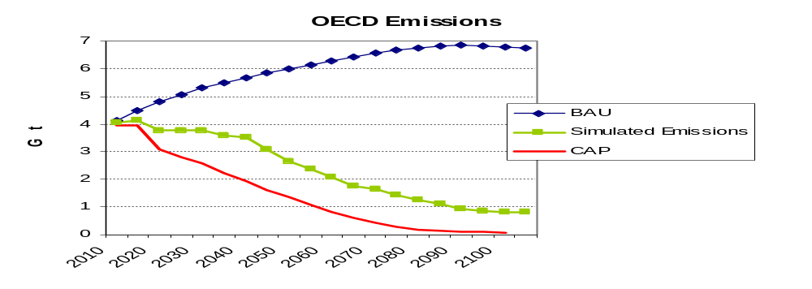
Figure 2b: Emissions path for industrialized countries in the aggregate
-- with earlier targets for developing countries
(Note: Predicted actual emissions exceed caps by amount of permit purchases)
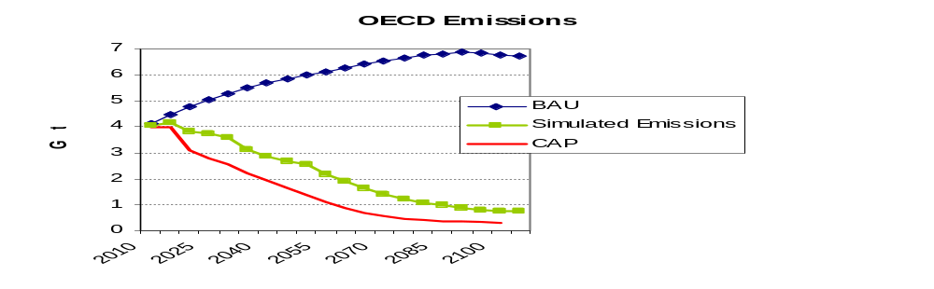

Figure 3a: Emission paths for poor countries in the aggregate
-- with later targets for developing countries
(Note: Predicted actual emissions fall below caps by amount of permit sales)
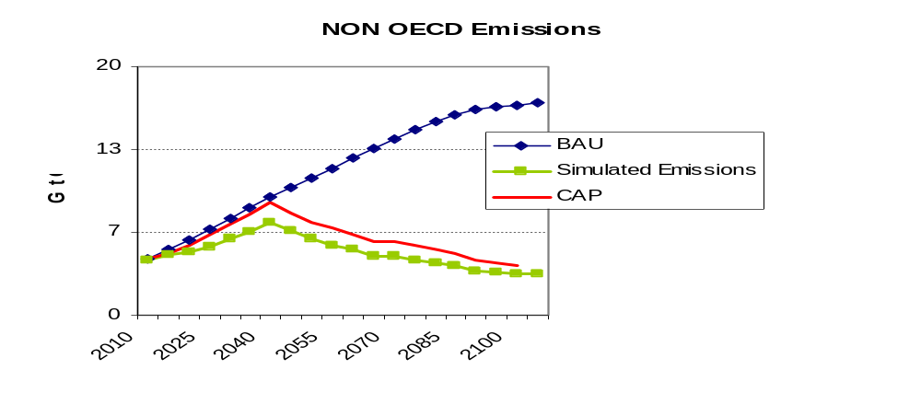

Figure 3b: Emission paths for poor countries in the aggregate
-- with earlier targets for developing countries
(Note: Predicted actual emissions fall below caps by amount of permit sales)
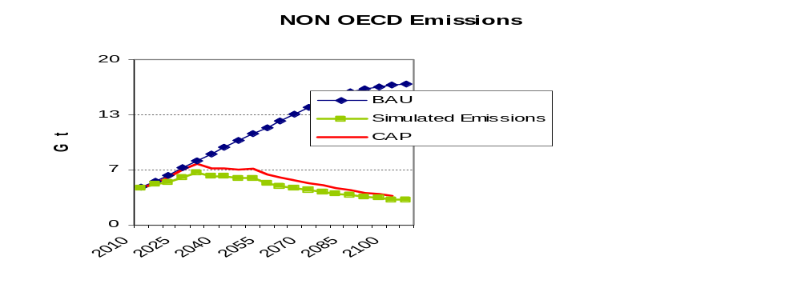

Figure 4a: Emissions path for the world, in the aggregate
-- with later targets for developing countries
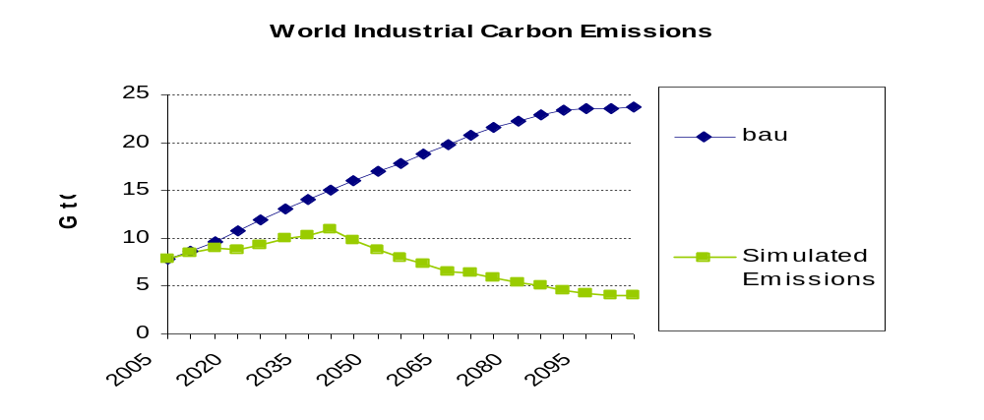

Figure 4b: Emissions path for the world, in the aggregate
-- with earlier targets for developing countries
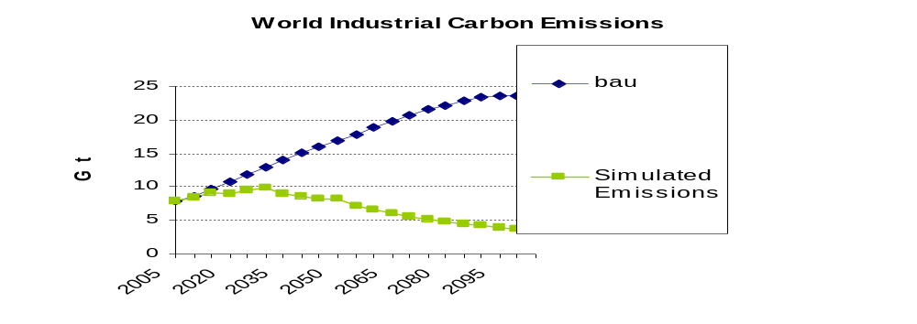

Emissions in the non-rich countries, the TE group (transition economies), MENA, China, and Latin America all peak in 2040. Emissions in sub-Saharan Africa and the smaller East Asian economies all remain at very low levels throughout the century. Figure 3a shows that among non-OECD countries overall, both emissions targets and actual emissions peak in 2040, with the latter substantially below the former. In other words, the poor countries emit below their targets and sell permits to the rest.
Total world emissions peak in 2045 at a little above 10 Gt, in the case where China and MENA are given the later starting points (Figure 4a). They peak ten years earlier, and without exceeding 10 Gt, in the case where China and MENA are given the earlier starting points (Figure 4b). In either case, emissions subsequently decline rather rapidly, falling below 5 Gt by 2090. Thanks to the post-2050 equalization formula, emissions per capita converge nicely in the long run, falling to below 1 ton per capita toward the end of the century.

Economic and environmental consequences of the proposed targets, according to the WITCH model

Estimating the economic and environmental implications of these targets is a complex task. There are many fine models out there. I was fortunate to link up with the WITCH model of FEEM (Fondazione Eni Enrico Mattei, in Milan), as applied by Valentina Bosetti.
WITCH (www.feem-web.it/witch) is an energy-economy-climate model developed by the climate change modeling group at FEEM. The model has been used extensively in the past three years to analyze the economic impacts of climate change policies. WITCH is a hybrid top-down economic model with energy sector disaggregation. Those who might be skeptical of economists’ models on the grounds that “technology is really the answer” should rest assured that technology is central to this model. (Economists are optimists when it comes to what new technologies might be called forth by a higher price for carbon, but pessimists when it comes to how much technological response to international treaties will occur absent an increase in price.) The model features endogenous technological change via both experience and innovation processes. Countries are grouped in twelve regions, when Western Europe and Eastern Europe are counted separately, that cover the world and that strategically interact following a game theoretic set-up. The WITCH model and detailed structure are described in Bosetti et al. (2006) and Bosetti, Massetti, and Tavoni (2007).
Original baselines in many models have been disrupted in recent years by such developments as stronger-than-expected growth in Chinese energy demand and the unexpected spike in world oil prices that culminated in 2008. WITCH has been updated with more recent data and revised projections for key drivers such as population, GDP, fuel prices, and energy technology characteristics. The base calibration year has been set at 2005, for which data on socio-economic, energy, and environmental variables are now available (Bosetti, Carraro, Sgobbi, and Tavoni 2008).

Economic effects

While economists trained in cost-benefit analysis tend to focus on economic costs expressed as a percentage of income, the politically attuned tend to focus at least as much on the predicted carbon price, which in turn has a direct impact on the prices of gasoline, home heating oil, and electric power.

Figure 5a: Price of Carbon Dioxide Rises Slowly Over 50 Years, then Rapidly
-- with later targets for developing countries
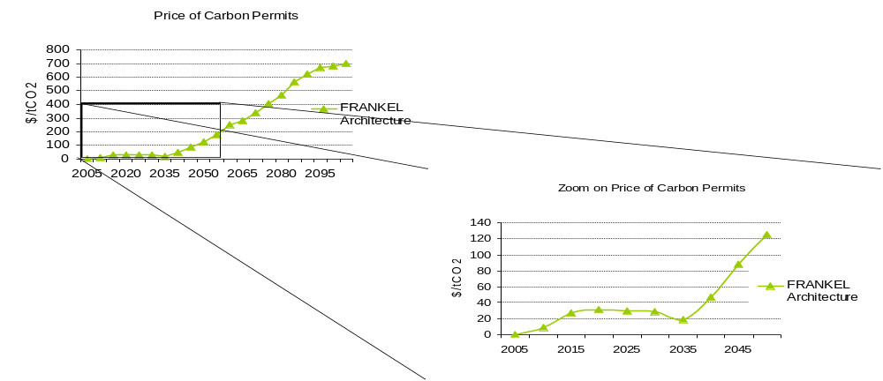

Figure 5b: Price of Carbon Dioxide Rises Slowly Over 50 Years, then Rapidly
-- with earlier targets for developing countries
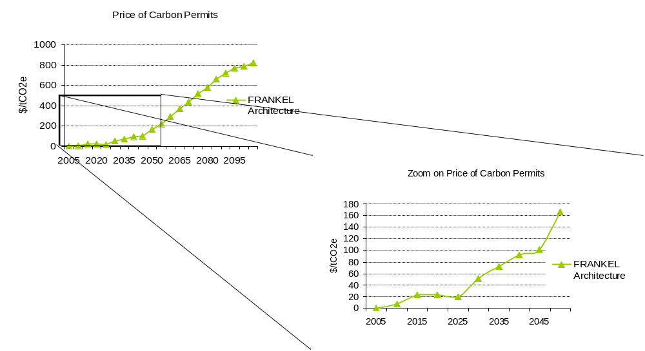

Based on the WITCH simulations conducted for this analysis, the world price of CO₂ under our proposal surpasses $20 per ton in 2015, as Figure 5 shows. It is then flat until 2030, as a consequence of the assumption that major developing countries do not take on major emission cuts before then. The price even dips slightly before beginning a steep ascent, an undesirable feature. It climbs steadily in the second half of the century, as the formula-based targets begin to bite seriously for developing countries. Before 2050 the carbon price has surpassed $100 per ton of CO₂. Only toward the end of the century does it level off, at almost $700 per ton of CO₂ in the case where some developing countries are spared early cuts, and at $800 per ton in the case where they are not spared.

Most regions sustain economic losses that are small in the first half of the century —under 1 percent of income —but that rise toward the end of the century. Given a positive rate of time discount, this is a good outcome. No region in any period experiences costs in excess of our self-imposed threshold of 5 percent of national income. The estimated costs of the policy to each country-group, in present discounted value (PDV) terms, are reported in Table 3a. No country is asked to incur costs that are expected to exceed 1 percent of income over the century. Only China’s costs creep up to 1.1% of uncome, when it takes on an earlier target, in Table 3b. (All economic effects are gross of environmental benefits—that is, no attempt is made to estimate environmental benefits or net them out.)

These costs of participation are overestimated in one sense, and increasingly so in the later decades, if the alternative to staying in the treaty one more decade is dropping out after seven or eight decades of participation. The reason is that countries will have already substantially altered their capital stock and economic structure in a carbon-friendly direction. The economic costs reported in the simulations and graphs treat the alternative to participation as never having joined the treaty in the first place. In another sense, however, the costs are underestimated: any country that drops out can exploit leakage opportunities to the hilt. Its firms can buy fossil fuels at far lower prices than their competitors in countries that continue to participate.

Figure 6 provides Gross World Product loss aggregated across across regions worldwide, and discounted to present value using a discount rate of 5 percent. Total economic costs come to 0.24 percent of annual gross world product in the case where China and MENA start later and Southeast Asia and Africa are not given targets below BAU. Overall policy costs come to 0.65 percent in the case where the former two start earlier, the latter two are given targets below BAU, and as a result the price of carbon hits $800 per ton.

Figure 6: Loss of Aggregate Gross World Product by Budget Period, 2015-2100
-- with later targets for developing countries
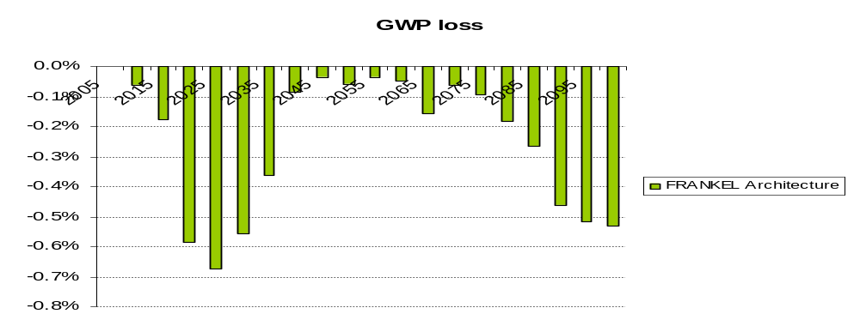

Environmental effects
The outcome of this proposal in terms of cumulative emissions of GHGs is close to those of some models that build in environmental effects or science-based constraints, even though no such inputs were used here. The concentration of CO₂ in the atmosphere stabilizes at 500 ppm in the last quarter of the century.

Figure 7a:
CO₂ concentrations nearly achieve year-2100 concentration goal of 500 ppm
-- with later targets for developing countries

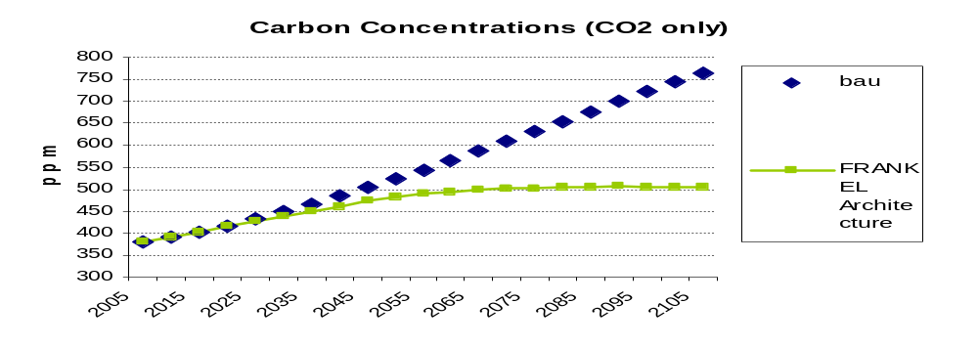

Figure 7b: CO₂ concentrations achieve year-2100 goal of 500 ppm
-- with earlier targets for developing countries

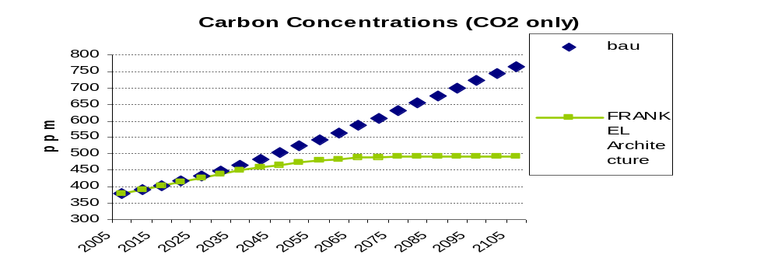

Based on the modeled concentration trajectory, global average temperature is projected to hit 3 degrees Celsius (°C) above pre-industrial levels at the end of the century, as opposed to almost 4°C under the BAU trajectory, as shown in Figure 8. (Many scientists and environmentalists prefer objectives that are substantially more ambitious.) The relationship between concentrations and temperature is highly uncertain and depends on assumptions made about climate sensitivity. For this reason both figures are reported.

Figure 8a: Rise in temperature under proposed targets vs. BAU
– with later targets for developing countries
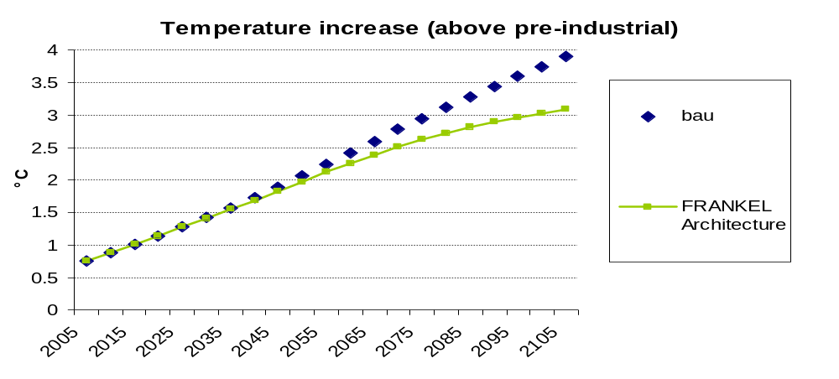

Figure 8b: Rise in temperature under proposed targets vs. Business as Usual
– with earlier targets for developing countries
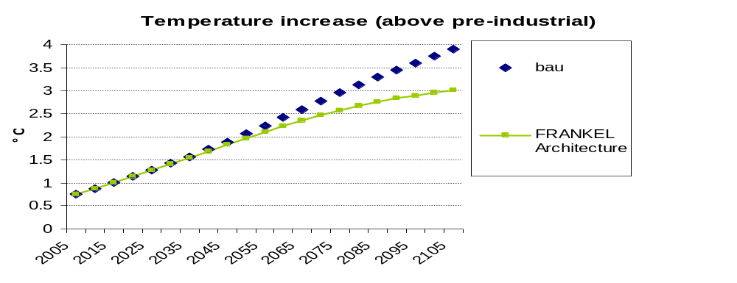

Conclusion

The analysis described here is only the beginning. Several particular extensions are high priority for future research.

Directions for future research

A first priority is to facilitate comparisons by tightening some parameters to see what it would take to hit a 2100 concentration level of 450 ppm or 2°C, which is the goal that G-8 leaders supposedly agreed to in the summit of July 2009. Our first attempts to do this impose costs on some countries, in some periods, as high as 10–20 percent of income, which we regard as not practical. But we plan to try tinkering further with model parameters so as to hit the 450 ppm target without any country bearing an unreasonable burden. In the other direction, we could also calibrate the adjustment so as to hit a 2100 target of 550 ppm, again facilitating comparisons.
Second, we could design an algorithm to search over values of some of the key parameters in such a way as to attain the same environmental goal— 450 or 500 ppm —with minimum economic cost. To continue emphasizing political feasibility, the objective could be to minimize the expected income loss for any country in any period, so as to minimize the incentive for any country to drop out. Or we could declare that we have already specified a sufficient political constraint (e.g., no loss to any country in any period above 5 percent of income), and proceed to a cost-benefit optimization exercise subject to those constraints.
Third, we could compare our proposed set of emissions paths to other proposals under discussion in the climate change policy community or being analyzed using other integrated assessment models. Our hypothesis is that we could identify countries and periods in alternative pathways where we believe an agreement would be unlikely to hold up because its targets were not designed to limit economic costs for each country.
Fourth, we could eventually design a user-friendly "game" that anybody could play, choosing different emissions targets for various countries over time, and discovering how easy it is to generate outcomes that are unacceptable, either in economic or environmental terms. It would be a learning tool, hypothetically, for policymakers themselves. Anyone who believes that the GHG abatement targets presented in this paper are insufficiently ambitious, or that the burden imposed on a particular country is too high, would be invited to try out alternatives for themselves. Perhaps a character from an adversely impacted country would pop up on the screen and explain to the user how many millions of his compatriots have been plunged into dire poverty by the user’s policy choices.
Fifth, we could take into account GHGs other than CO₂.
Sixth, we could implement constraints on international trading, along the lines that the Europeans have sometimes discussed. Such constraints can arise either from a worldview that considers it unethical to pay others to take one’s medicine, or from a more cynical worldview that assumes international transfers via permit sales will only line the pockets of corrupt leaders. Constraints on trading could take the form of quantity restrictions—for example, that a country cannot satisfy more than Z percent of its emissions obligation by international permit purchases. Or eligibility to sell permits could be restricted to countries with a score in international governance ratings over a particular threshold, or to countries that promise to use the funds for green projects, or to those that have a track record of demonstrably meeting their commitments under the treaty.

The seventh possible extension of this research represents the most important step intellectually: to introduce uncertainty, especially in the form of stochastic growth processes. The variance of the GDP forecasts at various horizons would be drawn from historical data. We would adduce the consequences of our rule that if any country makes an ex post determination in any period that by staying in the treaty it loses more than 5 percent of income, even though this had not been the expectation ex ante, that country will drop out. At a first pass, we could keep the assumption that if one country pulls out, the entire system falls apart. The goal would then be to design a version of the formulas framework that minimizes the probability of collapse.
A more sophisticated approach would be to allow the possibility that the system could withstand the loss of one or two members. We would try to account for the effect of dropouts on remaining members, with some sort of application of game theory. Ideally we would also try to account from the start for the effect of possible future breakdown on expectations of firms deciding long-term investments. Of course we could try other values of X besides 5 percent.
The ultimate objective in making the model stochastic is to seek modifications of the policy framework that are robust, that protect against inadvertent stringency on the one hand—that is, a situation where the cost burden imposed on a particular country is much higher than expected—or inadvertent “hot air” on the other hand. “Hot air” refers to the possibility that targets are based on obsolete emission levels with the result that countries are credited for cutting tons that wouldn’t have been emitted anyway. Three possible modifications are promising. First, we could allow for some degree of re-adjustment to emission targets in the future, based solely on unexpected changes in the evolution in population and income. (Note that adjustments should not be allowed on the basis of unexpected changes in emissions levels, for to do so would be to introduce moral hazard.) Second, when the target for each decade is set, it should be indexed to GDP within that budget period. Perhaps the constant of proportionality in the indexation formula would simply equal 1, in which case it becomes an efficiency target, expressed in carbon emissions per unit of GDP. This approach would be much less vulnerable to within-decade uncertainty. A third possible feature that would make the policy more robust and that is strongly favored by many economists is an escape clause or safety valve that would limit costs in the event that mitigation proves more expensive than expected, perhaps with a symmetric floor on the price of carbon in addition to the usual ceiling.

A politically credible framework
Our results suggest that the feasible set of emission target paths may be far more constrained than many modelers have assumed. Lofty debates over the optimal discount rate or fair allocation rules might prove fairly irrelevant: For many discount rates or cross-country allocations, an international climate agreement could at some point during the century collapse altogether because it imposes unacceptably high costs on some countries, relative to defecting. Each defection could raise costs on those who remain in the agreement, thereby increasing incentives for further defections and posing the prospect of a snow-balling effect. Commitments to a century-long path that is highly likely to result in a collapse of the agreement after a few decades would not be believed today, and thus might evoke few actual steps in the near term toward achieving long-term emission reductions.

The traditional integrated assessment result is that an economically optimal path entails relatively small increases in the price of carbon in the first half of the century and much steeper ones later. It is interesting that a similar result emerges here purely from political considerations, with no direct input from cost/benefit calculations. This broad similarity of results for the aggregate path does not mean that the difference in approaches does not matter. The framework proposed here specifies the allocation of emission targets across countries in such a way that every country is given reason to feel that it is only doing its fair share and in such a way as to build trust as the decades pass. Without such a framework, announcements of distant future goals are not credible and so will not have the desired effects. Furthermore, this framework—in providing for a decade-by-decade sequence of emission targets, each determined on the basis of a few principles and formulas—is flexible enough that it can accommodate, by small changes in the formula parameters, major changes in circumstances during the course of the century.

References

Aldy, Joseph, Scott Barrett, and Robert Stavins (2003), “Thirteen Plus One: A Comparison of Global Climate Architectures,” Climate Policy, 3, no. 4, 373-97.

Aldy, Joseph, and Jeffrey Frankel (2004), “Designing a Regime of Emission Commitments for Developing Countries that is Cost-Effective and Equitable,” G20 Leaders and Climate Change, Council on Foreign Relations.

Aldy, Joseph E., Peter R. Orszag, and Joseph E. Stiglitz. 2001. "Climate Change: An Agenda for Global Collective Action." Prepared for The Pew Center Workshop on the Timing of Climate Change Policies. The Westin Grand Hotel, Washington, D.C. October 11-12, 2001.

Baer, Paul, Tom Athanasiou, Sivan Kartha and Eric Kemp-Benedict, 2008, The Greenhouse Development Rights Framework: The Right to Development in a Climate Constrained World, Hendrich Boll Stiftung, Stockholm, 2nd ed..

Barrett, Scott (2006) “Climate Treaties and ‘Breakthrough’ Technologies,” American Economic Review, Papers and Proceedings, vol. 96, no. 2, May, 22-25.

Baumert, Kevin and Donald Goldberg, 2006, “Action targets: A new approach to international greenhouse gas controls,“ Climate Policy, 5, pp. 561-81.

Bosetti, V., C. Carraro, M. Galeotti, E. Massetti and M. Tavoni, (2006). “WITCH: A World Induced Technical Change Hybrid Model.” The Energy Journal, Special Issue on Hybrid Modeling of Energy-Environment Policies: Reconciling Bottom-up and Top-down, 13-38.

Bosetti, V., C. Carraro, A. Sgobbi, M. Tavoni, 2008, "The 2008 WITCH model: new model features and baseline," Mimeo, August. Forthcoming as a FEEM Working paper,

Bosetti, V., E. Massetti and M. Tavoni, “The WITCH Model. Structure, Baseline, Solutions”. Working Paper 10. Milan: Fondazione Eni Enrico Mattei. 2007.

Bowles, Ian, and David Sandalow, 2001, “Fundamentals of Treaty-Making on Climate Change,” Science, 8 June: Vol. 292, no. 5523, pp. 1839 – 1840
Cao, Jing. 2008, "Reconciling Human Development and Climate Protection: Perspectives from Developing Countries on Post-2012 International Climate Change Policy." Discussion Paper 08-25, Cambridge, Mass.: Harvard Project on International Climate Agreements, December.

Council of Economic Advisers, 1998, The Kyoto Protocol and the President’s Policies to Address Climate Change: Administration Economic Analysis, White House, July.

Edmonds, J.A., H.M. Pitcher, D.Barns, R.Baron, and M.A. Wise (1992), “Modeling Future Greenhouse Gas Emissions: The Second Generation Model,” in Modeling Global Climate Change, Lawrence Klein and Fu-chen Lo, eds., United Nations University Press: Tokyo, pp. 295-340.

Edmonds, J.A., S.H. Kim, C.N.McCracken, R.D. Sands, and M.A. Wise, 1997, “Return to 1990: The Cost of Mitigating United States Carbon Emission in the Post-2000 Period,” October, Pacific Northwest National Laboratory, Operated by Battelle Memorial Institute.

Ellerman, Denny, and Barbara Buchner, 2008, "Over-Allocation or Abatement? A Prelminary Analyusis of the EU ETS Based on the 2005-06 Emissions Data." In Environmental and Resource Economics, vol. 39, no. 2, October.

Frankel, Jeffrey (1998) “Economic Analysis of the Kyoto Protocol,” After Kyoto: Are There Rational Pathways to a Sustainable Global Energy System? Aspen Energy Forum, Aspen, Colorado, July 6.

Frankel, Jeffrey (1999), “Greenhouse Gas Emissions,” Policy Brief no.52, Brookings Institution, Washington, DC, June.

Frankel, Jeffrey (2005) “You’re Getting Warmer: The Most Feasible Path for Addressing Global Climate Change Does Run Through Kyoto,” in Trade and Environment: Theory and Policy in the Context of EU Enlargement and Transition Economies, edited J.Maxwell and R.Reuveny, Edward Elgar Publishers, UK.

Frankel, Jeffrey (2007), “Formulas for Quantitative Emission Targets,” in Architectures for Agreement: Addressing Global Climate Change in the Post Kyoto World, Joe Aldy and Robert Stavins, eds., Cambridge University Press.

Frankel, Jeffrey (2009) “Global Environment and Trade Policy,” for the Harvard Project on International Climate Agreements (forthcoming, Cambridge University Press, Cambridge UK), edited by Joe Aldy and Rob Stavins. Research Working Paper 08-058, Harvard Kennedy School.

Gore, Al (1993), Earth in the Balance (Penguin Books, New York).

Hammett, James (1999) “Evaluation Endpoints and Climate Policy: Atmospheric Stabilization, Benefit-Cost Analysis, and Near-Term Greenhouse Gas Emissions, Harvard Univ. Climatic Change 41: 447-468.

Hufbauer, Gary, Daniel Esty, Diana Orejas, Luis Rubio, and Jeffrey Schott, 2000, NAFTA and the Environment: Seven Years Later, Policy Analyses in International Economics No. 61, Institute for International Economics: Washington DC.
Hufbauer, Gary, Steve Charnovitz, and Jisun Kim, 2009, Global Warming and the World Trading System, Peterson Institute for International Economics: Washington DC.

Keohane, Robert, and Kal Raustiala, 2008, “Toward a Post-Kyoto Cliamte Change Architecture: A Political Analysis,” HPICA Discussion Paper No. 08-01, July.

Lutter, Randy (2000) Developing Countries’ Greenhouse Emissions: Uncertainty and Implications for Participation in the Kyoto Protocol. Energy Journal 21(4): 93-120.

Manne, Alan, Robert Mendelsohn, Richard Richels (1995), "MERGE: A Model for Evaluating Regional and Global Effects of GHG Reduction Policies." Energy Policy 23:17.

Manne, Alan, and Richard Richels (1997), “On Stabilizing CO2 Concentrations – Cost-Effective Emission Reduction Strategies,” Stanford University and Electric Power Research Institute, April.

McKibbin, Warwick, Adele Morris and Peter Wilcoxen (2008) “Expecting the Unexpected: Macroeconomic Volatility and Climate Policy,” HPICA, Discussion Zpaper No. 08-16, November.

McKibbin, Warwick, and Peter Wilcoxen (2007), “A Credible Foundation for Long Term International Cooperation on Climate Change,” in Architectures for Agreement: Addressing Global Climate Change in the Post-Kyoto World, edited by Joseph Aldy and Robert Stavins, Cambridge University Press.

Nordhaus, William, 1994, Managing the Global Commons: The Economics of Climate Change, MIT Press: Cambridge.

Nordhaus, William (2006), “Life After Kyoto: Alternative Approaches Global Warming Policies,” American Economic Review, Papers and Proceedings, vol. 96, no. 2, May: 31-34.

Nordhaus, William (2008), A Question of Balance: Weighing the Options on Global Warming Policies (Yale University Press).

Olmstead, Sheila, and Robert Stavins (2006), “An International Policy Architecture for the Post-Kyoto Era,” American Economic Review, Papers and Proceedings, vol. 96, no. 2, May: 35-38.

Pizer, William (2006), “The Evolution of a Global Climate Change Agreement,” American Economic Review, Papers and Proceedings, May, 26-30.

Seidman, Laurence, and Kenneth Lewis, 2009, “Compensations and Contributions Under an International Carbon Treaty,” Journal of Policy Modeling,

Stewart, Richard, and Jonathan Weiner (2003), Reconstructing Climate Policy: Beyond Kyoto (American Enterprise Institute Press, Washington DC).

Victor, David (2004), Climate Change: Debating America’s Policy Options, Council on Foreign Relations, New York .

Wagner, Gernot, James Wang, Stanislas de Margerie and Daniel Dudek, 2008, “The CLEAR path: How to ensure that if devleoping nations adopt carbon limits, their early actions will be rewarded,” Environmental Defense Fund Working Paper, October 30.

Weyant, John P. (2001). "Economic Models: How They Work & Why Their Results Differ." In Climate Change: Science, Strategies, & Solutions. Eileen Claussen, Vicki Arroyo Cochran, and Debra Davis, (eds.). The Pew Center on Global Climate Change. Brill Academic Press, Leiden, pp. 193-208.

Tom M.L. Wigley, Rich G. Richels and Jae A. Edmonds, “Overshoot Pathways to CO2 Stabilization in Multi-GasContext,” in Human-induced climate change: An interdisciplinary assessment (Cambrige University Press), edited by RG Richels, AS Manne, and TML Wigley, 2007, Chapter 32 pp. 387-401.

Zhang, Yongsheng, 2008, “An analytical framework and proposal to succeed Kyoto Protocol: a Chinese perspective, “ Development Research Center of the State Council, China, Dec 8.
EUROPE = Old Europe + New Europe KOSAU = Korea, South Africa + Australia (all coal-users)
CAJAZ = Canada, Japan + New Zealand TE = Russia and other Transition Economies
MENA = Middle East + North Africa SSA = Sub-Saharan Africa
SASIA= India and the rest of South Asia CHINA = PRC
EASIA = Smaller countries of East Asia LACA = Latin America + the Caribbean

* * *
Table 1: Emission Targets for each of 11 regions, according to the formulas
(version in which developing countries take on sub-BAU targets somewhat earlier)
Target Absolute  (tons C, thousand millions) |  | USA | WESTERN EUROPE | EASTERN EUROPE | KOSAU | CAJAZ | TE
2005 | 1 | unlimited | unlimited | unlimited | unlimited | unlimited | Unlimited
2010 | 2 | 1.87591 | 0.88556 | 0.22849 | 0.39768 | 0.57841 | 0.83501
2015 | 3 | 1.94157 | 0.83051 | 0.20819 | 0.42442 | 0.55573 | 0.91841
2020 | 4 | 1.30761 | 0.77407 | 0.18929 | 0.44852 | 0.37796 | 0.86844
2025 | 5 | 1.20331 | 0.69464 | 0.16579 | 0.39051 | 0.33085 | 0.81847
2030 | 6 | 1.16946 | 0.62428 | 0.14504 | 0.34938 | 0.28811 | 0.78070
2035 | 7 | 0.99089 | 0.55197 | 0.12448 | 0.30825 | 0.24575 | 0.74293
2040 | 8 | 0.87106 | 0.47851 | 0.10454 | 0.29015 | 0.20451 | 0.70293
2045 | 9 | 0.70636 | 0.40449 | 0.08551 | 0.27206 | 0.16478 | 0.66294
2050 | 10 | 0.61066 | 0.32972 | 0.06741 | 0.23973 | 0.12656 | 0.61993
2055 | 11 | 0.47577 | 0.26596 | 0.06289 | 0.20776 | 0.09307 | 0.57693
2060 | 12 | 0.36873 | 0.21539 | 0.05837 | 0.17718 | 0.06799 | 0.53787
2065 | 13 | 0.28016 | 0.17425 | 0.05385 | 0.14718 | 0.04866 | 0.49881
2070 | 14 | 0.21128 | 0.14247 | 0.04933 | 0.11754 | 0.03470 | 0.45995
2075 | 15 | 0.15125 | 0.11573 | 0.04481 | 0.10556 | 0.02353 | 0.42109
2080 | 16 | 0.14177 | 0.11158 | 0.04029 | 0.10221 | 0.02185 | 0.38258
2085 | 17 | 0.13229 | 0.10742 | 0.03577 | 0.09887 | 0.02017 | 0.34407
2090 | 18 | 0.12280 | 0.10327 | 0.03125 | 0.09552 | 0.01849 | 0.32559
2095 | 19 | 0.11332 | 0.09911 | 0.02673 | 0.09218 | 0.01681 | 0.30711
2100 | 20 | 0.10384 | 0.09496 | 0.02221 | 0.08883 | 0.01513 | 0.25166

Target per capita  Emissions/cap (ton C) |  | USA | EUROPE [CORRECTED] | KOSAU | CAJAZ | TE
2005
2010 |  | 5.95988 | 2.19314 | 1.91504 | 2.39863 | 1.63613
2015 |  | 5.90006 | 2.034108 | 1.70965 | 2.55284 | 1.56933
2020 |  | 3.81659 | 1.88247 | 1.52749 | 2.70695 | 1.06864
2025 |  | 3.38963 | 1.682114 | 1.31882 | 2.37698 | 0.93998
2030 |  | 3.19303 | 1.508378 | 1.14260 | 2.15334 | 0.82547
2035 |  | 2.63145 | 1.333237 | 0.97673 | 1.92996 | 0.71156
2040 |  | 2.25701 | 1.15741 | 0.82086 | 1.85037 | 0.59959
2045 |  | 1.79058 | 0.981416 | 0.67433 | 1.77042 | 0.49047
2050 |  | 1.51726 | 0.803789 | 0.53520 | 1.59314 | 0.38363
2055 |  | 1.16172 | 0.67294 | 0.50273 | 1.40777 | 0.28689
2060 |  | 0.88719 | 0.566716 | 0.47000 | 1.22254 | 0.21299
2065 |  | 0.66602 | 0.478019 | 0.43706 | 1.03310 | 0.15485
2070 |  | 0.49756 | 0.407192 | 0.40392 | 0.83854 | 0.11212
2075 |  | 0.35381 | 0.345552 | 0.37053 | 0.76486 | 0.07719
2080 |  | 0.33028 | 0.331652 | 0.33680 | 0.75175 | 0.07275
2085 |  | 0.30776 | 0.317507 | 0.30265 | 0.73761 | 0.06815
2090 |  | 0.28606 | 0.30306 | 0.26792 | 0.72246 | 0.06339
2095 |  | 0.26502 | 0.288251 | 0.23247 | 0.70622 | 0.05847
2100 |  | 0.24445 | 0.27301 | 0.19615 | 0.68884 | 0.05338

Emissions target relative to 1990 |  | USA | EUROPE [CORRECTED] |  | KOSAU | CAJAZ | TE
2005
2010 |  | 1.29911 | 0.923116 |  | 0.98322 | 0.89166 | 0.61078
2015 |  | 1.34458 | 0.860684 |  | 0.89587 | 0.95161 | 0.58683
2020 |  | 0.90555 | 0.798252 |  | 0.81453 | 1.00565 | 0.39911
2025 |  | 0.83331 | 0.712968 |  | 0.71343 | 0.87559 | 0.34937
2030 |  | 0.80987 | 0.637466 |  | 0.62411 | 0.78337 | 0.30423
2035 |  | 0.68621 | 0.560523 |  | 0.53567 | 0.69115 | 0.25950
2040 |  | 0.60322 | 0.483127 |  | 0.44985 | 0.65057 | 0.21595
2045 |  | 0.48917 | 0.40602 |  | 0.36795 | 0.60999 | 0.17400
2050 |  | 0.42290 | 0.32907 |  | 0.29009 | 0.53751 | 0.13364
2055 |  | 0.32948 | 0.272495 |  | 0.27064 | 0.46583 | 0.09828
2060 |  | 0.25535 | 0.226842 |  | 0.25118 | 0.39726 | 0.07179
2065 |  | 0.19402 | 0.189009 |  | 0.23173 | 0.33001 | 0.05139
2070 |  | 0.14632 | 0.158928 |  | 0.21228 | 0.26354 | 0.03664
2075 |  | 0.10475 | 0.133029 |  | 0.19283 | 0.23668 | 0.02485
2080 |  | 0.09818 | 0.125841 |  | 0.17338 | 0.22918 | 0.02308
2085 |  | 0.09161 | 0.118652 |  | 0.15393 | 0.22168 | 0.02130
2090 |  | 0.08504 | 0.111463 |  | 0.13447 | 0.21418 | 0.01953
2095 |  | 0.07848 | 0.104275 |  | 0.11502 | 0.20668 | 0.01775
2100 |  | 0.07191 | 0.097086 |  | 0.09557 | 0.19918 | 0.01598
Emissions Target relative to BAU |  | USA | WESTERN EUROPE | EASTERN EUROPE | KOSAU | CAJAZ | TE
2005
2010 |  | 1 | 0.82136 | 1.07575 | 1 | 1 | 1
2015 |  | 0.93718 | 0.72218 | 0.90219 | 1 | 0.90573 | 0.97
2020 |  | 0.58125 | 0.64149 | 0.75724 | 1 | 0.59071 | 0.9047
2025 |  | 0.49896 | 0.55440 | 0.61868 | 0.83061 | 0.50236 | 0.81418
2030 |  | 0.45683 | 0.48348 | 0.51106 | 0.71465 | 0.42927 | 0.7498
2035 |  | 0.36735 | 0.41717 | 0.41911 | 0.61113 | 0.36202 | 0.69396
2040 |  | 0.30826 | 0.35443 | 0.33976 | 0.5613 | 0.29957 | 0.64211
2045 |  | 0.23974 | 0.29457 | 0.27063 | 0.51626 | 0.24096 | 0.59511
2050 |  | 0.19949 | 0.23665 | 0.20943 | 0.44799 | 0.18517 | 0.54942
2055 |  | 0.15017 | 0.18851 | 0.19233 | 0.38312 | 0.13622 | 0.50533
2060 |  | 0.1121 | 0.15067 | 0.17483 | 0.32055 | 0.09942 | 0.4618
2065 |  | 0.0824 | 0.12053 | 0.15835 | 0.26209 | 0.0711 | 0.42076
2070 |  | 0.06037 | 0.09764 | 0.14270 | 0.20668 | 0.05067 | 0.38221
2075 |  | 0.04218 | 0.07874 | 0.12774 | 0.18386 | 0.03436 | 0.34573
2080 |  | 0.03874 | 0.07550 | 0.11333 | 0.17688 | 0.03191 | 0.3113
2085 |  | 0.03557 | 0.07241 | 0.09937 | 0.17042 | 0.02947 | 0.27831
2090 |  | 0.03266 | 0.06960 | 0.08588 | 0.16462 | 0.02708 | 0.26278
2095 |  | 0.0302 | 0.06766 | 0.07314 | 0.16046 | 0.02494 | 0.24922
2100 |  | 0.02781 | 0.06572 | 0.06049 | 0.15639 | 0.02273 | 0.20576

Table 1 continued

Target Absolute  (tons C, thousand millions) |  |  | MENA | SSA | SASIA | CHINA | EASIA | LACA
2005 |  | 1 | unlimited | unlimited | unlimited | unlimited | unlimited | unlimited
2010 |  | 2 | 0.51177 | unlimited | 0.41288 | 1.83009 | 0.39464 | 0.49779
2015 |  | 3 | 0.58766 | unlimited | 0.51088 | 2.08354 | 0.48358 | 0.58216
2020 |  | 4 | 0.65678 | unlimited | 0.63579 | 2.41191 | 0.57966 | 0.67417
2025 |  | 5 | 0.72000 | 0.11618 | 0.78210 | 2.78142 | 0.67840 | 0.77043
2030 |  | 6 | 0.65952 | 0.13962 | 0.94549 | 2.57781 | 0.77640 | 0.86843
2035 |  | 7 | 0.60771 | 0.16584 | 1.12277 | 2.27298 | 0.87116 | 0.75977
2040 |  | 8 | 0.60473 | 0.19496 | 1.31222 | 2.11931 | 0.96049 | 0.71027
2045 |  | 9 | 0.60176 | 0.22704 | 1.50976 | 1.94741 | 1.04308 | 0.66078
2050 |  | 10 | 0.59414 | 0.25983 | 1.40956 | 1.85137 | 0.86258 | 0.63716
2055 |  | 11 | 0.58653 | 0.26227 | 1.38141 | 1.79709 | 0.72852 | 0.57931
2060 |  | 12 | 0.57226 | 0.26470 | 1.35326 | 1.74282 | 0.66888 | 0.51555
2065 |  | 13 | 0.55800 | 0.26714 | 1.28759 | 1.68854 | 0.61368 | 0.42716
2070 |  | 14 | 0.52633 | 0.26957 | 1.21498 | 1.63427 | 0.55429 | 0.37107
2075 |  | 15 | 0.49466 | 0.26753 | 1.11969 | 1.58000 | 0.51749 | 0.36319
2080 |  | 16 | 0.47001 | 0.24386 | 0.94502 | 1.52572 | 0.48068 | 0.35531
2085 |  | 17 | 0.44535 | 0.23956 | 0.87403 | 1.47145 | 0.45211 | 0.34742
2090 |  | 18 | 0.40085 | 0.22707 | 0.73042 | 1.41717 | 0.42353 | 0.33954
2095 |  | 19 | 0.35634 | 0.22707 | 0.73042 | 1.36290 | 0.38115 | 0.33166
2100 |  | 20 | 0.35634 | 0.22707 | 0.73042 | 1.30863 | 0.33877 | 0.32377
Target per capita  Emissns./cap (ton C) |  |  | MENA | SSA | SASIA | CHINA | EASIA | LACA
2005
2010 |  |  | 2.36325 |  | unlimited | 0.30372 | 2.65865 | 0.70466
2015 |  |  | 2.39601 |  | unlimited | 0.36574 | 2.86261 | 0.81691
2020 |  |  | 2.10619 |  | unlimited | 0.44466 | 3.15812 | 0.93292
2025 |  |  | 1.86509 | 0.61237 | 0.05850 | 0.53767 | 3.49364 | 1.04729
2030 |  |  | 1.68639 | 0.50976 | 0.06711 | 0.64429 | 3.12618 | 1.15753
2035 |  |  | 1.53171 | 0.43006 | 0.07666 | 0.76506 | 2.67853 | 1.26318
2040 |  |  | 1.39177 | 0.39474 | 0.08710 | 0.90017 | 2.44300 | 1.36319
2045 |  |  | 1.26822 | 0.36505 | 0.09856 | 1.04778 | 2.20932 | 1.45799
2050 |  |  | 1.15372 | 0.33747 | 0.11028 | 0.99380 | 2.07893 | 1.19443
2055 |  |  | 1.05095 | 0.31442 | 0.10931 | 0.98961 | 2.00366 | 1.00215
2060 |  |  | 0.96373 | 0.29188 | 0.10881 | 0.98516 | 1.93479 | 0.91666
2065 |  |  | 0.88344 | 0.27300 | 0.10879 | 0.95269 | 1.87182 | 0.84028
2070 |  |  | 0.80924 | 0.24903 | 0.10925 | 0.91379 | 1.81427 | 0.76053
2075 |  |  | 0.73967 | 0.22822 | 0.10839 | 0.85613 | 1.76170 | 0.71361
2080 |  |  | 0.67432 | 0.21319 | 0.09923 | 0.73469 | 1.71366 | 0.66818
2085 |  |  | 0.61160 | 0.20025 | 0.09834 | 0.69100 | 1.66976 | 0.63538
2090 |  |  | 0.58662 | 0.18015 | 0.09448 | 0.58731 | 1.62959 | 0.60358
2095 |  |  | 0.56369 | 0.16138 | 0.09621 | 0.59741 | 1.59275 | 0.55244
2100 |  |  | 0.47295 | 0.16396 | 0.09843 | 0.60776 | 1.55886 | 0.50085
Emissions Target relative to 1990 |  |  | MENA | SSA | SASIA | CHINA | EASIA | LACA
2005
2010 |  |  | 2.67631 | 14.41159 | unlimited | 0.49685 | 14.52452 | 1.33324
2015 |  |  | 2.94363 | 16.54868 | unlimited | 0.61478 | 16.53603 | 1.63372
2020 |  |  | 2.78346 | 18.49511 | unlimited | 0.76509 | 19.14214 | 1.95831
2025 |  |  | 2.62330 | 20.27541 | 0.57515 | 0.94116 | 22.07476 | 2.29189
2030 |  |  | 2.50224 | 18.57228 | 0.69119 | 1.13777 | 20.45881 | 2.62297
2035 |  |  | 2.38119 | 17.11319 | 0.82099 | 1.35111 | 18.03953 | 2.94311
2040 |  |  | 2.25299 | 17.02942 | 0.96515 | 1.57909 | 16.81995 | 3.24490
2045 |  |  | 2.12480 | 16.94566 | 1.12396 | 1.81680 | 15.45561 | 3.52392
2050 |  |  | 1.98697 | 16.73121 | 1.28630 | 1.69622 | 14.69338 | 2.91413
2055 |  |  | 1.84914 | 16.51675 | 1.29836 | 1.66234 | 14.26264 | 2.46123
2060 |  |  | 1.72395 | 16.11511 | 1.31041 | 1.62847 | 13.83189 | 2.25973
2065 |  |  | 1.59877 | 15.71346 | 1.32247 | 1.54945 | 13.40114 | 2.07324
2070 |  |  | 1.47421 | 14.82157 | 1.33452 | 1.46207 | 12.97040 | 1.87260
2075 |  |  | 1.34965 | 13.92968 | 1.32442 | 1.34740 | 12.53965 | 1.74826
2080 |  |  | 1.22622 | 13.23548 | 1.20724 | 1.13720 | 12.10891 | 1.62393
2085 |  |  | 1.10279 | 12.54129 | 1.18594 | 1.05178 | 11.67816 | 1.52738
2090 |  |  | 1.04355 | 11.28795 | 1.12410 | 0.87897 | 11.24742 | 1.43084
2095 |  |  | 0.98431 | 10.03461 | 1.12410 | 0.87897 | 10.81667 | 1.28767
2100 |  |  | 0.80660 | 10.03461 | 1.12410 | 0.87897 | 10.38592 | 1.14451
Emissions Target relative to BAU |  |  | MENA | SSA | SASIA | CHINA | EASIA | LACA
2005 |  |  | 1 | 1 | 1 | 1 | 1 | 1
2010 |  |  | 1 | 1 | 1 | 1 | 1 | 1
2015 |  |  | 1 | 1 | 1 | 1 | 1 | 1
2020 |  |  | 1 | 1 | 1 | 1 | 1 | 1
2025 |  |  | 1 | 1 | 1 | 1 | 1 | 1
2030 |  |  | 0.84599 | 1 | 1 | 0.81467 | 1 | 1
2035 |  |  | 0.72519 | 1 | 1 | 0.64230 | 1 | 0.78628
2040 |  |  | 0.67434 | 1 | 1 | 0.54438 | 1 | 0.66805
2045 |  |  | 0.62911 | 1 | 1 | 0.46150 | 1 | 0.57042
2050 |  |  | 0.58430 | 0.99135 | 0.82410 | 0.41023 | 0.77162 | 0.50921
2055 |  |  | 0.54408 | 0.87452 | 0.72261 | 0.37592 | 0.61422 | 0.43097
2060 |  |  | 0.49920 | 0.77259 | 0.63130 | 0.34285 | 0.53174 | 0.35762
2065 |  |  | 0.45884 | 0.68832 | 0.54289 | 0.31506 | 0.46395 | 0.2777
2070 |  |  | 0.40912 | 0.61854 | 0.46904 | 0.29151 | 0.40179 | 0.22726
2075 |  |  | 0.36464 | 0.55153 | 0.40073 | 0.27137 | 0.36249 | 0.21065
2080 |  |  | 0.32977 | 0.45580 | 0.31732 | 0.25398 | 0.32782 | 0.1962
2085 |  |  | 0.29861 | 0.40966 | 0.27847 | 0.23879 | 0.30230 | 0.18365
2090 |  |  | 0.25850 | 0.35937 | 0.22346 | 0.22562 | 0.28003 | 0.17309
2095 |  |  | 0.22461 | 0.33996 | 0.21831 | 0.21508 | 0.25333 | 0.16574
2100 |  |  | 0.22041 | 0.32412 | 0.21513 | 0.20550 | 0.22748 | 0.15933

Table 2 :
Years when countries are to commit to targets at BAU and then below BAU

July 2008 Version (a)- Harvard (500 ppm CO2) --with later targets for developing countries | USA | EUROPE | KOSAU | CAJAZ | TE | MENA | SSA | SASIA | CHINA | EASIA | LACA
year when they are assumed to commit to TARGET or BAU | 2010 | 2010 | 2010 | 2010 | 2010 | 2010 | 2040 | 2010 | 2010 | 2010 | 2010
year when they are assumed to commit to TARGET (PCF & LCF) never above BAU | 2015 | 2010 | 2025 | 2015 | 2015 | 2030 | - | 2050 | 2040 | - | 2035
year when GEF kicks in | 2055 | 2055 | 2055 | 2055 | 2055 | 2055 | - | 2055 | 2055 | - | 2055
year when PCF and LCF drop out | 2055 | 2055 | 2075 | 2055 | 2090 | 2100 | - | 2095 | 2095 | - | 2080
per cap GDP 2010 K$  per person (2005 USD) | 46.67889 | 32.57178 | 17.12039 | 40.11022 | 4.833032 | 4.490123 | 0.635535 | 0.891818 | 2.490698 | 1.93462 | 5.606108
per cap GDP year of 1st cut, K$ (2005 $) | 51.60516 | 32.57178 | 23.52091 | 44.76398 | 5.995228 | 8.103633 |  | 6.095896 | 12.9065 |  | 14.67883
per cap GDP 2100 (with policy) K$ (2005 $) | 146.6341 | 125.8841 | 71.33147 | 125.4985 | 39.33137 | 38.16667 | 7.960843 | 22.07702 | 52.04833 | 21.56599 | 63.75807
per cap GDP 2100 (with-out policy) K$ (2005 $) | 149.4399 | 126.6184 | 72.33748 | 126.707 | 39.63715 | 39.0211 | 7.447119 | 22.01989 | 54.2875 | 18.06219 | 65.41224
per capita emissions  2010 | 5.959875 | 2.540625 | 3.33309 | 3.488708 | 2.361965 | 1.448415 | 0.072677 | 0.251596 | 1.346227 | 0.573311 | 0.888837
per cap emissions,  year of first cut | 6.295571 | 2.540625 | 3.739874 | 3.690558 | 2.551435 | 1.683975 |  | 0.72597 | 2.670631 |  | 1.401099
per cap emissions 2100  (with policy) | 0.775217 | 0.641313 | 0.772061 | 0.941758 | 1.284856 | 0.73267 | 0.100678 | 0.235541 | 0.889086 | 0.289966 | 0.672001
per cap emissions 2100  (without policy) | 8.789477 | 4.222235 | 5.01663 | 5.161716 | 4.315193 | 3.038271 | 0.322343 | 1.471802 | 5.298569 | 1.773993 | 3.004225

Table 2:
Years when countries are to commit to targets at BAU and then below BAU (continued)
January 2009 Version (b)- Poznan (500 ppm CO2 only) -- with earlier targets for developing countries | USA | EUROPE | KOSAU | CAJAZ | TE | MENA | SSA | SASIA | CHINA | EASIA | LACA
year when they are assumed to commit to TARGET or BAU | 2010 | 2010 | 2010 | 2010 | 2010 | 2010 | 2040 | 2010 | 2010 | 2010 | 2010
year when they are assumed to commit to TARGET (PCF & LCF) never above BAU | 2015 | 2010 | 2025 | 2015 | 2015 | 2025 | 2050 | 2050 | 2030 | 2050 | 2035
year when GEF kicks in | 2055 | 2055 | 2055 | 2055 | 2055 | 2055 | 2055 | 2055 | 2055 | 2055 | 2055
year when PCF  and LCF drop out | 2055 | 2055 | 2075 | 2055 | 2090 | 2100 | 2100 | 2095 | 2070 | 2100 | 2080
per capita GDP 2010 K$ per (2005 USD) | 46.67889 | 32.57178 | 17.12039 | 40.11022 | 4.833032 | 4.490123 | 0.635535 | 0.891818 | 2.490698 | 1.93462 | 5.606108
per capita GDP year of first cut | 51.60516 | 32.57178 | 23.52091 | 44.76398 | 5.995228 | 7.061138 | 2.129487 | 6.095896 | 8.242312 | 9.356524 | 14.67883
per capita GDP 2100 (with policy) | 146.2625 | 125.9363 | 72.18055 | 125.3994 | 39.08582 | 38.34169 | 7.424205 | 22.06178 | 53.39906 | 18.25157 | 64.29782
per capita GDP 2100 (without policy) | 149.4399 | 126.6184 | 72.33748 | 126.707 | 39.63715 | 39.0211 | 7.447119 | 22.01989 | 54.2875 | 18.06219 | 65.41224
per capita Emissions 2010 | 5.959875 | 2.540625 | 3.33309 | 3.488708 | 2.361965 | 1.448415 | 0.072677 | 0.251596 | 1.346227 | 0.573311 | 0.888837
per capita Emissions year of first cut | 6.295571 | 2.540625 | 3.739874 | 3.690558 | 2.551435 | 1.640705 | 0.148871 | 0.72597 | 2.156224 | 1.255288 | 1.401099
per capita emissions 2100 (with policy) | 0.716597 | 0.615706 | 0.75325 | 0.921674 | 1.245694 | 0.669224 | 0.094517 | 0.218605 | 0.840643 | 0.27635 | 0.633104
per capita emissions 2100 (without policy) | 8.789477 | 4.222235 | 5.01663 | 5.161716 | 4.315193 | 3.038271 | 0.322343 | 1.471802 | 5.298569 | 1.773993 | 3.004225

Table 3a: Implied Economic Cost of Emission Targets for each of 11 regions
with later targets for developing countries
PDV at discount rate = 5%. Expressed as per cent of GDP
USA | OLDEURO | NEWEURO | KOSAU | CAJAZ | TE | MENA | SSA | SASIA | CHINA
0.55% | 0.18% | 0.77% | 0.22% | 0.31% | 0.98% | 0.62% | -1.33% | -0.35% | 0.50%

Table 3b: Implied Economic Cost of Emission Targets for each of 11 regions
with earlier targets for developing countries
PDV at discount rate = 5%. Expressed as per cent of GDP
USA | WEURO | EEURO | KOSAU | CAJAZ | TE | MENA | SSA | SASIA | CHINA | EASIA | LACA
0.69% | 0.26% | 0.84% | 0.26% | 0.46% | 0.57% | 0.62% | -0.32% | -0.74% | 1.14% | -0.47% | 0.57%

An important example of the science-based approach is Wigley (2007). An important example of the cost-benefit-based approach is Nordhaus (1994, 2006). An important example of the rights-based approach is Baer et al. (2008).
Aldy, Barrett, and Stavins (2003) and Victor (2004) review a number of existing proposals. Numerous others have offered their own thoughts on post-Kyoto plans, at varying levels of detail, including Aldy, Orszag, and Stiglitz (2001); Barrett (2006); Nordhaus (2006); and Olmstead and Stavins (2006).
The possibility of trade sanctions is probably the only serious idea for penalizing non-participation. Such penalties are not currently being considered at the multilateral level (although they perhaps should be; Frankel, 2009).
Frankel (2007). Similar lists are provided by Bowles and Sandalow (2001), Stewart and Weiner (2003), and others.
Cuts expressed relative to BAU have been called “Action Targets” (Baumert and Goldberg 2006).
Many authors have pointed out that developing countries actually stand to gain economically in the short run by accepting targets and then selling permits, including the Council of Economic Advisers (1998), Keohane and Raustiala (2008), and Seidman and Lewis (2009). Of course this only works when the permits allocated to developing countries are sufficiently generous (i.e., do not reflect a significant abatement obligation), as is reasonable in the short run, but which the developing countries cannot expect in the long run.
Baer et al. (2008) suggest an income threshold of $7,500 per person per year.
A good topic for future efforts to extend this research is to apply game theory, allowing some relatively less important countries to drop out without necessarily sinking the whole scheme. That is, if the economic damage to remaining members arising from the defections, and the environmental damage, were not too great, remaining countries might continue to participate rather than retaliate by likewise dropping out.
Financial Times, Jan. 2, 2009, p.5.
It is not entirely clear to Americans that even Europe will meet its Kyoto targets. Perhaps the European Union will need to cover its shortfall with purchases of emission permits from other countries. European emissions were reduced in the early 1990s by coincidental events: Britain moved away from coal under Margaret Thatcher and Germany with reunification in 1990 acquired dirty power plants that were easy to clean up. But Americans who claim on this basis that the European Union has not yet taken any serious steps go too far. Ellerman and Buchner (2007, 26-29) show that the difference between allocations and emissions in 2005 and 2006 was probably in part attributable to abatement measures implemented in response to the positive price of carbon.
The current government’s plan calls for reducing Canadian emissions in 2020 by 20 percent below 2006 levels (which translates to 2.7 percent below 1990 levels) and in 2050 by 60–70 percent below 2006 levels. (“FACTBOX – Greenhouse gas curbs from Australia to India,” Sept.5, 2008, Reuters. www.alertnet.org/thenews/newsdesk/L5649578.htm.)
In 2007, Japanese Prime Minister Shinzo Abe supported an initiative to half global emissions by 2050. (Financial Times, May 25). But ahead of the 2008 G8 Summit, Japan declined to match the EU’s commitment to cut its emissions 20 per cent by 2020 (FT, April 24, 2008, p.3).
“Japan Pledges Big Cut in Emissions,” FT, June 10, 2008 p.6; and Associated Press, June 10, 2009, respectively.
The bills are conveniently summarized in Table 1A in Hufbauer, Charnovitz and Kim (2009).
S. 2191: America's Climate Security Act of 2007
Section 1201, pages 30-32. (The percentage is measured non-logarithmically.)
See, for example, http://theclimategroup.org/index.php/news_and_events/news_and_comment/carbon_trading_high_hopes_for_lieberman_warner/ (The number is 54 percent, measured logarithmically. This is the preferred way of defining percentage changes. Logarithms are too technical for non-specialist audiences. But measuring changes non-logarithmically has the undesirable property that a 50 percent increase [to 1.50] followed by a 50 percent reduction [to 0.75] does not get you back to your starting point [1.00].)
This paper was originally written during the 2008 US presidential election campaign, in which both major presidential candidates supported GHG reduction measures along the lines of recent congressional bills. John McCain advocated a 2050 emissions target of 60 percent below 1990 levels, or 66 percent below 2005 levels, close to Lieberman–Warner (Washington Post, May 13, 2008, p. A14; and FT, May 13, 2008, p.4). Barack Obama endorsed a more aggressive target of reducing 2050 emissions 80 percent below 1990 levels (FT, Oct. 17, 2008).
That is 67 percent logarithmically. Or a cut of about 62 percent according to J.R. Pegg, Environmental News Service, October 2007.
That is, 27 percent logarithmically.
Title VII, Part C, Section 721, sub-section (e) of HR 2454, also known as the Waxman-Markey bill. The preceding draft of the bill, proposed March 31, 2009, called for emissions targets that increased at about 2% per year from 2012 to 2017, peaked in 2021, and hit the same 2050 level as in the version passed by the House in June.
A July 16, 2008, government “green paper,” Carbon Pollution Reduction Scheme, reported details on implementation via a domestic cap-and-trade program. Rudd’s initiative appears to have domestic political support (The Economist, July 26, 2008, p.52). The government went on to set a target of 15 percent above 1990 levels by 2020 (FT, Jan. 2, 2009, p.5) and then 5 per cent below 2000 levels by 2020 (The Economist, June 6, 2009, p. 39).
“South Korea Plans to Cap Emissions,” International Herald Tribune, March 21, 2008.
“South Korea: Developing Countries Move Toward Targets,” Lisa Friedman, ClimateWire, Oct. 3, 2008.
This did not stop some environmental groups from criticizing the plan as not sufficiently ambitious. Such criticisms may give political leaders second thoughts about announcing any specific measures at all, as opposed to sticking with banal generalities.
One could note, first, that President Lee came to office setting a variety of ambitious goals beyond his power to bring about, especially for economic growth, and second that his popularity quickly plummeted. At the time of writing, his ability to persuade his countrymen to take serious measures was in question.
ClimateWire, Oct.3, 2008, op cit. Statements from environmental or foreign ministries do not necessarily carry a lot of weight, if they have not been vetted by finance or economics ministries let alone issued by heads of government or approved by parliaments,. An example would be Argentina’s announcement of a target in 1998.
This was China’s position in talks near Berlin with five big emerging nations (China, India, South Africa, Brazil and Mexico), ahead of the June 2007 G8 summit in Germany, according to Germany’s environment minister ( FT 3/12/07).
If Korea were to back away from its president’s commitment in light of recent economic difficulties, but some other important middle-income country were to step up to the plate with explicit and specific numerical targets, then the calculation could be redone.
Zhang (2008) and others, motivated by a rights-based approach, propose that countries “contract and converge” to targets that reflect equal emissions per capita. The Greenhouse Development Rights approach of Baer et al. (2008), as extended by Cao (2008), emphasizes, from a philosophical standpoint, the allocation of emission rights at the individual level, though these authors apparently recognize that, in practice, individual targets would have to be aggregated and implemented at the national level.
Tables 2.2a and 2.3a here, and the illustrations in Figures 2.2a-2.5a and 2.7a. HPICA Discussion Paper 08-08 reports detailed numerical targets by region and year [but is omitted from the published version to save space].
As shown in Figure 2 of HPICA Discussion Paper 08-08. The figure is omitted here to save space.
Figure 2 of HPICA Discussion Paper 08-08.
Figure 2 of HPICA Discussion Paper 08-08.
Researchers have applied a number of different models to estimate the economic and environmental effects of various specific proposed emission paths; see, for example, Edmonds, Pitcher, Barns, Baron, and Wise (1992); Edmonds, Kim, McCracken, Sands, and Wise (1997); Hammett (1999); Manne, Mendelsohn, and Richels (1995); Manne and Richels (1997); McKibbin and Wilcoxen (2006); and Nordhaus (1994, 2008). Weyant (2001) provides an explanation and comparison of different models.
Frankel (1998). This attitude may seem irrational to an economist; after all, price effects are largely redistributional. But the public’s instincts may be correct insofar as predicted price effects are more reliable indicators of the degree of economic dislocation caused by a carbon policy than GDP losses, which are subject to larger modeling uncertainty. Furthermore, distributional effects are key drivers of political support or opposition to a particular policy.
Figure 7 of HPICA Discussion Paper 08-08, omitted here to save space, illustrates economic costs, expressed as fractions of income, by region, for the case where the developing countries take on later targets. In this scenario, the highest decade costs are borne by China, just toward the end of the century, reaching 4.1% of GDP in 2100. On the other hand the PDV of China’s cost is less than those of the United States and several other regions. The maximum income loss for the United States in any decade is 1.9%, and for the EU 1.4%, both occurring around 2080. Earlier drafts use the term “GDP,” but it should really be “national income,” because the value of permit sales is added in, or the value of permit purchases is subtracted out. A theoretical cost-benefit analysis would go one step further, and use consumption in place of income; but our motivation here is political constraints, and our reading of politics is that consumer welfare is not the most relevant measure politically. (In the politics of trade policy, for example, importing so that consumption can exceed income is considered bad.)
Financial Times, July 9, 2009, p. 5.
For example, the CLEAR path proposed by Wagner et al. (2008, Table 2) proposes that by 2050 Russia has cut its emissions 30 percent below 1990 levels, China 46 percent below 2012 levels, India 8 percent above 2012 levels, and the other non-Annex I countries 23 percent below 2012. The Global Development Rights approach of Baer et al. (2008) apparently proposes a US emissions target for 2025 that is 99 percent below its BAU path. (These authors might say that their general approaches are more important than the specific parameter values by which they chose to illustrate them. I would say the same of mine.)
Among the papers that introduce uncertainty, McKibbin, Morris, and Wilcoxen (2008) address two of the most recently relevant unexpected developments: growth shocks in Asia and a global housing/equity crash.
Lutter (2000).
Integrated assessment models (IAMs) tend to give the result that the optimal path entails shallow cuts in earlier years, deeper cuts coming only later, because (for example) scrapping coal-fired power plants today is costly, while credibly announcing stringent goals that will take effect 50 years from now would be cheaper, by giving time to plan ahead. Benefit-cost maximization, though obviously right in theory, is not the most useful logic in practice, because of uncertainty about key model parameters, such as the discount rate, and uncertainty about the credibility of such announcements.

