HAA 97R: Methods and Theories of Art History
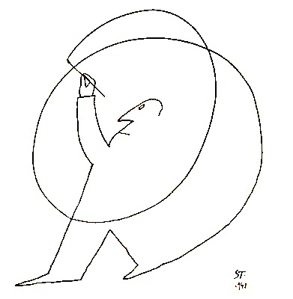

“The Greeks said that to marvel is the beginning of knowledge and when we cease to marvel we may be in danger of ceasing to know” –Ernst Gombrich

Instructor: Harmon Siegel
Email: harmonsiegel@g.harvard.edu
Cell: 914-330-5009.
Office Hours: Wednesday, 2-4 or by appointment, Harvard Art Museums.

Course Structure:

This course has a two-part structure. The first part is mostly historiographical (the history of art history). It aims to introduce students to a canon of art-theoretical texts, to build a common lexicon, and to facilitate discussion. The second part examines how the issues already discussed underlie contentious debates in art history through a series of case studies. This part is open to change, depending on students’ interests. In March, I will distribute a list of potential case studies. Students will vote and the most popular options will furnish our materials.

Course Requirements:

Readings and Participation (50%): In our weekly meetings, the assigned readings will be discussed and debated. For this reason, it is essential that all members of the tutorial read the assigned texts carefully and critically prior to each meeting. All readings will be available online on the course website.

Presentation (10%): Each week, at least one student will choose an object from her field of interest to ground the methodological issues at stake. Objects chosen should exemplify or dramatize questions raised by the week’s readings. The week’s respondent will give a ten minute presentation in two parts. First, an introduction to the object, consisting of relevant factual information (ie. Relevant names, dates, cultural/historical contexts, materials, medium, etc.). Second, a brief description of why and how the object in question helps us to think about the week’s readings and topic.

Writing Exercises (10%): A series of exercises designed to develop art historical writing. Skills to be fostered will range from the mechanics of prose to the flow of an argument and the mustering of evidence. These will be due to me by email every other week on the Tuesday before class.

Mid-Term (10%): 5 pages. Topics to be distributed with at least two weeks notice.

Final (20%): Assignment to be determined in consultation with students.

Policies

Accommodations: Any student needing academic adjustments or accommodations is requested to present a letter from the Accessible Education Office (AEO), preferably by the second week of the term. All discussions will remain confidential, although the AEO may be consulted to discuss appropriate implementation.

Late assignments: will be automatically deducted a half-grade per day.

Electronics: Please refrain from bringing your laptop to class.

Recordings: I plan to record each week’s discussion and post it to canvas. These recordings will serve as a record of our meetings and facilitate review, to be shared only with members of the seminar. If, for any reason, you do not wish to be recorded, please speak with me ASAP.

Attendance: Because participation is the highest weighted assignment, attendance is essential. If you need to miss class for any reason, please email me. I do not need to know the reason, but will ask you to listen to the recording for that session and either write a brief response or come talk with me in office hours. This policy is not putative, but to ensure everyone’s success.

Required Books:

WJT Mitchell, Iconology (ASAP)
Clement Greenberg, Homemade Esthetics

Course Schedule

PART I: Method and/versus Theory

1/26: Method

Erwin Panofsky, “Art as a Humanistic Discipline.”
W.J.T. Mitchell, “What do Pictures Want?”

Recommended:

Robert Pippin, “The Humanities and Ethical Knowledge”
Lisa Ruddick, “When Nothing is Cool.”
Bruno Latour, “Why has Critique Run out of Steam?”
Eve Sedgwick, “Paranoid Reading and Reparative Reading”

2/2: Image

W.J.T. Mitchell, “What is an image?” in Iconology
-- “Metapictures” in Picture Theory
Pliny, “Artists Who Painted with a Pencil”
Plato, Republic (VII.514a)
Richard Wollheim, “What the Spectator Sees,” in Painting as an Art

Recommended:

Gabriel Lear, “Plato’s Poetics”
Ernst Gombrich, “Meditation on a Hobby Horse”

2/9 Perception

Ernst Gombrich, Art and Illusion, selections
Joel Snyder, “Picturing Vision”

Richard Neer, The Emergence of the Classical Style, selections
Xenophon Memorabilia, selections

Recommended:
Norman Bryson, “The Essential Copy” in Vision and Painting,
Mitchell, Gombrich section in Iconology

2/16 Intention

Walter Benn Michaels, The Shape of the Signifier (introduction)
Sigmund Freud, The Means of Representation” in The Interpretation of Dreams (chapter VI.C)
Bruno Bettleheim, “Joey the Mechanical Boy”
David Summers, “Intention in Art History”

Recommended:

Roland Barthes, “The Death of the Author”
Walter Benn Michaels, “Intention at the College Art Association (2010)”
Whitney Davis, Replications (excerpts)
Thierry de Duve, “Intentionality and Art-Historical Methodology”
Leo Strauss, “Persecution and the Art of Writing”
Michel Foucault, “What is an Author?”

2/23 Medium

Gotthold Lessing, Laocöon.
Clement Greenberg, “Towards a New Laocöon.”
Luca Giuliani, Image and Myth (introduction).

Recommended:

Mitchell, Lessing section in Iconology
J.M. Bernstein, Classic and Romantic German Aesthetics (introduction)

3/2 Art

Immanuel Kant, Critique of Judgment (selections)
Clement Greenberg, Homemade Aesthetics (79-195)

Recommended:

Clement Greenberg, Homemade Aesthetics (1-78)
Thierry de Duve, Kant After Duchamp (selections).

3/9 Art History I

G.F.W. Hegel Aesthetics (vol 2: II.1.C: 1-3; III.1.1: a-c).
Alois Riegl, “Excerpts from The Dutch Group Portrait”

Recommended:

Johann Winckelmann, History of Ancient Art (selections).
Robert Pippin, After the Beautiful
Jas Elsner, “From Empirical Evidence to the Big Picture”

3/16 Art History II

Erwin Panofsky, “Iconography and Iconology,” pp. 26-40
Michael Baxandall, “The Period Eye” in Painting and Experience

Recommended:

TJ Clark, “Social Art History”
Ernst Gombrich, “On the Social History of Art.”
Erwin Panofsky, “On the Relationship of Art History and Art Theory”
-- “Iconography and Iconology” (40-54).
Ernst Gombrich, “Psychology and the Riddle of Style,” in Art and Illusion
Richard Neer, “Connoisseurship and the Stakes of Syle”

PART II: CASE STUDIES

3/30 Van Gogh’s Shoes

Heidegger, “Origins of the Work of Art,”
Schapiro, “The Still Life as Personal Object”

Recommended:

Hubert Dreyfus, “Heidegger’s Ontology of Art”

4/6 Impressionism

Jules-Antoine Castagnary, "Exhibition at the Boulevarde Capucines"
Stephan Mallarmé, "Manet and the Impressionists"
Edmond Duranty, "The New Painting"
Richard Shiff, Cezanne and the End of Impressionism (selections)

4/13 The Sexuality of Christ (guest: artist Loie Hollowell)

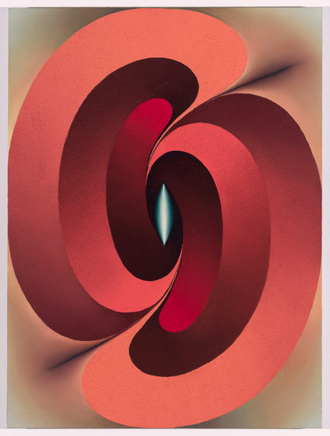

Leo Steinberg, The Sexuality of Christ
Caroline Walker Bynum, “Reply to Leo Steinberg”
Anna Chave, “Is this Good for Vulva? Female Genitalia in Contemporary Art”

Recommended:

Leo Steinberg, “Ad Bynum”
Anna Chave, “O’Keefe and the Masculine Gaze”
Anne Wagner, Three Artists (Three Women) (selections)

4/20 Indices

C.S. Pierce, “What is a Sign?”
James Elkins et al., Photography Theory

Recommended:

C.S. Pierce, “Three Trichotomies of Signs”
James Elkins, “What Does Pierce’s Sign Theory Have to Say to Art History?”
Rosalind Krauss, “Notes on the Index”
Henri Lefevre, “The Art of Pointing: On Pierce, Indexicality, and Photographic Images”
Tom Gunning, “What’s the Point of an Index? or, Faking Photographs”
-- “Moving Away from the Index: Cinema and the Impression of Reality”

