Online Appendix

Advance Market Commitments: Insights from Theory and Experience

By Michael Kremer, Jonathan Levin, and Christopher M. Snyder
Online Appendix Coauthored with Arthur Baker and Junyi Que

This online appendix is divided into two parts. Appendix A contains figures omitted from the published paper because of space constraints. Appendix B provides the details behind the numerical examples illustrating the asymmetry of the designer’s loss function under uncertainty.

Appendix A: Figures
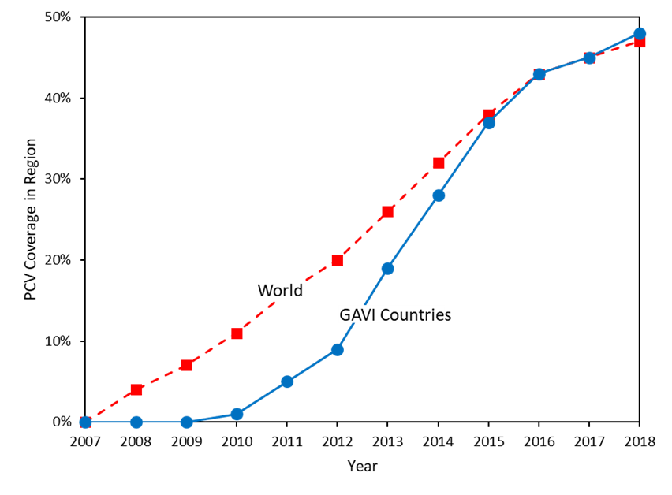
Figure 1. PCV Coverage in GAVI Countries Relative to World
Notes: Plots of vaccine coverage in 73 GAVI-eligible countries (solid blue line) and in the world (dashed red line). Coverage defined as percentage of children receiving third and final scheduled dose by the nationally recommended age. The figure demonstrates that pneumococcal conjugate vaccine (PCV) coverage in GAVI countries reached nearly 50% by 2018, surpassing the coverage rate in the rest of the world.
Source: Author calculations using WHO/UNICEF Estimates of National Immunization Coverage (WUENIC) provided on the “Aggregate estimates” worksheet of the coverage_estimates_series.xlsx file downloaded December 18, 2019 from http://www.who.int/immunization/ monitoring_surveillance/data/en/.

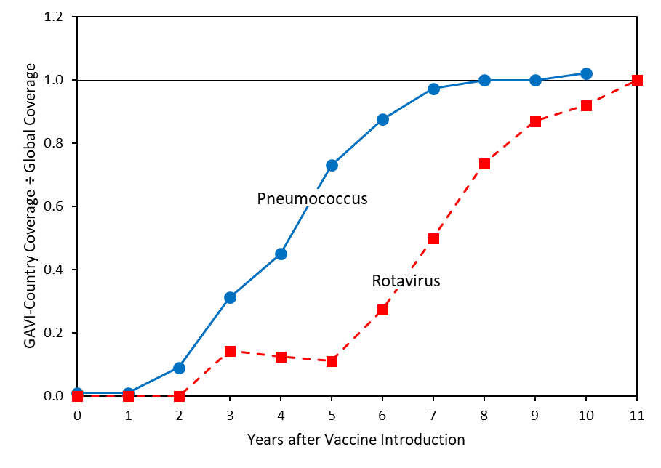
Figure 2. Coverage for Vaccines Rolled Out with and without an AMC
Notes: Plots of vaccine coverage in 73 GAVI-eligible countries divided by global coverage. Coverage defined as percentage of children receiving final scheduled dose (three for pneumococcus, two or three for rotavirus depending on schedule) by the nationally recommended age. Each series begins the first year the relevant vaccine was introduced globally: 2008 for pneumococcus and 2006 for rotavirus. Series cut off in 2018 for pneumococcus (year 10 relative to introduction) and 2017 (year 11) for rotavirus. Vaccine coverage in GAVI relative to global coverage represented by the solid blue line for pneumococcal conjugate vaccine (PCV) and by the dashed red line for rotavirus vaccine.
The figure demonstrates that rotavirus vaccine coverage in GAVI countries took almost five years longer (or almost twice as long) to converge to the global rate than PCV.
We calculate that if PCV coverage in GAVI countries converged to global rate at the slower rate of the rotavirus vaccine, 67 million fewer children under age 1 would have been immunized, amounting to a loss of over 12 million DALYs. We use the following formula to compute the shortfall in immunizations:

$$\sum_{t=2}^{10}{\left(\frac{{COV}_{pgt}}{{COV}_{pwt}}-\frac{{COV}_{rgt}}{{COV}_{rwt}}\right){COV}_{pwt}{UPOP}_{gt},}$$

where ${COV}_{ijt}$ denotes coverage of the vaccine against disease $i∈\left\{p,r\right\}$ and ${UPOP}_{jt}$ denotes the population under age 1 in location $j∈\left\{g,w\right\}$ at each time $t∈\left\{2,3,…,10\right\}$, for $p$ representing pneumococcus, $r$ rotavirus, $g$ GAVI countries, and $w$ the world. For each time $t$ along the horizontal axis of the graph, the factor in parentheses, which is the vertical distance between the graphs, is scaled by PCV coverage in the world and further scaled by the population under age 1 in GAVI countries. The figures for each year are summed to obtain total immunizations. To obtain DALYs lost, the immunization shortfall is multiplied by 3 (PCV doses per immunization) times 0.063 (DALYs per PCV dose).
We selected rotavirus from the six global vaccine initiatives proceeding around that time for the following reasons. Three of them (IPV, second dose of measles, birth dose of hepatitis) involved early-vintage rather than new vaccines. The yellow-fever vaccine was not rolled out in many high-income countries, leaving no good base rate for coverage speed comparison. We conjecture the results would be stronger using HPV, the remaining candidate apart from rotavirus, for comparison, but any slow rollout of HPV vaccine in GAVI countries could be attributed to its administration to older children, slowing coverage expansion.
Source: See Figure 1 for data sources used in graphs. The calculations in the notes use the World Bank’s Population Estimates and Projections downloaded January 22, 2020 from https://datacatalog.worldbank.org/dataset/population-estimates-and-projections and use the 0.063 DALYs per dose figure computed in Appendix B based on findings in Tasslimi, et al. (2011).

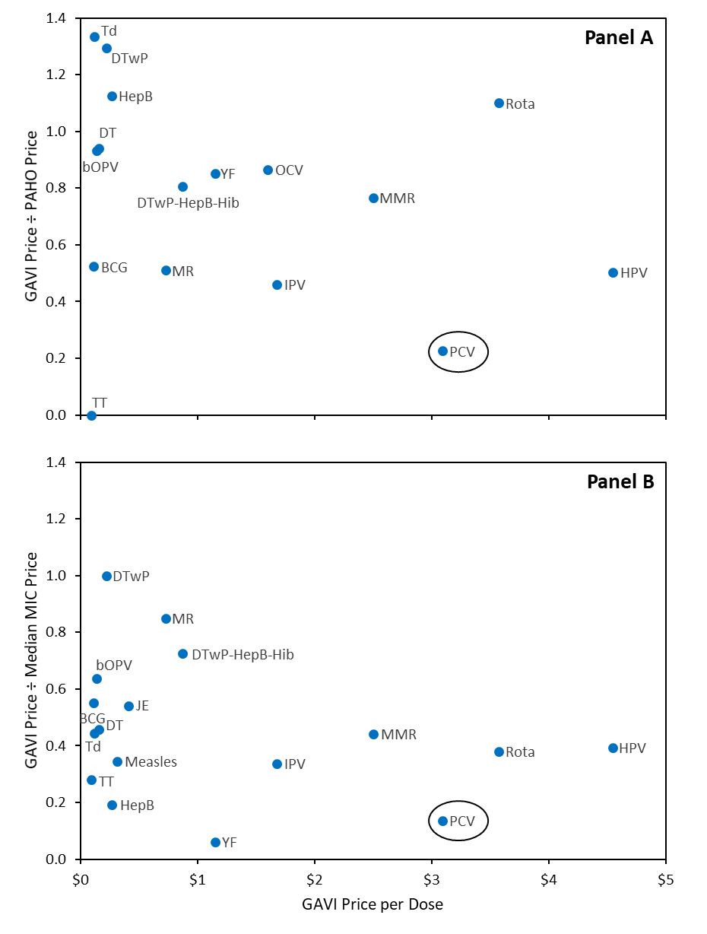
Figure 3. GAVI Relative to World Prices for Vaccines
Notes: Per-dose price paid by GAVI in 2018 plotted against the ratio of the GAVI price to Pan American Health Organization (PAHO) price (Panel A) or the median price paid by a self-procuring middle-income country (Panel B). The pneumococcal conjugate vaccine (PCV) is circled for emphasis.
Source: Author calculations using data from Figure 4.3 of World Health Organization, 2019, “Global Vaccine Market Report,” downloaded January 9, 2020 from http://www.who.int/immunization/programmes_systems/procurement/mi4a/platform/module2/2019_GlobalVaccine_Market_ Report.pdf?ua=1.

Appendix B: Numerical Example Illustrating Designer’s Asymmetric Loss Function
This appendix provides the details behind the numerical example in the paper illustrating the asymmetry of the Advance Market Commitment (AMC) designer’s loss function when trying to set
- prices offered to manufacturers and
- copayments required from countries
under uncertainty about these agents’ reservation values. The designer’s loss from setting too high a manufacturer price is that this increases program expense, diverting resources that could have been used to provide other health benefits. Setting too low a price risks not meeting the firms’ reservation values, leading them not to supply pneumococcal conjugate vaccine (PCV) to target countries. As we show, the substantial health benefit provided by PCV relative to alternative uses for the funds—even assuming these funds are used for health interventions that meet the WHO threshold for high cost effectiveness—will lead the loss from not meeting firms reservation values to be asymmetrically large.
Setting the country copayment involves an analogous tradeoff. Setting too low a copayment increases program expense, draining resources from alternative health programs. Setting too high a copayment risks the countries not participating in PCV rollout. Again, the substantial health benefit provided by PCV will lead the latter loss to be asymmetrically large.
To quantify these insights, we will analyze the conditions under which the pilot AMC design would have been improved if the manufacturer price were set below $3.50 or country copayment above $0.20.

1. Model
Suppose the AMC designer sets a manufacturer price $p$ per dose and a copayment $k$ per dose to maximize expected health benefits, recognizing that funds spent on the AMC have an opportunity cost because they can be used in alternative ways.
Let $x(p)$ be the probability that firms are induced to supply PCV under the AMC program, referred to as the participation probability for short. The participation probability is an increasing function of $p$ because higher $p$ is more likely to exceed firms’ reservation values, leading them to participate in the program. For this exercise, we focus on the effect of $p$ on firms’ extensive-margin decision of whether or not to supply the vaccine, implicitly assuming that decisions at the intensive margin such as the scale of capacity expansion or its timing do not depend on $p$. Allowing $p$ to incentivize these intensive-margin decisions in a more general analysis would only strengthen the conclusion about the asymmetry of the loss function. See Kremer, Levin, and Snyder (2019) for an elaborated model capturing incentives on the intensive margin. Denote the complementary probability by $f\left(p\right)=1-x(p)$, interpreted as the failure probability, i.e., the probability that the AMC fails to induce firm participation.
Let $q(k)$ denote the number of doses administered under the AMC. This is a decreasing function of the copayment $k$ because higher copayments are more likely to exceed countries’ reservation values.
Let $h_{a}$ be the health benefit per dose if firms participate in the AMC, measured in disability-adjusted life years (DALY) saved per dose. Let $h_{o}$denote the opportunity cost of each dollar spent on the AMC. This opportunity cost is the foregone health benefit from the alternative intervention, measured in DALYs per dollar.
Let $B$ be the total budget available to the AMC designer. The all-in cost of the AMC to the designer per dose (denoted $c$), equals the manufacturer price per dose ($p$), plus the AMC subsidy (denoted $s$), plus the administrative costs of distributing the vaccine (denoted $a$), minus the country co-payment ($k$):
$$c=p+s+a-k.$$ | (1)
The AMC designer’s objective function (denoted $W$ for welfare) is the expected health benefit that can be generated by its budget:
$$W=f(p)h_{o}B+x\left(p\right)\left\{q\left(k\right)h_{a}+\left[B-q\left(k\right)c\right]h_{o}\right\}.$$ | (2)
To derive equation (2), note that with probability $f(p),$ firms decline to provide vaccine at the offered price $p$, in which case the AMC budget $B$ is spent on an alternative intervention which brings health benefit per dollar $h_{o}$ for certain. With probability $x\left(p\right)$, firms participate in the AMC. In that case, the AMC designer orders the number of doses, $q(k)$, that adopting countries order. The remaining budget $B-q\left(k\right)c$ is spent on the alternative intervention. Equation (2) embodies the assumption that the AMC designer does not value firm profits nor money saved by developing countries in lieu of making copayments. If the designer were to place some welfare weight on savings to developing countries from lower copayments, then subsequent calculations would favor lower copayments.
Substituting from equation (1) into (2) and rearranging yields
$$W=h_{o}B+x\left(p\right)q\left(k\right)\left[h_{a}-\left(s+p+a-k\right)h_{o}\right].$$ | (3)
The designer chooses $p$ and $k$ to maximize equation (3).

2. Parameter Calibration
The model parameters are calibrated as follows. We fix the AMC subsidy at $s=\$0.75$, its average level in the pilot AMC. We fix the administrative cost at a reasonable, round figure of $a=\$1.00$. We start in the next section by fixing the country copayment at $k=\$0.20$ as in the pilot AMC; the section after that examines the welfare effects of varying $k$. Reflecting the observation that firms did participate at the price offered in the pilot AMC in practice, we assume firms certainly participate at the high AMC price, i.e., we set $x_{0}=1$.
The remaining parameters to calibrate are the health benefits. For $h_{o}$, the health benefit of alternative interventions, we posit a range of values in the sensitivity analysis below. Our calibration of $h_{a}$, the health benefit of a dose of PCV under the AMC program, based on results from Tasslimi, et al. (2011), requires some explanation.
Table 1 provides calculations of DALYs/dose for the two second-generation vaccines, PCV 10 and PCV 13, covered by the AMC. Since the AMC involved about equal distribution of PCV 10 and PCV 13, we take the average of the figures in the last column, yielding the calibration value $h_{a}=0.063$.

Table 1— Calibration of AMC Health Benefit from Tasslimi, et al. (2011)
Vaccine | DALYs (thousands) | Doses (billions) | DALYs/dose
PCV 10 | 106,878 | 1.8 | 0.059
PCV 13 | 119,636 | 1.8 | 0.067
Notes: The 1.8 billion is not the actual number of PCV procured under the AMC program but rather a counterfactual figure used by Tasslimi, et al. (2011) in their cost-effectiveness analysis. They calculate that this is the number of doses required for PCV to have the same rate of infant coverage as DTP-3.
Sources: The first two columns of figures from Table 5 of Tasslimi, et al. (2011). The last column is the quotient of the previous two.

3. Setting Manufacturer Price
In this section, we analyze the conditions under which the designer would prefer moving from the price $p_{0}=\$3.50$ set in the pilot AMC to a lower per-dose price of $p_{1}=\$2$.00. In particular, we solve for the threshold participation probability above which the designer would prefer $p_{1}$ to $p_{0}$, performing sensitivity analysis around various values of the health benefit $h_{o}$ of the alternative intervention
The designer prefers $p_{1}=\$2$.00 to $p_{0}=\$3.50$ if $W_{1}≥W_{0}$, where $W_{i}$ here denotes the welfare expression (3) evaluated at price $p_{i}$. Substituting from equation (3) into both sides of the preceding inequality, substituting the indicated prices, and rearranging yields

$$\frac{{x_{0}-x}_{1}}{x_{0}}≤\frac{(p_{0}-p_{1})h_{o}}{h_{a}-\left(p_{1}+s+a-k\right)h_{o}},$$ | (4)

where $x_{i}≡x(p_{i})$. The left-hand side equals the proportional reduction in certainty that firms participate in the AMC at the lower price. The numerator on the right-hand side equals the health benefit generated by investing the savings on a PCV dose in the alternative intervention. The denominator equals the health benefit from a PCV dose over the alternative use of this money spent on this dose at the low price, $p_{1}=\$2.00$.
The assumption that participation is certain under the original AMC price, i.e., $x_{0}=1$, allows expression (4) to be simplified. Substituting $x_{0}=1$ along with the other calibrated parameters and price values into (4) yields

$$f_{1}≤\frac{1.50h_{o}}{0.063-3.55h_{o}}.$$ | (5)

where $f_{i}≡1-x_{i}$. Intuitively, equation (5) says that the designer prefers the lower price only if it does not drive the probability the AMC fails to induce firm participation too high. The fact that the right-hand side of (5) is decreasing in $h_{o}$ implies that an increase in the opportunity cost of funds relaxes the condition, increasing the appeal of a low price. In other words, a reduction in the opportunity cost of funds tightens the condition under which the designer prefers the lower price; lowering the price to $p_{1}=\$2.00$ would only make sense if the designer remains fairly certain that firms participate at this lower price. Denote the threshold value of the failure rate at which condition (5) just holds with equality by ${\hat{f}}_{1}$
Table 2 computes the threshold ${\hat{f}}_{1}$ for a range of values of $h_{o}$. The first row assumes the cost of saving a DALY through alternative means is $4,914, three times per-capita GDP in GAVI countries measured in 2009, the year the AMC was launched. Saving a DALY at three times per-capita GDP is the WHO threshold for a cost-effective intervention in a country. This high figure of $4,914 translates into a low opportunity cost of AMC funds in the third column, $h_{o}=2.305\text{e-4}$. With such a low opportunity cost, an AMC price of $p_{1}=\$2.00$ is preferred only if there is a less than ${\hat{f}}_{1}=0.5\%$ chance (one in two hundred) that firms fail to participate at this lower price.

Table 2— Threshold Rate of Participation Failure for Designer to Prefer $2.00 Price
Cost effectiveness of  alternative intervention, $1/h_{o}$  ($ per DALY) | Rationale for cost-effectiveness measure | $$h_{o}$$ | Threshold failure  rate ${\hat{f}}_{1}$
4,914 | Three times per-capita GDP | 2.035e-4 | 0.5%
1,638 | Per-capita GDP | 6.105e-4 | 1.5%
1,000 | Higher round figure | 1.000e-3 | 2.5%
500 | Medium round figure | 2.000e-3 | 5.4%
150 | Lower round figure | 6.667e-3 | 25.4%
Notes: The first column contains a range of cost-effectiveness measures for alternative interventions. The second column provides rationales for entries in the first column. The third column is the reciprocal of the first. The last column substitutes the third column into expression (5). In the first row, three times per-capita GDP is the WHO threshold for a cost-effective intervention. In the second row, one times per-capita GDP is the WHO standard for a highly cost-effective intervention. Per-capita GDP is that of GAVI-eligible countries and is measured in 2009, the year of AMC launch.
Sources: GDP figures taken from World Bank, International Comparison Program database.

The second row assumes the cost of saving a DALY thorough alternative means is $1,638, equal to per-capita GDP in GAVI countries, the WHO standard for a highly cost-effective intervention. With this opportunity cost, the designer would prefer the $p_{1}=\$2.00$ price only if the failure rate were no greater than ${\hat{f}}_{1}=1.5\%$.
As the alternative becomes more and more cost effective, the designer requires less and less certain participation to prefer the lower price. The $1,000, $500, and $150 are round figures for cost effectiveness that trace out a range of possibilities.

4. Setting Country Copayments

Introduction.— A similar approach can be used to study the country copayment, which the pilot AMC set at $0.20 per dose. A higher copayment lowers the cost to GAVI and AMC sponsors, but may deter countries from adopting the vaccine. A lower copayment increases the cost but reduces the resources for alternative interventions. The high health benefit of vaccine usage creates an asymmetry between the losses on the two sides that generally favors low copayments.

Calibration.— We maintain all the parameter calibrations from before except now we fix the price at the original AMC level, $p=\$3.50$, and consider reductions in the country copayment from the original level of $k_{0}=\$0.20$ to some lower copayment $k_{1}$. Recall that we calibrated the continuation probability as $x\left(p\right)=1$, i.e., certain firm participation, when evaluated at the pilot AMC price of $p=\$3.50$.
The designer prefers lower copayment $k_{1}$ to $k_{0}=\$0.20$ if $W_{1}≥W_{0}$, where we have redefined $W_{i}$ in this section to denote welfare in equation (3) evaluated at copayment $k_{i}$. Substituting from (3) into both sides of the preceding inequality, substituting the indicated copayments, and rearranging yields

$$\frac{q_{1}-q_{0}}{q_{0}}≥\frac{\left(k_{0}-k_{1}\right)h_{o}}{h_{a}-\left(p+s+a-k_{1}\right)h_{o}},$$ | (6)

where $q_{i}≡q(k_{i})$. Substituting the calibrated parameters and copayments into (6) yields

$$∆q≥\frac{(0.20-k_{1})h_{o}}{0.063-(5.25-k_{1})h_{o}}.$$ | (7)

where $∆q≡{(q_{1}-q_{0})}/{q_{0}}$. Intuitively, condition (7) says that the designer prefers the copayment if the market expansion on the left-hand side of the inequality exceeds the ratio of the health benefits bought with proceeds from the higher copayment (in the numerator on the right-hand side) to the incremental health benefit of a dose of PCV under the AMC compared to the same money being spent on an alternative intervention (in the denominator). The fact that the right-hand side of (7) is decreasing in $h_{o}$ implies that an increase in the opportunity cost of funds relaxes the condition, increasing the appeal of a lower copayment. In other words, a reduction in the opportunity cost of funds tightens the condition under which the designer prefers the lower copayment; lowering the copayment to $k_{1}$ would only makes sense if this boosts country take up sufficiently. Denote the threshold market expansion at which condition (7) just holds with equality by $\hat{∆q}$.
Table 3 shows the market expansion required to make various lower copayments ($k_{1}=\$0.10$, $k_{1}=\$0.05$, $k_{1}=\$0.00$) preferable to $k_{0}=\$0.20$ given different level of the opportunity cost $h_{o}$. Across all table entries, the required market expansion is quite small to make lower copayments beneficial.

Table 3— Threshold Market Expansion for Designer to Prefer Lower Copayments
Cost effectiveness of  alternative intervention, $1/h_{o}$ ($ per DALY) |  | Threshold quantity increase $\hat{∆q}$ for alternative copayments
 | $$h_{o}$$ | $$k_{1}=\$0.10$$ | $$k_{1}=\$0.05$$ | $$k_{1}=\$0.00$$
4,914 | 2.035e-4 | 0.03% | 0.05% | 0.07%
1,638 | 6.105e-4 | 0.10% | 0.15% | 0.20%
1,000 | 1.000e-3 | 0.17% | 0.26% | 0.34%
500 | 2.000e-3 | 0.38% | 0.57% | 0.76%
150 | 6.667e-3 | 2.33% | 3.53% | 4.76%
Notes: See previous table for rationales for cost-effectiveness measures. The second column is the reciprocal of the first. The last three columns substitute the respective values of $h_{o}$ and $k_{1}$ into third column into expression (7).

Speeding Rollout in Populous Countries.— According to Table 3, reducing co-payments to zero would be justified if this increased the number of children vaccinated by a mere 4.76% even using the cost effectiveness in the last row for the alternative intervention ($150/DALY). To provide further context for this result, we will analyze conditions under which lowering the copayment would have been justified if it encouraged take up by populous countries like India and Bangladesh, which were late adopters under the AMC program.
Start with India, which did not participate in the AMC program until 2017 and then only in five states. The potential for market expansion can be gauged from India’s experience with the HiB vaccine, introduced with GAVI support in 2013 in India. By our calculations, 79 million Indian children were immunized against HiB by 2018. Assuming that the coverage of PCV in India were similar, adding India to the program would have expanded the AMC market by 53% over the 143 million immunizations administered under the program by 2018.
This 53% market expansion surpasses the 4.76% threshold by such a large margin that the copayment reduction would be justified even the expansion into the India market were uncertain, with a probability as low as 9% (where $9\%=4.76\%÷53\%$). This is true even though the expansion is limited to one country but extra cost per dose to make up for the reduced copayment is paid in all countries and across all periods in the model.
India rolled out PCV in five states in 2017. Calculations similar to those above can be used to show that if reducing the copayment to zero would have induced India to roll out PCV three years earlier in those five states, this alone would justify the extra cost (indeed, even if this market expansion were only 88% certain).
Turn to Bangladesh, which did not introduce PCV until 2015. If a copayment of zero would have induced Bangladesh to introduce the vaccine three years earlier, in 2012, this alone would justify the extra cost (indeed, even if this market expansion were only 82% certain).

Copayments by Vintage.— Having a lower copayment for new, more expensive vaccines than for older, cheaper vaccines may feel counterintuitive. Yet, countries may arguably have a greater elasticity of demand for newer vaccines than older ones because policymaking is subject to status quo bias and inertia. It may thus make sense to introduce new vaccines with a “free sample” policy.

Copayments as Market Test.— As well as contributing financing, copayments have another function, providing a “market test” for the AMC. This mitigates the problem of incomplete contracting when specifying the target of the AMC well in advance of production. If countries do not value the product when it is developed, no funds need to be expended under the AMC program.
Reducing the co-payment to zero removes this market test. A small copayment might therefore be beneficial, even if it is not justified by the calculations along the lines of Table 3.
The market test is more important for technologically distant products, because it is both more difficult to specify their characteristics, and because the problem they intend to solve might not be there in future. For instance, an AMC for a malaria vaccine might stimulate the production of that vaccine. However, if malaria-carrying mosquitos are rendered extinct using genetic modification, then even a very good malaria vaccine will no longer be useful.
The PCV covered by the pilot AMC was a technologically close product, so the “market test” function of country copayments was less important there. Calculations along the lines of Table 3 are thus relevant for the pilot AMC, implying that lower copayments may have improved the efficiency of the program.

