Medieval Philosophy

PHIL 117

Fall 2021

Syllabus

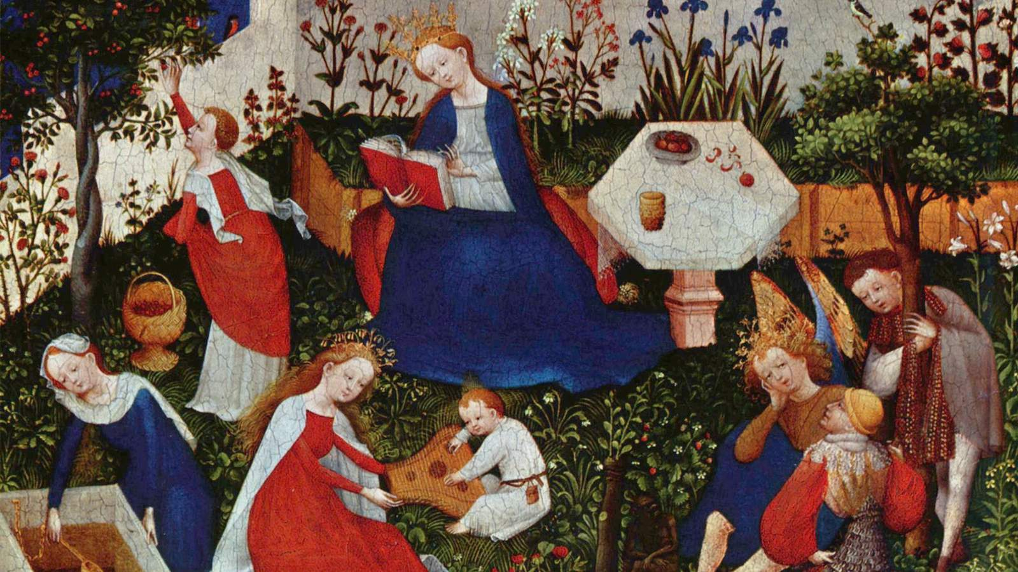

Important Information:

Lecture: Tuesdays and Thursdays, 9:00 am – 10:15 am, Emerson 310
Professor: Jeffrey McDonough
Office Hours: Immediately after class and by appointment
E-mail: jkmcdon@fas.harvard.edu
Course Web Page: https://canvas.harvard.edu/courses/89698

Course Description:

Notoriously dismissed by Petrarch as the “Dark Ages” and still often overlooked today, the medieval period included some of the most profound thinkers in the history of Western philosophy. In this course, we will examine three of its great traditions, Platonism, Scholastic-Aristotelianism, and Nominalism, through the works of their greatest proponents, Augustine, Aquinas and Ockham. Specific topics will include skepticism, knowledge, human nature, divine nature, language, realism, conceptualism, and happiness.

Required Texts (available through the COOP, https://tinyurl.com/F21-PHIL-217-1):

Peter King, ed. and trans., Augustine: Against the Academicians and The Teacher (Indianapolis: Hackett).

Philotheus Boehner, ed. and trans., William of Ockham: Philosophical Writings, revised and edited by Stephen F. Brown (Indianapolis, Indiana: Hackett 1990).

Recommended Texts (through the COOP, https://tinyurl.com/F21-PHIL-217-1):

Thomas Williams, ed. and trans., Augustine: On Free Choice of the Will
(Indianapolis: Hackett). [There are other editions of On Free Choice of Will available, but I highly recommend this inexpensive edition.]

Henry Chadwick, ed. and trans., Saint Augustine: Confessions (New York: Oxford University Press). [There are many translations of the Confessions; any will do.]

Alfred J. Freddoso and Francis E. Kelley, eds. and trans., William of Ockham Quodlibetal Questions (Yale University Press).

Requirements and Grading:

1. Reading

The ability to read texts carefully and thoughtfully is one of the most important skills the study of philosophy can foster. In order to better understand what is being taught, and to promote informed classroom discussions, required readings should be completed before lecture. Note: I will be distributing my “lecture notes” after each class. Students are encouraged to read those notes carefully – you are likely to find them helpful for completing writing assignments and doing well on the final exam.

2. Papers

In order to give students a chance to explore topics in greater depth, and to improve their writing skills, each student will be required to write three short papers, one paper corresponding to each of the sections of the course. Papers should be 1000 - 1500 words. All papers should be submitted on the course web site as Word documents. Details concerning paper assignments will be discussed in class. If you have any questions, please ask.

3. Participation

Our classroom time will be a mixture of lecture and discussion. It is crucial both for your own learning and for the learning of others that you regularly attend our meeting sessions. Attendance will be taken. Please note: to pass this course, you must pass all components of this course. In particular, that means that a failing participation grade will result in a failing grade for the course.

4. Final exam

In order to give students an opportunity to review what they have learned over the course of the semester a final exam will be provided. The exam will be limited to one hour and administered on a date to be determined by the FAS Registrar’s Office.

5. Grading

Grades will be determined by scores received for classroom participation, papers, and the final exam according to the following percentages:

First short paper: 10 %
Second short paper: 20 %
Third short paper: 20 %
Participation: 20 %
Final exam: 30 %

6. Special Needs and Emergencies

Students requiring special assistance are encouraged to inform the professor at the beginning of the term. We are happy to accommodate those with special needs as far as possible. Absences from class or exam periods and late papers will be dealt with in accordance with the policies described in the Harvard College Handbook for Students. Students should expect that late papers will be marked down a third of a letter grade for each day that they are late. Requests made to prior to an absence or due date may result in special accommodation.

7. Academic Integrity

Discussion and the exchange of ideas are essential to academic work. For assignments in this course, you are encouraged to consult with your classmates on the choice of paper topics and to share sources. You may find it useful to discuss your chosen topic with your peers. You should, however, ensure that any written work you submit for evaluation is the result of your own research and writing and that it reflects your own approach to the topic. You must also adhere to standard citation practices in this discipline and properly cite any books, articles, websites, lectures, etc. that have helped you with your work. If you received any help with your writing (feedback on drafts, etc.), you must also acknowledge this assistance. Further information on university policies concerning academic integrity can be found through the Harvard College Handbook for Students under Academic Integrity and Academic Dishonesty.

Tentative Schedule

Thurs, Sept 2 | Introduction to Medieval Philosophy
Required reading: | Course Syllabus
Topics: | The medieval period; Platonic background; Aristotelian background (optional)

--Augustine--

-- Seminal Themes from Augustine --

Tues, Sept 7 | Introduction to Augustine
Required reading: | Confessions Book II and Book VII [Chadwick, pp. 24-35, 111-133]
Optional reading: | Confessions, Books I – IX (posted texts)
Topics: | Augustine the philosopher? Platonic hierarchies; Themes from the Confessions; Three heresies (optional)

Thurs, Sept 9 | Skepticism and Its Refutation
Required reading: | Against the Academicians 1.2.5 – 1.4.11; 2.4.10 – 2.11.25; 3.1.1 - 3.12.27 [King, pp. 5-12; 34-48; 52-77]; City of God [Book] 11.[Chapter] 26 (posted texts)
Optional reading: | Against the Academicians (all)
Topics: | Academic skepticism; Refuting skepticism; Faith and reason

Tues, Sept 14 | Philosophy of Language
Required reading: | The Teacher 1.1 – 4.7, 10.31-13.46 [King, 94-104, 133-146]; Confessions 1.6.8, 1.8.13 [Chadwick, pp. 7, 10-11]
Optional reading: | The Teacher (all)
Topics: | The purpose of language; How language works; Language, teaching, and learning

Thurs, Sept 16 | Theory of Knowledge
Required reading: | The Literal Meaning of Genesis, Book XII, Chapters 6-12, 14,16, 23-25 [Posted texts, pp. 185-195, 196-198, 199-201, 211-216]
Optional reading: | The Literal Meaning of Genesis, Book XII (all, posted texts)
Topics: | Corporeal vision; Spiritual vision; Intellectual vision

Tues, Sept 21 | Evil, Evil, Evil
Required reading: | Enchiridion (available in translation on-line as Handbook on Faith, Hope and Love (posted texts) chapters III (God the Creator of All and the Goodness of all Creation) and IV (The Problem of Evil), VII (The Plight of Man after the Fall), XIII (Baptism and Original Sin). Note chapters and headings may vary from translation to translation.)
Optional reading: | Enchiridion (all, posted texts)
Topics: | The problem of evil, Can evil be a privation of good? Original sin

Thurs, Sept 23 | Freedom and Foreknowledge
Required reading: | On Free Choice of the Will, I.1-I.2, I.16, II.1-II.2, II.18 – II.20, III.1 – III.5 [Williams, pp. 1-4, 27-28, 31-33, 64-69, 70-83]; City of God, V.10, XI.21 (posted texts).
Optional reading: | On Free Choice of the Will (all)
Topics: | Free will and responsibility, Foreknowledge and freedom, Evil for freedom’s sake?

Thurs, Sept 28 | Paradoxes of Time
Required reading: | Confessions XI.12-XI.41 [Chadwick, pp. 228-245] (posted texts)
Optional reading: | Confessions X – XIII (all) (posted texts)
Topics: | Before creation? What is time? Is there an objective time? The direction of time

Thurs, Sept 30 | Happiness
Required reading: | The Happy Life (on course web site)
Optional reading: | City of God, Book 19 (link on course web site); On the Trinity Book 13, chapters 3-9.
Topics: | The art of living; The ultimate end; The path to happiness

DUE: Sunday, October 3, short paper on Augustine section. Papers must be submitted on the course website as Word documents by 11:59 pm (EST).

--Aquinas--

-- Aquinas on Human Nature and Cognition --

Tues, Oct 5 | Introduction to Thomas Aquinas
Required reading: | The Principles of Nature (on course web site)
Topics: | Life and Works; Hylomorphism; Four causes; Four causes developed (optional)

Thurs, Oct 7 | Substance, Accident, Essence
Required reading: | On Being and Essence, Chapters 1-3 (link on course web site)
Optional reading: | De mixtione elementorum (link on course web site) [Compare, Ockham Quodlibetal Questions, translated Alfred Freddoso, III question 5 (pp. 185-189).]
Topics: | Substance and accident; Kinds and essences; Material substances; Common vs. signate matter

Tues, Oct 12 | Angels and Essences
Required reading: | On Being and Essence, Chapters 4-5 (link on course web site)
Optional reading: | Treatise on the Angels, ST I.qq 50-64 [=Summa Theologica, Part I, Questions 50-60)] (link to ST on course web site)
Topics: | Immaterial substances, Essence and being, Essences revisited

Thurs, Oct 14 | Human Nature
Required reading: | Treatise on Human Nature, ST Iq75.1-2 [=Summa Theologica, Part I, Question 75, articles 1-2], ST I.q75.4, ST Iq76a1, ST Iq76a8
Optional reading: | Aquinas’s Commentary on De Anima: Lecture 1; Lecture 2; ST Iq76aa3-4, a8 [=Summa Theologica, Part I, Question 76, Articles 3-4, 8]); Ockham, Quodlibet, Question 10-11 (text on course web site)
Topics: | Special status, Living creatures, Hylomorphic compounds, Body and Soul, Substantial form

Tues, Oct 19 | Materialism, Dualism and Passions
Required reading: | Summa Contra Gentiles = SCG II: 65 [Book 2, Chapter 65]; ST Iq75a5; ST Iq76a1; ST Iq80a1; ST I81a1-3
Optional reading: | ST Iq75aa1-2 (reread), ST Iq76a1 (reread)
Topics: | Materialism, Dualism, Passions

Thurs, Oct 21 | Sensory Powers
Required reading: | ST Iq78aa3-4; ST Iq85aa1-2
Optional reading: | ST Iq78; ST Iq85
Topics: | Cognition, External Sensory Powers, Internal Sensory Powers, How are the Passions Structured?

Tues, Oct 26 | The Intellect
Required reading: | ST Iq84a1-7; ST 85a1-2; ST 89a1;
Optional reading: | “The Nature of the Intellect, its Activity, and Its Separability,” selections from Aquinas’s Commentary on Aristotle’s De Anima, pp. 34-59
Topics: | Raw materials, Normal cognition, Plasticity and immateriality, Immateriality and universality

Thurs, Oct 28 | Happiness
Required reading: | ST Ia-IIae, q1.aa1,2,4,5,7,8; q2aa1,3,8; q. 3aa1,5,8; q. 4a6; q5aa1,5,8. (Posted on-line, but note you’ll need to scroll down for “First Part of the Second Part,” the first question is titled, “Of man’s last end.”)
Topics: | The End of human happiness, The Structure of human action, Intellectualism and voluntarism

DUE: Sunday, October 31, short paper on Aquinas section. Papers must be submitted on the course website as Word documents by 11:59 pm (EST).

--Ockham--

-- Ockham’s Ontological Program --

Tues, Nov 2 | Introduction to William Ockham
Required reading: | None
Topics: | Life and works, Methods, The via moderna

Thurs, Nov 4 | Logic of Terms
Required reading: | Summa 1:1 (“On the Term in General”); Summa 1:2 (“On Three Senses of ‘Term’”); Summa 1:4 (“On Categormatic and Syncategormatic Terms”); Summa 1:10 “On Connotative and Absolute Terms,”); Summa 1:63 (“’On Supposition’”); and Summa 1:64 (“On the Division of Supposition”) [All Summa readings are in Boehner required text.]
Topics: | Signification, Absolute vs. connotative terms, Supposition

Tues, Nov 9 | Mental Language
Required reading: | Summa I.3 “On the Correspondence between Vocal and Mental Terms;”  Ockham Quodlibetal Questions, translated Alfred Freddoso, V question 8 [“Do all the grammatical accidents of spoken terms belong to mental terms?”] (pp. 424-429). [All Quodlibetal texts are posted on course site and available in recommended reading.]
Optional reading: | Ockham Quodlibetal Questions, translated Alfred Freddoso, V question 10-11 (pp. 433-440).  Steven Pinker on Mentalese from The Language Instinct
Topics: | What is a mental language? Ockham’s mental language, An ideal language?

Tues, Nov 11 | The Problem of Universals
Required reading: | Selected passages from Ockham’s Ordinatio, d. 2, qq. 4-8 translated by Paul Vincent Spade (page numbers followed by paragraph numbers in parentheses): 114 – 128 (Q4: 1-94); 149-153 (Q5: 1-25). [All Ordinatio passages posted on course site.]
Optional reading: | Selected passages from Ockham’s Ordinatio, d. 2, qq. 4-8 translated by Paul Vincent Spade (page numbers followed by paragraph numbers in parentheses): 153-171 (Q6: 1-103).
Topics: | The problem of universals, Against realism: Walter Burley, Against realism: multiplied universals, Against realism: Duns Scotus

Thurs, Nov 16 | Conceptualism
Required reading: | Selected passages from Ockham’s Ordinatio, d. 2, qq. 4-8 translated by Paul Vincent Spade (page numbers followed by paragraph numbers in parentheses): 217 (17-19); 218-224 (22-54); 229-231 (86-93)
Topics: | Three Questions, Kind Membership, Kind Concepts, Two Theories of Concepts (optional)

Tues, Nov 18 | Quantity
Required reading: | Ockham Quodlibetal Questions, translated Alfred Freddoso, IV, question 25 [“Can it be proved evidently that a quantity is an absolute thing distinct from substance and quality”] (pp. 343-350).
Optional reading: | Ockham Quodlibetal Questions, translated Alfred Freddoso, V, question  22 [“Are there ten categories”] (pp. 471-474).  Ockham’s Treatise on Quantity, Questions I [pp. 7-29], translated T. Bruce Birch (posted on course web site).  Ockham Quodlibetal Questions, translated Alfred Freddoso, IV, questions 26-35 (pp. 350-391).
Topics: | Against “the moderns”, Quantity among the moderns, Argument from condensation and rarefaction, Points

Tues, Nov 23 | Relations and Causation
Required reading: | Ockham Quodlibetal Questions, translated Alfred Freddoso, VI question 8 [“Is similarity or dissimilarity a ‘little thing’ distinct from absolute things?”] (pp. 512-518);  Ockham Quodlibetal Questions, translated Alfred Freddoso. VI question 12 [“Is the relation of efficient causality a thing distinct from absolute things?”] (pp.529-533);  Ockham Quodlibetal Questions, translated Alfred Freddoso. IV question 2 [“Can it be sufficiently proved that God is a final cause of some effect”] (pp. 250-256).  Ockham On Aristotle’s Physics, Book II, Chapter 6 [“The Final Cause”] pp. 35-37.
Optional reading: | Ockham Quodlibetal Questions, translated Alfred Freddoso, II question 8; III question 4; IV question 1; VI questions 9-11, questions 13-14, questions 16-30. (pp. 122-126, 180-185, 245-250, 518-528, 533-534).  Ockham On Aristotle’s Physics, Book II, pp. 25-38
Topics: | Relations, Efficient causation, Final Causation

Thurs, Nov 25 | No Classes – Thanksgiving Day

Tues, Nov 30 | Freedom and Happiness
Required reading: | Ockham Quodlibetal Questions, translated Alfred Freddoso, I question 16-17 (pp. 75-79); III question 19-22 (pp. 228-242); IV question 1-2 (pp. 245-256)
Optional reading: | Ockham Quodlibetal Questions, translated Alfred Freddoso, II questions 15-17; III questions 14-18 (pp. 150-158, 211-227)
Topics: | Background, Will and nature, Legacy

Thurs, Dec 2 | Conclusion

DUE: Sunday, December 5, short paper on Ockham section. Papers must be submitted on the course website as Word documents by 11:59 pm (EST).

-- Final Exam Friday, December 17, 9:00 am --

