Philosophy 320L – Philosophy in Translation: Latin
Seneca’s Letters

Fall 2020
Syllabus
Jeffrey K. McDonough

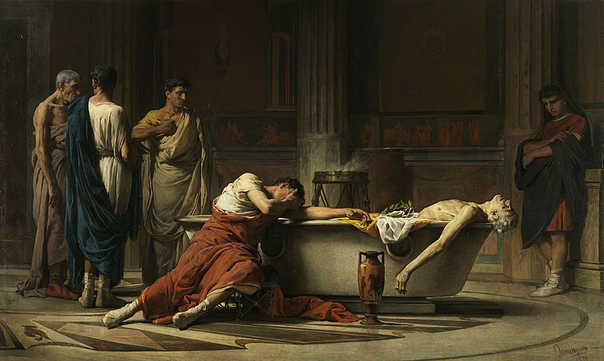

Important Information:
Meeting: On-line, Fridays 1:45-3:00
Zoom link: https://harvard.zoom.us/j/95848297698
Professor: Jeffrey McDonough
Email: jkmcdon@fas.harvard.edu

Course Description:

Lucius Annaeus Seneca was a Roman Stoic philosopher, essayist, celebrity, and renown playwright. Exorbitantly rich, he defended the virtues of poverty. Advisor to Nero, he insisted that political power is worthless. Maintaining that death is not evil, he was compelled to commit suicide in his sixty-ninth year. This course will meet weekly to read passages in Latin from one of Seneca’s most celebrated philosophical texts, his Letters to Lucilius. The course is open to undergraduates, graduates, and faculty of all reading levels. It can be audited with minimal commitment or taken as a course towards the satisfaction of the Philosophy Department’s language requirement. Please contact the instructor if you would like to be placed (with no commitment) on the course e-mail distribution list.

Optional Texts and Background Reading:

Peter Adamson, Later Antiquity, The History of Philosophy without any Gaps, online at: https://historyofphilosophy.net/later-antiquity/hellenistic
Keimpe Algra, Jonathan Barnes, et al (eds), The Cambridge History of Hellenistic Philosophy (Cambridge: 1999).
Richard M. Gummere, trans. Seneca, Lucius Annaeus. Epistulae Morales (Letters). (Harvard University Press, 1917) 3 vols.

Brad Inwood, Seneca: Selected Philosophical Letters (Clarendon: 2010). Translations of selected letters with extensive philosophical commentaries.

Brad Inwood, Reading Seneca: Stoic Philosophy at Rome (Oxford 2005).

A.A. Long and D.N. Sedley, The Hellenistic Philosophers (Cambridge: 1987), vol. 1: translations and commentary, vol.2: texts.

Martha Nussbaum, The Therapy of Desire: Theory and Practice in Hellenistic Ethics, (Princeton University Press, 1994).

John Rist, Stoic Philosophy (Cambridge University Press, 1969).

James S. Romm, Dying Every Day: Seneca at the Court of Nero (Random House, 2014).

Katja Vogt, "Seneca", The Stanford Encyclopedia of Philosophy (Spring 2020 Edition), Edward N. Zalta (ed.), URL = <https://plato.stanford.edu/archives/spr2020/entries/seneca/>.

Robert Wagoner, Lucius Annaeus Seneca, The Internet Encyclopedia of Philosophy, online at:
https://www.iep.utm.edu/seneca/

Emily Wilson, The Greatest Empire: A Life of Seneca (Oxford University Press, 2014).

Tentative Schedule

Latin text links are to: Loeb Classical Library digital editions, Richard M Gummere trans.:
Seneca, Epistles 1-65,
Seneca, Epistles 66-92,
Seneca, Epistles 93-124

Reading #1: Letter 58 – On Being

Broader context: Letter 58

Latin reading: Paragraphs 25-34

Commentary: Inwood, pp. 111-136

Reading #2: Letter 65 – On the First Cause

Broader context: Letter 65

Latin reading: Paragraphs 11-14, 18-24

Commentary: Inwood, pp. 136-155

Reading #3: Letter 66 – On Various Aspects of Virtue

Broader context: Letter 66

Latin reading: Paragraphs 12-20

Commentary: Inwood, pp. 155-181

Reading #4: Letter 71 – On the Supreme Good

Broader context: Letter 71

Latin reading: Paragraphs 2-8, 26-28

Commentary: Inwood, pp. 183-200

Reading #5: L 76 – On Learning Wisdom in Old Age

Broader context: Letter 76

Latin reading: Paragraphs 7-17, 25-26

Commentary: Inwood, pp. 200-219

Reading #6: L 85 – On Some Vain Syllogisms

Broader context: Letter 85

Latin reading: Paragraphs 6-13, 39 (start a few lines up, at “Ita nulla fortuna …”)-41

Commentary: Inwood, pp. 220-238

Reading #7: L 87 - Some Arguments in Favor of the Simple Life

Broader context: Letter 87

Latin reading: Paragraphs 31-41

Commentary: Inwood, pp. 239-260

Reading #8: The Corporeality of Virtue

Broader context: Letter 106

Latin reading: Paragraphs 1-12

Commentary: Inwood, pp. 261-271

Reading #9: The Vanity of Place Seeking

Broader context: Letter 118

Latin reading: Paragraphs 8-17

Commentary: Inwood, pp. 306-314

Reading #10: More about Virtue

Broader context: Letter 120

Latin reading: Paragraphs 1-5, 10-14

Commentary: Inwood, pp. 322-331

Reading #11: The Conflict between Pleasure and Virtue

Broader context: Letter 123

Latin reading: Paragraphs 1-6, 12-14

Commentary: Inwood, pp. 355-360

Reading #12: The True Good as Attained by Reason

Broader context: Letter 124

Latin reading: Paragraphs 2-4, 12-20

Commentary: Inwood, pp. 361-377

The image is of Le muerte de Séneca, by Manuel Domínguez Sánchez (1871).

