Philosophy 126 – The Philosophy of Émilie Du Châtelet

Spring 2020
Syllabus
Jeffrey McDonough and Clara Carus

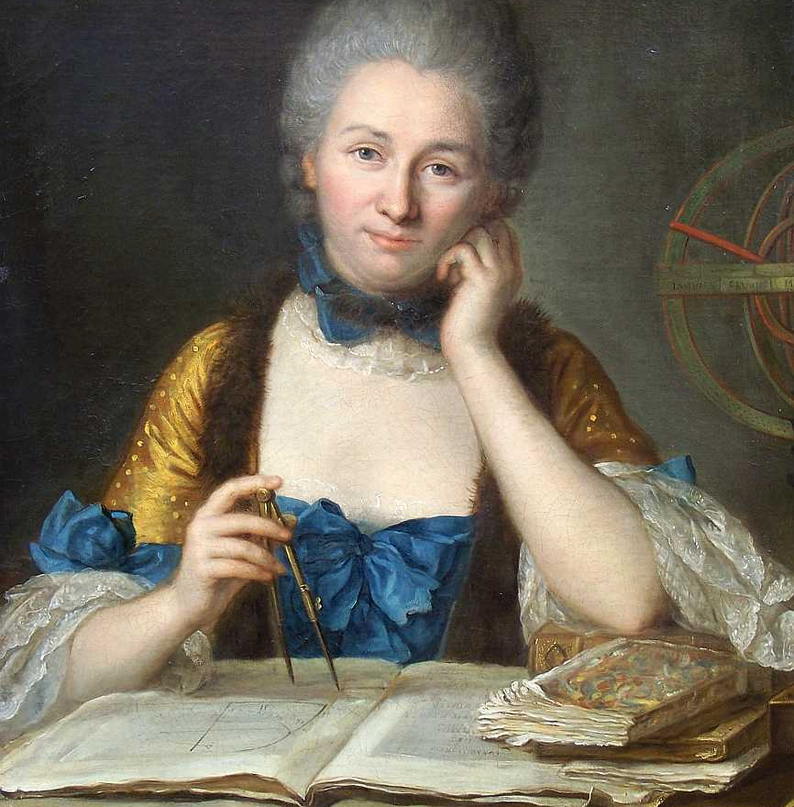

Important Information:
Meeting: Tuesdays 9:00 – 11:00, Emerson Hall 107
Professor: Jeffrey McDonough with Clara Carus
Office Hours (McDonough): Thursdays 3:00 – 5:00, 202 Emerson Hall
Email: jkmcdon@fas.harvard.edu; claracarus@fas.harvard.edu

Course Description:

Émilie Du Châtelet was one of the most remarkable figures of the early modern Enlightenment. Overcoming the prejudices of her time, she rose to become a prominent philosopher, author and translator in the first half of the eighteenth century. This seminar will focus on Du Châtelet’s magnum opus the Institutions de Physique in which she explicitly attempts to bring together principles and developments of both Newtonian science and Leibnizian philosophy. Topics will include: principles of knowledge, space, time, body, motion, gravity, force and optics.
Required Text: Copy available from instructor and through Amazon

Katherine Brading, Émilie Du Châtelet and the Foundations of Physical Science (Routledge 2019). Copy available from instructor and through Amazon (Kindle edition currently $21.99).

Optional Text: available at the COOP, https://tinyurl.com/300-W20-PHIL-126-1

Emilie Du Châtelet, Selected Philosophical and Scientific Writings, ed. and trans., Judith P. Zinsser and Isabelle Bour (The University of Chicago Press, 2009). ISBN-13: 978-0-226-16807-4. Abbreviated below as SPSW.

On-line Materials:

Professor Katherine Brading hosts a full translation of Du Châtelet’s Foundations of Physics on-line at:
https://www.kbrading.org/translations

Project Vox hosts a page devoted to Du Châtelet that contains a great deal of information and helpful links. Available on-line here: https://projectvox.org/du-chatelet-1706-1749/

The Center for History of Women Philosophers and Scientists hosts a page devoted to Du Châtelet’s Foundations of Physics, including links to scanned editions of the Foundations, and to Dr. Andrea Reichenberger’s Reading Guide to the Foundations. Available on-line here: https://historyofwomenphilosophers.org/project/du-chatelets-foundations-of-physics/

Requirements and Grading:

1. Reading

The ability to read texts carefully and thoughtfully is one of the most important skills the study of philosophy can foster. In order to better understand what is being taught, and to promote informed classroom discussions, required readings should be completed before lecture.

2. Participation

With the exception of our first meeting, our classroom time will be focused on discussion of primary texts, context readings, and secondary literature. Students should come to each class ready to discuss all three. More specifically, each student should come to class with three developed questions, comments or passages of interest prepared, one for each type of reading. Please note: Attendance is required and will be taken, and in order to pass this course, you must pass all components of this course. In particular, that means that a failing participation grade will result in a failing grade for the course.

3. Writing

In order to give students a chance to better prepare for class and explore topics in greater depth, as well as improve their writing skills, each student will be required complete two kinds of writing assignments.

First, each student will be required to submit a one page (or less) weekly response paper. Response papers should propose a question, thought, or identify a passage that might be taken up in classroom discussion, one for each type of reading. (That is to say, response papers should typically include three entries, one focused on the primary text, one on a context text, and one focused on the secondary reading). Each student will have a free pass for any two weeks (and no writing assignments are due for the first or last class meeting).

Second, each student will be required to complete a term paper on a topic of his or her own choosing and will be required to complete a number of small “scaffolding” assignments. (Due dates for scaffolding assignments are noted on the syllabus. Examples include selecting a topic, writing an introduction, providing a brief outline, etc.) Undergraduate term papers should be 3000-4000 words. Graduate term papers should be 6000-8000 words.

All papers should be submitted on the course web site as Word documents at least 24 hours before the start of class.

Tentative Schedule

1. Tues, Jan 28 | Context and Purpose
Required: | Syllabus – on Course site.
Primary: | Du Châtelet, Foundations, Preface, pp. 116-124.
Secondary (optional), | Linda Gardiner Janik, “Searching for the Metaphysics of Science: The Structure and Composition of Madame du Châtelet’s Institutions de physique 1737-1740,” Studies on Voltaire and the Eighteenth Century1982 (201): 85-113. Course site.  Ruth Hagengruber, “Section 1: Who Was Emilie du Châtelet,” in Emilie du Châtelet between Leibniz and Newton (Springer, 2012), pp. 1-4. Course site.  Judith P. Zinsser, Emilie Du Châtelet, Daring Genius of the Enlightenment (New York: Penguin, 2006). Widner Library.

2. Tues, Feb 4 | Principles of Our Knowledge
Primary: | Du Châtelet, Foundations, Ch 1: Of the Principles of Our Knowledge, pp. 124-138.
Context: | Descartes, Rules for the Direction of our Native Intelligence, Rule Twelve, pp. 12-18. Course Site.  Leibniz, First Truths. Available on EMT.  Leibniz, Meditations on Knowledge, Truth and Ideas. EMT.  Leibniz, Letter of Mr. Leibniz on a General Principle Useful in Explaining the Laws of Nature Through A Consideration of the Divine Wisdom, ed. and trans. Leroy E. Loemker, pp.351-354. Course site.  Leibniz, Monadology, Sections 29-36. EMT.  Wolff, “Chapter 4: The Method of Philosophy,” in Preliminary Discourse on Philosophy in General, pp. 59-78. Course Site.
Secondary: | Karen Detlefsen, “Section 2: First Principles of Knowledge,” in Émilie du Châtelet, The Stanford Encyclopedia of Philosophy (Winter 2018 Edition), Edward N. Zalta (ed.). URL = https://plato.stanford.edu/archives/win2018/entries/emilie-du-chatelet/  Katherine Brading, Émilie Du Châtelet and the Foundations of Physical Science (Routledge, 2019), Chapter 2: Method (selection), pp. 26-40. Course Site.

3. Tues, Feb 11 | The Existence of God
Primary: | Du Châtelet, Foundations, Ch 2: Of the Existence of God, pp. 138-147.
Context: | Locke, Essay Concerning Human Understanding, Bk IV, chapter 10: Our Knowledge of the Existence of God. EMT.  Leibniz, Theodicy, Part 1, Section 7 (begins, “God is the first reason of things …”).Project Gutenberg.  Leibniz, Monadology, Sections 36-47. EMT.  Voltaire, The Metaphysics of Newton, Chapter 1: Of God, pp. 3 [A2]-10. Google Books. (Available in French through fr.wikisource.org, here.)
Secondary: | Marcy P. Lascano, “Emilie du Châtelet on the Existence and Nature of God: An Examination of Her Arguments in Light of their Sources,” British Journal for the History of Philosophy 2011 (19:4): 741-758. Course site.  Karen Detlefsen, “Section 3: God,” in Émilie du Châtelet, The Stanford Encyclopedia of Philosophy (Winter 2018 Edition), Edward N. Zalta (ed.). URL = https://plato.stanford.edu/archives/win2018/entries/emilie-du-chatelet/

4. Tues, Feb 18 | Essence, Attributes and Modes
Primary: | Du Châtelet, Foundations, Ch 3: Of Essence, Attributes, and Modes, pp. 1-9.
Context: | Descartes, Principles, Part I, sections 51-54,56-57. EMT.  Descartes, Selection of writings on Eternal Truths, read:  (i) Reply to Fifth set of objections (Gassendi);  (ii) Letter to Mersenne 27 May 1630=CSMK 25-26. Course site.  Locke, Essay, Book II, Ch. 12 (pp. 43-45). EMT.  Locke, Essay, Book II, Ch. 13, §§ 17-20 (pp. 133-135). Google Books.  Locke, Essay, Book III, Ch. 3 (pp. 148-154). EMT.  Locke, Selection from Correspondence with Stillingfleet, Note E, (pp. 654-659). Course Site.  Leibniz, The Ultimate Origin of Things, (pp. 1-7). EMT.
Secondary: | Marius Stan, “Emilie du Chatelet's Metaphysics of Substance,” Journal of the History of Philosophy 2018, (56:3): 477-496. Course site.

Saturday, Feb 22 -- History Workshop on Emilie Du Châtelet 10:00 am – 5:00 pm

5. Tues, Feb 25 | Hypotheses
Primary: | Du Châtelet, Foundations, Ch 4: Of Hypotheses, pp. 147-155.
Context: | Descartes, Discourse on Method, Part Six (pp. 24-31). EMT.  Descartes, Principles, Part III, §§ 42-47 (pp. 48-50). EMT.  Descartes, Principles, Part IV, §206 (pp. 58-72). EMT.  Newton, General Scholium to the Principia, English trans. by Andrew Motte, 1729, The Newton Project Canada. [For other translations, including Du Châtelet’s French translation, see here.]  Pemberton (1728), A View of Sir Isaac Newton’s Philosophy, Introduction, sections 15-25, pp. 13-26. Google books.  Musschenbroek (1744), The Elements of Natural Philosophy, Volume 1, pp. iii-x. Gale Primary Sources.
Secondary: | Ruth Hagengruber, “Numbers and Hypotheses,” in Emilie du Châtelet between Leibniz and Newton (Springer, 2012), pp. 23-25. Course site.  Katherine Brading, “Chapter 2: Method (selection),” in Émilie Du Châtelet and the Foundations of Physics (Routledge, 2019), pp. 40-53. Course site.
Secondary (recommended, but optional): | Karen Detlefsen, “Du Châtelet and Descartes on the Roles of Hypothesis and Metaphysics in Natural Philosophy,” in E. O’Neill and M. Lascano (Eds.), Feminist History of Philosophy: The Recovery and Evaluation of Women's Philosophical Thought (Springer, 2010), pp. 97-127. Course site.

6. Tues, March 3 | Space and Time: Space
Primary: | Du Châtelet, Foundations, Ch 5: On Space, pp. 1-9.
Context: | Descartes, Principles of Philosophy, Book II, §§ 10-22. EMT.  Locke, Essay, Book II section 13 (Of Space, and Its simple Modes). EMT.  Newton, from “Descartes on Body, Space and Motion,” trans. and ed. J. Bennett, pp. 7-12.EMT.  Leibniz and Clarke, “The Controversy Between Leibniz and Clarke,” First three letters, ed. and trans. Leroy E. Loemker, pp. 675-687. Course site.  Voltaire, The Metaphysics of Newton, Chapter 2: Of Space and Duration, pp 11-18. Google Books. (Available in French through fr.wikisource.org, here.)
Secondary: | Richard T.W. Arthur, “Chapter 7: The Philosophy of Space and Time,” in Leibniz (Polity, 2014), pp. 142-159. Course site.

7. Tues, March 10 | Space and Time: Time
Primary: | Du Châtelet, Foundations, Ch 6: Of Time, pp. 155-163..
Context: | Newton, General Scholium to the Principia, English trans. by Andrew Motte, 1729, The Newton Project Canada. [For other translations, including Du Châtelet’s French translation, see here.]  Locke, Essay, Book II, Ch. 14-15 (pp. 52-60). EMT.  Leibniz, New Essays, Book II, Ch. 14-15.  Leibniz, Letters to De Volder, ed. and trans. Leroy E. Loemker, 20 June 1703, third full paragraph (starting, “I had said that extension …,” p. 531; 30 June 1704, first full paragraph (starting “I come now to the ground …,” p. 536. Course Site.
Secondary: | Clara Carus, “Du Châtelet’s Contribution to the Concept of Time. History of Philosophy between Leibniz and Kant,” forthcoming in Philosophy and Science in the Age of Emilie Du Châtelet 1706-1749 (Springer, 2020). Course site.
Optional: | Leibniz, The Metaphysical Foundations of Mathematics, ed. and trans. Leroy E. Loemker, pp. 666-673. Course site. This is a rich and helpful, but also very difficult, piece. I think it is worth reading at least the first two pages if you can.

8. Tues, March 24 | Matter, Part 1
Primary: | Du Châtelet, Foundations, Ch 7: Of the Elements of Matter, partial translation here, pp. 163-173; additional passages here, pp. 1-3.  Du Châtelet, Foundations, Ch 8: Of the Nature of Bodies, pp. 1-10.
Context: | Descartes, Principles, Book II, §§4-6, 8-9, 11-12. EMT.  Descartes, Meditations, Second Meditation, Discussion of Wax (pp. 6-8). EMT.  Leibniz, Discourse on Metaphyiscs, §12. EMT.  Leibniz, Principles of Nature and Grace. EMT.  Leibniz, Monadology. EMT.  Leibniz, On Body and Force, Against the Cartesians=AG 250-256. Course Site.  Voltaire, The Metaphysics of Newton, Chapter 8: Of the Nature of Elements of Matter, or of Monades, pp. 60-64. Google Books. (Available in French through fr.wikisource.org, here.)
Secondary: | Katherine Brading, Émilie Du Châtelet and the Foundations of Physical Science (Routledge, 2019), chapter 3.1.1 – 3.1.3, pp. 59-65. Course site.  Eric Watkins, “On the Necessity and Nature of Simples: Leibniz, Wolff, Baumgarten, and the Pre-Critical Kant.” In D. Garber & S. Nadler (Eds.), Oxford Studies in Early Modern Philosophy Volume 3, pp. 261–314. (Clarendon Press, 2006). Course site.
Due: | Three possible term paper topics (1 page or less in total)

Tuesday March 24 – No classes, Spring Break

9. Tues, March 31 | Matter, Part 2
Primary: | Du Châtelet, Foundations, Ch 9: On the Divisibility and Subtlety of Matter, pp. 332-342.  Du Châtelet, Foundations, Ch 10: Of the Shape and Porosity of Bodies, pp 1-7.
Context: | Descartes, Principles II:§§6, 7, 17-23, 33-35. EMT.  Leibniz, Metaphysical definitions and reflections, LOC 236-255. Course site.  Leibniz, Body is not a substance, LOC 258-260. Course site.  Leibniz, On Secrets of the Sublime, or On the Supreme Being, LOC 297-299. Course site.  Leibniz, There is no perfect shape in bodies, LOC 296-298. Course site.  Keill, An Introduction to Natural Philosophy, Lecture III: Of the Divisibility of Magnitude, pp. 20- 32. Google Books.
Secondary: | Katherine Brading, Émilie Du Châtelet and the Foundations of Physical Science (Routledge, 2019), 3.1.4 – 3.2., pp. 65-78. Course site.  Richard T.W. Arthur, “Introduction,” In Leibniz: The Labyinth of the Continuum: Writings on the Contiuum Problem, 1672-1686, pp. xxiii-lxxxviii. Course site.
Due: | Proposed topic for term paper (1 page or less in total)

10. Tues, April 7 | Motion and Rest
Primary: | Du Châtelet, Foundations, Ch 11: Of Motion and Rest in General, and of Simple Motion, pp. 174-185, additional passages here.  Du Châtelet, Foundations, Ch 12: Of Composite Motion, pp. 1-5.
Descartes, Principles II: §§24, 25, 26, 27, 28, 29, 30, 31, 32, 33, 36-53. EMT.

Newton, “Three Laws of motion and Title Sentences to the Six Corollaries,” Principia, Wikisource. (Latin originals available through the Newton Project here.)

Leibniz, Critical Thoughts on the General Part of the Principles of Descartes, Part II, Articles 25-53, ed. and trans. Leroy E. Loemker, pp. 393-403. Course site.

Leibniz, Letter of Mr. Leibniz On a General Principle Useful in Explaining the Laws of Nature Through a Consideration of the Divine Wisdom; To Serve as a Reply to the Response of the Rev. Father Malebranche, ed. and trans. Leroy E. Loemker, pp. 351-353. Course site.

Leibniz, On Copernicanism and the Relativity of Motion, AG 90 – 94. Course site.

Leibniz, Discourse on Metaphysics §18. EMT.

Pemberton (1728), A View of Sir Isaac Newton’s Philosophy, Concerning the Motion of Bodies in General, pp. 27-48. Google books.

Secondary: | Katherine Brading, Émilie Du Châtelet and the Foundations of Physics (Routledge, 2019), chapter 4.1 and 4.2., pp. 80-87. Course site.  Richard T.W. Arthur, “Newton and Leibniz on the Relativity of Motion,” in Eric Schliesser and Chris Smeenk (Eds.), The Oxford Handbook of Newton (Oxford University Press, 2017), pp. 1-21. Course site.
Context (optional): | Keill, An Introduction to Natural Philosophy Lecture I: Of the Method of Philosophizing, Lecture VI: Of Motion, Place and Time, pp 68-77; Lecture VI, Definitions, pp. 78-87. Google books.
Secondary (optional): | Andrea Reichenberger, “Émilie Du Châtelet's interpretation of the laws of motion in the light of 18th century mechanics,” Studies in History and Philosophy of Science, 69 (2018): 1-11. Course site.
Due: | Brief (no more than one page) outline of term paper

11. Tues, April 14 | Newtonian Attraction
Primary: | Du Châtelet, Foundations, Ch 16: Of Newtonian Attraction, pp. 1-11.
Context: | Descartes, Principles, Book III, Selections, CSM 248-266. EMT.  Newton, Correspondence with Cotes, ed. by Andrew Janiak, pp. 118- 122. Course site.  Newton, Queries to the Opticks, selections ed. by Andrew Janiak, pp. 127- 140. Course site.  Newton, Newton to the Editor of the Memoirs of Literature, ed. by Andrew Janiak, pp. 114-117. Course site.  Leibniz, Leibniz to Hartsoeker Published in Memoirs of Literature, ed. by Andrew Janiak, pp. 109-114. Course site.  Leibniz, Against Barbaric Physics, AG 312-320. Course site.  Voltaire, Chapter XV: Introductory Ideas concerning Gravity and the Laws of Attraction: That the Opinions of a Subtil Matter, Vortices, and a Plentitude, ought to be rejected, The Elements of Newton’s Philosophy, pp. 159-167. Course site.  Maupertuis, “Chapter II A Metaphysical Discourse on Attraction,” Appendix to, J. Keill, Dr. Burnet’s Theory of Earth (Oxford), pp. 356-366 [numbered in the appendix as pp. 8-18].
Secondary: | Katherine Brading, Émilie Du Châtelet and the Foundations of Physics (Routledge, 2019), Chapter 4, sections 4.3. and 4.4, pp. 87-99. Course site.  Lisa Downing, “Maupertuis on Attraction as an Inherent Property of Matter,” In Andrew Janiak and Eric Schliesser (Eds.), Interpreting Newton (Cambridge University Press, 2012), pp. 282-300.
Due: | Introductions for Term Papers

12. Tues, April 21 | Forces
Primary: | Du Châtelet, Foundations, Ch 20: Of Dead Forces, of Pressing Forces and the Equilibrium of Powers, pp. 1-5.  Du Châtelet, Foundations, Ch 21: Of the Force of Bodies, pp. 187-200.
Context: | Leibniz, Essay in Dynamics (pp. 1-18). EMT.  Leibniz, A Brief Demonstration of a Notable Error of Descartes and Others Concerning a Natural Law, 1686, ed. and trans. Leroy E. Loemker, pp. 296-302. Course site.  Leibniz, Selection of Letters to De Volder, AG 171-186. Course site.  De Volder, Letter to Bernoulli 21 November 1698, The Leibniz-De Volder Correspondence, ed. and trans. by Paul Lodge, pp. 13-25. Course site.  Voltaire, The Metaphysics of Newton, Chapter XI: Of Active Power, pp. 65-72. Google books.
Secondary: | Katherine Brading, Émilie Du Châtelet and the Foundations of Physics (Routledge, 2019), Chapter 4, sections 4.5. and 4.6, pp. 95-101. Course site.  Carolyn Iltis, “Madame Du Châtelet's Metaphysics and Mechanics,”Studies in the History of Philosophy of Science 8 (1977), (1): 29-48. Course site.
Secondary (optional): | Hauping Lu-Adler, “Between Du Châtelet’s Leibniz Exegesis and Kant’s Early Philosophy: A Study of Their Responses to the Vis Viva Controversy,” Logical Analysis and History of Philosophy 21 (2018): 177-94. Course site.  Andrea Reichenberger, “Leibniz’s Quantity of Force: A ‘Heresy’? Émilie Du Châtelet’s Institutions in the Context of the Vis Viva Controversy,” in: Ruth Hagengruber (Ed.), Émilie Du Châtelet between Leibniz and Newton, (New York, 2012 Springer, 2012), pp. 157–171. Course site.  Hartmut Hecht, “Vis Viva. Das Problem ihrer Begründung,” in Ruth Hagengruber and Hartmut Hecht (Eds.), Emilie du Chatelet (1706-1749) und die deutsche Aufklärung (Springer, 2018), pp. 1-26.
Due: | Revised introduction and outline

13. Tues, April 28 | Taking Stock
Due: | Students present their paper topics.

Final Papers Due - TBA

