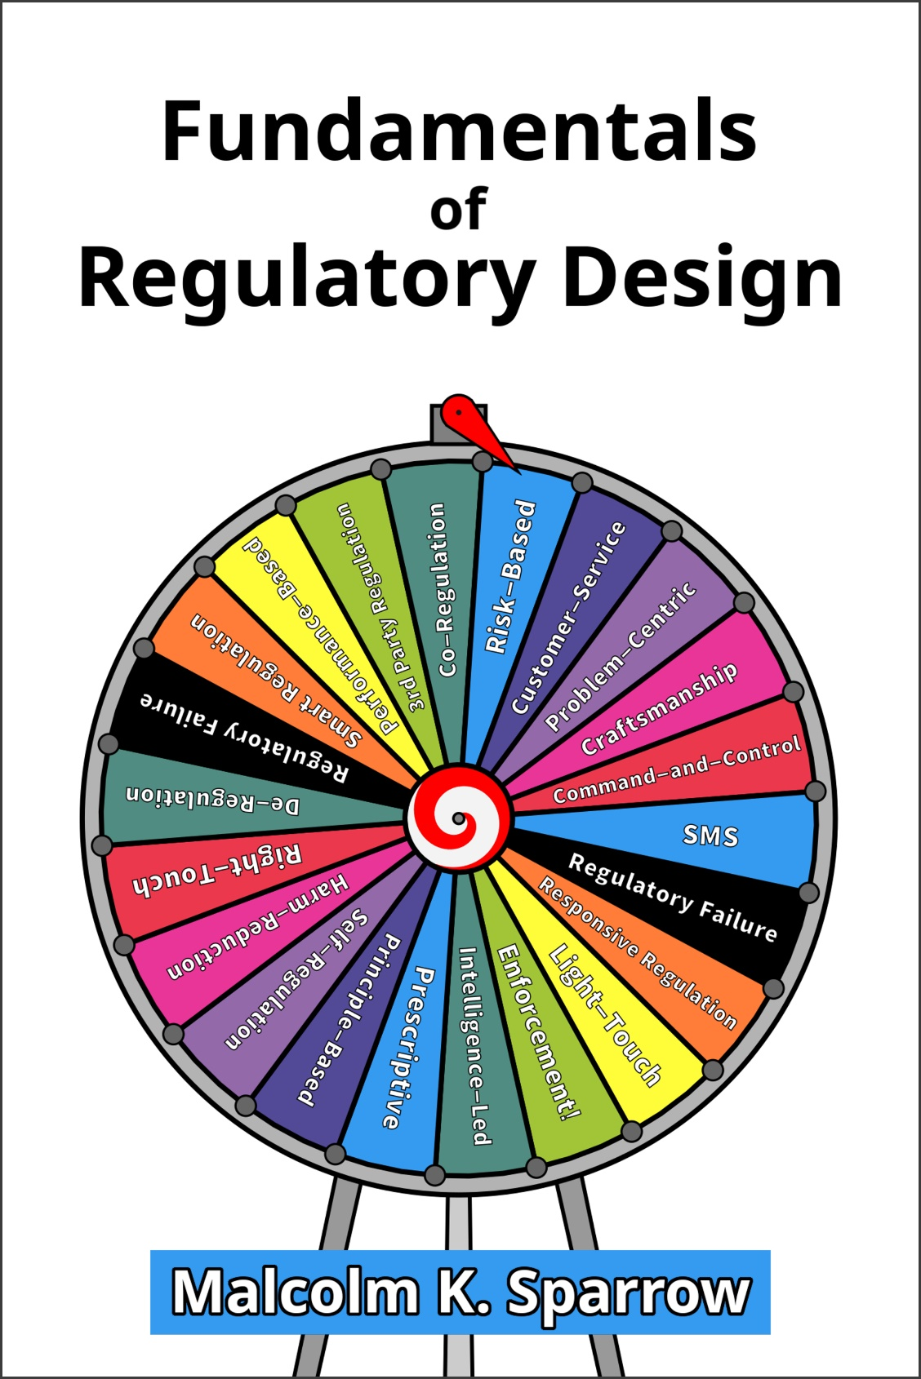

Diagnostic Exercises
Chapter 1: Setting the Mission
Diagnostic Exercise

- Is your agency already operating in the “Expert” model? If so, can you identify specific issues/threats/harms you have tackled that sit in the Expert territory?

- If the agency is operating in the Expert Model, does everyone within the agency understand the implications of that choice? (e.g. for data-gathering, analysis, range of tools, performance-reporting etc.)

- Do external stakeholders understand and accept the implications? When and where do tensions arise, given that some of the stakeholders might not?

Chapter 2: Promoting Goods or Controlling “Bads”?

Diagnostic Exercise

- In your agency, what would you say is the current balance (in terms of the proportions of overall operational effort) between activities that promote “goods”, and activities that seek to identify and control specific “bads”?

- Do you think the current balance is about right, or do you have some reason to believe it needs to be adjusted one way or the other?

Chapter 3: The Emergence of Regulatory Craftsmanship

Diagnostic Exercise

- Who within your agency is expected to exercise regulatory craftsmanship? (i.e. to fashion and implement tailored solutions to specific problems)

- Are they properly authorized, and do they have the necessary authority, to carry out that role?

- Are they suitably trained for that role?

- Are they adequately supported by others in the organization as they carry out that role? Are there particular groups that currently do not support them, but should?

Chapter 4: Program-Centric & Problem-Centric Work

Diagnostic Exercise

- Is problem-centric work within your agency formally managed? Or is it done only occasionally and in an ad-hoc manner?

- How much problem-centric work would you estimate your agency currently does, as a proportion of overall operational effort?

- How much problem-centric work (roughly speaking) do you think it should do, or could usefully do?

- What, if anything, stands in the way of your agency developing a mature problem-centric capacity?

Chapter 5: Alternative Regulatory Structures

Diagnostic Exercise

- Which models does you agency currently operate?

- Are you satisfied that the selection of models you use aligns well with the range of risks you are responsible for controlling?

- Are there specific risks that you think might not be adequately controlled given the selection of models your agency currently operates?

