Appendix Table 1: Match Rate
 | Total |  |  | Distrito Federal |  |  | Estado de Mexico
 | (1) | (2) |  | (3) | (4) |  | (5) | (6)
Panel A: Census Block Match Rate
Total Census Blocks | 481 |  |  | 242 |  |  | 239
Matched to Location | 389 | 80.9% |  | 199 | 82.2% |  | 190 | 79.5%
Within 8 km of a Station | 265 | 55.1% |  | 190 | 78.5% |  | 75 | 31.4%
Panel B: Observations in Labor Supply Dataset Matched to Location
Number of Observations | 385586 |  |  | 234813 |  |  | 150773
Number in Labor Force | 209303 | 54.3% |  | 129839 | 55.3% |  | 79464 | 52.7%
Within 8 km of a Station | 143311 | 37.2% |  | 105545 | 44.9% |  | 37766 | 25.0%
Notes: Census blocks matched to a location were defined as those that were matched to accurate centroid coordinates.

Appendix Table 2: Comparing Included and Excluded Census Blocks
 | Unemployment | Hours Worked | Unemployment | Hours Worked
 | (1) | (2) | (3) | (4)
Matched to Location | -0.0000 | -0.6072
 | (0.0020) | (0.5367)
Matched and Within 8 km of a Station |  |  | 0.0039* | -1.2213***
 |  |  | (0.0022) | (0.2775)
Year FE | X | X | X | X
Observations | 1,946 | 1,946 | 1,946 | 1,946
Notes: This table compares the unemployment rate and the mean hours worked for included and excluded census blocks. An observation is a census block-year. In columns 1 and 3, the variable of interest is an indicator for whether the census block was matched to GIS data. In columns 2 and 4, the variable of interest is an indicator for whether the census block was both matched to the GIS data and was within 8 kilometers of a station. All regressions are estimated using OLS and include year fixed effects. Standard errors (provided in parentheses) are clustered at the municipality. Statistical significance is denoted by *** for p<0.01, ** for p<0.05, and * for p<0.10.

Appendix Table 3: Alternative First Stage Specifications
 | Log(SO₂) | SO₂ | SO₂ | SO₂ | SO₂
 | (1) | (2) | (3) | (4) | (5)
Post x Distance | 0.0096** | 0.0342 | 0.2534*** | 0.4048*
 | (0.0045) | (0.0265) | (0.0700) | (0.2040)
Post x Distance² |  |  | -0.0091*** | -0.0240
 |  |  | (0.0030) | (0.0194)
Post x Distance³ |  |  |  | 0.0004
 |  |  |  | (0.0005)
 |  |  |  |  | 0.2379***
Slope below 8 km cutoff |  |  |  |  | (0.0712)  -0.0190
Slope above 9 km cutoff |  |  |  |  | (0.0327)
Observations | 143,311 | 143,311 | 143,311 | 143,311 | 143,311
F-test | 4.574 | 1.672 | 7.328 | 6.231 | 17.02
p-value | 0.0433 | 0.209 | 0.00345 | 0.00296 | 2.76e-05
Notes: In this table, we provide the coefficient estimates from alternative specifications of the first stage regression. In column 1, we explore a log-level model. In Column 2, we explore a simple linear model, while we provide the estimates from a quadratic model in column 3. In column 4, we provide the estimates of the cubic model. Column 5 shows the estimates using a spline with a break at 8 km. We provide the F-tests of the instruments and corresponding p-values to provide an indication of goodness of fit of the respective models. Standard errors (provided in parentheses) are clustered by municipality. Statistical significance is denoted by *** for p<0.01, ** for p<0.05, and * for p<0.10.

Appendix Table 4: Employment in Oil Industry, by Quarter
Year | Quarter | Number in Labor Force | Percent Employed | Percent Employed in Oil Industry
 |  | (1) | (2) | (3)
1989 | 1 | 6774 | 94.86% | 0.48%
1989 | 2 | 6783 | 95.18% | 0.31%
1989 | 3 | 7001 | 94.96% | 0.42%
1989 | 4 | 6982 | 95.75% | 0.36%
1990 | 1 | 6897 | 96.10% | 0.36%
1990 | 2 | 6600 | 95.42% | 0.25%
1990 | 3 | 6625 | 95.62% | 0.30%
1990 | 4 | 7053 | 96.37% | 0.29%
1991 | 1 | 6723 | 96.70% | 0.29%
1991 | 2 | 7276 | 96.95% | 0.10%
1991 | 3 | 7516 | 96.00% | 0.06%
1991 | 4 | 7447 | 96.17% | 0.10%
1992 | 1 | 7491 | 95.96% | 0.06%
1992 | 2 | 7470 | 95.96% | 0.04%
1992 | 3 | 7454 | 96.18% | 0.04%
1992 | 4 | 7140 | 96.13% | 0.00%
1993 | 1 | 7436 | 94.76% | 0.03%
1993 | 2 | 7563 | 95.74% | 0.04%
1993 | 3 | 7663 | 95.03% | 0.01%
1993 | 4 | 7417 | 95.81% | 0.04%
Notes: This table provides the employment rates at the quarter level from 1989-1993 for the labor force as a whole as well as the oil industry specifically. Employment in the oil industry is defined as all workers whose job coding corresponds to the oil industry, except for extraction. The dotted line signifies the refinery closure.

Appendix Table 5: Effect on Wages (LS)
 | Log(Wage)
 | (1) | (2)
Post * Close | 0.0389
 | (0.0295)
Post * Distance |  | 0.0003
 |  | (0.0056)
Post * Distance Squared |  | -0.0001
 |  | (0.0002)
Week FE | X | X
Census Block FE | X | X
Census Block Year Trends | X | X
Notes: This table presents the coefficient estimates of the reduced-form estimate of the effect of the refinery closure on the log of weekly wages for salaried workers. All regressions have 81,246 observations. Standard errors (provided in parentheses) are clustered by municipality. Statistical significance is denoted by *** for p<0.01, ** for p<0.05, and * for p<0.10.

Appendix Table 6: Minimum and Maximum
Wind Direction in the Course of a Year
Distance in 5 km Bins | Distance | Min Wind | Max Wind
1 | 4.76 | 27.00319 | 68.44519
1 | 5.03 | 126.0968 | 158.1368
1 | 1.79 | 101.9904 | 130.2722
1 | 6.00 | 19.11826 | 33.95612
1 | 4.01 | 34.48251 | 67.16835
1 | 2.38 | 64.91675 | 76.81982
1 | 5.95 | 0.090942 | 26.83394
1 | 1.45 | 22.10873 | 46.06363
1 | 4.58 | 55.30859 | 86.61421
1 | 4.22 | 53.62774 | 80.07849
1 | 3.22 | 127.8788 | 156.5053
1 | 5.33 | 103.941 | 132.311
1 | 4.89 | 118.2229 | 149.8156
1 | 4.63 | 40.10227 | 76.30561
1 | 5.57 | 10.03629 | 37.19345
1 | 4.37 | 44.17017 | 72.20801
1 | 4.67 | 16.37837 | 55.92877
1 | 4.84 | 6.859329 | 37.30049
1 | 4.24 | 37.06291 | 61.34953
1 | 3.96 | 29.06635 | 43.66765
1 | 3.92 | 113.3856 | 136.895
1 | 5.78 | 25.64207 | 61.54767
1 | 3.02 | 12.3726 | 39.40446
1 | 1.86 | 57.06774 | 87.27477
1 | 4.06 | 87.36926 | 110.0011
1 | 5.77 | 9.397461 | 47.40967
1 | 2.68 | 4.543243 | 36.08928
1 | 5.95 | 50.73966 | 79.44747
1 | 3.35 | 119.2215 | 138.177
1 | 3.13 | 121.2095 | 150.1885
1 | 1.45 | 67.26413 | 94.1951
1 | 2.40 | 72.27094 | 99.66461
1 | 5.20 | 130.5468 | 144.3615
1 | 1.31 | 66.88343 | 91.29361
1 | 2.37 | 34.5647 | 54.28581
1 | 5.56 | 62.23267 | 97.15033
1 | 2.85 | 1.213806 | 13.4584
2 | 9.14 | 101.3173 | 131.341
2 | 10.28 | 116.7235 | 154.0071
2 | 6.70 | 102.8452 | 112.3393
2 | 7.34 | 24.91928 | 65.02319
2 | 10.05 | 8.604935 | 51.42659
2 | 7.40 | 129.4792 | 173.7108
2 | 6.66 | 58.65431 | 92.13747
2 | 9.98 | 121.4321 | 174.5613
2 | 10.33 | 33.03592 | 70.32521
2 | 6.30 | 48.27472 | 86.01942
2 | 10.50 | 16.13295 | 55.84145
2 | 10.39 | 20.73184 | 69.35605
2 | 9.72 | 0.642532 | 35.0863
2 | 7.58 | 0.43335 | 25.26886
2 | 7.03 | 47.3988 | 82.33749
2 | 9.58 | 1.190491 | 40.40883
2 | 9.93 | 0.295349 | 42.51295
2 | 10.18 | 15.30702 | 51.43469
2 | 9.01 | 16.12709 | 51.30438
2 | 8.18 | 17.60536 | 48.97726
2 | 10.77 | 5.065796 | 44.92792
2 | 7.80 | 40.38972 | 70.64626
2 | 9.85 | 34.29144 | 65.05657
2 | 7.51 | 120.9216 | 130.4139
2 | 9.65 | 159.5581 | 169.3783
2 | 9.85 | 8.156906 | 43.32434
2 | 8.58 | 149.0257 | 179.7213
2 | 8.21 | 104.774 | 139.4393
2 | 10.55 | 87.75098 | 129.8125
2 | 8.75 | 5.759689 | 48.32887
2 | 9.99 | 24.44342 | 61.47647
2 | 8.64 | 143.8382 | 173.4151
2 | 6.86 | 34.20256 | 73.72606
2 | 8.99 | 22.49775 | 65.95412
2 | 7.98 | 125.4982 | 166.3381
2 | 8.69 | 111.0439 | 136.6152
2 | 7.68 | 10.99602 | 49.97905
2 | 8.66 | 19.40083 | 59.11778
2 | 7.66 | 115.5522 | 142.7528
2 | 8.21 | 24.84824 | 65.40485
2 | 9.00 | 121.5497 | 134.7753
2 | 6.52 | 37.42886 | 72.72988
2 | 8.10 | 14.28458 | 61.07216
2 | 7.34 | 70.76831 | 98.17072
2 | 6.70 | 3.01593 | 38.9025
2 | 7.78 | 114.2688 | 136.56
2 | 6.47 | 65.461 | 90.88635
2 | 9.20 | 16.97687 | 53.6301
2 | 10.43 | 127.4922 | 179.8861
2 | 6.50 | 137.7506 | 157.7509
2 | 8.47 | 28.89476 | 69.40372
2 | 9.15 | 16.73431 | 61.14574
2 | 7.08 | 0.133575 | 20.24536
2 | 7.59 | 21.75282 | 61.97696
2 | 9.51 | 4.104782 | 49.73981
2 | 8.35 | 8.826221 | 47.08876
2 | 9.14 | 102.228 | 133.9648
2 | 10.19 | 67.54114 | 109.4977
2 | 9.35 | 134.0301 | 176.2994
2 | 7.82 | 21.93172 | 62.94836
2 | 8.09 | 22.87554 | 63.76777
2 | 8.93 | 108.3722 | 143.2088
2 | 7.37 | 18.88446 | 55.30556
2 | 6.88 | 19.30028 | 58.33676
2 | 6.19 | 66.06879 | 100.2719
2 | 7.92 | 0.497894 | 26.76074
2 | 6.89 | 13.82452 | 52.35878
2 | 9.81 | 10.42194 | 50.43251
2 | 6.75 | 7.080948 | 33.49596
2 | 7.24 | 12.60811 | 55.70084
2 | 7.35 | 150.5629 | 177.7151
2 | 9.73 | 31.21104 | 68.42159
3 | 14.62 | 138.5785 | 178.2664
3 | 12.42 | 18.04845 | 57.73393
3 | 12.77 | 24.36398 | 53.80863
3 | 15.06 | 14.01917 | 65.44055
3 | 10.84 | 71.35077 | 111.2021
3 | 11.43 | 108.2652 | 165.8953
3 | 14.80 | 99.1795 | 136.3819
3 | 11.29 | 59.40735 | 103.6219
3 | 11.48 | 117.0094 | 166.6568
3 | 12.26 | 15.37234 | 59.90871
3 | 15.02 | 143.537 | 179.3279
3 | 14.41 | 134.988 | 177.6895
3 | 15.51 | 24.24178 | 49.39795
3 | 11.78 | 14.75046 | 51.06425
3 | 13.81 | 129.6204 | 172.6013
3 | 12.21 | 54.58759 | 92.02679
3 | 12.21 | 96.14087 | 120.7192
3 | 12.69 | 92.14609 | 131.2346
3 | 14.38 | 24.06278 | 63.00646
3 | 11.65 | 89.30615 | 124.9192
3 | 15.50 | 19.66313 | 67.10944
3 | 14.84 | 1.802536 | 20.4792
3 | 12.35 | 26.3111 | 50.94204
3 | 12.99 | 12.31636 | 60.97061
3 | 12.92 | 102.9113 | 139.2025
3 | 13.39 | 44.58165 | 72.43736
3 | 13.67 | 41.05109 | 62.26296
3 | 14.74 | 25.02084 | 67.71761
3 | 14.90 | 2.419296 | 22.77159
3 | 12.89 | 95.21518 | 128.3895
3 | 12.89 | 8.005859 | 44.58384
3 | 11.28 | 21.91016 | 72.8127
3 | 12.96 | 29.07764 | 63.08427
3 | 12.28 | 9.380226 | 39.55462
3 | 13.46 | 17.07948 | 36.48351
3 | 12.99 | 107.3645 | 140.3413
3 | 14.12 | 10.12373 | 48.61853
3 | 11.74 | 100.2422 | 133.0899
3 | 12.33 | 109.2329 | 137.946
3 | 15.52 | 19.47889 | 41.45437
3 | 15.38 | 9.069641 | 60.5045
3 | 11.64 | 134.4142 | 179.3295
3 | 11.28 | 43.01556 | 64.11872
3 | 15.34 | 109.2676 | 140.8449
3 | 11.69 | 20.02278 | 71.91008
3 | 14.67 | 12.8938 | 43.02499
3 | 11.71 | 22.3089 | 66.90047
3 | 13.37 | 5.902512 | 32.04872
3 | 15.32 | 17.30061 | 54.34242
3 | 11.71 | 9.075439 | 49.63306
3 | 13.56 | 2.116791 | 27.70299
3 | 14.69 | 11.42395 | 39.37145
3 | 14.11 | 9.954544 | 31.37833
3 | 11.11 | 18.84762 | 48.97115
3 | 11.75 | 30.04182 | 66.77144
3 | 13.77 | 92.62646 | 131.7444
3 | 13.81 | 23.78323 | 53.72284
3 | 12.59 | 85.83231 | 126.0646
3 | 14.73 | 146.7063 | 175.219
3 | 14.51 | 0.559967 | 26.40559
3 | 13.00 | 98.02795 | 130.4661
3 | 12.63 | 52.23712 | 90.30585
3 | 13.26 | 33.17394 | 62.52148
3 | 10.80 | 23.20567 | 62.91564
4 | 18.11 | 147.1785 | 179.8685
4 | 19.97 | 13.3679 | 41.48423
4 | 18.32 | 6.436462 | 30.11649
4 | 18.99 | 9.021851 | 42.4312
4 | 16.98 | 0.803101 | 22.2123
4 | 15.84 | 8.511427 | 37.98344
4 | 18.46 | 146.2913 | 179.3141
4 | 17.46 | 87.54083 | 103.7113
4 | 15.57 | 13.55498 | 42.21606
4 | 17.81 | 21.17463 | 34.35596
4 | 16.01 | 0.689331 | 26.74372
4 | 19.80 | 151.3358 | 177.7533
4 | 16.59 | 91.48523 | 138.2782
4 | 18.88 | 12.99847 | 42.37759
4 | 19.21 | 0.827148 | 20.56027
4 | 16.78 | 12.97121 | 39.94033
4 | 18.13 | 67.08374 | 120.9787
4 | 16.10 | 106.7142 | 143.8646
4 | 19.06 | 96.05832 | 125.8533
4 | 19.61 | 0.330048 | 40.18187
4 | 19.88 | 81.0683 | 118.6376
4 | 17.29 | 9.100815 | 46.83318
4 | 16.47 | 99.11029 | 138.384
4 | 17.53 | 1.001709 | 26.25833
4 | 18.59 | 0.002213 | 23.00363
4 | 19.44 | 10.09058 | 44.85889
4 | 16.78 | 0.496048 | 29.51364
4 | 18.94 | 2.20369 | 36.972
4 | 16.91 | 23.56114 | 51.21974
4 | 19.62 | 16.01519 | 36.89516
4 | 19.17 | 10.23234 | 46.93883
4 | 18.32 | 88.34897 | 120.3938
4 | 18.84 | 15.69925 | 41.85474
4 | 17.61 | 139.2233 | 179.4895
4 | 19.81 | 0.778793 | 43.60661
4 | 18.65 | 12.70148 | 26.30096
4 | 17.25 | 6.809204 | 34.84387
4 | 17.69 | 12.6277 | 45.77069
4 | 17.25 | 72.96249 | 127.3056
4 | 18.45 | 1.758087 | 27.01471
4 | 17.75 | 78.82901 | 115.0769
4 | 20.01 | 23.78065 | 36.87089
4 | 19.21 | 6.658066 | 38.01259
4 | 15.85 | 14.69241 | 48.87401
4 | 19.14 | 8.696777 | 34.87357
4 | 16.02 | 21.38066 | 63.03801
5 | 25.00 | 0.635391 | 29.65298
5 | 22.31 | 0.273285 | 55.61954
5 | 23.96 | 0.62175 | 31.49432
5 | 20.37 | 9.558357 | 52.60205
5 | 24.41 | 20.81632 | 43.81774
5 | 20.90 | 1.804428 | 44.84812
5 | 21.93 | 26.72457 | 42.57465
5 | 21.55 | 52.78534 | 109.248
5 | 21.23 | 53.89471 | 110.8521
5 | 22.58 | 0.982056 | 35.49049
5 | 20.69 | 18.09578 | 37.50279
5 | 20.79 | 1.957458 | 30.97505
5 | 21.37 | 156.1345 | 177.9491
5 | 22.21 | 13.39836 | 51.62242
5 | 20.92 | 9.10788 | 47.45065
5 | 20.82 | 2.884491 | 40.86307
5 | 20.28 | 79.27454 | 91.09796
5 | 21.05 | 60.05981 | 99.26495
5 | 22.58 | 10.38334 | 50.23516
5 | 24.00 | 25.0789 | 38.00103
5 | 22.56 | 139.0598 | 179.0577

 | Appendix Table 7: First Stage Effect on SO₂, Varying the Close Indicator (OLS)
 | (1) | (2) | (3) | (4) | (5) | (6) | (7) | (8)
 | 3 km | 4 km | 5 km | 6 km | 7 km | 8 km | 9 km | 10 km
Post x Close | -0.9469*** | -0.9580*** | -0.9903*** | -0.8339*** | -0.8005** | -0.6688* | -0.3944 | -0.3186
 | (0.1758) | (0.1706) | (0.2061) | (0.2109) | (0.3275) | (0.3302) | (0.3007) | (0.2833)
Observations | 143,311 | 143,311 | 143,311 | 143,311 | 143,311 | 143,311 | 143,311 | 143,311
Notes: This table explores different cutoffs for the definition of “close” for the first stage estimation. We specify indicator variables with a cutoff of 3 to 10 kilometers. We control for census block fixed effects, week fixed effects, and linear census block time trends. Standard errors (provided in parenthesis) are clustered by municipality. Statistical significance is denoted by *** for p<0.01, ** for p<0.05, and * for p<0.10.

Appendix Table 8: Effect of the Closure on Sulfur Dioxide (SO₂), with Demographic Controls
 | (1) | (2)
Post x Distance |  | 0.2534***
 |  | (0.0700)
Post x Distance² |  | -0.0091***
 |  | (0.0030)
Post x Close | -0.9903***
 | (0.2061)
Observations | 143,311 | 143,311
F-test | 23.08 | 7.33
p-value | 0.000 | 0.003
Notes: This table provides OLS estimates of the effect of the closure on sulfur dioxide. In column 1, we provide the coefficient estimate of the interaction between the post closure indicator (Post) and indicator variable for less than five km of distance between the census block and the refinery (Close). In column 2, we provide the estimates on the interaction between Post and a quadratic in distance. We control for census block fixed effects, week fixed effects, linear census block time trends, and demographic controls. Standard errors (provided in parentheses) are clustered by municipality. Statistical significance is denoted by *** for p<0.01, ** for p<0.05, and * for p<0.10.

Appendix Table 9: Effect of Closure on Hours Worked, with Demographic Controls
 | (1) | (2)
Panel A: Reduced Form
Post x Distance |  | -0.3152**
 |  | (0.1295)
Post x Distance² |  | 0.0104*
 |  | (0.0056)
Post x Close | 1.5654***
 | (0.4520)
F-stat | 12.00 | 6.730
p-value | 0.00211 | 0.00500
Panel B: Instrumental Variables
SO₂ | -1.5798*** | -1.3663**
 | (0.5601) | (0.5837)
Instruments | Post x Close | Post x Distance, Post x Distance2
Observations | 143,311 | 143,311
First Stage F | 23.14 | 7.339
p-value | 7.46e-05 | 0.00343
Notes: This table provides the reduced form estimates (Panel A) of the refinery closure on a continuous measure of hours worked (including “0” for the unemployed), as well as the instrumental variables estimates of the effect of sulfur dioxide hours worked (Panel B). In column 1, the instrument is an interaction of the Post dummy with an indicator variable for census blocks within five km of the refinery. In column 2, the instruments are Post interacted with a quadratic in distance. See Table 1 notes for the corresponding first stage estimates and included control variables. Standard errors (provided in parentheses) are clustered by municipality. Statistical significance is denoted by: *** for p<0.01, ** for p<0.05, and * for p<0.10.

Appendix Table 10: Heterogeneous Treatment Effects (Reduced Form Results)
 | Education |  |  | Gender |  |  | Children under age 11 |  |  | Age
 | Secondary + | Primary - |  | Male | Female |  | No Kids | Kids |  | Age < 40 | Age > 40
 | (1) | (2) |  | (3) | (4) |  | (5) | (6) |  | (7) | (8)
Post x Close | 1.2174* | 1.9582* |  | 2.1480*** | 0.5102 |  | 0.8616 | 1.8236*** |  | 1.7241** | 0.5701
 | (0.6704) | (1.0391) |  | (0.4170) | (0.9329) |  | (0.7268) | (0.5490) |  | (0.8195) | (1.3772)
N | 93,836 | 49,475 |  | 91,138 | 52,173 |  | 62,466 | 57,063 |  | 98,524 | 44,787
Note: This table explores several key dimensions of heterogeneity. Standard errors (listed below each estimate in parenthesis) are clustered by municipality. Statistical significance is denoted by: *** p<0.01, ** p<0.05, * p<0.10.

Appendix Table 11A: Sensitivity of IV Results to Maximum Distance from Census Block to Air Pollution Station
 | (1) | (2)
Panel A: 5 Kilometer Restriction
SO₂ | -0.9265** | -0.6612*
 | (0.3647) | (0.3655)
Observations | 109,501 | 109,501
First Stage F | 33.36 | 22.21
p-value | 9.84e-06 | 6.58e-06
Panel B: 10 Kilometer Restriction
SO₂ | -0.6343 | -1.1693***
 | (0.4814) | (0.3553)
Observations | 155,385 | 155,385
First Stage F | 33.61 | 14.10
p-value | 6.60e-06 | 0.000101
Instruments | Post x Close | Post x Distance, Post x Distance2
Notes: This table replicates the IV estimates in Table 4, but imposes the restriction of 5 kilometers (Panel A) and 10 kilometers (Panel B) from the air pollution stations to the census blocks. In column 1, the instrument is an interaction of the Post dummy with an indicator variable for census blocks within five km of the refinery. In column 2, the instruments are Post interacted with a quadratic in distance. Standard errors (provided in parentheses) are clustered by municipality. Statistical significance is denoted by: *** for p<0.01, ** for p<0.05, and * for p<0.10.

Appendix Table 11B: Sensitivity of Results to Maximum Distance from Census Block to Air Pollution Station—10 kilometers
 | (1) | (2)
Panel A: Reduced Form
Post x Distance |  | -0.1723**
 |  | (0.0830)
Post x Distance² |  | 0.0040
 |  | (0.0036)
Post x Close | 0.4576
 | (0.3993)
F-stat | 1.313 | 9.416
p-value | 0.264 | 0.00103
Panel B: Instrumental Variables
SO₂ | -0.6343 | -1.1693***
 | (0.4814) | (0.3553)
Instruments | Post x Close | Post x Distance, Post x Distance2
Observations | 155,385 | 155,385
First Stage F | 33.61 | 14.10
p-value | 6.60e-06 | 0.000101
Notes: This table replicates Table 4, but imposes the restriction of 5 kilometers from the air pollution stations to the census blocks. We provide the reduced form estimates (Panel A) of the refinery closure on a continuous measure of hours worked (including “0” for the unemployed), as well as the instrumental variables estimates of the effect of sulfur dioxide hours worked (Panel B). In column 1, the instrument is an interaction of the Post dummy with an indicator variable for census blocks within five km of the refinery. In column 2, the instruments are Post interacted with a quadratic in distance. Standard errors (provided in parentheses) are clustered by municipality. Statistical significance is denoted by: *** for p<0.01, ** for p<0.05, and * for p<0.10.

Appendix Table 12: Effect of Closure on Hours Worked, Concurrent Pollution
 | (1) | (2)
SO₂ | -1.6072** | -1.1487*
 | (0.7563) | (0.6164)
Instruments | Post x Close | Post x Distance, Post x Distance2
Observations | 143,311 | 143,311
First Stage F | 693.0 | 510.4
p-value | 0.000 | 0.000
Notes: In this table, we replicate the IV analysis in Table 4, but we do not lag pollution values. Standard errors (provided in parenthesis) are clustered by municipality. Statistical significance is denoted by *** for p<0.01, ** for p<0.05, and * for p<0.10.

Appendix Table 13A: Alternative Specifications of Standard Errors
 | Reduced Form with No Trends and Standard Errors Clustered at Census Block (OLS) |  | Reduced Form with No Trends with Conley Standard Errors (OLS)
 | (1) | (2) | (3) | (4)
Post x Distance |  | -0.2635** |  | -0.2755**
 |  | (0.1099) |  | (0.1075)
Post x Distance² |  | 0.0103** |  | 0.0109**
 |  | (0.0045) |  | (0.0045)
Post x Close | 0.4889 |  | 0.4791
 | (0.4054) |  | (0.4124)
Observations | 143311 | 143311 | 143311 | 143311
F-stat | 1.454 | 2.891 | 1.349 | 3.337
p-value | 0.229 | 0.0573 | 0.245 | 0.0355
Census Block Trends | NO | NO | NO | NO
Estimation Method | OLS | OLS | OLS | OLS
Instrument

Appendix Table 13B: Donald-Lang Estimates
 | (1) | (2)
SO2 | -1.0937*** | -0.7796***
 | (0.3528) | (0.2852)
Observations | 300 | 300
First Stage F | 17.19 | 3.618
p-value | 0.000677 | 0.0491

Appendix Table 14: Effect of Closure on Hours Worked, Sample years 1990 to 1992 (dropping 1989 and 1993)
 | (1) | (2)
Panel A: Reduced Form
Post x Distance |  | -0.2907***
 |  | (0.0888)
Post x Distance² |  | 0.0100**
 |  | (0.0041)
Post x Close | 1.1439***
 | (0.2270)
Panel B: Instrumental Variables
SO₂ | -2.4158*** | -2.2804***
 | (0.8167) | (0.8575)
Instruments | Post x Close | Post x Distance, Post x Distance2
Observations | 143,311 | 143,311
First Stage F | 10.01 | 3.471
p-value | 0.00568 | 0.0545
Notes: This table replicates Table 4, but for the years 1990 to 1992 rather than 1989 to 1993. This allows us to test the effect of the closure using data even closer to the policy change. Standard errors (provided in parentheses) are clustered by municipality. Statistical significance is denoted by: *** for p<0.01, ** for p<0.05, and * for p<0.10.

Appendix Table 15A: First Stage and Reduced Form Estimates Using Triple Interactions
 | First Stage: Dependent Variable is SO₂ |  |  | Reduced Form: Dependent Variable is Hours Worked
 | (1) | (2) |  | (3) | (4)
Post*Distance*Wind Direction | 0.0021*** | 0.0013 |  | -0.0041** | -0.0107***
 | (0.0007) | (0.0015) |  | (0.0016) | (0.0033)
Post*Distance²*Wind Direction | -0.0001*** | -0.0000 |  | 0.0002*** | 0.0004***
 | (0.0000) | (0.0001) |  | (0.0001) | (0.0001)
Post*Distance*Altitude | 2.9104 | 4.3007* |  | -5.7453 | -1.4409
 | (1.6822) | (2.2905) |  | (4.1059) | (6.3357)
Post*Distance²*Altitude | -0.0893 | -0.1387* |  | 0.1379 | 0.0157
 | (0.0536) | (0.0776) |  | (0.1255) | (0.1939)
Post*Distance | -6.5065 | -9.5443* |  | 12.8593 | 3.7639
 | (3.7764) | (5.1505) |  | (9.2869) | (14.2884)
Post*Distance² | 0.0029 | -0.0012 |  | -0.0020 | -0.0228*
 | (0.0020) | (0.0044) |  | (0.0079) | (0.0111)
Post*Altitude | -22.9852* | -34.4400** |  | 52.4390 | 16.4715
 | (12.0616) | (14.6130) |  | (31.9691) | (48.2798)
Post*Wind Direction | -0.0106** | -0.0082 |  | 0.0126 | 0.0536***
 | (0.0040) | (0.0069) |  | (0.0093) | (0.0174)
Distance*Wind Direction | (0.0021) | (0.0023) |  | -0.0003* | -0.0004**
 | 0.0001* | 0.0001 |  | (0.0002) | (0.0002)
Distance²*Wind Direction | (0.0001) | (0.0001) |  | -0.0287 | -0.0496
 | 0.0176 | 0.0169 |  | (0.0328) | (0.0346)
F-statistic for triple interactions | 5.656 | 3.390 |  | 8.615 | 4.083
p-value for joint test | 0.00396 | 0.0311 |  | 0.000456 | 0.0158
Census Block Trends | No | Yes |  | No | Yes
Observations | 137,184 | 137,184 |  | 137,184 | 137,184
Notes: This table provides alternative first stage and reduced form estimates of the effect of the refinery closure on the sulfur dioxide and the continuous measure of hours worked. In all regressions, we control for Wind Direction as well as census block fixed effects and week fixed effects. In columns 2 and 4, we additionally include linear census block time trends. Standard errors (provided in parentheses) are clustered at the municipality level. Statistical significance is denoted by *** for p<0.01, ** for p<0.05, and * for p<0.10.

Appendix Table 15B: Instrumental Variables Estimates Using Triple Interactions as Instruments
 | (1) | (2)
SO₂ | -1.3288** | -0.9588
 | (0.5898) | (0.8804)
Census Block Trends | No | Yes
Observations | 137,184 | 137,184
Notes: This table provides alternative IV estimates of the effect of air pollution on hours worked using Post × Distance × Wind Direction, Post × Distance² × Wind Direction, Post × Distance × Altitude and Post × Distance² × Altitude as instruments for air pollution conditional on all double interactions and Wind Direction. In all regressions, we control for census block fixed effects and week fixed effects. In column 2 we additionally include linear census block time trends. Standard errors (provided in parentheses) are clustered at the municipality level. Statistical significance is denoted by *** for p<0.01, ** for p<0.05, and * for p<0.10.

Appendix Table 16: Alternative Triple Difference Methods
 | Instrument Type
 | Interaction of Close with Post, Wind, and Altitude |  |  | Interaction of Distance Variables with Post, Wind, and Altitude
 | (1) | (2) |  | (3) | (4)
Panel A: Sharp Angle
SO₂ | -4.0604*** | -4.4302*** |  | -1.9150** | -0.4271
 | (0.6497) | (1.6194) |  | (0.7130) | (1.4021)
F-stat | 9.130 | 5.131 |  | 2.742 | 7.895
p-value | 0.000183 | 0.0172 |  | 0.0602 | 0.0007
Panel B: Wide Angle
SO₂ | -3.6195*** | -5.6494*** |  | -0.9698 | 1.3950
 | (0.8499) | (2.2664) |  | (0.7771) | (0.8721)
F-stat | 12.63 | 9.566 |  | 6.451 | 7.055
p-value | 3.74e-08 | 0.0015 |  | 0.00210 | 0.00134
Panel C: Instrument Only Includes Wind Direction
SO₂ | -3.0788*** | -6.8581 |  | -0.9970* | -2.1074
 | (0.8175) | (6.7534) |  | (0.5801) | (1.5424)
F-stat | 6.327 | 1.380 |  | 4.874 | 2.118
p-value | 0.0216 | 0.255 |  | 0.0203 | 0.1490
Panel D: Only Closest Station Included
SO₂ | -3.2147*** | -5.7109*** |  | -1.0487* | -1.1328
 | (0.7472) | (1.7645) |  | (0.6075) | (0.7997)
F-stat | 7.283 | 4.930 |  | 5.656 | 3.390
p-value | 0.0048 | 0.0196 |  | 0.0040 | 0.0311
 | NO | YES |  | NO | YES
Notes: This table provides alternative triple difference approaches. In columns 1 and 2, the instruments are the triple interactions of Post x Close x Wind direction and Post x Close x Altitude. In columns 3 and 4, the instruments are the triple interactions of Post with the distance variables, wind, and altitude. We control for the main effects and interactions of all instruments as well as census block fixed effects and week fixed effects. In columns 2 and 4, we additionally include linear census block time trends. Standard errors (provided in parenthesis) are clustered at the municipality level. Statistical significance is denoted by *** for p<0.01, ** for p<0.05, and * for p<0.10.

Appendix Figure 1: The Difference in SO₂ Between Close and Far Areas Over Time
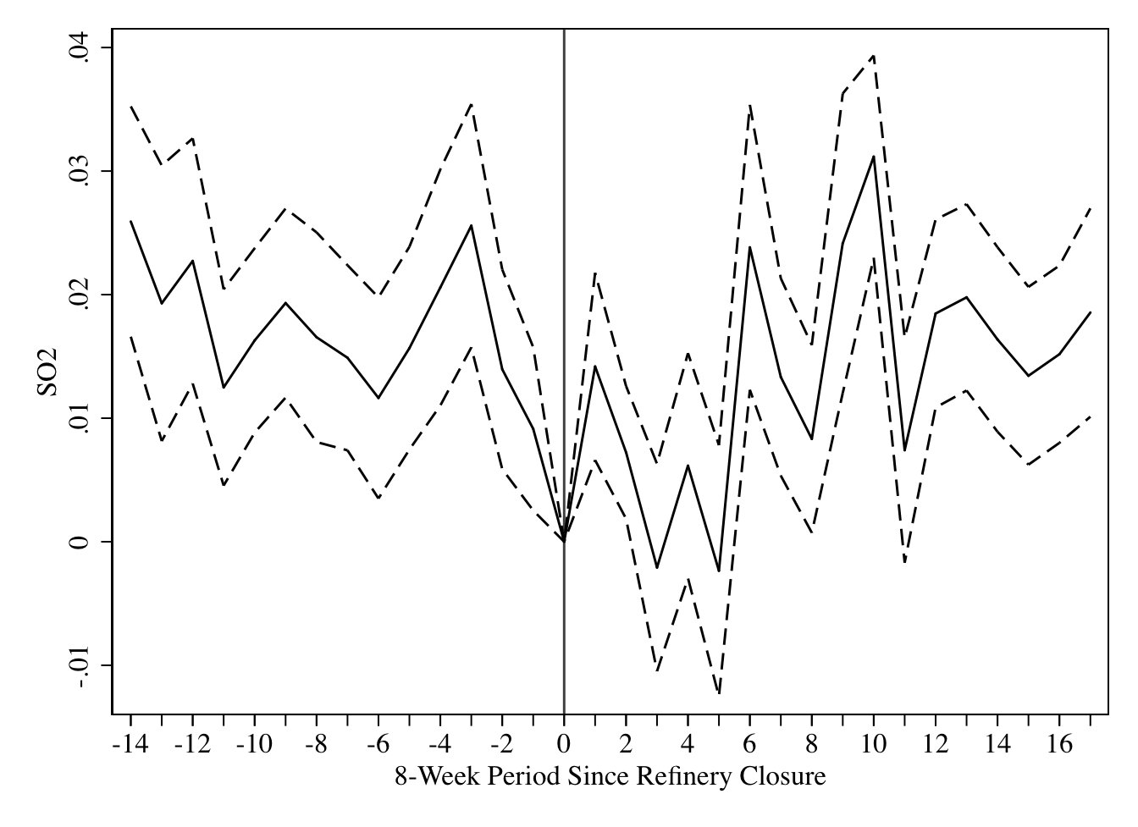
Notes: This graph plots the coefficients of leads and lags of the refinery closure where the dependent variable is sulfur dioxide. The time units are aggregated into 8-week windows to reduce the noise of the estimates. These regressions include as controls the interaction between the indicator variable for close and the moving average window, as well as week and census block fixed effects. The error bands correspond to the 95 percent confidence interval with municipality clustered standard errors.

Appendix Figure 2: The Difference in Hours Worked Between Close and Far Areas Over Time
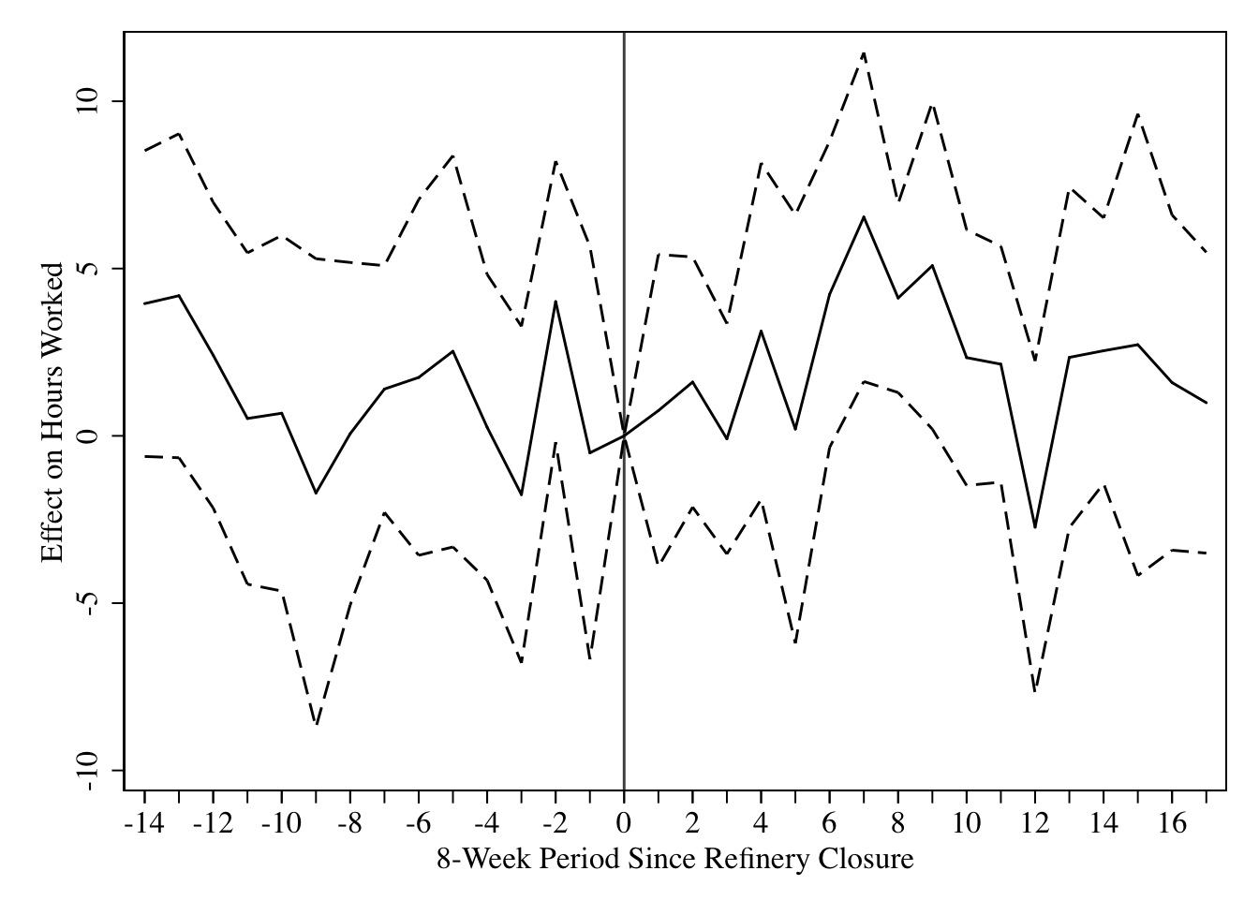
Notes: This graph plots the coefficients of leads and lags of the refinery closure where the dependent variable is hours worked. The time units are aggregated into 8-week windows to reduce the noise of the estimates. These regressions include as controls the interaction between the indicator variable for close and the moving average window, as well as week and census block fixed effects. The error bands correspond to the 95 percent confidence interval with municipality clustered standard errors.

