Introduction to Econometrics

The statistical analysis of economic (and related) data
Brief Overview of the Course

Economics suggests important relationships, often with policy implications, but virtually never suggests quantitative magnitudes of causal effects.
- What is the quantitative effect of reducing class size on student achievement?
- How does another year of education change earnings?
- What is the price elasticity of cigarettes?
- What is the effect on output growth of a 1 percentage point increase in interest rates by the Fed?
- What is the effect on housing prices of environmental improvements?
This course is about using data to measure causal effects.
- Ideally, we would like an experiment
  - what would be an experiment to estimate the effect of class size on standardized test scores?
- But almost always we only have observational (nonexperimental) data.
  - returns to education
  - cigarette prices
  - monetary policy
- Most of the course deals with difficulties arising from using observational to estimate causal effects
  - confounding effects (omitted factors)
  - simultaneous causality
  - “correlation does not imply causation”
In this course you will:

- Learn methods for estimating causal effects using observational data
- Learn some tools that can be used for other purposes, for example forecasting using time series data;
- Focus on applications – theory is used only as needed to understand the “why”s of the methods;
- Learn to evaluate the regression analysis of others – this means you will be able to read/understand empirical economics papers in other econ courses;
- Get some hands-on experience with regression analysis in your problem sets.
Review of Probability and Statistics
(SW Chapters 2, 3)

Empirical problem: Class size and educational output

- Policy question: What is the effect on test scores (or some other outcome measure) of reducing class size by one student per class? by 8 students/class?
- We must use data to find out (is there any way to answer this without data?)
The California Test Score Data Set

All K-6 and K-8 California school districts (n = 420)

Variables:
- 5P^{thP} grade test scores (Stanford-9 achievement test, combined math and reading), district average
- Student-teacher ratio (STR) = no. of students in the district divided by no. full-time equivalent teachers
Initial look at the data:
(You should already know how to interpret this table)
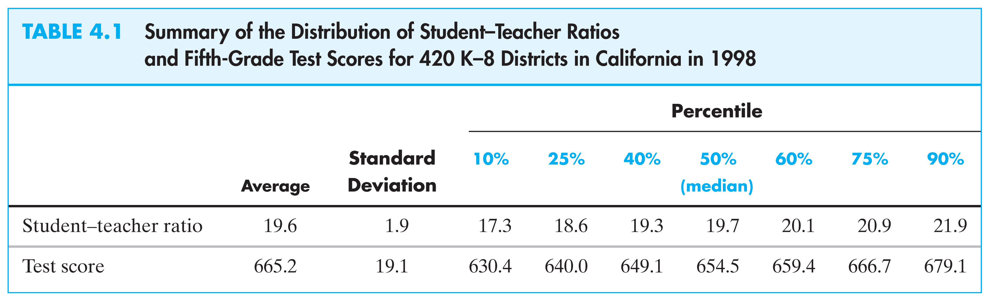
This table doesn’t tell us anything about the relationship between test scores and the STR.
Do districts with smaller classes have higher test scores?
Scatterplot of test score v. student-teacher ratio
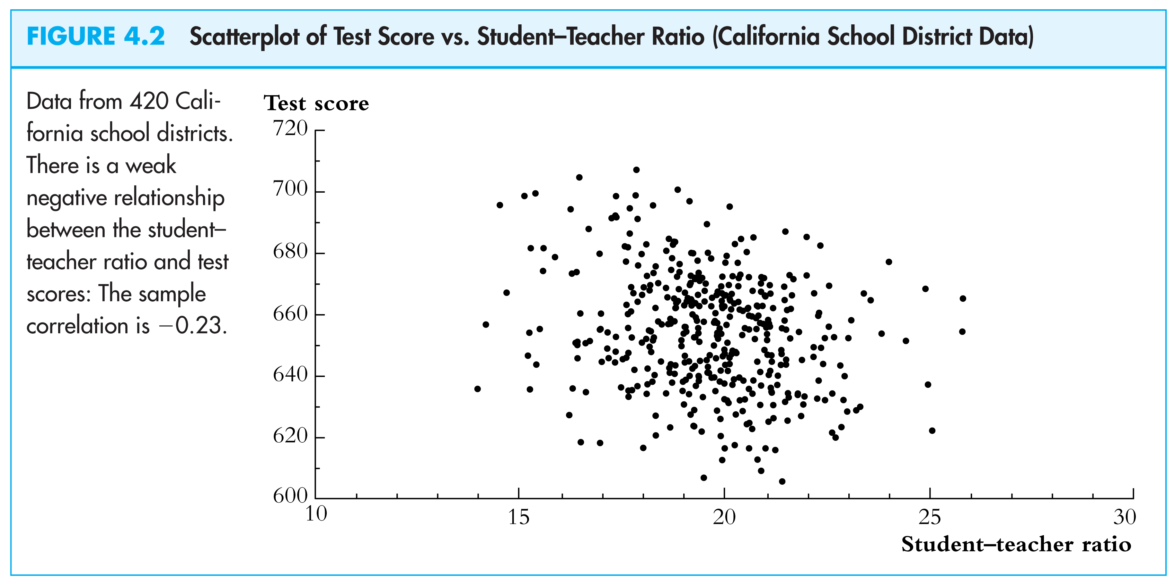
what does this figure show?
We need to get some numerical evidence on whether districts with low STRs have higher test scores – but how?

- Compare average test scores in districts with low STRs to those with high STRs (“estimation”)

- Test the “null” hypothesis that the mean test scores in the two types of districts are the same, against the “alternative” hypothesis that they differ (“hypothesis testing”)

- Estimate an interval for the difference in the mean test scores, high v. low STR districts (“confidence interval”)
Initial data analysis: Compare districts with “small” (STR < 20) and “large” (STR ≥ 20) class sizes:

Class Size | Average score (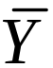) | Standard deviation (sB_{YB}) | n
Small | 657.4 | 19.4 | 238
Large | 650.0 | 17.9 | 182

- Estimation of Δ = difference between group means
- Test the hypothesis that Δ = 0
- Construct a confidence interval for Δ
1. Estimation
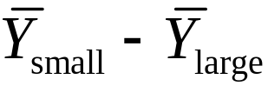 = 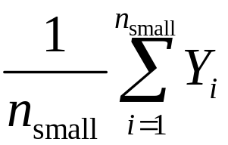 – 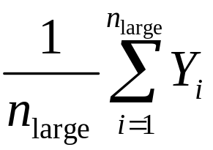
= 657.4 – 650.0
= 7.4

Is this a large difference in a real-world sense?
- Standard deviation across districts = 19.1
- Difference between 60P^{thP} and 75P^{thP} percentiles of test score distribution is 667.6 – 659.4 = 8.2
- This is a big enough difference to be important for school reform discussions, for parents, or for a school committee?
2. Hypothesis testing

Difference-in-means test: compute the t-statistic,

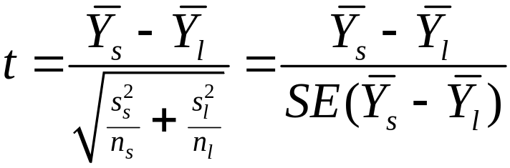 (remember this?)

where SE(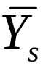 – 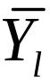) is the “standard error” of – , the subscripts s and l refer to “small” and “large” STR districts, and 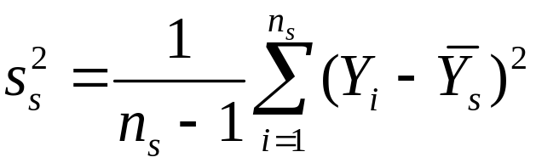 (etc.)
Compute the difference-of-means t-statistic:

Size |  | sB_{YB} | n
small | 657.4 | 19.4 | 238
large | 650.0 | 17.9 | 182

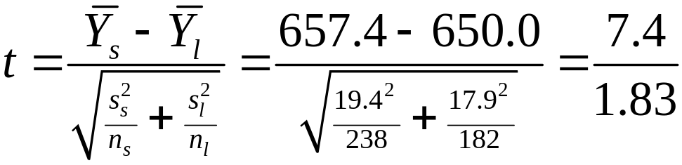 = 4.05

|t| > 1.96, so reject (at the 5% significance level) the null hypothesis that the two means are the same.
3. Confidence interval

A 95% confidence interval for the difference between the means is,

( – )  1.96SE( – )
= 7.4  1.961.83 = (3.8, 11.0)
Two equivalent statements:
- The 95% confidence interval for Δ doesn’t include 0;
- The hypothesis that Δ = 0 is rejected at the 5% level.

What comes next…

- The mechanics of estimation, hypothesis testing, and confidence intervals should be familiar
- These concepts extend directly to regression and its variants
- Before turning to regression, however, we will review some of the underlying theory of estimation, hypothesis testing, and confidence intervals:
  - why do these procedures work, and why use these rather than others?
  - So we will review the intellectual foundations of statistics and econometrics
Review of Statistical Theory

- The probability framework for statistical inference
- Estimation
- Testing
- Confidence Intervals

The probability framework for statistical inference
- Population, random variable, and distribution
- Moments of a distribution (mean, variance, standard deviation, covariance, correlation)
- Conditional distributions and conditional means
- Distribution of a sample of data drawn randomly from a population: YB_{1B},…, YB_{nB}
(a) Population, random variable, and distribution

Population
- The group or collection of all possible entities of interest (school districts)
- We will think of populations as infinitely large ( is an approximation to “very big”)

Random variable Y
- Numerical summary of a random outcome (district average test score, district STR)
Population distribution of Y

- The probabilities of different values of Y that occur in the population, for ex. Pr[Y = 650] (when Y is discrete)
- or: The probabilities of sets of these values, for ex. Pr[640  Y  660] (when Y is continuous).
(b) Moments of a population distribution: mean, variance, standard deviation, covariance, correlation

mean = expected value (expectation) of Y
= E(Y)
= μB_{YB}
= long-run average value of Y over repeated
realizations of Y
variance = E(Y – μB_{YB})P^{2P}
= 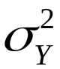
= measure of the squared spread of the
distribution
standard deviation = 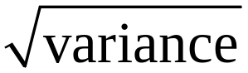 = σB_{YB}
Moments, ctd.
skewness = 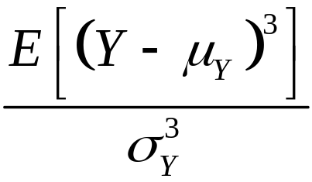
= measure of asymmetry of a distribution
- skewness = 0: distribution is symmetric
- skewness > (<) 0: distribution has long right (left) tail

kurtosis = 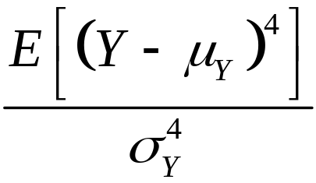
= measure of mass in tails
= measure of probability of large values
- kurtosis = 3: normal distribution
- skewness > 3: heavy tails (“leptokurtotic”)
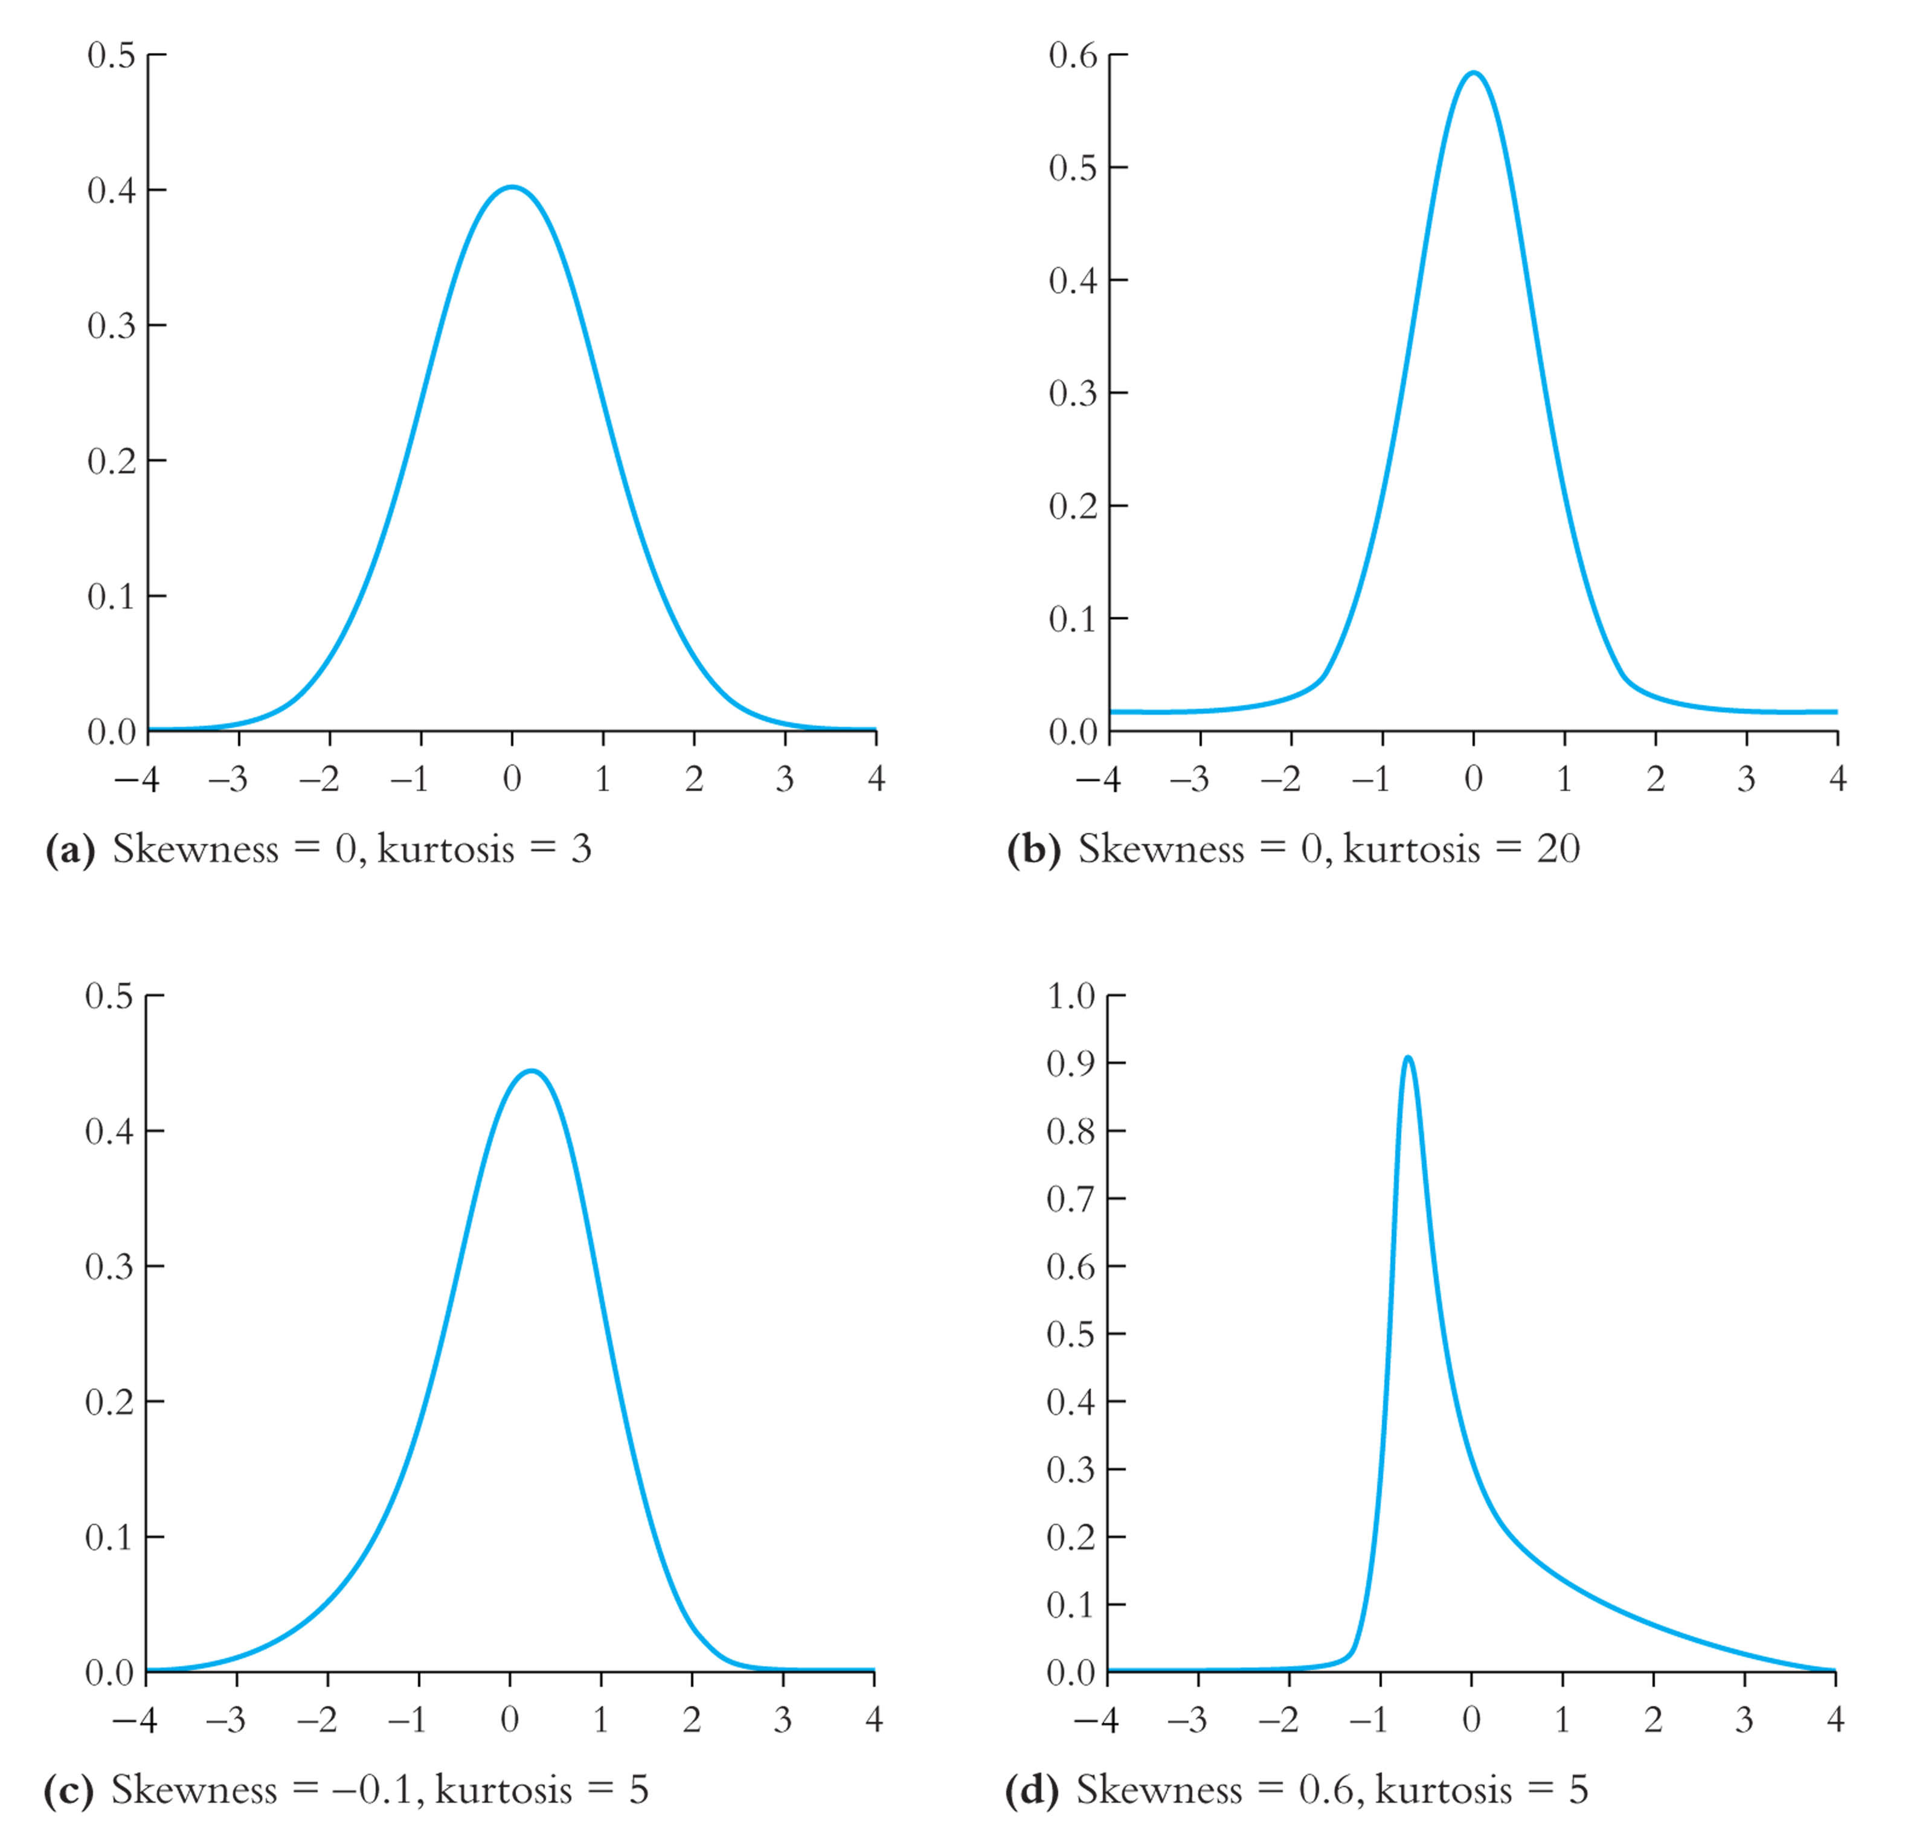
2 random variables: joint distributions and covariance

- Random variables X and Z have a joint distribution
- The covariance between X and Z is
cov(X,Z) = E[(X – μB_{XB})(Z – μB_{ZB})] = σB_{XZB}

- The covariance is a measure of the linear association between X and Z; its units are units of X  units of Z
- cov(X,Z) > 0 means a positive relation between X and Z
- If X and Z are independently distributed, then cov(X,Z) = 0 (but not vice versa!!)
- The covariance of a r.v. with itself is its variance:
cov(X,X) = E[(X – μB_{XB})(X – μB_{XB})] = E[(X – μB_{XB})P^{2P}] = 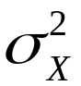
The covariance between Test Score and STR is negative:

so is the correlation…
The correlation coefficient is defined in terms of the covariance:

corr(X,Z) = 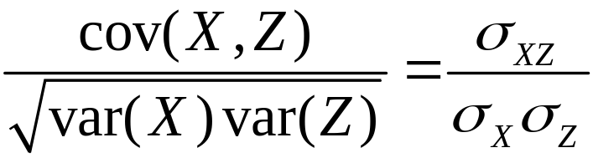 = rB_{XZB}

- –1  corr(X,Z)  1
- corr(X,Z) = 1 mean perfect positive linear association
- corr(X,Z) = –1 means perfect negative linear association
- corr(X,Z) = 0 means no linear association
The correlation coefficient measures linear association
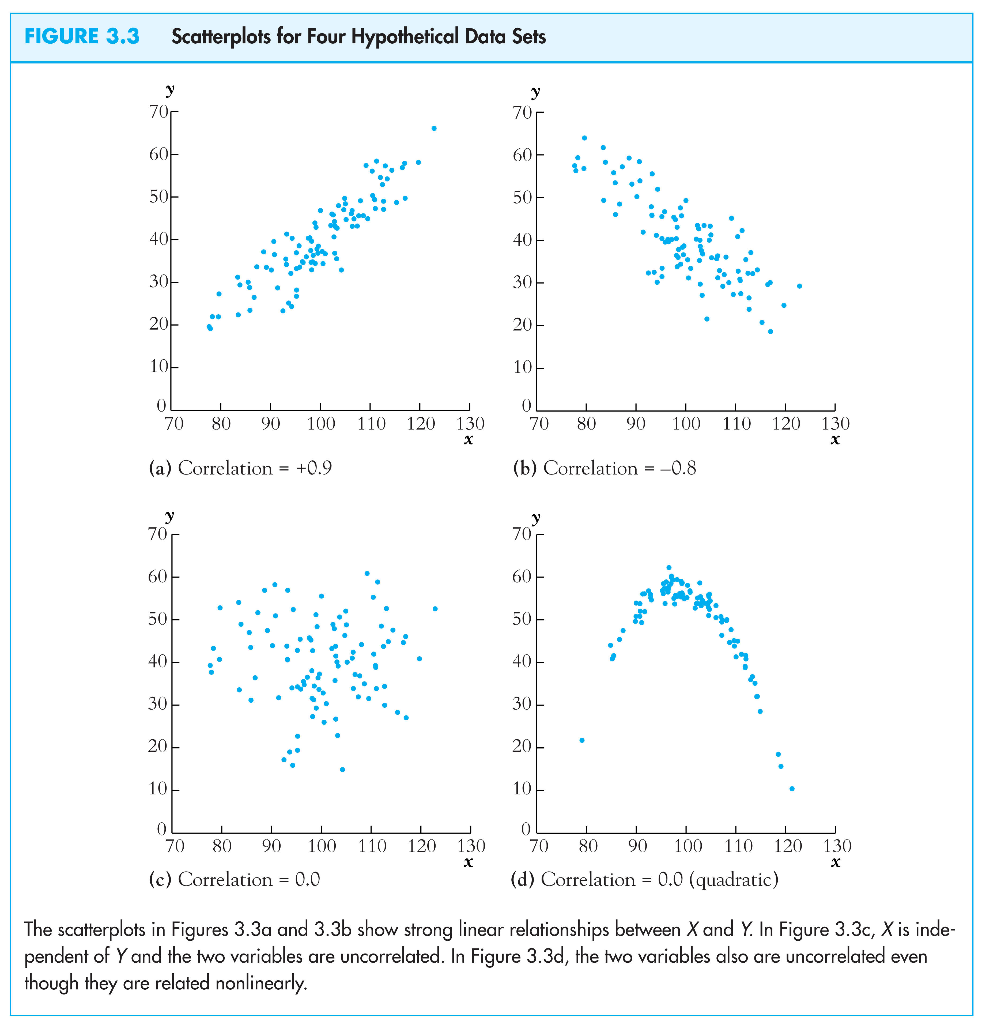
(c) Conditional distributions and conditional means

Conditional distributions
- The distribution of Y, given value(s) of some other random variable, X
- Ex: the distribution of test scores, given that STR < 20
Conditional expectations and conditional moments
- conditional mean = mean of conditional distribution
= E(Y|X = x) (important concept and notation)
- conditional variance = variance of conditional distribution
- Example: E(Test scores|STR < 20) = the mean of test scores among districts with small class sizes
The difference in means is the difference between the means of two conditional distributions:
Conditional mean, ctd.

Δ = E(Test scores|STR < 20) – E(Test scores|STR ≥ 20)

Other examples of conditional means:
- Wages of all female workers (Y = wages, X = gender)
- Mortality rate of those given an experimental treatment (Y = live/die; X = treated/not treated)
- If E(X|Z) = const, then corr(X,Z) = 0 (not necessarily vice versa however)
The conditional mean is a (possibly new) term for the familiar idea of the group mean
(d) Distribution of a sample of data drawn randomly
from a population: YB_{1B},…, YB_{nB}

We will assume simple random sampling
- Choose and individual (district, entity) at random from the population
Randomness and data
- Prior to sample selection, the value of Y is random because the individual selected is random
- Once the individual is selected and the value of Y is observed, then Y is just a number – not random
- The data set is (YB_{1B}, YB_{2B},…, YB_{nB}), where YB_{iB} = value of Y for the iP^{thP} individual (district, entity) sampled
Distribution of YB_{1B},…, YB_{nB} under simple random sampling
- Because individuals #1 and #2 are selected at random, the value of YB_{1B} has no information content for YB_{2B}. Thus:
  - YB_{1B} and YB_{2B} are independently distributed
  - YB_{1B} and YB_{2B} come from the same distribution, that is, YB_{1B}, YB_{2B} are identically distributed
  - That is, under simple random sampling, YB_{1B} and YB_{2B} are independently and identically distributed (i.i.d.).
  - More generally, under simple random sampling, {YB_{iB}}, i = 1,…, n, are i.i.d.

This framework allows rigorous statistical inferences about moments of population distributions using a sample of data from that population …
- The probability framework for statistical inference
- Estimation
- Testing
- Confidence Intervals

Estimation
is the natural estimator of the mean. But:
- What are the properties of ?
- Why should we use rather than some other estimator?
- YB_{1B} (the first observation)
- maybe unequal weights – not simple average
- median(YB_{1B},…, YB_{nB})
The starting point is the sampling distribution of …
(a) The sampling distribution of
is a random variable, and its properties are determined by the sampling distribution of
- The individuals in the sample are drawn at random.
- Thus the values of (YB_{1B},…, YB_{nB}) are random
- Thus functions of (YB_{1B},…, YB_{nB}), such as , are random: had a different sample been drawn, they would have taken on a different value
- The distribution of over different possible samples of size n is called the sampling distribution of .
- The mean and variance of are the mean and variance of its sampling distribution, E() and var().
- The concept of the sampling distribution underpins all of econometrics.
The sampling distribution of , ctd.
Example: Suppose Y takes on 0 or 1 (a Bernoulli random variable) with the probability distribution,
Pr[Y = 0] = .22, Pr(Y =1) = .78
Then
E(Y) = p×1 + (1 – p)×0 = p = .78
= E[Y – E(Y)]² = p(1 – p) [remember this?]
= .78(1–.78) = 0.1716
The sampling distribution of depends on n.
Consider n = 2. The sampling distribution of is,
Pr( = 0) = .22² = .0484
Pr( = ½) = 2×.22×.78 = .3432
Pr( = 1) = .78² = .6084
The sampling distribution of when Y is Bernoulli (p = .78):
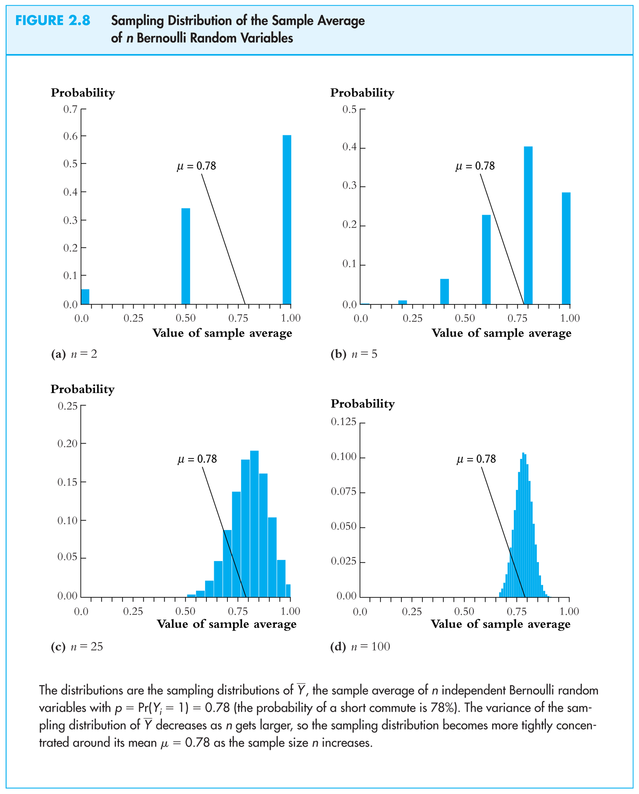
Things we want to know about the sampling distribution:

- What is the mean of ?
  - If E() = true μ = .78, then is an unbiased estimator of μ
- What is the variance of ?
  - How does var() depend on n (famous 1/n formula)
- Does become close to μ when n is large?
  - Law of large numbers: is a consistent estimator of μ
- – μ appears bell shaped for n large…is this generally true?
  - In fact, – μ is approximately normally distributed for n large (Central Limit Theorem)
The mean and variance of the sampling distribution of

General case – that is, for Y_{i} i.i.d. from any distribution, not just Bernoulli:
mean: E() = E(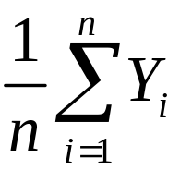) = 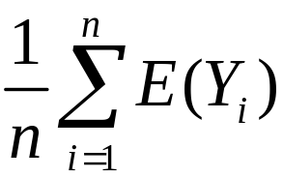 = 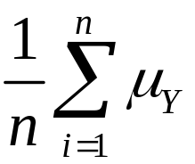 = μ_{Y}

Variance: var() = E[ – E()]²
= E[ – μ_{Y}]²
= E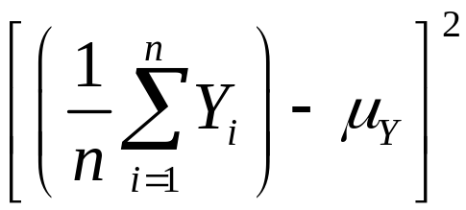
= E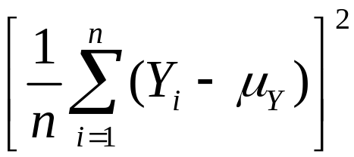
so var() = E
= 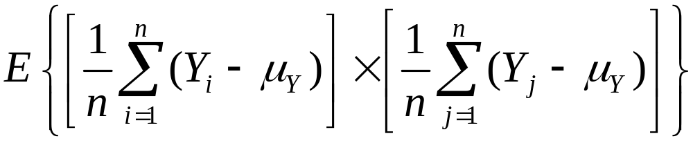
= 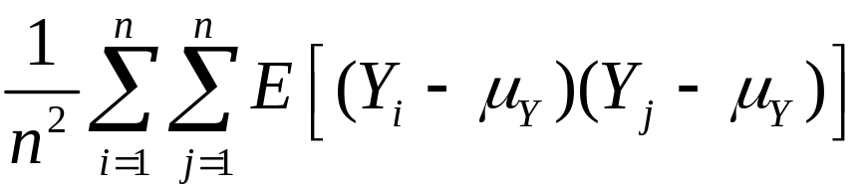
= 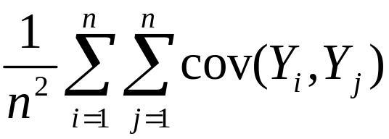
= 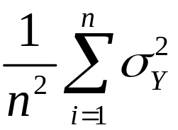
= 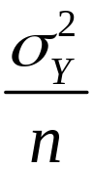
Mean and variance of sampling distribution of , ctd.

E() = μ_{Y}
var() =

Implications:
- is an unbiased estimator of μ_{Y} (that is, E() = μ_{Y})
- var() is inversely proportional to n
- the spread of the sampling distribution is proportional to 1/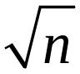
- Thus the sampling uncertainty associated with is proportional to 1/ (larger samples, less uncertainty, but square-root law)
The sampling distribution of when n is large

For small sample sizes, the distribution of is complicated, but if n is large, the sampling distribution is simple!
- As n increases, the distribution of becomes more tightly centered around μ_{Y} (the Law of Large Numbers)
- Moreover, the distribution of – μ_{Y} becomes normal (the Central Limit Theorem)
The Law of Large Numbers:
An estimator is consistent if the probability that its falls within an interval of the true population value tends to one as the sample size increases.
If (Y₁,…,Y_{n}) are i.i.d. and < , then is a consistent estimator of μ_{Y}, that is,
Pr[| – μ_{Y}| < ε]  1 as n  
which can be written, 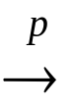 μ_{Y}
(“ μ_{Y}” means “ converges in probability to μ_{Y}”).
(the math: as n  , var() =  0, which implies that Pr[| – μ_{Y}| < ε]  1.)
The Central Limit Theorem (CLT):
If (Y₁,…,Y_{n}) are i.i.d. and 0 < < , then when n is large the distribution of is well approximated by a normal distribution.
- is approximately distributed N(μ_{Y}, ) (“normal distribution with mean μ_{Y} and variance /n”)
- ( – μ_{Y})/σ_{Y} is approximately distributed N(0,1) (standard normal)
- That is, “standardized” = 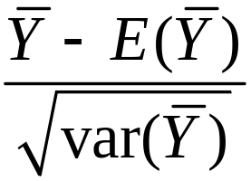 = 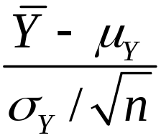 is approximately distributed as N(0,1)
- The larger is n, the better is the approximation.
Sampling distribution of when Y is Bernoulli, p = 0.78:
Same example: sampling distribution of :
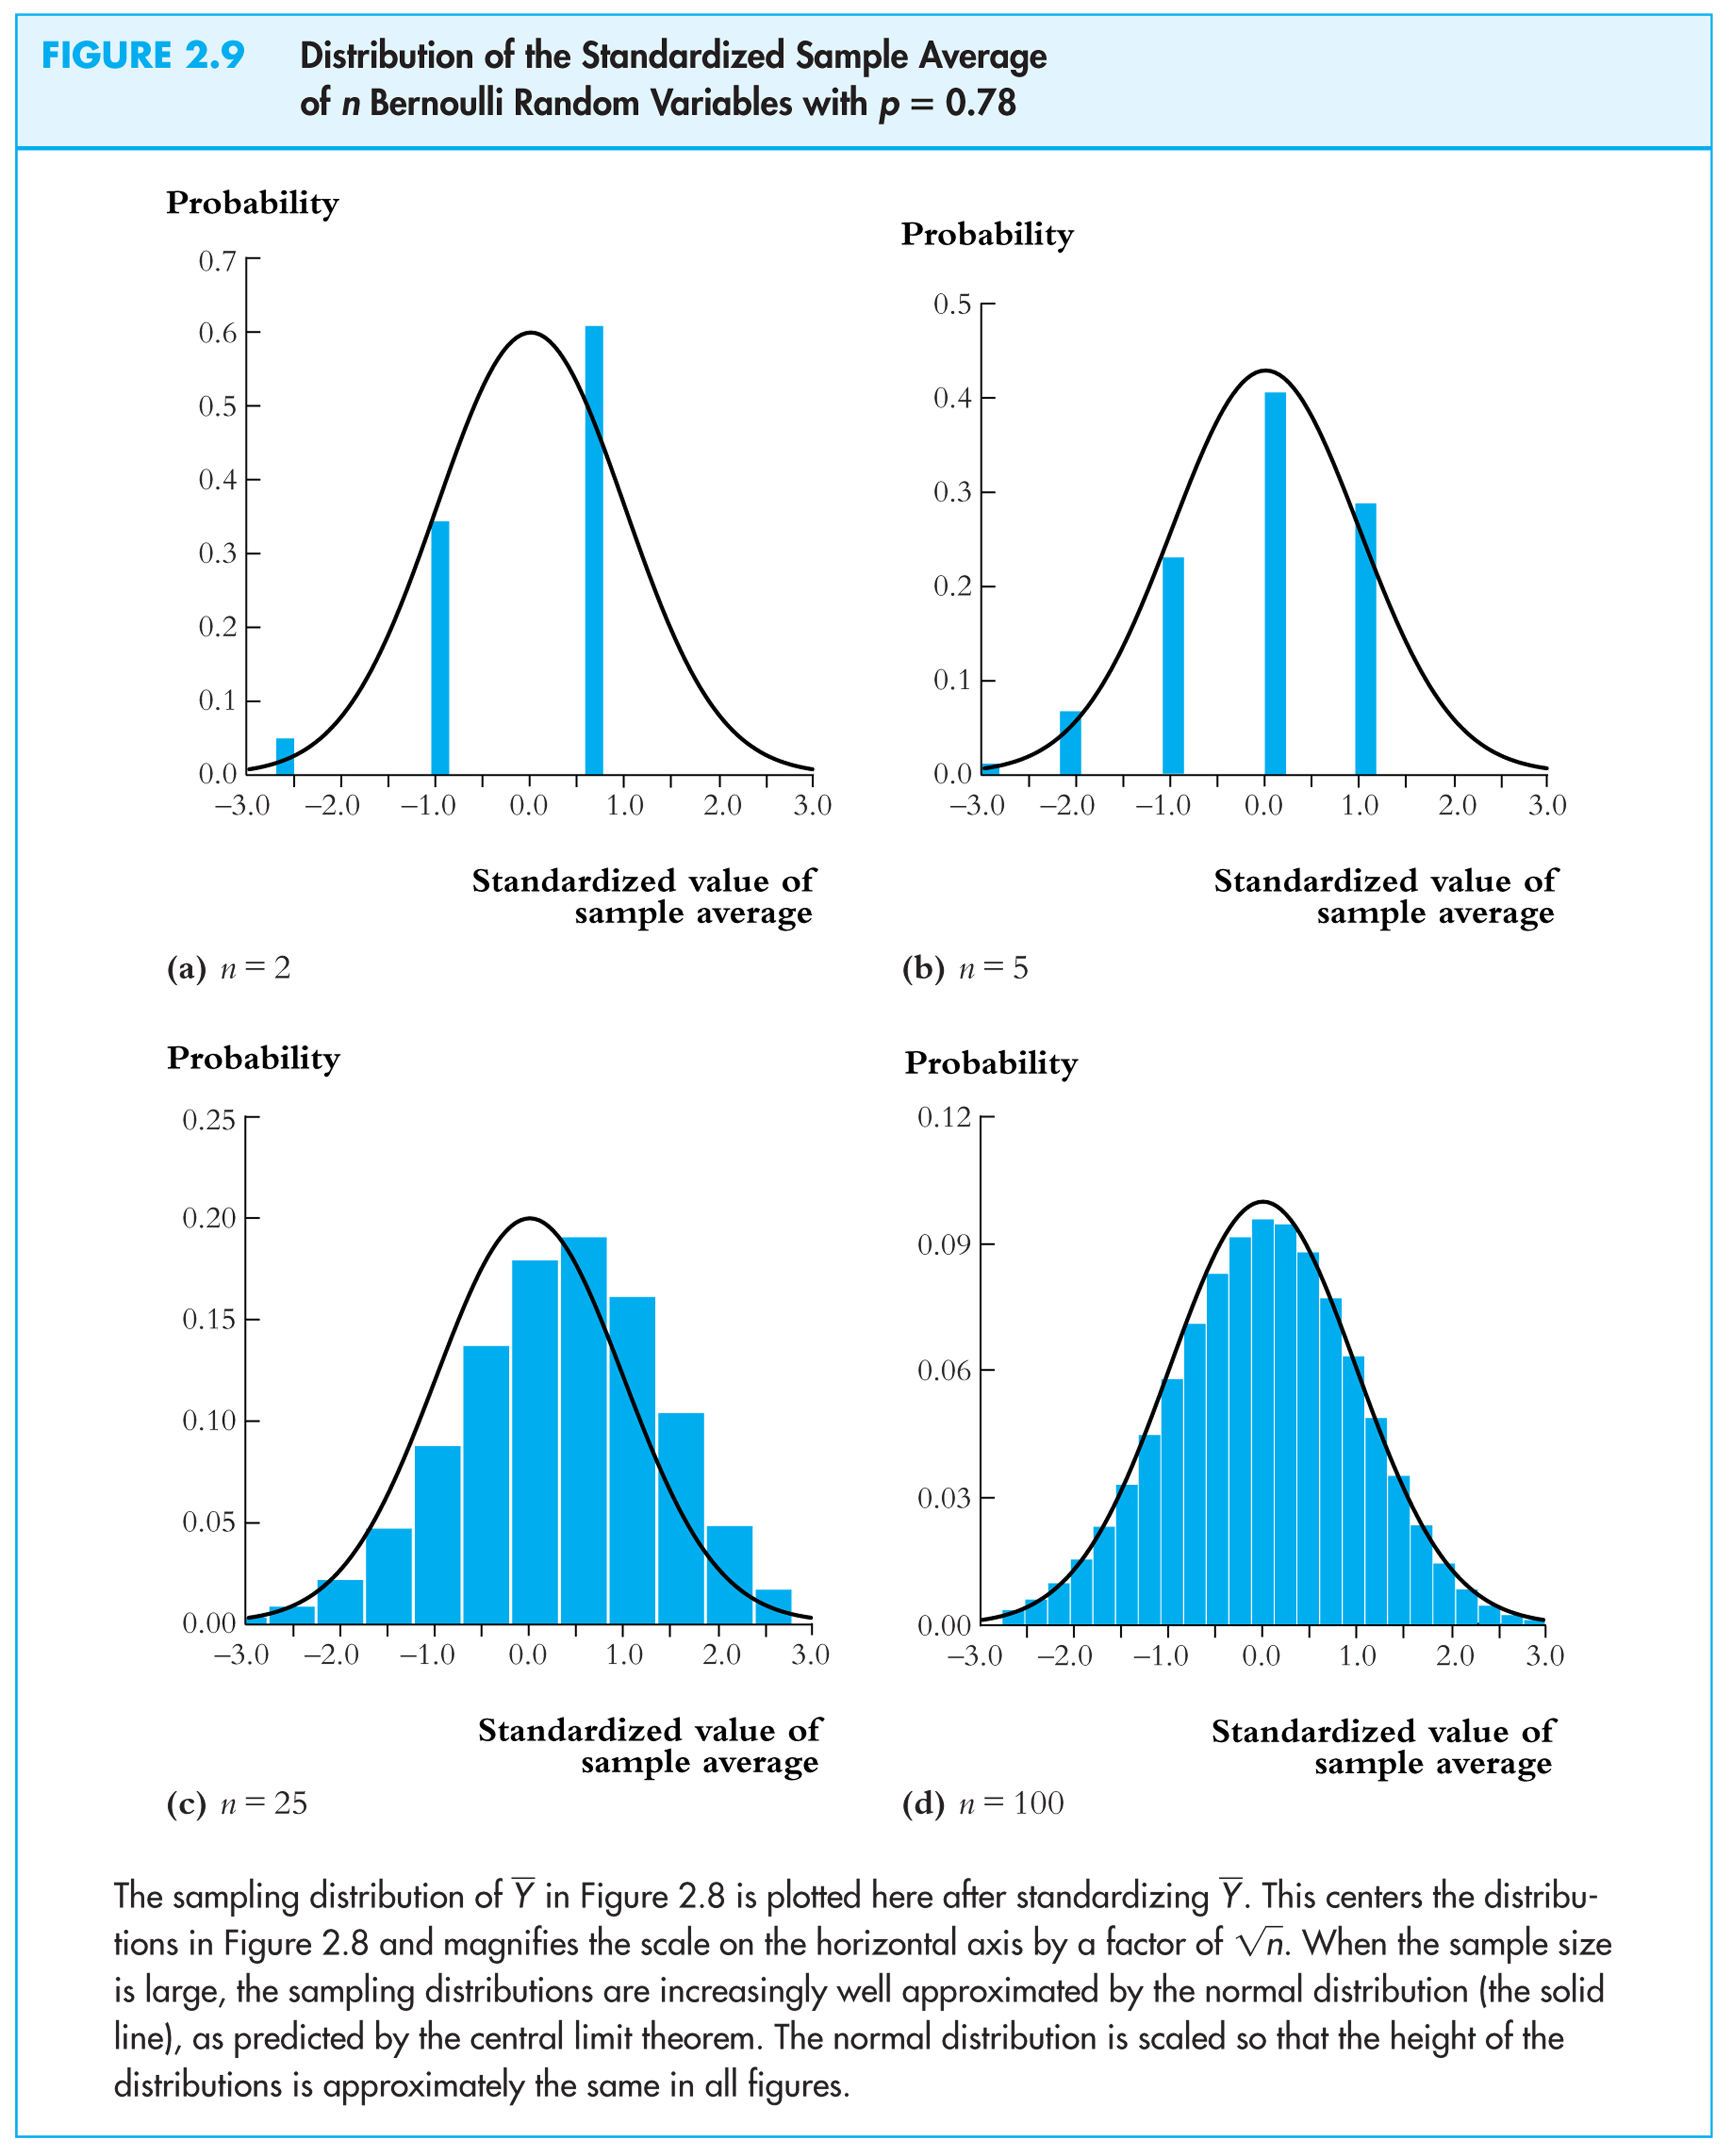
Summary: The Sampling Distribution of
For Y₁,…,Y_{n} i.i.d. with 0 < < ,
- The exact (finite sample) sampling distribution of has mean μ_{Y} (“ is an unbiased estimator of μ_{Y}”) and variance /n
- Other than its mean and variance, the exact distribution of is complicated and depends on the distribution of Y (the population distribution)
- When n is large, the sampling distribution simplifies:
  - μ_{Y} (Law of large numbers)
  - is approximately N(0,1) (CLT)
(b) Why Use To Estimate μ_{Y}?
- is unbiased: E() = μ_{Y}
- is consistent: μ_{Y}
- is the “least squares” estimator of μ_{Y}; solves,
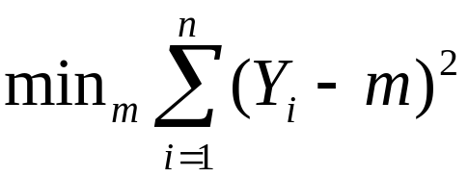
so, minimizes the sum of squared “residuals”
optional derivation (also see App. 3.2)
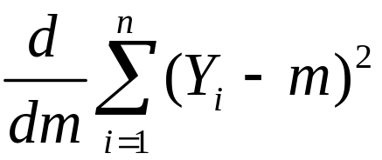 = 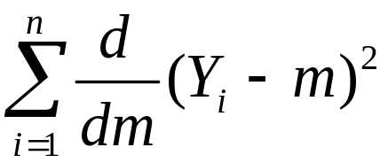 = 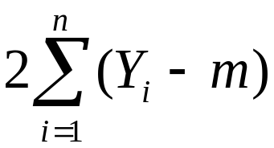
Set derivative to zero and denote optimal value of m by 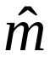:
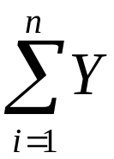 = 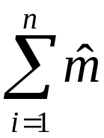 = 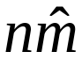 or = 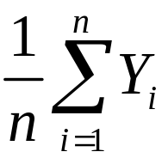 =
Why Use To Estimate μ_{Y}, ctd.

- has a smaller variance than all other linear unbiased estimators: consider the estimator, 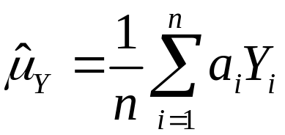, where {a_{i}} are such that 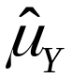 is unbiased; then var()  var() (proof: SW, Ch. 17)
- isn’t the only estimator of μ_{Y} – can you think of a time you might want to use the median instead?
- The probability framework for statistical inference
- Estimation
- Hypothesis Testing
- Confidence intervals

Hypothesis Testing
The hypothesis testing problem (for the mean): make a provisional decision, based on the evidence at hand, whether a null hypothesis is true, or instead that some alternative hypothesis is true. That is, test
H₀: E(Y) = μ_{Y,0} vs. H₁: E(Y) > μ_{Y,0} (1-sided, >)
H₀: E(Y) = μ_{Y,0} vs. H₁: E(Y) < μ_{Y,0} (1-sided, <)
H₀: E(Y) = μ_{Y,0} vs. H₁: E(Y) μ_{Y,0} (2-sided)
Some terminology for testing statistical hypotheses:

p-value = probability of drawing a statistic (e.g. ) at least as adverse to the null as the value actually computed with your data, assuming that the null hypothesis is true.

The significance level of a test is a pre-specified probability of incorrectly rejecting the null, when the null is true.

Calculating the p-value based on :

p-value = 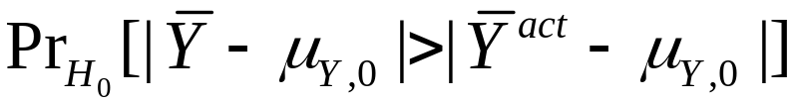

where 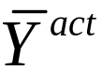 is the value of actually observed (nonrandom)
Calculating the p-value, ctd.
- To compute the p-value, you need the to know the sampling distribution of , which is complicated if n is small.
- If n is large, you can use the normal approximation (CLT):

p-value = ,
= 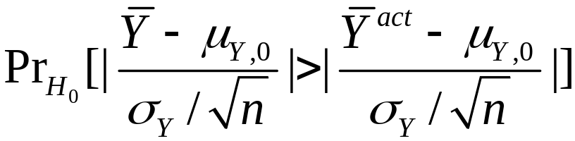
= 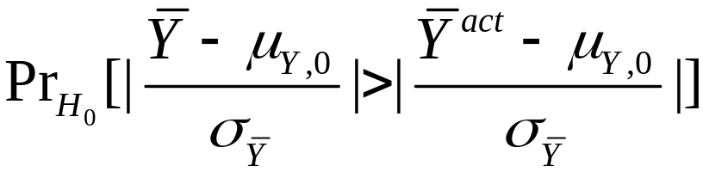
 probability under left+right N(0,1) tails
where 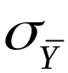 = std. dev. of the distribution of = σ_{Y}/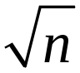.
Calculating the p-value with σ_{Y} known:
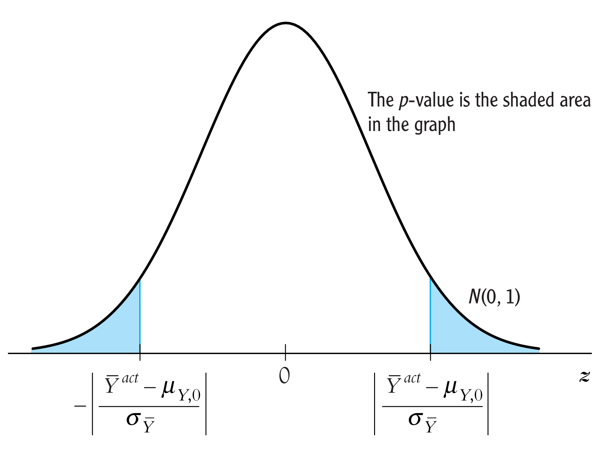
- For large n, p-value = the probability that a N(0,1) random variable falls outside |(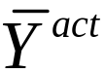– μ_{Y,0})/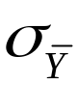|
- In practice, is unknown – it must be estimated
Estimator of the variance of Y:

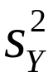 = 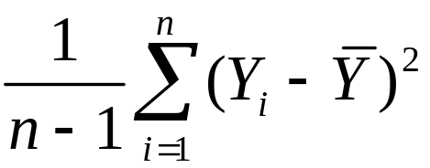 = “sample variance of Y”
Fact:
If (Y₁,…,Y_{n}) are i.i.d. and E(Y⁴) < , then

Why does the law of large numbers apply?
- Because is a sample average; see Appendix 3.3
- Technical note: we assume E(Y⁴) <  because here the average is not of Y_{i}, but of its square; see App. 3.3
Computing the p-value with estimated:

p-value = ,
=
 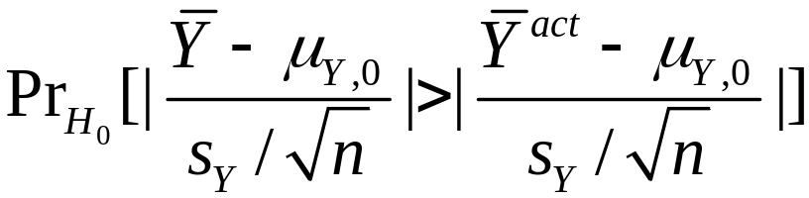 (large n)
so
p-value = 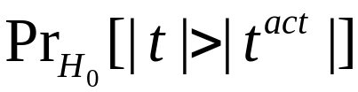 ( estimated)
 probability under normal tails outside |t^{act}|
where t = 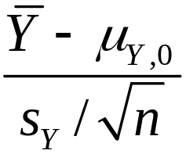 (the usual t-statistic)
What is the link between the p-value and the significance level?

The significance level is prespecified. For example, if the prespecified significance level is 5%,
- you reject the null hypothesis if |t|  1.96
- equivalently, you reject if p  0.05.
- The p-value is sometimes called the marginal significance level.
- Often, it is better to communicate the p-value than simply whether a test rejects or not – the p-value contains more information than the “yes/no” statement about whether the test rejects.
At this point, you might be wondering,...
What happened to the t-table and the degrees of freedom?

Digression: the Student t distribution
If Y_{i}, i = 1,…, n is i.i.d. N(μ_{Y},), then the t-statistic has the Student t-distribution with n – 1 degrees of freedom.
The critical values of the Student t-distribution is tabulated in the back of all statistics books. Remember the recipe?
- Compute the t-statistic
- Compute the degrees of freedom, which is n – 1
- Look up the 5% critical value
- If the t-statistic exceeds (in absolute value) this critical value, reject the null hypothesis.
Comments on this recipe and the Student t-distribution

  - The theory of the t-distribution was one of the early triumphs of mathematical statistics. It is astounding, really: if Y is i.i.d. normal, then you can know the exact, finite-sample distribution of the t-statistic – it is the Student t. So, you can construct confidence intervals (using the Student t critical value) that have exactly the right coverage rate, no matter what the sample size. This result was really useful in times when “computer” was a job title, data collection was expensive, and the number of observations was perhaps a dozen. It is also a conceptually beautiful result, and the math is beautiful too – which is probably why stats profs love to teach the t-distribution. But….
Comments on Student t distribution, ctd.

  - If the sample size is moderate (several dozen) or large (hundreds or more), the difference between the t-distribution and N(0,1) critical values are negligible. Here are some 5% critical values for 2-sided tests:

degrees of freedom  (n – 1) | 5% t-distribution critical value
10 | 2.23
20 | 2.09
30 | 2.04
60 | 2.00
∞ | 1.96
Comments on Student t distribution, ctd.

  - So, the Student-t distribution is only relevant when the sample size is very small; but in that case, for it to be correct, you must be sure that the population distribution of Y is normal. In economic data, the normality assumption is rarely credible. Here are the distributions of some economic data.
  - Do you think earnings are normally distributed?
  - Suppose you have a sample of n = 10 observations from one of these distributions – would you feel comfortable using the Student t distribution?
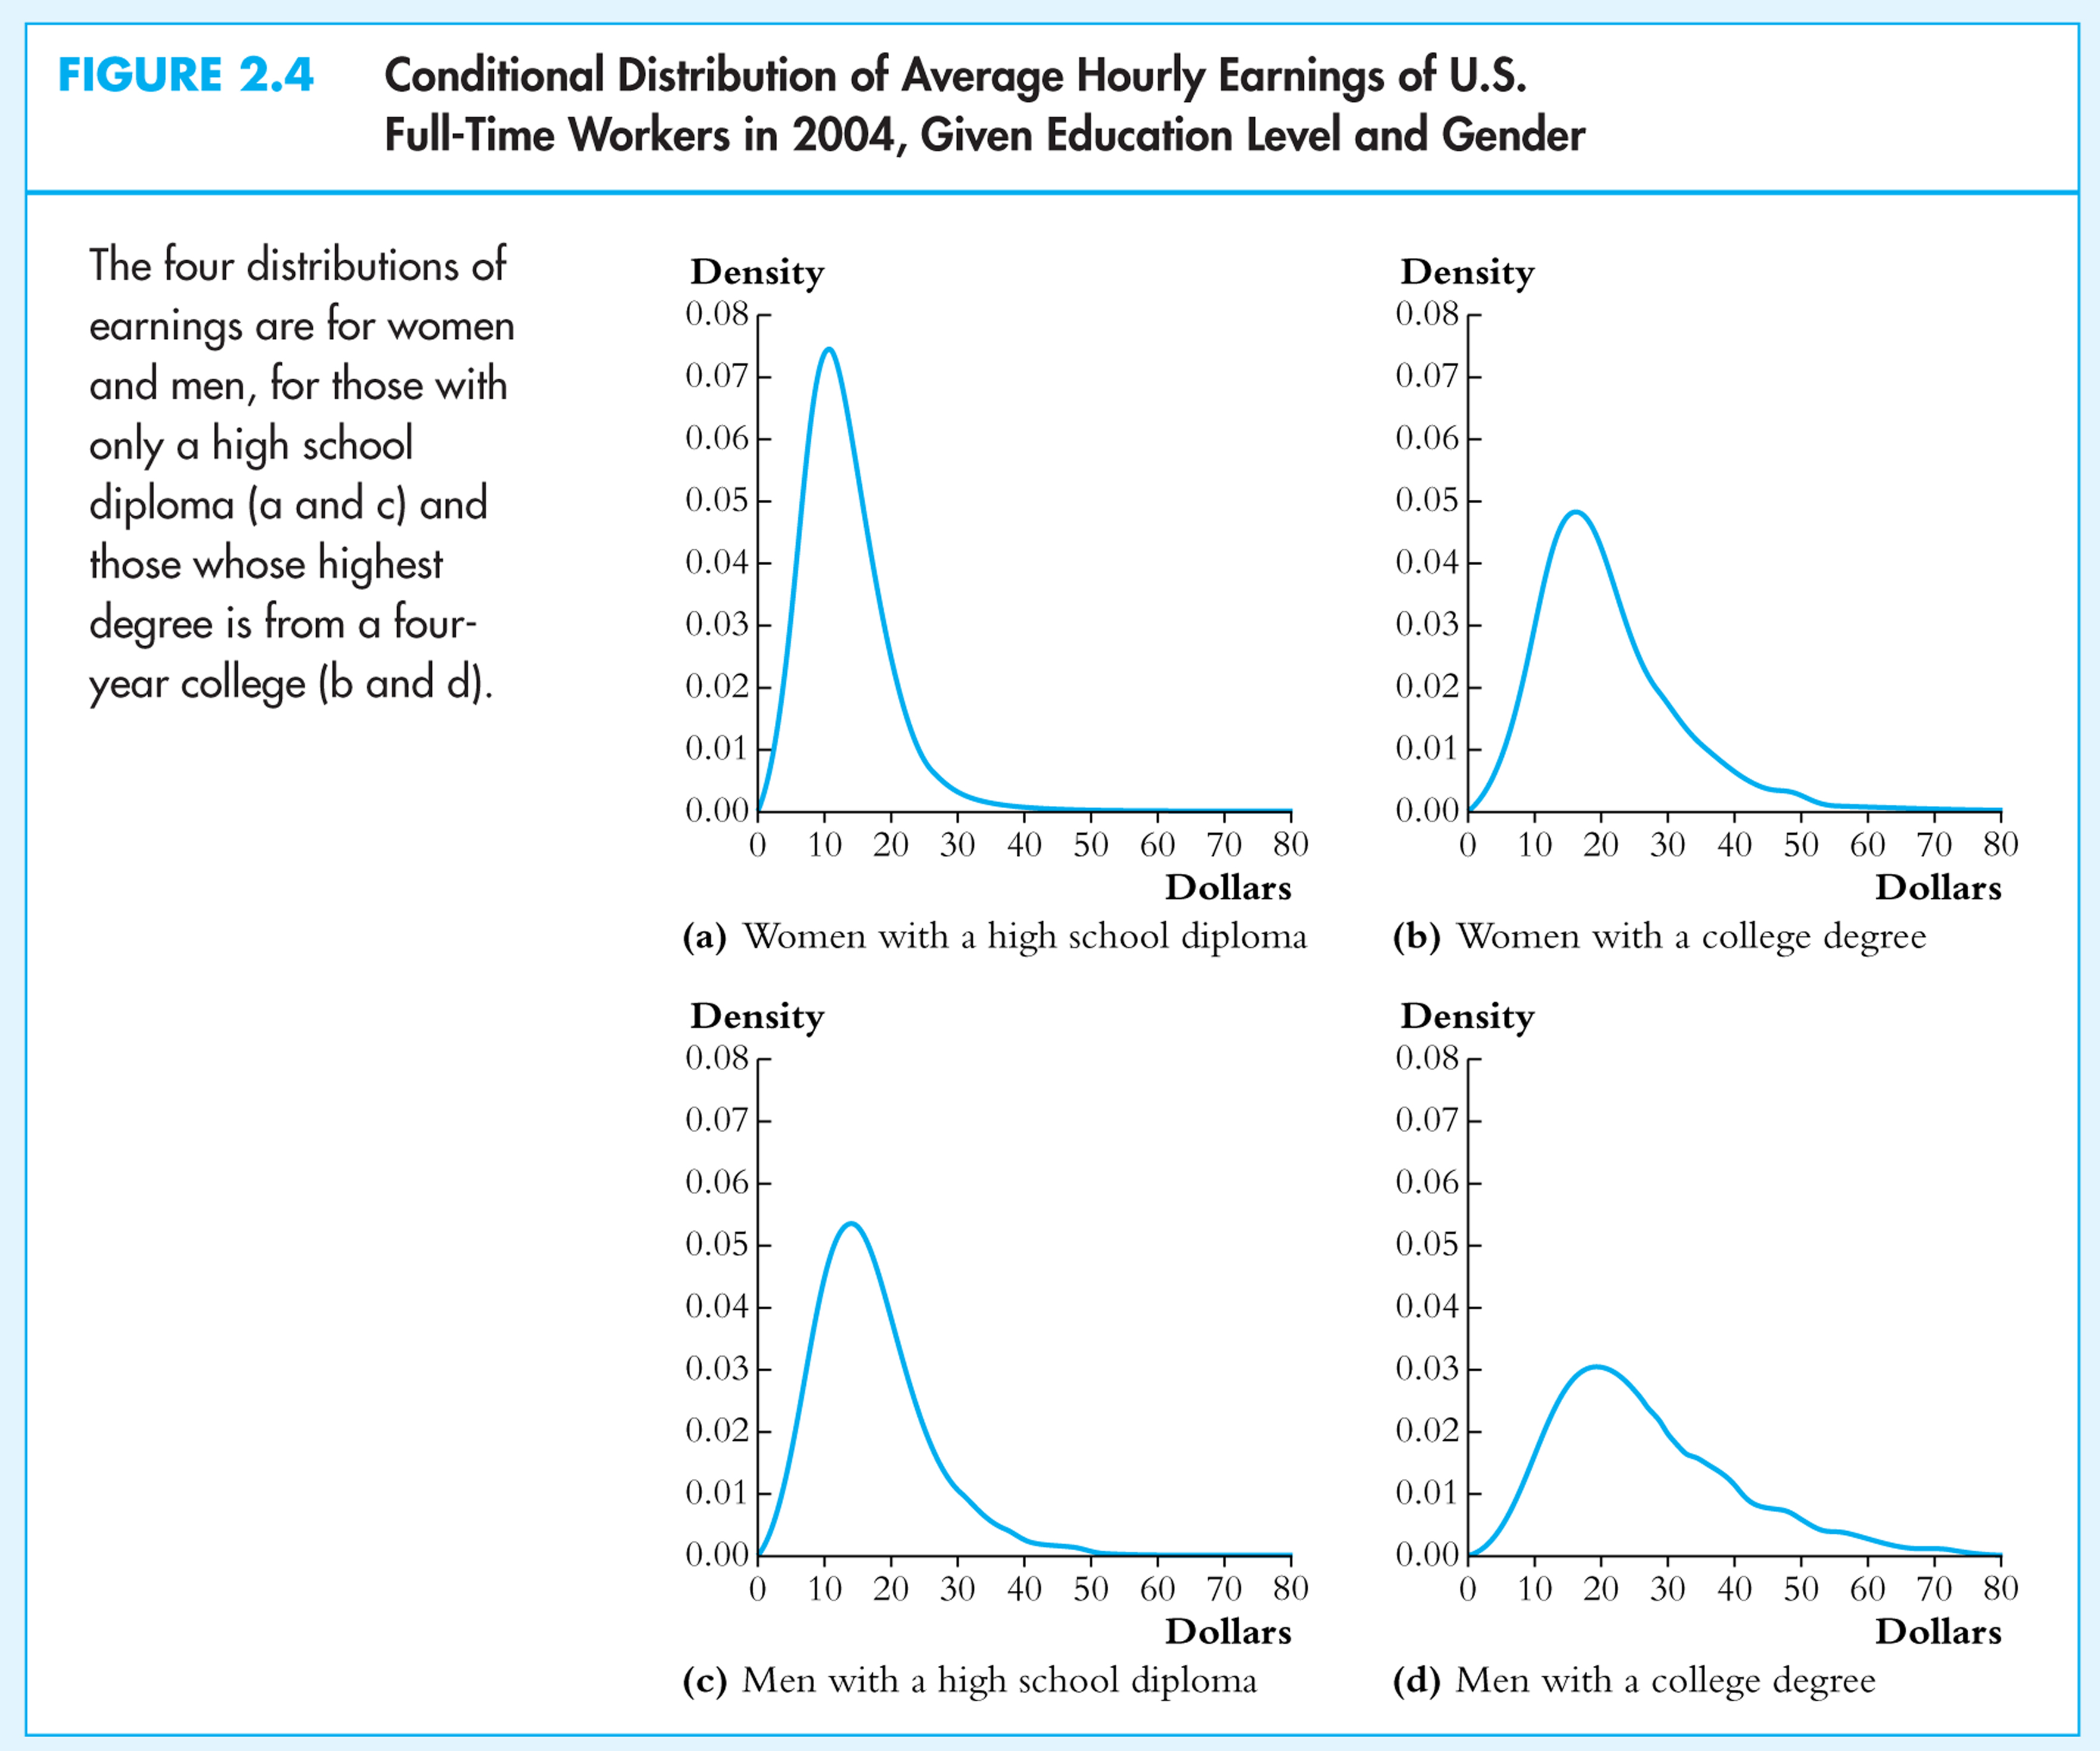
Comments on Student t distribution, ctd.
  - You might not know this. Consider the t-statistic testing the hypothesis that two means (groups s, l) are equal:
Even if the population distribution of Y in the two groups is normal, this statistic doesn’t have a Student t distribution!
There is a statistic testing this hypothesis that has a normal distribution, the “pooled variance” t-statistic – see SW (Section 3.6) – however the pooled variance t-statistic is only valid if the variances of the normal distributions are the same in the two groups. Would you expect this to be true, say, for men’s v. women’s wages?
The Student-t distribution – summary

- The assumption that Y is distributed N(μ_{Y},) is rarely plausible in practice (income? number of children?)
- For n > 30, the t-distribution and N(0,1) are very close (as n grows large, the t_{n–1} distribution converges to N(0,1))
- The t-distribution is an artifact from days when sample sizes were small and “computers” were people
- For historical reasons, statistical software typically uses the t-distribution to compute p-values – but this is irrelevant when the sample size is moderate or large.
- For these reasons, in this class we will focus on the large-n approximation given by the CLT
- The probability framework for statistical inference
- Estimation
- Testing
- Confidence intervals

Confidence Intervals
A 95% confidence interval for μ_{Y} is an interval that contains the true value of μ_{Y} in 95% of repeated samples.

Digression: What is random here? The values of Y₁,…,Y_{n} and thus any functions of them – including the confidence interval. The confidence interval it will differ from one sample to the next. The population parameter, μ_{Y}, is not random, we just don’t know it.
Confidence intervals, ctd.
A 95% confidence interval can always be constructed as the set of values of μ_{Y} not rejected by a hypothesis test with a 5% significance level.

{μ_{Y}: 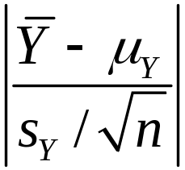  1.96} = {μ_{Y}: –1.96  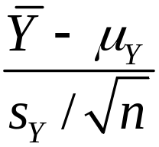  1.96}
= {μ_{Y}: –1.96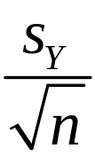  – μ_{Y}  1.96}
= {μ_{Y}  ( – 1.96 , + 1.96)}
This confidence interval relies on the large-n results that is approximately normally distributed and .
Summary:
From the two assumptions of:
- simple random sampling of a population, that is,
{Y_{i}, i =1,…,n} are i.i.d.
- 0 < E(Y⁴) < 
we developed, for large samples (large n):
- Theory of estimation (sampling distribution of )
- Theory of hypothesis testing (large-n distribution of t-statistic and computation of the p-value)
- Theory of confidence intervals (constructed by inverting test statistic)
Are assumptions (1) & (2) plausible in practice? Yes
Let’s go back to the original policy question:
What is the effect on test scores of reducing STR by one student/class?
Have we answered this question?

