Multiple Regression
(SW Chapter 5)

OLS estimate of the Test Score/STR relation:
 = 698.9 – 2.28STR, R² = .05, SER = 18.6
(10.4) (0.52)
Is this a credible estimate of the causal effect on test scores of a change in the student-teacher ratio?
No: there are omitted confounding factors (family income; whether the students are native English speakers) that bias the OLS estimator: STR could be “picking up” the effect of these confounding factors.
Omitted Variable Bias
(SW Section 5.1)

The bias in the OLS estimator that occurs as a result of an omitted factor is called omitted variable bias. For omitted variable bias to occur, the omitted factor “Z” must be:
- a determinant of Y; and
- correlated with the regressor X.

Both conditions must hold for the omission of Z to result in omitted variable bias.
In the test score example:
- English language ability (whether the student has English as a second language) plausibly affects standardized test scores: Z is a determinant of Y.
- Immigrant communities tend to be less affluent and thus have smaller school budgets – and higher STR: Z is correlated with X.

- Accordingly, 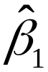 is biased
- What is the direction of this bias?
  - What does common sense suggest?
  - If common sense fails you, there is a formula…
A formula for omitted variable bias: recall the equation,
– β₁ = 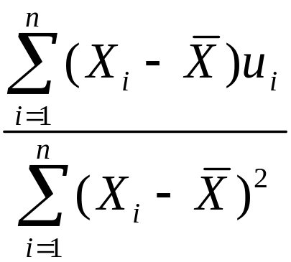 = 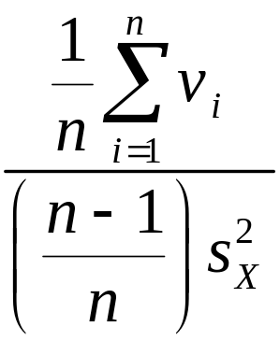

where v_{i} = (X_{i} – 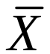)u_{i}  (X_{i} – μ_{X})u_{i}. Under Least Squares Assumption #1,

E[(X_{i} – μ_{X})u_{i}] = cov(X_{i},u_{i}) = 0.

But what if E[(X_{i} – μ_{X})u_{i}] = cov(X_{i},u_{i}) = σ_{Xu}  0?
Then
– β₁ = =
so
E() – β₁ = 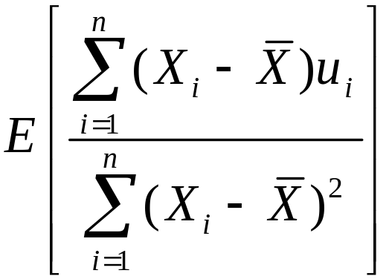  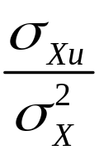 = 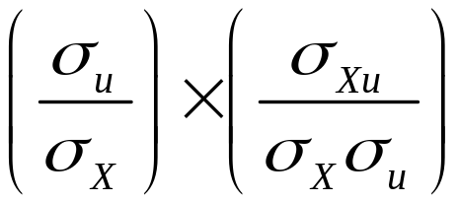
where  holds with equality when n is large; specifically,
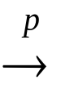 β₁ + 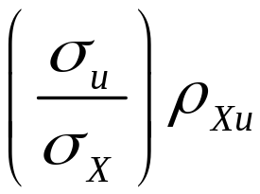, where ρ_{Xu} = corr(X,u)
Omitted variable bias formula: β₁ + .
If an omitted factor Z is both:
(1) a determinant of Y (that is, it is contained in u); and
(2) correlated with X,
then ρ_{Xu}  0 and the OLS estimator is biased.

The math makes precise the idea that districts with few ESL students (1) do better on standardized tests and (2) have smaller classes (bigger budgets), so ignoring the ESL factor results in overstating the class size effect.
Is this is actually going on in the CA data?
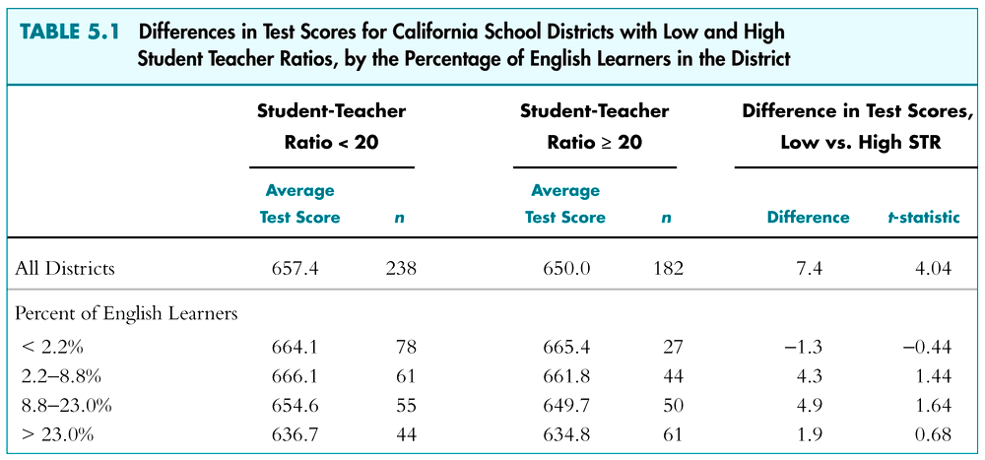
- Districts with fewer English Learners have higher test scores
- Districts with lower percent EL (PctEL) have smaller classes
- Among districts with comparable PctEL, the effect of class size is small (recall overall “test score gap” = 7.4)
Three ways to overcome omitted variable bias
- Run a randomized controlled experiment in which treatment (STR) is randomly assigned: then PctEL is still a determinant of TestScore, but PctEL is uncorrelated with STR. (But this is unrealistic in practice.)
- Adopt the “cross tabulation” approach, with finer gradations of STR and PctEL (But soon we will run out of data, and what about other determinants like family income and parental education?)
- Use a method in which the omitted variable (PctEL) is no longer omitted: include PctEL as an additional regressor in a multiple regression.
The Population Multiple Regression Model
(SW Section 5.2)

Consider the case of two regressors:

Y_{i} = β₀ + β₁X_{1i} + β₂X_{2i} + u_{i}, i = 1,…,n

- X₁, X₂ are the two independent variables (regressors)
- (Y_{i}, X_{1i}, X_{2i}) denote the i^{th} observation on Y, X₁, and X₂.
- β₀ = unknown population intercept
- β₁ = effect on Y of a change in X₁, holding X₂ constant
- β₂ = effect on Y of a change in X₂, holding X₁ constant
- u_{i} = “error term” (omitted factors)
Interpretation of multiple regression coefficients

Y_{i} = β₀ + β₁X_{1i} + β₂X_{2i} + u_{i}, i = 1,…,n

Consider changing X₁ by ΔX₁ while holding X₂ constant:
Population regression line before the change:

Y = β₀ + β₁X₁ + β₂X₂

Population regression line, after the change:

Y + ΔY = β₀ + β₁(X₁ + ΔX₁) + β₂X₂
Before: Y = β₀ + β₁(X₁ + ΔX₁) + β₂X₂

After: Y + ΔY = β₀ + β₁(X₁ + ΔX₁) + β₂X₂

Difference: ΔY = β₁ΔX₁
That is,
β₁ = 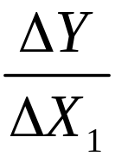, holding X₂ constant
also,
β₂ = 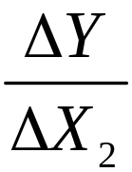, holding X₁ constant
and
β₀ = predicted value of Y when X₁ = X₂ = 0.
The OLS Estimator in Multiple Regression
(SW Section 5.3)

With two regressors, the OLS estimator solves:

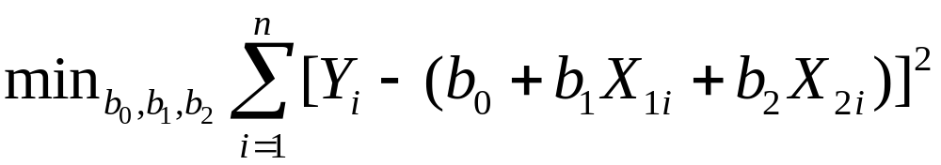

- The OLS estimator minimizes the average squared difference between the actual values of Y_{i} and the prediction (predicted value) based on the estimated line.
- This minimization problem is solved using calculus
- The result is the OLS estimators of β₀ and β₁.
Example: the California test score data

Regression of TestScore against STR:

= 698.9 – 2.28STR

Now include percent English Learners in the district (PctEL):

= 696.0 – 1.10STR – 0.65PctEL

- What happens to the coefficient on STR?
- Why? (Note: corr(STR, PctEL) = 0.19)
Multiple regression in STATA

reg testscr str pctel, robust;

Regression with robust standard errors Number of obs = 420
F( 2, 417) = 223.82
Prob > F = 0.0000
R-squared = 0.4264
Root MSE = 14.464

------------------------------------------------------------------------------
| Robust
testscr | Coef. Std. Err. t P>|t| [95% Conf. Interval]
-------------+----------------------------------------------------------------
str | -1.101296 .4328472 -2.54 0.011 -1.95213 -.2504616
pctel | -.6497768 .0310318 -20.94 0.000 -.710775 -.5887786
_cons | 686.0322 8.728224 78.60 0.000 668.8754 703.189
------------------------------------------------------------------------------

= 696.0 – 1.10STR – 0.65PctEL

What are the sampling distribution of and 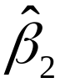?
The Least Squares Assumptions for Multiple Regression (SW Section 5.4)

Y_{i} = β₀ + β₁X_{1i} + β₂X_{2i} + … + β_{k}X_{ki} + u_{i}, i = 1,…,n

- The conditional distribution of u given the X’s has mean zero, that is, E(u|X₁ = x₁,…, X_{k} = x_{k}) = 0.
- (X_{1i},…,X_{ki},Y_{i}), i =1,…,n, are i.i.d.
- X₁,…, X_{k}, and u have four moments: E(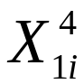) < ,…, E(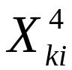) < , E(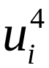) < .
- There is no perfect multicollinearity.

Assumption #1: the conditional mean of u given the included X’s is zero.

- This has the same interpretation as in regression with a single regressor.
- If an omitted variable (1) belongs in the equation (so is in u) and (2) is correlated with an included X, then this condition fails
- Failure of this condition leads to omitted variable bias
- The solution – if possible – is to include the omitted variable in the regression.

Assumption #2: (X_{1i},…,X_{ki},Y_{i}), i =1,…,n, are i.i.d.
This is satisfied automatically if the data are collected by simple random sampling.

Assumption #3: finite fourth moments
This is technical assumption is satisfied automatically by variables with a bounded domain (test scores, PctEL, etc.)
Assumption #4: There is no perfect multicollinearity
Perfect multicollinearity is when one of the regressors is an exact linear function of the other regressors.

Example: Suppose you accidentally include STR twice:

regress testscr str str, robust
Regression with robust standard errors Number of obs = 420
F( 1, 418) = 19.26
Prob > F = 0.0000
R-squared = 0.0512
Root MSE = 18.581
-------------------------------------------------------------------------
| Robust
testscr | Coef. Std. Err. t P>|t| [95% Conf. Interval]
--------+----------------------------------------------------------------
str | -2.279808 .5194892 -4.39 0.000 -3.300945 -1.258671
str | (dropped)
_cons | 698.933 10.36436 67.44 0.000 678.5602 719.3057
-------------------------------------------------------------------------
Perfect multicollinearity is when one of the regressors is an exact linear function of the other regressors.
- In the previous regression, β₁ is the effect on TestScore of a unit change in STR, holding STR constant (???)
- Second example: regress TestScore on a constant, D, and B, where: D_{i} = 1 if STR ≤ 20, = 0 otherwise; B_{i} = 1 if STR >20, = 0 otherwise, so B_{i} = 1 – D_{i} and there is perfect multicollinearity
- Would there be perfect multicollinearity if the intercept (constant) were somehow dropped (that is, omitted or suppressed) in the regression?
- Perfect multicollinearity usually reflects a mistake in the definitions of the regressors, or an oddity in the data
The Sampling Distribution of the OLS Estimator
(SW Section 5.5)

Under the four Least Squares Assumptions,
- The exact (finite sample) distribution of has mean β₁, var() is inversely proportional to n; so too for .
- Other than its mean and variance, the exact distribution of is very complicated
- is consistent: β₁ (law of large numbers)
- 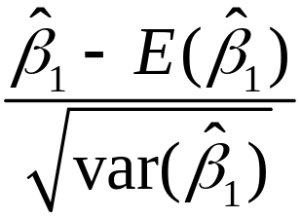 is approximately distributed N(0,1) (CLT)
- So too for ,…, 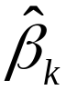
Hypothesis Tests and Confidence Intervals for a Single Coefficient in Multiple Regression
(SW Section 5.6)
- is approximately distributed N(0,1) (CLT).
- Thus hypotheses on β₁ can be tested using the usual t-statistic, and confidence intervals are constructed as {  1.96SE()}.
- So too for β₂,…, β_{k}.
- and are generally not independently distributed – so neither are their t-statistics (more on this later).
Example: The California class size data
(1) = 698.9 – 2.28STR
(10.4) (0.52)
(2) = 696.0 – 1.10STR – 0.650PctEL
(8.7) (0.43) (0.031)

- The coefficient on STR in (2) is the effect on TestScores of a unit change in STR, holding constant the percentage of English Learners in the district
- Coefficient on STR falls by one-half
- 95% confidence interval for coefficient on STR in (2) is {–1.10  1.960.43} = (–1.95, –0.26)
Tests of Joint Hypotheses
(SW Section 5.7)

Let Expn = expenditures per pupil and consider the population regression model:

TestScore_{i} = β₀ + β₁STR_{i} + β₂Expn_{i} + β₃PctEL_{i} + u_{i}

The null hypothesis that “school resources don’t matter,” and the alternative that they do, corresponds to:

H₀: β₁ = 0 and β₂ = 0
vs. H₁: either β₁  0 or β₂  0 or both
TestScore_{i} = β₀ + β₁STR_{i} + β₂Expn_{i} + β₃PctEL_{i} + u_{i}

H₀: β₁ = 0 and β₂ = 0
vs. H₁: either β₁  0 or β₂  0 or both

A joint hypothesis specifies a value for two or more coefficients, that is, it imposes a restriction on two or more coefficients.
- A “common sense” test is to reject if either of the individual t-statistics exceeds 1.96 in absolute value.
- But this “common sense” approach doesn’t work! The resulting test doesn’t have the right significance level!

Here’s why: Calculation of the probability of incorrectly rejecting the null using the “common sense” test based on the two individual t-statistics. To simplify the calculation, suppose that and are independently distributed. Let t₁ and t₂ be the t-statistics:
t₁ = 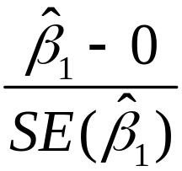 and t₂ = 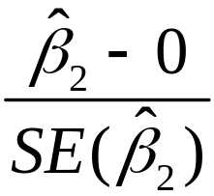
The “common sense” test is:
reject H₀: β₁ = β₂ = 0 if |t₁| > 1.96 and/or |t₂| > 1.96

What is the probability that this “common sense” test rejects H₀, when H₀ is actually true? (It should be 5%.)
Probability of incorrectly rejecting the null
= 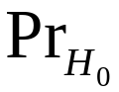[|t₁| > 1.96 and/or |t₂| > 1.96]
= [|t₁| > 1.96, |t₂| > 1.96]
+ [|t₁| > 1.96, |t₂| ≤ 1.96]
+ [|t₁| ≤ 1.96, |t₂| > 1.96] (disjoint events)
= [|t₁| > 1.96]  [|t₂| > 1.96]
+ [|t₁| > 1.96]  [|t₂| ≤ 1.96]
+ [|t₁| ≤ 1.96]  [|t₂| > 1.96]
(t₁, t₂ are independent by assumption)
= .05.05 + .05.95 + .95.05
= .0975 = 9.75% – which is not the desired 5%!!
The size of a test is the actual rejection rate under the null hypothesis.

- The size of the “common sense” test isn’t 5%!
- Its size actually depends on the correlation between t₁ and t₂ (and thus on the correlation between and ).

Two Solutions:
- Use a different critical value in this procedure – not 1.96 (this is the “Bonferroni method – see App. 5.3)
- Use a different test statistic that test both β₁ and β₂ at once: the F-statistic.
The F-statistic
The F-statistic tests all parts of a joint hypothesis at once.

Unpleasant formula for the special case of the joint hypothesis β₁ = β_{1,0} and β₂ = β_{2,0} in a regression with two regressors:

F = 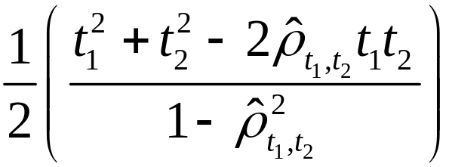

where 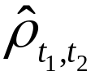 estimates the correlation between t₁ and t₂.

Reject when F is “large”
The F-statistic testing β₁ and β₂ (special case):

F =

- The F-statistic is large when t₁ and/or t₂ is large
- The F-statistic corrects (in just the right way) for the correlation between t₁ and t₂.
- The formula for more than two β’s is really nasty unless you use matrix algebra.
- This gives the F-statistic a nice large-sample approximate distribution, which is…
Large-sample distribution of the F-statistic
Consider special case that t₁ and t₂ are independent, so 0; in large samples the formula becomes

F =  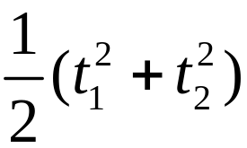

- Under the null, t₁ and t₂ have standard normal distributions that, in this special case, are independent
- The large-sample distribution of the F-statistic is the distribution of the average of two independently distributed squared standard normal random variables.
The chi-squared distribution with q degrees of freedom (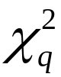) is defined to be the distribution of the sum of q independent squared standard normal random variables.

In large samples, F is distributed as /q.

Selected large-sample critical values of /q
q 5% critical value
1 3.84 (why?)
2 3.00 (the case q=2 above)
3 2.60
4 2.37
5 2.21

p-value using the F-statistic:
p-value = tail probability of the /q distribution beyond the F-statistic actually computed.

Implementation in STATA
Use the “test” command after the regression

Example: Test the joint hypothesis that the population coefficients on STR and expenditures per pupil (expn_stu) are both zero, against the alternative that at least one of the population coefficients is nonzero.
F-test example, California class size data:

reg testscr str expn_stu pctel, r;

Regression with robust standard errors Number of obs = 420
F( 3, 416) = 147.20
Prob > F = 0.0000
R-squared = 0.4366
Root MSE = 14.353

------------------------------------------------------------------------------
| Robust
testscr | Coef. Std. Err. t P>|t| [95% Conf. Interval]
-------------+----------------------------------------------------------------
str | -.2863992 .4820728 -0.59 0.553 -1.234001 .661203
expn_stu | .0038679 .0015807 2.45 0.015 .0007607 .0069751
pctel | -.6560227 .0317844 -20.64 0.000 -.7185008 -.5935446
_cons | 649.5779 15.45834 42.02 0.000 619.1917 679.9641
------------------------------------------------------------------------------
NOTE

test str expn_stu; The test command follows the regression

( 1) str = 0.0 There are q=2 restrictions being tested
( 2) expn_stu = 0.0

F( 2, 416) = 5.43 The 5% critical value for q=2 is 3.00
Prob > F = 0.0047 Stata computes the p-value for you
Two (related) loose ends:
- Homoskedasticity-only versions of the F-statistic
- The “F” distribution

The homoskedasticity-only (“rule-of-thumb”) F-statistic
To compute the homoskedasticity-only F-statistic:
- Use the previous formulas, but using homoskedasticity-only standard errors; or
- Run two regressions, one under the null hypothesis (the “restricted” regression) and one under the alternative hypothesis (the “unrestricted” regression).
- The second method gives a simple formula

The “restricted” and “unrestricted” regressions
Example: are the coefficients on STR and Expn zero?

Restricted population regression (that is, under H₀):
TestScore_{i} = β₀ + β₃PctEL_{i} + u_{i} (why?)

Unrestricted population regression (under H₁):
TestScore_{i} = β₀ + β₁STR_{i} + β₂Expn_{i} + β₃PctEL_{i} + u_{i}

- The number of restrictions under H₀ = q = 2.
- The fit will be better (R² will be higher) in the unrestricted regression (why?)
By how much must the R² increase for the coefficients on Expn and PctEL to be judged statistically significant?

Simple formula for the homoskedasticity-only F-statistic:

F = 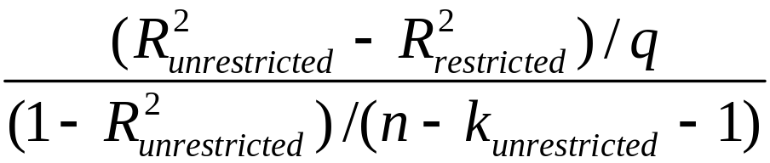
where:
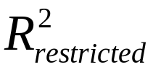= the R² for the restricted regression
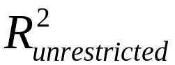 = the R² for the unrestricted regression
q = the number of restrictions under the null
k_{unrestricted} = the number of regressors in the
unrestricted regression.
Example:
Restricted regression:
= 644.7 –0.671PctEL, = 0.4149
(1.0) (0.032)
Unrestricted regression:
= 649.6 – 0.29STR + 3.87Expn – 0.656PctEL
(15.5) (0.48) (1.59) (0.032)
= 0.4366, k_{unrestricted} = 3, q = 2
so:
F =
= 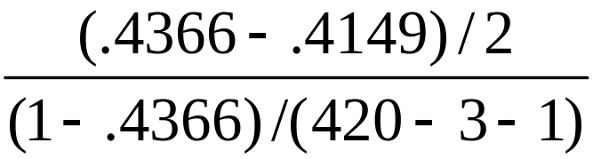 = 8.01
The homoskedasticity-only F-statistic
F =

- The homoskedasticity-only F-statistic rejects when adding the two variables increased the R² by “enough” – that is, when adding the two variables improves the fit of the regression by “enough”
- If the errors are homoskedastic, then the homoskedasticity-only F-statistic has a large-sample distribution that is /q.
- But if the errors are heteroskedastic, the large-sample distribution is a mess and is not /q
The F distribution

If:
- u₁,…,u_{n} are normally distributed; and
- X_{i} is distributed independently of u_{i} (so in particular u_{i} is homoskedastic)

then the homoskedasticity-only F-statistic has the
“F_{q,n-k–1}” distribution, where q = the number of restrictions and k = the number of regressors under the alternative (the unrestricted model).

The F_{q,n–k–1} distribution:
- The F distribution is tabulated many places
- When n gets large the F_{q,n-k–1} distribution asymptotes to the /q distribution:
F_{q,} is another name for /q
- For q not too big and n≥100, the F_{q,n–k–1} distribution and the /q distribution are essentially identical.
- Many regression packages compute p-values of F-statistics using the F distribution (which is OK if the sample size is 100
- You will encounter the “F-distribution” in published empirical work.
Digression: A little history of statistics…
- The theory of the homoskedasticity-only F-statistic and the F_{q,n–k–1} distributions rests on implausibly strong assumptions (are earnings normally distributed?)
- These statistics dates to the early 20th century, when “computer” was a job description and observations numbered in the dozens.
- The F-statistic and F_{q,n–k–1} distribution were major breakthroughs: an easily computed formula; a single set of tables that could be published once, then applied in many settings; and a precise, mathematically elegant justification.
A little history of statistics, ctd…
- The strong assumptions seemed a minor price for this breakthrough.
- But with modern computers and large samples we can use the heteroskedasticity-robust F-statistic and the F_{q,} distribution, which only require the four least squares assumptions.
- This historical legacy persists in modern software, in which homoskedasticity-only standard errors (and F-statistics) are the default, and in which p-values are computed using the F_{q,n–k–1} distribution.
Summary: the homoskedasticity-only (“rule of thumb”) F-statistic and the F distribution
- These are justified only under very strong conditions – stronger than are realistic in practice.
- Yet, they are widely used.
- You should use the heteroskedasticity-robust F-statistic, with /q (that is, F_{q,}) critical values.
- For n ≥ 100, the F-distribution essentially is the /q distribution.
- For small n, the F distribution isn’t necessarily a “better” approximation to the sampling distribution of the F-statistic – only if the strong conditions are true.
Summary: testing joint hypotheses
- The “common-sense” approach of rejecting if either of the t-statistics exceeds 1.96 rejects more than 5% of the time under the null (the size exceeds the desired significance level)
- The heteroskedasticity-robust F-statistic is built in to STATA (“test” command); this tests all q restrictions at once.
- For n large, F is distributed as /q (= F_{q,})
- The homoskedasticity-only F-statistic is important historically (and thus in practice), and is intuitively appealing, but invalid when there is heteroskedasticity

Testing Single Restrictions on Multiple Coefficients
(SW Section 5.8)

Y_{i} = β₀ + β₁X_{1i} + β₂X_{2i} + u_{i}, i = 1,…,n

Consider the null and alternative hypothesis,

H₀: β₁ = β₂ vs. H₁: β₁  β₂

This null imposes a single restriction (q = 1) on multiple coefficients – it is not a joint hypothesis with multiple restrictions (compare with β₁ = 0 and β₂ = 0).

Two methods for testing single restrictions on multiple coefficients:

- Rearrange (“transform”) the regression
Rearrange the regressors so that the restriction becomes a restriction on a single coefficient in an equivalent regression

- Perform the test directly
Some software, including STATA, lets you test restrictions using multiple coefficients directly

Method 1: Rearrange (“transform”) the regression

Y_{i} = β₀ + β₁X_{1i} + β₂X_{2i} + u_{i}
H₀: β₁ = β₂ vs. H₁: β₁  β₂

Add and subtract β₂X_{1i}:
Y_{i} = β₀ + (β₁ – β₂) X_{1i} + β₂(X_{1i} + X_{2i}) + u_{i}
or
Y_{i} = β₀ + γ₁ X_{1i} + β₂W_{i} + u_{i}
where
γ₁ = β₁ – β₂
W_{i} = X_{1i} + X_{2i}
(a) Original system:
Y_{i} = β₀ + β₁X_{1i} + β₂X_{2i} + u_{i}
H₀: β₁ = β₂ vs. H₁: β₁  β₂

(b) Rearranged (“transformed”) system:
Y_{i} = β₀ + γ₁ X_{1i} + β₂W_{i} + u_{i}
where γ₁ = β₁ – β₂ and W_{i} = X_{1i} + X_{2i}
so
H₀: γ₁ = 0 vs. H₁: γ₁  0

The testing problem is now a simple one:
test whether γ₁ = 0 in specification (b).
Method 2: Perform the test directly

Y_{i} = β₀ + β₁X_{1i} + β₂X_{2i} + u_{i}
H₀: β₁ = β₂ vs. H₁: β₁  β₂

Example:

TestScore_{i} = β₀ + β₁STR_{i} + β₂Expn_{i} + β₃PctEL_{i} + u_{i}

To test, using STATA, whether β₁ = β₂:

regress testscore str expn pctel, r
test str=expn
Confidence Sets for Multiple Coefficients
(SW Section 5.9)

Y_{i} = β₀ + β₁X_{1i} + β₂X_{2i} + … + β_{k}X_{ki} + u_{i}, i = 1,…,n

What is a joint confidence set for β₁ and β₂?

A 95% confidence set is:
- A set-valued function of the data that contains the true parameter(s) in 95% of hypothetical repeated samples.
- The set of parameter values that cannot be rejected at the 5% significance level when taken as the null hypothesis.
The coverage rate of a confidence set is the probability that the confidence set contains the true parameter values

A “common sense” confidence set is the union of the 95% confidence intervals for β₁ and β₂, that is, the rectangle:

{  1.96SE(),  1.96 SE()}

- What is the coverage rate of this confidence set?
- Des its coverage rate equal the desired confidence level of 95%?
Coverage rate of “common sense” confidence set:
Pr[(β₁, β₂)  {  1.96SE(), 1.96  SE()}]
= Pr[ – 1.96SE()  β₁  + 1.96SE(),
– 1.96SE()  β₂  + 1.96SE()]
= Pr[–1.96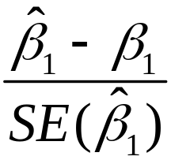1.96, –1.96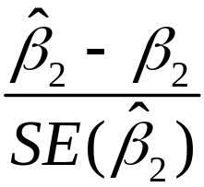1.96]
= Pr[|t₁|  1.96 and |t₂|  1.96]
= 1 – Pr[|t₁| > 1.96 and/or |t₂| > 1.96]  95% !
Why?
This confidence set “inverts” a test for which the size doesn’t equal the significance level!
Recall: the probability of incorrectly rejecting the null
= [|t₁| > 1.96 and/or |t₂| > 1.96]
= [|t₁| > 1.96, |t₂| > 1.96]
+ [|t₁| > 1.96, |t₂| ≤ 1.96]
+ [|t₁| ≤ 1.96, |t₂| > 1.96] (disjoint events)
= [|t₁| > 1.96]  [|t₂| > 1.96]
+ [|t₁| > 1.96]  [|t₂| ≤ 1.96]
+ [|t₁| ≤ 1.96]  [|t₂| > 1.96]
(if t₁, t₂ are independent)
= .05.05 + .05.95 + .95.05
= .0975 = 9.75% – which is not the desired 5%!!
Instead, use the acceptance region of a test that has size equal to its significance level (“invert” a valid test):

Let F(β_{1,0},β_{2,0}) be the (heteroskedasticity-robust) F-statistic testing the hypothesis that β₁ = β₁,₀ and β₂ = β_{2,0}:

95% confidence set = {β_{1,0}, β_{2,0}: F(β_{1,0}, β_{2,0}) < 3.00}

- 3.00 is the 5% critical value of the F_{2,} distribution
- This set has coverage rate 95% because the test on which it is based (the test it “inverts”) has size of 5%.
The confidence set based on the F-statistic is an ellipse
{β₁, β₂: F = ≤ 3.00}
Now
F = 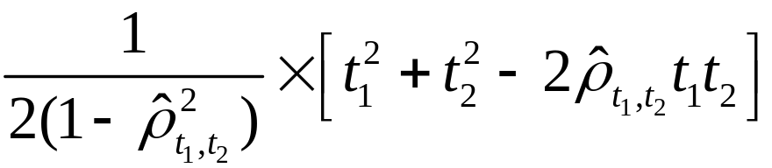
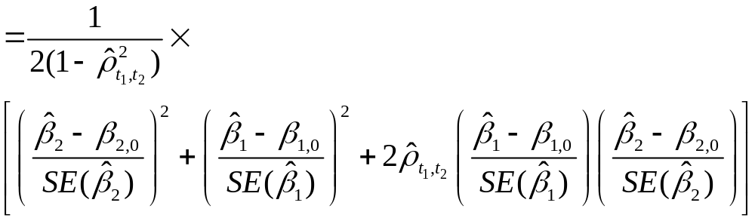This is a quadratic form in β_{1,0} and β_{2,0} – thus the boundary of the set F = 3.00 is an ellipse.
Confidence set based on inverting the F-statistic
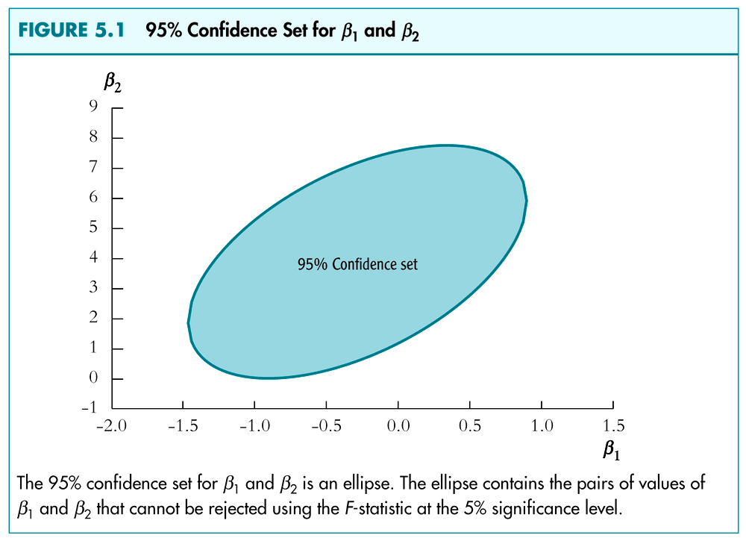

The R², SER, and 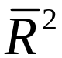 for Multiple Regression
(SW Section 5.10)

Actual = predicted + residual: Y_{i} = 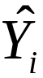 + 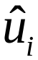

As in regression with a single regressor, the SER (and the RMSE) is a measure of the spread of the Y’s around the regression line:

SER = 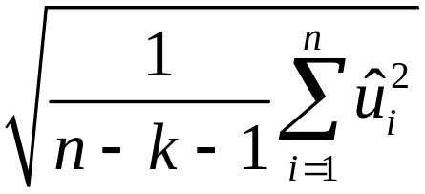
The R² is the fraction of the variance explained:
R² = 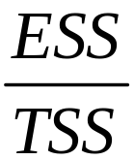 = 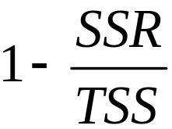,
where ESS = 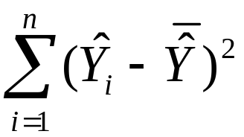, SSR = 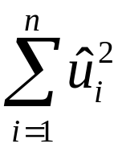, and TSS = 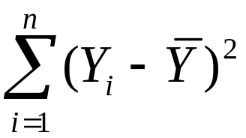 – just as for regression with one regressor.
- The R² always increases when you add another regressor – a bit of a problem for a measure of “fit”
- The corrects this problem by “penalizing” you for including another regressor:

= 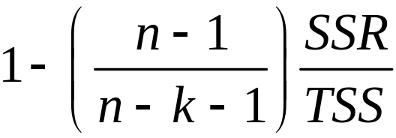 so < R²

How to interpret the R² and ?
- A high R² (or ) means that the regressors explain the variation in Y.
- A high R² (or ) does not mean that you have eliminated omitted variable bias.
- A high R² (or ) does not mean that you have an unbiased estimator of a causal effect (β₁).
- A high R² (or ) does not mean that the included variables are statistically significant – this must be determined using hypotheses tests.

Example: A Closer Look at the Test Score Data
(SW Section 5.11, 5.12)

A general approach to variable selection and model specification:
- Specify a “base” or “benchmark” model.
- Specify a range of plausible alternative models, which include additional candidate variables.
- Does a candidate variable change the coefficient of interest (β₁)?
- Is a candidate variable statistically significant?
- Use judgment, not a mechanical recipe…

Variables we would like to see in the California data set:

School characteristics:
- student-teacher ratio
- teacher quality
- computers (non-teaching resources) per student
- measures of curriculum design…

Student characteristics:
- English proficiency
- availability of extracurricular enrichment
- home learning environment
- parent’s education level…

Variables actually in the California class size data set:
- student-teacher ratio (STR)
- percent English learners in the district (PctEL)
- percent eligible for subsidized/free lunch
- percent on public income assistance
- average district income
A look at more of the California data
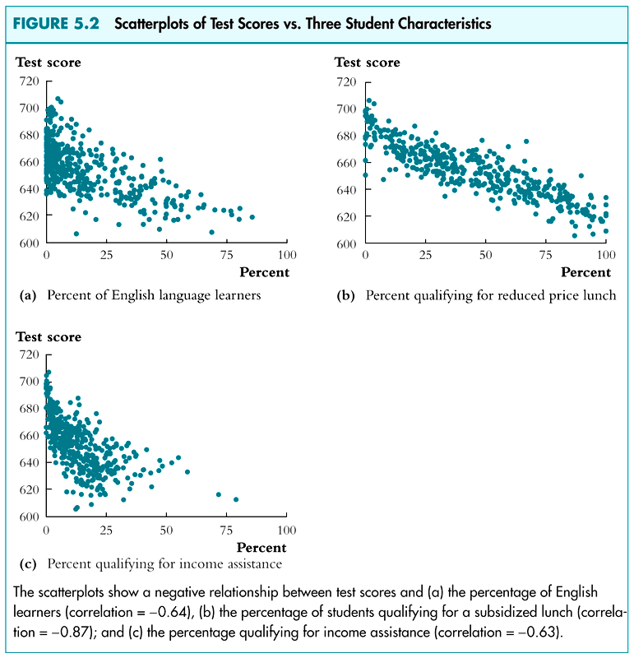
Digression: presentation of regression results in a table
- Listing regressions in “equation” form can be cumbersome with many regressors and many regressions
- Tables of regression results can present the key information compactly
- Information to include:
  - variables in the regression (dependent and independent)
  - estimated coefficients
  - standard errors
  - results of F-tests of pertinent joint hypotheses
  - some measure of fit
  - number of observations
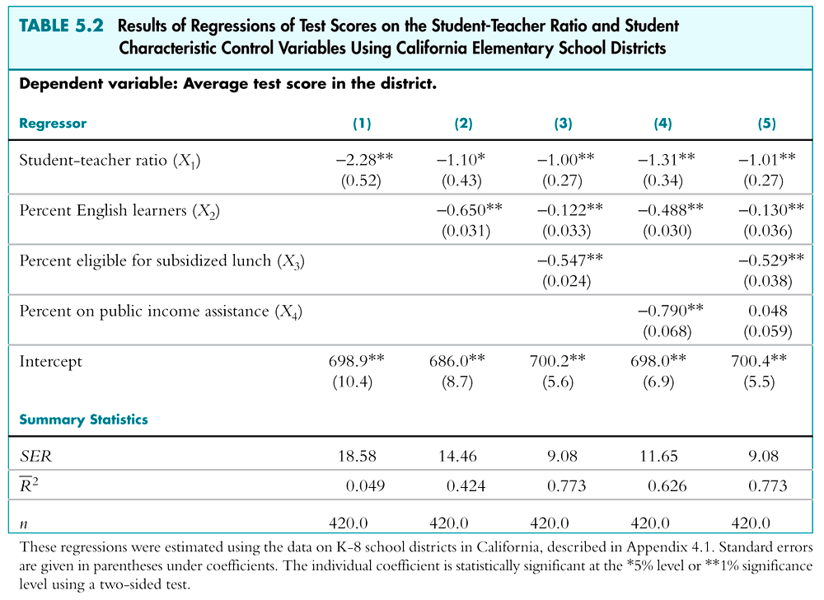

Summary: Multiple Regression

- Multiple regression allows you to estimate the effect on Y of a change in X1, holding X2 constant.
- If you can measure a variable, you can avoid omitted variable bias from that variable by including it.
- There is no simple recipe for deciding which variables belong in a regression – you must exercise judgment.
- One approach is to specify a base model – relying on a-priori reasoning – then explore the sensitivity of the key estimate(s) in alternative specifications.

