Assessing Studies Based on
Multiple Regression
(SW Ch. 7)

Multiple regression has some key virtues:
- It provides an estimate of the effect on Y of arbitrary changes ΔX.
- It resolves the problem of omitted variable bias, if an omitted variable can be measured and included.
- It can handle nonlinear relations (effects that vary with the X’s)
Still, OLS might yield a biased estimator of the true causal effect.
A Framework for Assessing Statistical Studies

Internal and External Validity
- Internal validity: the statistical inferences about causal effects are valid for the population being studied.
- External validity: the statistical inferences can be generalized from the population and setting studied to other populations and settings, where the “setting” refers to the legal, policy, and physical environment and related salient features.
Threats to External Validity

How far can we generalize class size results from California school districts?
- Differences in populations
  - California in 2005?
  - Massachusetts in 2005?
  - Mexico in 2005?
- Differences in settings
  - different legal requirements concerning special education
  - different treatment of bilingual education
  - differences in teacher characteristics
Threats to Internal Validity of
Multiple Regression Analysis
(SW Section 7.2)

Internal validity: the statistical inferences about causal effects are valid for the population being studied.
Five threats to the internal validity of regression studies:
- Omitted variable bias
- Wrong functional form
- Errors-in-variables bias
- Sample selection bias
- Simultaneous causality bias
All of these imply that E(u_{i}|X_{1i},…,X_{ki})  0.
1. Omitted variable bias
Arises if an omitted variable both (i) is a determinant of Y and (ii) is correlated with at least one included regressor.

Potential solutions to omitted variable bias
- If the variable can be measured, include it as a regressor in multiple regression;
- Possibly, use panel data in which each entity (individual) is observed more than once;
- If the variable cannot be measured, use instrumental variables regression;
- Run a randomized controlled experiment.
2. Wrong functional form
Arises if the functional form is incorrect – for example, an interaction term is incorrectly omitted; then inferences on causal effects will be biased.

Potential solutions to functional form misspecification

- Continuous dependent variable: use the “appropriate” nonlinear specifications in X (logarithms, interactions, etc.)
- Discrete (example: binary) dependent variable: need an extension of multiple regression methods (“probit” or “logit” analysis for binary dependent variables).
3. Errors-in-variables bias

So far we have assumed that X is measured without error.
In reality, economic data often have measurement error
- Data entry errors in administrative data
- Recollection errors in surveys (when did you start your current job?)
- Ambiguous questions problems (what was your income last year?)
- Intentionally false response problems with surveys (What is the current value of your financial assets? How often do you drink and drive?)

In general, measurement error in a regressor results in “errors-in-variables” bias.

Illustration: suppose

Y_{i} = β₀ + β₁X_{i} + u_{i}

is “correct” in the sense that the three least squares assumptions hold (in particular E(u_{i}|X_{i}) = 0).

Let
X_{i} = unmeasured true value of X
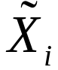 = imprecisely measured version of X
Then
Y_{i} = β₀ + β₁X_{i} + u_{i}
= β₀ + β₁ + [β₁(X_{i} – ) + u_{i}]
or
Y_{i} = β₀ + β₁ + 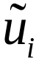, where = β₁(X_{i} – ) + u_{i}

If is correlated with then 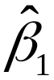 will be biased:
cov(,) = cov(,β₁(X_{i} – ) + u_{i})
= β₁cov(,X_{i} – ) + cov(,u_{i})
= β₁[cov(,X_{i}) – var()] + 0  0

because in general cov(,X_{i})  var().

Y_{i} = β₀ + β₁ + , where = β₁(X_{i} – ) + u_{i}

- If X_{i} is measured with error, is in general correlated with , so is biased and inconsistent.
- It is possible to derive formulas for this bias, but they require making specific mathematical assumptions about the measurement error process (for example, that and X_{i} are uncorrelated). Those formulas are special and particular, but the observation that measurement error in X results in bias is general.
Potential solutions to errors-in-variables bias

- Obtain better data.
- Develop a specific model of the measurement error process.
- This is only possible if a lot is known about the nature of the measurement error – for example a subsample of the data are cross-checked using administrative records and the discrepancies are analyzed and modeled. (Very specialized; we won’t pursue this here.)
- Instrumental variables regression.

4. Sample selection bias

So far we have assumed simple random sampling of the population. In some cases, simple random sampling is thwarted because the sample, in effect, “selects itself.”

Sample selection bias arises when a selection process (i) influences the availability of data and (ii) that process is related to the dependent variable.

Example #1: Mutual funds
- Do actively managed mutual funds outperform “hold-the-market” funds?
- Empirical strategy:
  - Sampling scheme: simple random sampling of mutual funds available to the public on a given date.
  - Data: returns for the preceding 10 years.
  - Estimator: average ten-year return of the sample mutual funds, minus ten-year return on S&P500
  - Is there sample selection bias?
Sample selection bias induces correlation between a regressor and the error term.

Mutual fund example:

return_{i} = β₀ + β₁managed_fund_{i} + u_{i}

Being a managed fund in the sample (managed_fund_{i} = 1) means that your return was better than failed managed funds, which are not in the sample – so corr(managed_fund_{i},u_{i})  0.

Example #2: returns to education
- What is the return to an additional year of education?
- Empirical strategy:
  - Sampling scheme: simple random sampling of workers
  - Data: earnings and years of education
  - Estimator: regress ln(earnings) on years_education
  - Ignore issues of omitted variable bias and measurement error – is there sample selection bias?

Potential solutions to sample selection bias

- Collect the sample in a way that avoids sample selection.
  - Mutual funds example: change the sample population from those available at the end of the ten-year period, to those available at the beginning of the period (include failed funds)
  - Returns to education example: sample college graduates, not workers (include the unemployed)
- Randomized controlled experiment.
- Construct a model of the sample selection problem and estimate that model (we won’t do this).
5. Simultaneous causality bias

So far we have assumed that X causes Y.
What if Y causes X, too?

Example: Class size effect
- Low STR results in better test scores
- But suppose districts with low test scores are given extra resources: as a result of a political process they also have low STR
- What does this mean for a regression of TestScore on STR?

Simultaneous causality bias in equations

(a) Causal effect of X on Y: Y_{i} = β₀ + β₁X_{i} + u_{i}

(b) Causal effect of Y on X: X_{i} = γ₀ + γ₁Y_{i} + v_{i}

- Large u_{i} means large Y_{i}, which implies large X_{i} (if γ₁>0)
- Thus corr(X_{i},u_{i})  0
- Thus is biased and inconsistent.
- Ex: A district with particularly bad test scores given the STR (negative u_{i}) receives extra resources, thereby lowering its STR; so STR_{i} and u_{i} are correlated
Potential solutions to simultaneous causality bias

- Randomized controlled experiment. Because X_{i} is chosen at random by the experimenter, there is no feedback from the outcome variable to Y_{i} (assuming perfect compliance).
- Develop and estimate a complete model of both directions of causality. This is the idea behind many large macro models (e.g. Federal Reserve Bank-US). This is extremely difficult in practice.
- Use instrumental variables regression to estimate the causal effect of interest (effect of X on Y, ignoring effect of Y on X).
Applying this Framework: Test Scores and Class Size
(SW Chapter 7.3)

Objective: Assess the threats to the internal and external validity of the empirical analysis of the California test score data.

- External validity
  - Compare results for California and Massachusetts
  - Think hard…
- Internal validity
  - Go through the list of five potential threats to internal validity and think hard…
Check of external validity
compare the California study to one using Massachusetts data

The Massachusetts data set
- 220 elementary school districts
- Test: 1998 MCAS test – fourth grade total (Math + English + Science)
- Variables: STR, TestScore, PctEL, LunchPct, Income
The Massachusetts data: summary statistics
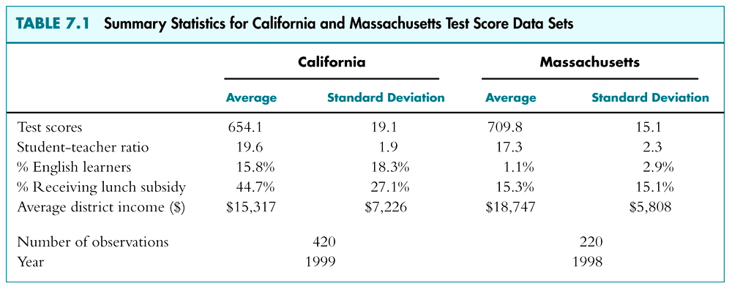
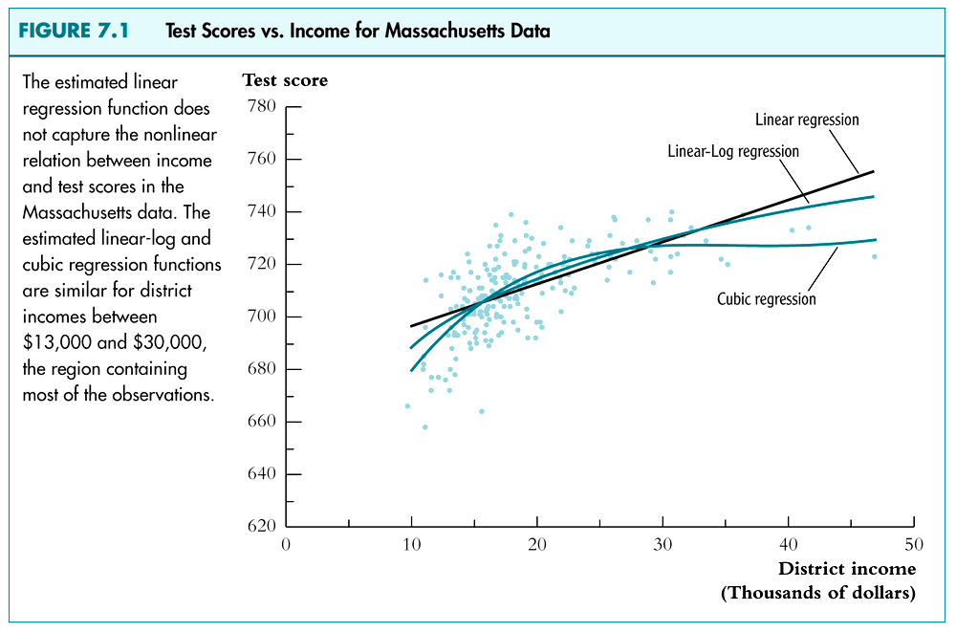
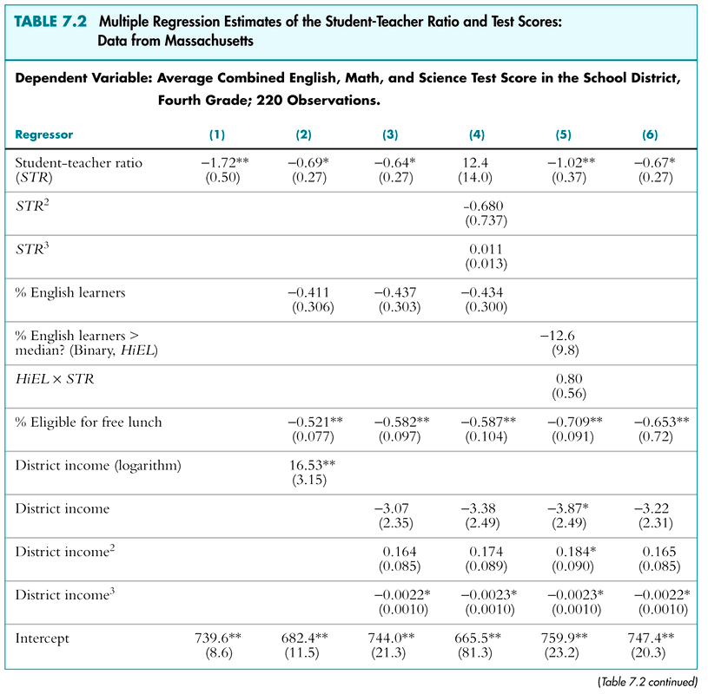
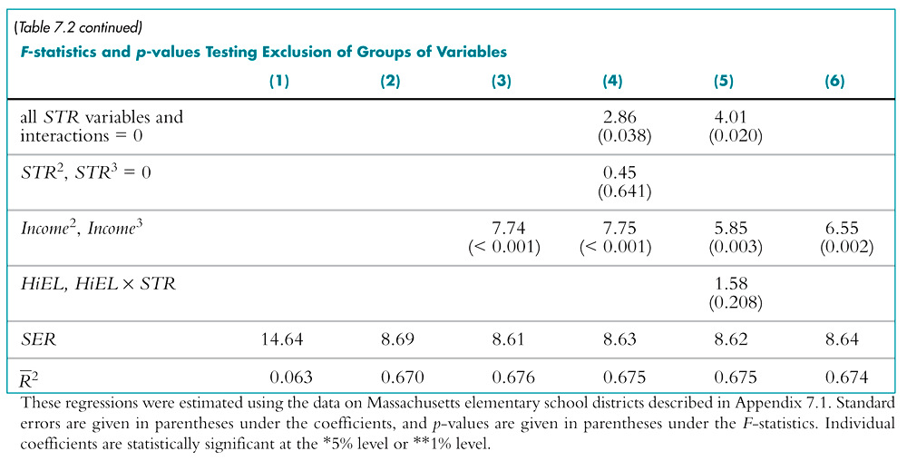
- Logarithmic v. cubic function for STR?
- Evidence of nonlinearity in TestScore-STR relation?
- Is there a significant HiELSTR interaction?
Predicted effects for a class size reduction of 2
Linear specification for Mass:

 = 744.0 – 0.64STR – 0.437PctEL – 0.582LunchPct
(21.3) (0.27) (0.303) (0.097)

– 3.07Income + 0.164Income² – 0.0022Income³
(2.35) (0.085) (0.0010)
Estimated effect = -0.64(-2) = 1.28
Standard error = 20.27 = 0.54
NOTE: var(aY) = a²var(Y); SE(a) = |a|SE()
95% CI = 1.28  1.960.54 = (0.22, 2.34)
Computing predicted effects in nonlinear models
Use the “before” and “after” method:

= 655.5 + 12.4STR – 0.680STR² + 0.0115STR³
– 0.434PctEL – 0.587LunchPct
– 3.48Income + 0.174Income² – 0.0023Income³
Estimated reduction from 20 students to 18:
Δ = [12.420 – 0.68020² + 0.011520³]
– [12.418 – 0.68018² + 0.011518³] = 1.98
- compare with estimate from linear model of 1.28
- SE of this estimated effect: use the “rearrange the regression” (“transform the regressors”) method
Summary of Findings for Massachusetts

- Coefficient on STR falls from –1.72 to –0.69 when control variables for student and district characteristics are included – an indication that the original estimate contained omitted variable bias.
- The class size effect is statistically significant at the 1% significance level, after controlling for student and district characteristics
- No statistical evidence on nonlinearities in the TestScore – STR relation
- No statistical evidence of STR – PctEL interaction

Comparison of estimated class size effects: CA vs. MA
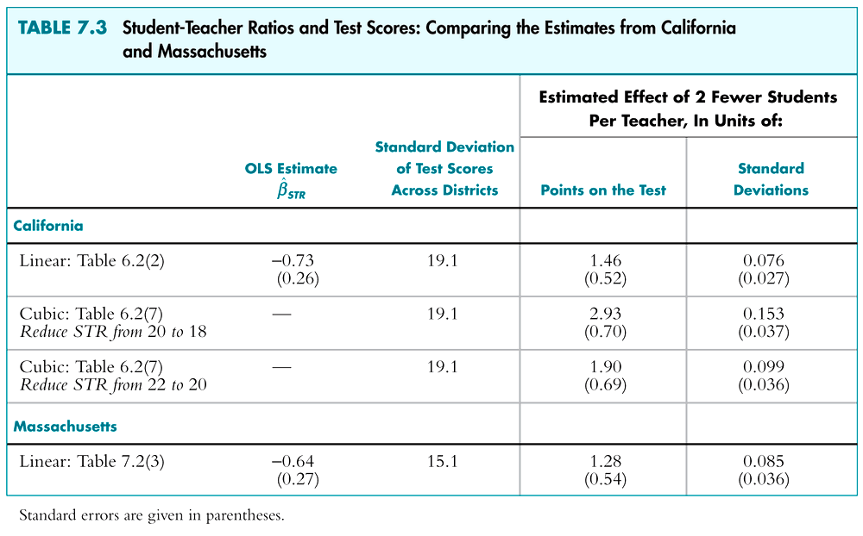
Summary: Comparison of California and Massachusetts Regression Analyses

- Class size effect falls in both CA, MA data when student and district control variables are added.
- Class size effect is statistically significant in both CA, MA data.
- Estimated effect of a 2-student reduction in STR is quantitatively similar for CA, MA.
- Neither data set shows evidence of STR – PctEL interaction.
- Some evidence of STR nonlinearities in CA data, but not in MA data.
Remaining threats to internal validity
What the CA v. MA comparison does and doesn’t show

1. Omitted variable bias
This analysis controls for:
- district demographics (income)
- some student characteristics (English speaking)
What is missing?
- Additional student characteristics, for example native ability (but is this correlated with STR?)
- Access to outside learning opportunities
- Teacher quality (perhaps better teachers are attracted to schools with lower STR)
Omitted variable bias, ctd.

- We have controlled for many relevant omitted factors;
- The nature of this omitted variable bias would need to be similar in California and Massachusetts to be consistent with these results;
- In this application we will be able to compare these estimates based on observational data with estimates based on experimental data – a check of this multiple regression methodology.

2. Wrong functional form
- We have tried quite a few different functional forms, in both the California and Mass. data
- Nonlinear effects are modest
- Plausibly, this is not a major threat at this point.

3. Errors-in-variables bias
- STR is a district-wide measure
- Presumably there is some measurement error – students who take the test might not have experienced the measured STR for the district
- Ideally we would like data on individual students, by grade level.
4. Selection
- Sample is all elementary public school districts (in California; in Mass.)
- no reason that selection should be a problem.

5. Simultaneous Causality
- School funding equalization based on test scores could cause simultaneous causality.
- This was not in place in California or Mass. during these samples, so simultaneous causality bias is arguably not important.
Summary

- Framework for evaluating regression studies:
  - Internal validity
  - External validity
- Five threats to internal validity:
- Omitted variable bias
- Wrong functional form
- Errors-in-variables bias
- Sample selection bias
- Simultaneous causality bias
- Rest of course focuses on econometric methods for addressing these threats.

