Transcript: Foreign Policy Lecture

[ON LOCATION, BOSTON WATERFRONT]
THOMAS PATTERSON: When Americans think of national security, they tend to think in terms of military threats.
But national security is also a question of maintaining a nation's way of life, where the people have the jobs and the goods that they're accustomed to.
Increasingly, we've asked that question in the context of international trade. Many of the goods that we buy come from abroad. Each day, about six million containers of the kind that you can see behind me arrive in the United States from other countries carrying everything from television sets to clothes to toys, you name it.
That globalized economy has turned out to be both a challenge and an opportunity for the United States.
The United States has important comparative advantages. We have a strong tech sector, and we have the most fertile agricultural sector in the world. Those two sectors through international trade have generated millions of American jobs. But we also have comparative disadvantages. The wage scale in the United States is much higher than it is in countries like China and India and Guatemala. That means that those goods often can be produced more cheaply abroad.
That's good for consumers. We pay less for the goods we buy as a result, but it also means that millions of American jobs have been lost to foreign firms.
The fact that global trade involves winners and losers has made it one of the most important policy issues of our time.
#
[STUDIO PORTION]
US foreign policy is rooted in what's called the national interest, the conditions necessary to protect American security and well-being.
President Dwight D. Eisenhower described the national interest as well as anyone. Said Eisenhower, "We do not keep security establishments merely to defend property or territory or rights abroad or at sea. We keep the security forces to defend a way of life."
In previous sessions, we discussed how diplomacy and national defense fit into America's foreign policy.
Here, we'll concentrate on foreign trade, examining America's emergence as a global economic power, the connection between trade and national security, and the emergence of free trade as a cornerstone of contemporary US foreign policy.
At the end of World War II, the United States was the world's strongest military power, and its strongest economic power. Large parts of Europe and Asia had been devastated by the war, whereas America's manufacturing sectors were intact.
The US economy was generating half of all the world's goods and services, and the American dollar had replaced the British pound as the leading international currency.
The United States took the lead role in rebuilding Western Europe and Japan. The most ambitious effort was the Marshall Plan, which provided more than $150 billion in today's dollars for European reconstruction.
When the Marshall Plan concluded in 1952, the economy of every European country was stronger than it was before the war.
That situation was a godsend for US companies. As European nations recovered, so did their demand for American made products.
American investors were also active. Before the war, they had concentrated on domestic projects, but after the war, looked overseas as well, including the oil rich Middle East. Arab states needed capital and technical know-how to open new fields, and American oilmen were happy to oblige.
Underlying these activities was a conviction among US policymakers that the global economy was a key to America's security. Trade would make nations mutually dependent, diminishing the likelihood they would resort to conflict.
Now, America's economic vitality was also a key to containing Soviet expansionism.
After World War II, the Soviet Union had orchestrated communist takeovers in Poland, Hungary, Czechoslovakia, and other countries in Eastern Europe.
President Harry S. Truman responded with a policy of containment. The West, led by the United States, would contest Soviet expansionism at every turn.
Military power was part of that strategy. In 1949, the United States took the lead in creating the North Atlantic Treaty Organization, or NATO, a defense alliance that included 10 Western European countries and Canada. NATO's first secretary general said that the alliance was formed to “keep the Russians out and the Americans in.” Americans were indeed "in" in Europe. 300,000 US troops were permanently stationed there.
Whereas the United States had fully demobilized after World War I, it did not do so after World War II, maintaining a large military establishment and a permanently high level of defense spending.
Even today, the United States spends far more on defense than any nation, more than four times that of China, the next highest spender.
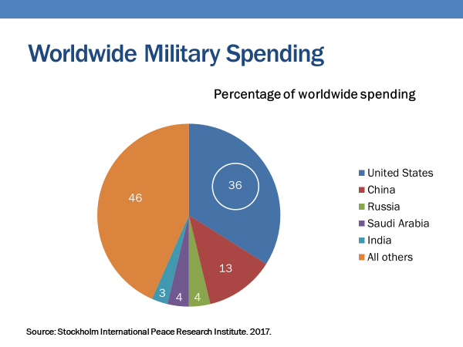
Containment policy also aimed at keeping the Soviet Union out of the global economy. The Soviet economy would be marginalized, denied access to Western capital, technology, and markets.
In the long run, that proved decisive. When the Soviet Union collapsed from within in 1991, it did so largely because its economy was in shambles.
America's postwar strategy also included financial support for developing countries. The US took the lead in forming and funding the International Monetary Fund, or IMF, which makes short term loans to countries experiencing economic problems, and the World Bank, which makes long term development loans to poor countries for capital investment projects, such as dams, highways, factories.
These financial instruments, along with direct US financial aid and investment, were aimed at helping developing countries expand their economies, which would increase the demand for goods made in the United States and elsewhere.
In these various actions, the United States acted as had no conquering power in world history. Rather than seizing the territory of its defeated enemies, it helped them rebuild.
Yet, there were some dark chapters too.
In 1953 in Iran, and a year later in Guatemala, the United States helped sponsor coups that replaced democratically elected leaders with military dictators. In each case, the coup came at the demand of business firms, an oil consortium in Iran, and United Fruit in Guatemala that had been exploiting the host country, and had been more tightly regulated when the elected government came into office.
Now, by the 1950s, Americans were in the midst of a period of sustained growth and prosperity.
US firms were still producing more than 40% of the world's total goods and services, and good paying jobs were plentiful.
Nevertheless, America's postwar economic position was unsustainable. As the European and Japanese economies strengthened, they increasingly looked to sell their goods in foreign markets. By 1960, Germany accounted for a sixth of industrialized nations manufacturing output.
Japan's productivity was lower, but by 1970, it was accounting for an eighth of the output.
In other words, America's trading partners had also become its trading rivals.
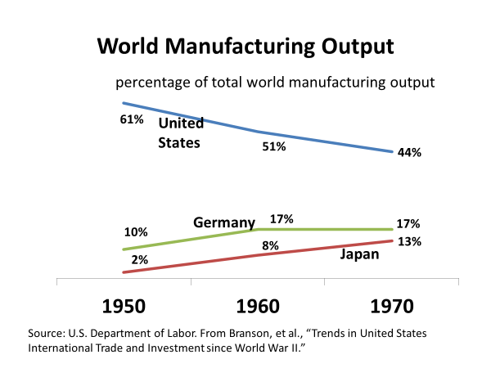
As you can see from this chart, the United States through the 1960s was a net exporter, meaning it was selling more goods abroad than it was importing.
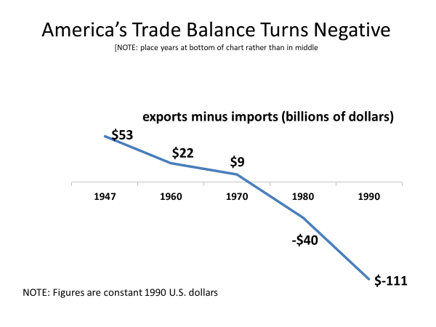
By the early 1970s, the US balance of trade had leveled out. Each year since, the United States has had a negative balance of trade, consuming more goods from abroad than it was shipping overseas.
The 1970s were also a tipping point in other ways. As the Vietnam War dragged on, the limits of US military power had become clear. The Korean War two decades earlier had ended in stalemate, and Vietnam would end with an American defeat.
President Richard Nixon declared that the United States would no longer act as the free world's lone ranger, fighting localized wars to contain communist threats that posed no immediate danger to America's security.
Nixon also sought to reduce tensions with the Soviet Union. He initiated the Strategic Arms Limitation Talks, or SALT, which resulted in cutbacks in the US and Soviet nuclear arsenals.
Then in 1972, Nixon visited the People's Republic of China, the first official contact with that country since the communists seized power in 1949.
The Vietnam War also contributed to a major change in US economic policy.
The war had produced budget deficits and sparked an inflationary spiral, prompting Nixon to take the United States off the gold standard in 1971. Up to that point, a country could demand gold for the dollars it had accumulated through trade with the United States. By eliminating the gold standard, the United States would not face that burden. The price of the dollar would now be determined by its value relative to other currencies. Its value would float, going up or down depending on the strength of the nation's economy and those of other nations.
Given the dollar's position as the world's leading currency, the advantages of letting it float easily outweighed the advantages of pegging its value to gold. US policymakers didn't have to worry that other nations would refuse to accept paper dollars. They were in demand everywhere.
Moreover, the US now had greater flexibility during economic downturns to pump paper money into the economy without worrying that it would drain the nation's gold reserves.
In addition, devaluation of the dollar was a way to improve the balance of trade.
When the dollar depreciates, it drops in value relative to other currencies, which means that goods made in the United States are less expensive abroad.
By the 1980s, the American and world economies had changed fundamentally from what they were in the years immediately after World War II. There was vastly more market competition between countries, and business practices had evolved.
Business firms had become international players in their own right. Changes in communication and transportation had made it easier for them to conduct operations without regard for national borders. A firm could be headquartered in New York with its factories in Thailand, giving it the best of both worlds, access to management and finance in New York and access to low wage workers in Thailand. Why pay high wages to American workers when the same goods could be produced less expensively abroad and shipped back to US markets?
An obstacle to the success of this production strategy was tariffs. Tariffs are taxes imposed on imported goods. High tariffs on goods produced abroad could wipe out the savings from making them there.
America's multinational corporations began to pressure lawmakers to adopt free trade agreements, which would reduce or eliminate barriers to trade, including tariffs. They found a rhetorical ally in Republican president Ronald Reagan, who declared, "Our trade policy rests firmly on the foundation of free and open markets. I recognize the inescapable conclusion that all of history has taught, the freer the flow of World Trade, the stronger the tides of human progress and peace among nations."
Nevertheless, Reagan's rhetoric wasn't quite matched by his actions. For instance, he successfully persuaded Japan to voluntarily restrict its auto imports as a means of protecting domestic US automakers.
Economists were also preaching the benefits of free trade. Their research showed that free trade was a net economic gain for industrialized countries, largely because of the job losses to lower wage countries were more than offset by the savings to consumers of lower cost consumer goods, such as TVs, clothes, and cars.
A survey of US economists found that seven in every eight agreed that the United States should eliminate remaining tariffs and other barriers to trade.
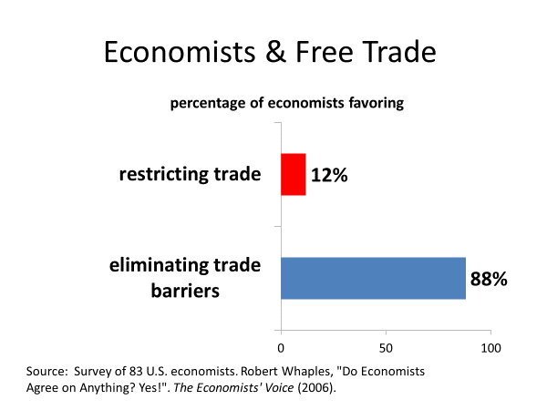
A third force behind the push for free trade was the increased power of Republican lawmakers, who because of their party's ties to business, are more supportive than Democrats of free trade. In the 1960s and 1970s, congressional Republicans were far outnumbered by Democrats. But by the early '80s, they had staged a strong comeback. They had taken control of the Senate and had narrowed the gap in the house.
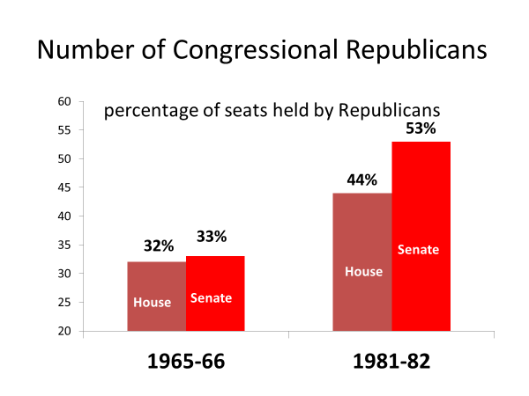
Developments elsewhere also added to the momentum behind free trade. European nations were on a path to economic integration, a passport free Europe with few tariffs on trade. As a result, trade between European countries was increasing, with American products being squeezed out because they were more expensive.
Upon taking office in 1989, president George H.W. Bush committed to negotiating a trade agreement that would serve as America's answer to Europe. It was NAFTA, the North American Free Trade Agreement, a trade compact involving the United States, Canada, and Mexico.
NAFTA would result in the immediate elimination of a wide range of three nations tariffs and the gradual elimination of nearly all the rest.
Bush lacked the authority to implement NAFTA on his own. Congress has constitutional authority over tariffs and commerce with other nations, so it would have to approve the agreement.
That was not a sure thing. Free trade can look different to a member of Congress than it does to a president.
From a White House perspective, free trade is a winning formula in that it's likely to boost national economic growth.
To members of Congress on the other hand, free trade is a question of its impact on their constituency. Although most members of Congress say they support free trade in principle, they don't always do so when confronted with an actual trade agreement. If the agreement will harm a major interest in their district or state, they sometimes opt for protectionism, the use of tariffs or other trade barriers to protect the domestic company from foreign competitors.
As it happened, President Bush was no longer in office when NAFTA came up for a vote in Congress. He had lost his bid for a second presidential term, the Democrat, Bill Clinton. That complicated the issue.
With their ties to business, Republican lawmakers tend to be strong advocates of free trade. Democratic lawmakers tend to be less supportive because of their ties to labor groups, which regard free trade as a threat to jobs.
Organized labor had come out strongly against NAFTA, believing that American jobs would be lost to lower paid Mexican workers.
Labor groups threatened to withhold election support from any Democratic lawmaker who backed NAFTA. Environmental groups, another Democratic constituency, were also opposed, citing Mexico's weak environmental protection laws.
Nevertheless, after studying the issue, Clinton came out in favor of NAFTA, concluding it would foster economic growth. Said Clinton, "NAFTA means jobs, American jobs, and good paying American jobs. If I didn't believe that, I wouldn't support this agreement."
Clinton's support was crucial. If Clinton, instead of rallying Democratic members of Congress to support NAFTA, had vigorously opposed it, it might have been defeated in Congress. And even if it had passed, Clinton could have vetoed it.
When NAFTA was voted on in Congress in 1993, it had overwhelming Republican support in both chambers, and enough support from the Democratic majority in each chamber to pass easily, even though the House vote was somewhat close, 55% in favor to 45% opposed.
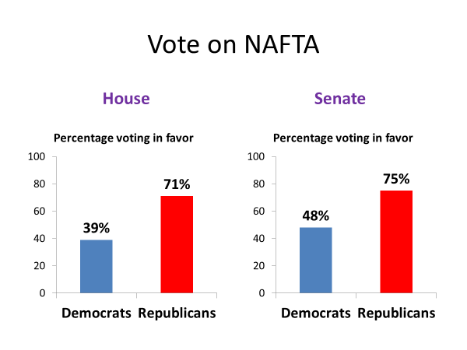
A similar scenario played out in the case of the three most recent major trade agreements, pacts with Colombia, Panama, and Korea.
They were initiated by the second President Bush, a Republican like his father, and passed into law when a Democrat, Barack Obama, was President.
Obama argued that the agreements individually and collectively would increase American exports, benefiting US firms and workers alike.
All three agreements passed Congress in 2011.
Each had the overwhelming support of Republican lawmakers, and enough support from congressional Democrats to pass comfortably. In each case, though, the vote was much closer in the House than in the Senate.
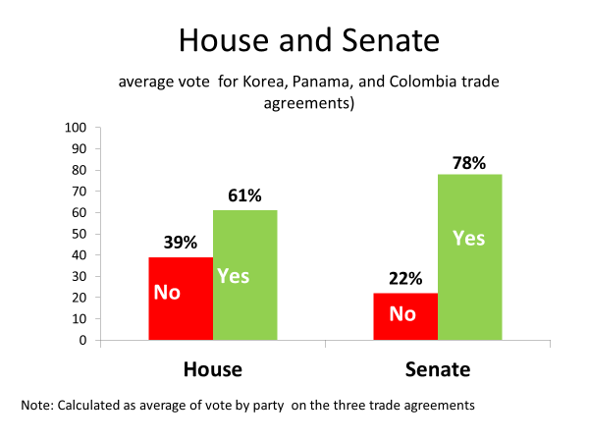
Now, why do you think that was the case?
You think it was closer in the house mostly because the House has traditionally played a much smaller role than the Senate in foreign affairs, and thus, House members are less likely than senators to take a national perspective on foreign policy issues?
Or do you think it's because House members represent a district within the state, whereas senators represent the entire state?
It's the second one.
Because house members represent smaller constituencies, there's a greater likelihood that a particular interest will be a large part of its economy. If such an interest is adversely affected by a trade agreement, the House member may oppose it.
Here's a map that shows the district by district House votes on the Korean trade agreement. Notice the large number of no votes in southern Virginia and in North and South Carolina. Most House members from these areas, Republicans as well as Democrats, voted against the Korean trade agreement. These geographical areas contain much of what's left of America's textile industry. The Korean trade agreement was a threat to this industry because Korea is the leading textile manufacturer. And their products would have a price advantage over American competitors if the tariff was eliminated through the trade agreement.
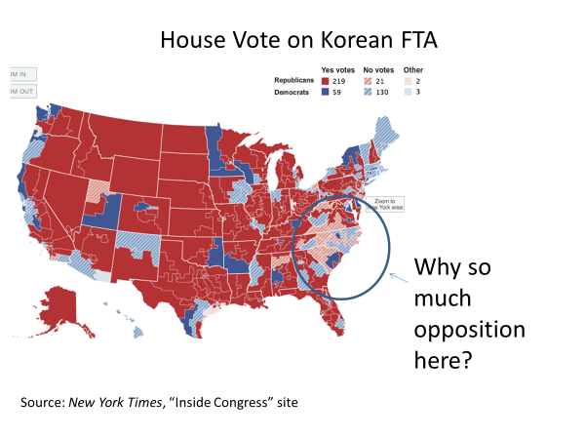
Now, here's a chart you've seen in previous sessions. It's based on the cost and benefits of public policies.
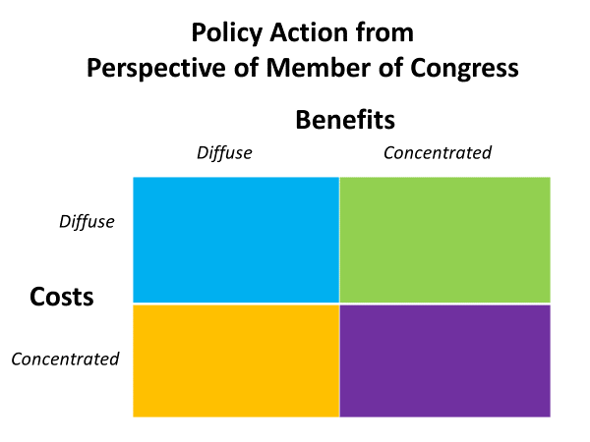
The cost and benefits can be concentrated, that is, focused on a particular interest, or they can be diffuse, that is, spread across the society.
Look at the chart for a moment to locate the cell that describes where the Korean trade agreement would be from the perspective of a House member from the areas we just identified.
It fits in the category of concentrated costs and diffused benefits.
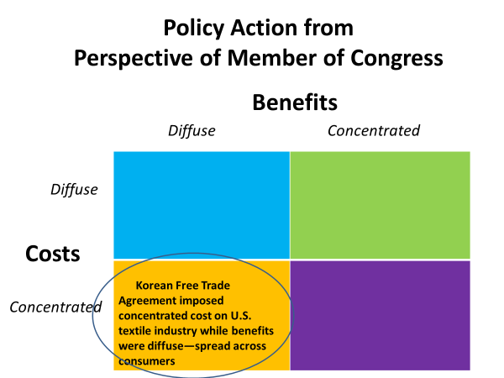
The Korean trade agreement would impose costs on textile firms, while the benefits would be diffused across the consuming public.
Elected officials are wary of backing such policies. They get little credit for doing so while risking loss of support from those hurt by the policy.
In 2017, in one of his first acts as President, Donald Trump killed a free trade agreement that had been negotiated by the Obama administration. It would have created a trading partnership involving the United States and 10 other countries bordering on the Pacific Ocean.
Trump claimed the agreement would result in huge job and manufacturing losses.
Opponents criticized Trump as shortsighted, noting that the decline in the US manufacturing sector began decades ago, and is due largely to factors other than free trade. They claim that the main effect of killing their agreement would be higher prices for consumers.
Opponents also had another argument, one based on national security, for why they viewed Trump's action as a mistake. The free trade agreement would have linked the United States more closely with a number of Asian countries, helping to offset China's growing presence in that region.
In the past decade, China has greatly expanded its economic reach, including sponsoring infrastructure and commercial projects in Asian countries for the purpose of drawing them into its sphere of influence.
To a lesser extent, China has been pursuing the same strategy in Africa, South America, and the Middle East.
The relationship between China and the United States is complex. For one thing, the American and Chinese economies are closely tied. China accounts for a sixth of all US trade. Roughly 80% of that trade consists of imports from China. Only 20% is accounted for by US exports to China.
That trade imbalance has existed for years, with the effect that China holds more than $1 trillion in US treasury bonds, the largest such holding in the world.
China's growing wealth has enabled it to enlarge its navy. It was structured to protect China's territorial waters, but is being reconfigured to operate throughout the Pacific Ocean.
In recent years, China has aggressively pursued claims to islands held by Japan, Vietnam, and the Philippines. In 2014, for example, it deployed its navy to protect the Chinese rig drilling for oil in waters off the coast of Vietnam.
China has pointedly refused to recognize international laws governing the oceans, and has laid claim to waters far beyond its coastline. China's claim is set forth in its so-called nine dash line, which runs down the full length of Vietnam, nearly to Malaysia, and then back up past the Philippines.
In response to China's actions, the United States has enlarged its Pacific fleet, and recently signed a mutual defense treaty with the Philippines.
Nevertheless, it's unclear whether a serious provocation by China would be met with a forceful response from the United States. That option seems almost unthinkable, given the importance of China to the US economy.
And it seems unlikely that China would want to start a fight with the United States. Although its navy is expanding, it's vastly overmatched by the US Navy. China, for example, has one aircraft carrier, while the United States has 10 plus 2 in reserve.
China's growing use of military and economic power is reminiscent of the path the United States followed after World War II, when it leveraged its military and economic power to shape the world in ways more to its liking.
But there's a difference between today and then that many analysts believe will allow China's rise to power to be a relatively peaceful one.
The old system that the United States replaced after World War II was based on imperial rivalries that contributed to the Franco-Prussian wars of the late 1800s, and then to World Wars I and II.
That system had been set up in a way that blocked the rise to power of any country that threatened the existing power structure.
The international system that the United States helped construct after World War II is designed differently. It is meant to be inclusive, to allow nations to emerge and be welcomed into the larger world community.
In fact, China has already benefited substantially from that system. When it opened itself to world markets, it unleashed a massive economic growth that has brought it to the position it holds today. Rather than being blocked by the west, China has been asked to be a full partner in the international community. It has been granted a seat on the Security Council and has been admitted to the WTO.
Today's system is probably the thing that's most likely to keep China on a peaceful path. It can realize its ambitions by working within the system's rules and institutions.
The major uncertainty surrounding US relations with China and also with other nations is President Donald Trump's America first policy, which is more confrontational and less international than the policies pursued by other post-World War II presidents.
In addition to withdrawing the United States from the Trans-Pacific Partnership, and threatening to pull out of NAFTA, Trump has imposed tariffs on steel aluminum and other goods, including those of traditional allies like Canada. They've responded by placing tariffs on American exports.
It's unclear at this moment how far the Trump administration will go in pursuing such policies, but President Trump does not share previous presidents' belief that the United States has a special role in promoting international cooperation.
#
OK, let's summarize what's been said in this session.
We began with a look at developments after World War II, where the United States had overwhelming military and economic power, and used it to create a global trading system and to assist in the reconstruction of countries devastated by the war.
They gradually emerged as trading rivals, as well as trading partners of the United States. By the 1970s, America's dominant position in world trade had given way to a more evenly balanced system.
It was also a time when the United States reached out to relax tensions with the Soviet Union and China, and took itself off the gold standard.
By the 1980s, pressures for free trade coming from business firms, economists, and political leaders were building. And in 1993, Congress passed the country's first major free trade agreement, the North American Free Trade Agreement, NAFTA.
The momentum toward free trade has slowed recently over concern about its impact on American firms and jobs.
Nevertheless, free trade remains a component of US foreign policy, stemming from the notion that strong trade relations, in addition to their economic benefits, draw nations closer together, diminishing the likelihood of conflict between them.
We ended with a look at US-China relations, noting their economic interdependence, but also noting their rivalry for power, particularly in the Asia-Pacific region.
We suggested that if that rivalry remains peaceful, much of the credit will go to the inclusive international economic and governing system that the United States helped create after the Second World War.

