Draft Chapter for:
Managing Volatility and Crises
A Practitioner’s Guide
March 2004

Managing Macroeconomic Crises: Policy Lessons*

by

Jeffrey Frankel (Harvard University) and Shang-Jin Wei (IMF)

Peer Reviewers: Barry Eichengreen (University of California at Berkeley)
and Robert P. Flood Jr. (IMF)

Abstract

This study is an attempt to review broadly what the last decade reveals about which policies for crisis prevention or crisis management seem to work and which do not. The empirical investigation tries out a variety of methodological approaches: reasoning from examples of prominent crises of the last eight years, formal probit analysis, a regression tree analysis, conventional regression analysis, and a look at the typical profile of financing during the sudden stop preceding a crisis.

The authors seek to draw greater attention to policy decisions that are made during the phase when capital inflows come to a sudden stop. Procrastination---the period of financing a balance of payments deficit rather than adjusting---had serious consequences in some cases. Crises are more frequent and more severe when short-term borrowing and dollar denomination external debt are high, and foreign direct investment (FDI) and reserves are low, in large part because balance sheets are then very sensitive to increases in exchange rates and short-term interest rates.

Our point is that these compositional measures are affected by decisions made by policymakers in the period immediately after capital inflows have begun to dry up but before the speculative attack itself has hit. If countries that are faced with a fall in inflows adjusted more promptly, rather than stalling for time by running down reserves or shifting to loans that are shorter-termed and dollar-denominated, they might be able to adjust on more attractive terms.

* The authors wish to thank Harvard University students Yannis Itokatlidis, Evren Pacalioglu, Li Zeng, and especially Dora Douglass for very capable research assistance; and Joshua Aizenman and Brian Pinto (World Bank) for useful comments. Shang-Jin Wei contributed to this chapter before joining the staff of the International Monetary Fund (IMF). The views expressed do not necessarily reflect the views or policies of the IMF.
In the last 30 years, emerging markets have experienced at least two complete boom-bust cycles. The last cycle was marked by rapid capital inflows from 1990 to 1996, followed by severe crises for some countries and scarce capital for all from 1997 to 2003. This cycle bore similarities to the preceding 14 years, as well: large loans to developing countries from 1975 to 1981, followed by the international debt crisis of 1982--89. Despite this volatility, many developing countries---although certainly not all---have ended this 30-year period with a far higher level of per capita income than they began it.

Taking Stock of Recent History

It is a good time to take stock of what has been learned from recent experience about the determinants of economic performance in emerging market countries. Which policies seem to work and which do not? Scholarly research has not neglected the topic. Indeed, it is striking how much emphasis has shifted within the field of international macroeconomics to the problems of developing countries. But most of the contributions to the subject focus on one particular model, or one particular empirical effect. While there are overviews of the late-1990s crises, there are not many that attempt to summarize and integrate what we have learned from the numbers. It would help if the lists of variables that are run through statistical predictors of crisis probabilities were more visibly tied to the various competing theoretical models of crises.

One lesson we are learning from the trend of recent research is that policymakers making decisions in real time are far more constrained in their options than we have pretended to believe. (The international financial institutions are of course one step further removed from the policy levers than the national authorities.) Committing to a non-inflationary monetary policy with 100 percent credibility may simply not be an option in light of past history and current political structures, no matter how sincere the governor of the central bank. This is the case even in a pro-reform political environment, such as prevailed in many countries in the late 1980s and early 1990s, and even if an institutional commitment such as a currency board does happen to be an option politically. These policies can always be reversed later, as history has shown. Similarly, a decision to remove capital controls may not put a developing country in the same category of financial integration as an OECD country, because of the risk that capital controls will be re-imposed in the future. Moreover, measures of the composition of capital inflows, such as the maturity structure or the share of foreign-denominated debt, may not be amenable to policy choice in any given year. Accordingly, the fourth section of this chapter will take a longer-run perspective. The data set will be constructed from country-averages over the period 1990--2002. The analysis focuses on whether countries that on average had a particular degree of exchange rate flexibility or financial openness over this period tended on average to have a high or low level of volatility over the period.

The study begins with a whirlwind summary of academic literature, emphasizing what is recent and what seems capable of producing a bottom line. Included are the theoretical models of speculative attacks, which come in three “generations.” In addition, each of the major policy questions that a country must decide has produced its own body of literature: the choice of exchange rate regime; the choice of capital account regime; openness to trade; institutional issues such as the quality of financial regulation; the composition of capital inflows; and the management of “sudden stop” events once they occur. Included in the empirical section of the literature review are studies of leading indicators or crisis warning signals, which seek to include many factors, but which are not designed specifically to look at a variety of policy variables. Given all the theories and claims that have been offered, this study seeks to ask what combinations of policy variables seem empirically to be the most important, and which policy choices seem to work.

Methodologies

The study tries out a number of different methodologies to discern determinants of economic performance. An impressionistic consideration of the most visible crises of the 1994--2002 period (Mexico, Thailand, Korea, Indonesia, Malaysia, Russia, Brazil, Turkey, and Argentina) concludes that there are more variables and hypotheses that need to be evaluated than there are major-crisis data points. More systematic analysis requires turning to a larger set of developing countries. The study approaches this larger data set several ways.

First, a simple probit analysis looks to see which of the variables that are suggested by the literature are capable of helping forecast the increased likelihood of a currency crisis on an annual basis. Second, the technique of regression tree analysis allows the data to choose freely which variables seem to matter the most. The technique has been used in macroeconomics much less often than factor analysis. But it has the advantage that it does not impose a linear functional form on the relationship. It is a flexible way to look for robust statistical relationships including threshold and interactive effects. This will be particularly important when we consider some of the hypotheses that are on the research frontier. This includes the proposition that capital account liberalization is not helpful for all countries, but is helpful for those that have strong macroeconomic fundamentals, or those that have strong structural fundamentals, or those that have attained a threshold stage of financial or economic development. The study uses regression analysis on a broad sample of countries from the 1970s to the present to offer direction as to which directions our econometric energies may be best spent.

Third, the study applies conventional regression analysis to a cross-section of countries to explain performance during the most recent decade (taken to be 1990--2002, which includes both the boom and bust phase). Fourth, the analysis focuses on the timing of currency crises---in particular, looking at a typical month-by-month profile for reserves preceding crises---again to see which crisis management policies seem to help and which do not.

We use as our main criteria of economic performance the probability of having currency crises and the total output lost during crises. The crisis prevention policies that we examine include: macroeconomic discipline (as measured by inflation, debt, budget deficits, money creation); institutional quality (corruption); financial integration (freedom from capital controls); currency regime (hard pegs, intermediate, and floating); openness (trade/GDP ratio); composition of inflows (maturity, share of FDI, currency mismatch) and reserves. The crisis management policies that we examine include: promptness versus delay of adjustment (measured either as the length of the lag after reserves peak, or the amount of reserve loss during this period); changes in composition (again, maturity and currency); and the mix of policies during the adjustment period (expenditure reduction versus devaluation).

Measures of Performance

Before going further, it is important to be explicit about the objective function. What is meant by “economic performance”? The econometrics undertaken for this study included among the performance measures growth in real income over the sample period, or real income per capita, as in the standard growth literature. However, the chapter places more emphasis on economic volatility than on the average growth rate. The second measure of performance examined was the standard deviation of real growth. The third measure was the number of financial crises, where each crisis is defined as a sharp drop in reserves or in the foreign exchange value of the currency (with the choice between the two presumed to be a matter of crisis management, rather than of the magnitude of the sudden stop of international investment). The fourth measure was the average severity of the crises that do occur, measured by the depth of the output loss. The fifth measure was the cumulation of output lost in financial crises. This is a direct aggregation of measures 3 and 4, but is also intended to be correlated with measures 1 and 2. While this fifth composite measure, called “crisis loss,” has no precise economic interpretation–the study does not attempt to guess what potential output might be during the crisis, for example–it is intended to be a good single heuristic to capture overall economic performance in a study on volatility. This composite measure is the one that is emphasized in the reported results.

In firmly grounded theoretical models, the key variable to use in evaluating economic performance is not real income, but consumption. In theory, fluctuations in income (for example, as a result of exogenous fluctuations in the terms of trade) are not damaging for a small country integrated into world financial markets, because the country can sustain a smooth path for consumption by borrowing and lending. Indeed, this is one of several important arguments in favor of open capital markets. The study does not look at consumption data, for three reasons. First, during any given sample period, even one as long as several decades, consumption could grow unusually rapidly (as in Mexico in the early 1990s) or unusually slowly (as in Romania in the 1980s) because of expansionary or contractionary expenditure policies that will have to be reversed in the future. A country with a spending boom that ends the sample period with correspondingly high levels of debt and inflation should not count as high-performing. GDP is less vulnerable to this problem.

Second, there is by now a rough consensus that international financial markets do not in fact work in the perfect textbook fashion. International investors are not willing to lend more to countries undergoing recession to smooth consumption; if anything, the reverse is true. Third, as imperfect as are the data on GDP and the other variables in the analysis, the data on consumption are worse. For all three reasons, the study uses GDP to calculate the measures of economic performance: average growth, variability, and output lost to crises.

Literature Review and Hypotheses to Be Tested

Theories of Speculative Attacks

Economists’ theories of speculative attacks have organized themselves into three “generations.” Each generation of models was launched by a seminal article or articles, of which a key feature was an attempt to answer the timing question, “What determines precisely when crises occur?” Each relied on the assumption that speculators think ahead, and form their expectations rationally. Before considering the question of timing, it may be useful to explain the distinction among the three categories in terms of their attempts to answer the less technical and more inflammatory question of why they occur: Whose fault is the crisis? The first generation says domestic macroeconomic policy, the second generation says volatile financial markets, and the third generation says financial structure. In neutral language, the explanations are, respectively, excessive macroeconomic expansion, “multiple equilibria,” and moral hazard. In finger-pointing language, the respective culprits are undisciplined domestic policymakers, crazy international investors, and crony capitalists.

First generation: Overly expansionary macroeconomic policy. The first generation of speculative attack models attributes balance of payments crises ultimately to overly expansionary macroeconomic policies. Most textbook analysis falls into this category. Budget deficits must be financed by borrowing or monetary expansion. Either way, the result is a current account deficit. If nothing is done to adjust in the face of what has become an overvalued currency, eventually the country will run out of reserves. Macroeconomic overexpansion and overvaluation were the standard diagnoses of balance of payments crises in developing countries before 1995, and were the basis of most adjustment programs administered by the International Monetary Fund. The international debt crisis of the 1980s is an important example.

What determines the timing of the attack? This was the insight of the seminal article in the first generation approach by Paul Krugman (1979), the more intuitively accessible version of the model produced by Robert Flood and Peter Garber (1984), and the progenitor written by Stephen Salant and Dale Henderson (1978).

Consider a country in which the balance of payments deficit is a steady $1 billion a year, because of ongoing monetary and fiscal expansion. If the country has reserves of $5 billion, then apparently it can hold out for five years. Absent some change, it will run out of reserves at the end of that time and will be forced to devalue or depreciate, by enough to eliminate the deficit. Krugman’s contribution was to identify the time at which the attack will come, in a country that will eventually run out of reserves. It will be sooner than five years. If speculators are rational, they will not wait until then. To do so would mean holding an asset–domestic currency–while knowing that it will suffer a discrete loss in value in the immediate future. Any self-respecting speculator would instead shift his or her money out of the country at an earlier date. When speculators all do this, they move the date of the crisis forward.

One might then try to take this logic to the other limit, reasoning that the attack must take place much earlier: at the moment when the pattern of overexpansion and eventual devaluation first become clear. But this also is not the right solution. As long as the central bank has plenty of reserves to defend the exchange rate, speculators will be happy to wait. There is an intermediate date, when the remaining stock of reserves has been run down to just the right level: still high enough that the speculators can get their money out, but no higher than that. That is the date when the attack occurs. The remainder of the reserves is then suddenly depleted in a single day. This theory helps explain why the level of reserves is statistically a useful predictor---a low level of reserves signaling danger of crisis. More precisely, the most useful prediction is that, under the particular assumptions of the Krugman-Flood-Garber model, the speculative attack will occur when the level of reserves has fallen to a level equal to the semi-elasticity of money demand times the post-crisis rate of inflation. The latter variable is determined by the rate of expansion of domestic credit (assumed the same either pre-crisis or post-crisis).

There have been many extensions and elaborations of the approach. The original Krugman model emphasized certainty and assumed that the authorities would defend the parity until reserves declined to zero, giving the unrealistic implication that everyone could predict the date of the crisis with certainty. Incorporating uncertainty has been one of the more important extensions.

Second generation: Multiple equilibria. The second generation of models argues that there is more than one possible outcome–crisis and no-crisis–that can be consistent with equilibrium, even if there has been no change in true fundamentals. The multiple equilibrium approach originally took its inspiration from the crises in the European Exchange Rate Mechanism (ERM) of 1992--93.

There had always been some who claimed that financial markets were excessively volatile, alternating between waves of optimism and pessimism. But the usual view among academic economists, as well as the international financial establishment, had been that markets are based on economic fundamentals, and that declining market prices or flows are merely the messenger or symptom of underlying problems. This view became harder to maintain as a sequence of European currencies succumbed to attack. The attack on France in 1993 was particularly puzzling, because the government had over the preceding years succeeded in attaining a level of macroeconomic discipline that by most indicators looked at least as great as that of Germany, its partner in the ERM. Moreover, after the bands were widened, the crisis passed without a substantial further depreciation of the franc, even though there had been no tightening of macroeconomic policy in the meantime. How then could the fundamentals have been responsible for the earlier speculative pressure? Also puzzling were the cases of Sweden and the United Kingdom. Both had shown a willingness to raise interest rates to extremely high levels to defend the krona and the pound in 1992. Yet speculators were unimpressed, and nonetheless persisted in attacks against those currencies. Such a response, known as the interest rate defense, could apparently no longer be relied upon to work.

The second generation point is most easily understood as a game played among speculators, along the lines of the classic “prisoners’ dilemma.” Consider two speculators. Each realizes that if the other sells, the resulting depreciation will reduce the value of his holdings of domestic currency. Neither wants to stand pat if the other might sell. Thus the prisoners dilemma equilibrium might entail both selling, even though everyone may be worse off after the devaluation.

Can one say anything about what conditions will make a country vulnerable to such an attack? If the fundamentals are particularly weak, both speculators will sell. If the central bank holds a sufficiently low level of reserves, then each speculator knows that if he chooses to sell his domestic currency, he will deplete the central banks’ holdings of foreign reserves, and thereby force a devaluation. Each knows this, and so will sell to avoid being the one left “holding the bag.” If the fundamentals are particularly strong, there will be no attack. For example, if the level of reserves is sufficiently high that both speculators know they cannot break the bank even acting together, they have no reason to attack. The interesting case comes in the intermediate range. If the fundamentals are bad but not terrible, then the country is vulnerable to an attack. But the game theory cannot predict what the outcome will be in this case. The attack and no-attack outcomes are equally valid equilibria. This is what is meant by multiple equilibria.

One variant is an international version of a standard model of domestic bank runs. Each bank depositor is motivated to take his money out of the bank only if he thinks others might do the same, so that there might not be enough cash to go around. The recommended solution is deposit insurance and adequate reserve holdings by the banks.

Another variant treats monetary policy as endogenous. After all, why should governments decide to embark on a dangerous path of excessive money growth that they stubbornly maintain regardless of adverse developments, as the first generation models assumed? The ultimate fundamentals are not macroeconomic policies, but rather the political conditions that might make the benefits of devaluation and monetary expansion more likely to outweigh the costs, from the viewpoint of the monetary authorities. Some models suggest that a key fundamental variable, determining whether a country is in the intermediate range where speculative attacks are a danger, is the level of unemployment; some say it is the level of debt. If these indicators are at particularly high levels, then the tight monetary policy necessary to fight a speculative attack will involve particularly high costs relative to benefits. This is because the high interest rates may spark banking failures or social unrest. Speculators know that the high interest rates are not politically sustainable, which makes an attack more likely even if the policymakers sincerely do their best to hold the line.

Third generation: “Crony capitalism” and moral hazard. If crises of the 1970s and 1980s are represented by the first generation approach, and if the 1992--93 ERM crises inspired the second generation models, then the East Asian crises of 1997--98 motivated the third generation models.

Unlike Latin America and other parts of the world with a history of large budget deficits, high inflation monetary policies, and overvalued currencies, East Asia in the latter third of the 20th century earned a relatively good reputation for fiscal discipline and monetary stability. This record was largely maintained right up until the crisis. True, Thailand and Korea clung to overvalued currencies in the sense that they depleted their net reserves in futile attempts to defend the exchange rate, before trying something else. But there had been limited evidence of profligate monetary and fiscal policy on the part of these governments, or of currencies that were overvalued in real terms. Indeed, westerners had argued earlier that such high-growth countries should experience real appreciations, reasoning according to the Balassa-Samuelson effect.

In light of the judgment that most of these countries had relatively good macroeconomic policies, diagnoses have placed new emphasis on a different sort of fundamentals: structural distortions in the financial structures of emerging economies. “Crony capitalism,” defined more formally as implicit government guarantees for poorly regulated banks and corporate debtors, has been the inspiration behind a “third generation” approach to currency crises. (For some, the phrase “third generation” refers to the problems of balance sheet mismatch, particularly among banks. The two sets of issues are closely related.)

The third generation models interpret recent crises as illustrations of the perils of moral hazard. Borrowers and lenders are less likely to be careful evaluating the true profitability of investment opportunities if they believe they will be bailed out in the event that the project goes badly.

Some believe that international bailouts by the IMF and G-7 create the moral hazard problem. But in the third generation models, the root-cause of moral hazard is at the national level rather than the international level. If moral hazard at the international level were the original and only root of the problem, then it would follow that the amount of capital flowing from rich to poor countries overall would be greater than socially optimal. But instead, the amount of capital flowing, on average, is less than predicted by neoclassical economic models. In other words, the large existing differences across countries in capital/labor ratios and therefore in the rate of return to capital predict that capital flow should be larger than what is observed, not smaller.

The phrase “crony capitalism” suddenly became popular in 1997, to describe newly evident flaws in the structure of Asian financial systems. In fairness, some of these same characteristics had been seen as strengths of Asian economies a short time earlier. Business deals are said to be dominated by personal connections (guan xi, in China), large family-run conglomerates (chaebol, in Korea), comprehensive clusters of allied firms (keiretsu, in Japan), or insider links to the government (charges of corruption, collusion and nepotism in Indonesia, regarding President Suharto). Firms may fund investments by borrowing from bankers with whom they have close personal or political ties. The loans may come from a bank to which the firm is affiliated, in which case they are called connected lending, or may come under guidance from the government, in which case they are called directed lending. In some countries, corruption pervades the system.

An idealized version of American capitalism is held up as a contrasting example (or was, until the Enron scandals): transactions among corporations are said to be made at arms length, based on explicit contracts enforced under a transparent legal system. Corporations rely heavily on securities markets to fund investment, where rules require accounting by recognized standards, and public disclosure of information. The Asian system is termed “relationship-based,” and the American system, “market-based.”

The insurance model of Michael Dooley (1997, 2000) starts from the assumption that government officials have a pot of resources that can be used to bail out political cronies if they get into financial difficulty. This pot is mainly identified with the central banks’ holdings of foreign exchange reserves, but it could also include whatever sources of hard currency the government can lay its hands on in the event of a crisis, whether funds that the country can borrow from the IMF, the government’s claim on revenue from export taxes, or any profitable state-owned enterprises or other holdings that the government could sell off. Well-connected banks and businessmen are able to borrow from abroad to finance risky projects, such as real estate development or a new factory in the already-glutted steel industry. They are aware of the risk. But they believe that they will be bailed out by the government if things go badly. In the worst countries, they have been explicitly promised that they will be bailed out. In other cases, the government may have tried to declare in advance that it will not be responsible for private debts, but this disclaimer is not believed.

Asian countries did not suddenly develop critical structural flaws in their financial systems for the first time in 1997. Why does the crisis occur when it does? The timing of the attack again comes out of the calculations of speculators who worry that if they wait too long, there will not be enough foreign exchange reserves to go around. But there is a key difference from the first generation models, which watched reserves decline steadily over time, and identified the timing of the attack as the point at which reserves sank to a particular critical level. The third generation models watch liabilities rise steadily over time, artificially encouraged by moral hazard. They identify the timing of the attack with the point at which the liabilities have climbed to the critical level given by the level of reserves. At that point, speculators suddenly cash in their investments. If they wait any longer, they might not be able to get their money out. The speculative attack, as usual, then forces the central bank to abandon the exchange rate.

Empirical implications of speculative attack models. Much of the theoretical literature on speculative attacks does not lead directly to empirical predictions. There exists a small empirical literature. It is for the most part not designed to distinguish among the competing models of speculative attack.

One testable implication is the importance of the level of reserves, which features prominently in all three generations of models. The first generation models suggest looking at the level of reserves relative to macroeconomic fundamentals such as the inflation rate and the rate of growth of domestic credit, or the budget deficit viewed as a key determinant of the rate of growth of domestic credit. The second generation agrees that reserves are important; but if there are other empirical measures that matter, they are more likely to concern unemployment, elections, and other political variables. The role of reserves in the third generation is less clearcut. The Dooley version says, surprisingly, that a high level of reserves actually makes a speculative attack more likely---because there is a bigger pot of money to be exploited through shady connections---conditioned on the other variable the model considers to be most important: corruption. Important counterexamples to this prediction would seem to be the success of China and Taiwan, Province of China, each with very high levels of reserves, in weathering the volatility of 1997 and subsequently. One cannot claim that a higher quality of regulation is the explanation. Directed lending, connected lending, corruption, and bad loans are at least as important in these countries as in the rest of Asia.

When Korea rebounded strongly from the recession of 1998, recovering as quickly as had Mexico in 1995, some critics proclaimed that the V-pattern disproved the view on the parts of the international financial institutions and the U.S. Treasury that the cause of the crisis was crony capitalism: what is here termed the third generation approach. They argued that, just as institutions go bad only slowly over time, they do not improve suddenly. Therefore the crisis must have been due to something else, such as an unfounded speculative attack (second generation) or IMF malfeasance.

The counter-argument is that the Korean government did undertake fundamental economic reforms pursuant to the late-December 1997 agreement with the IMF, for the first time challenging the power of both the chaebols and the labor unions. The combination of an evident national economic emergency and the election of a new president with traditional anti-establishment support (Kim Dae Jung) allowed measures to be put through that had previously been impossible politically. Although the reform process may not have progressed very far by the time that Korean economic growth was fully restored (1999), the shift in approach worked to restore investor confidence from early 1998, and is sufficient to explain the turnaround. Indeed, some Korean economists argue that the country was better off, in light of the reforms, than it was before the crisis, and even that the country might have been better off if the recovery had come later, to keep up pressure for reform (although one need not go that far). Similarly, although the Russian devaluation and default of 1998 appeared at the time to augur disaster, in retrospect the crisis helped politically to bring about reforms that had previously been viewed as impossible, such as effective collection of taxes and hardening of firms’ budget constraints (see chapter 10, this volume).

Early Warning Indicators

We now turn from theory without numbers, to numbers without theory.

Everyone would like to be able to predict ahead of time when a crisis will happen. This is not easy to do. Even private “rating services,” professionals who make their living by evaluating the risk of bonds from various issuers, have a poor track record. Indeed, if it were easy to predict the date of a crisis, according to the theory of efficient markets, investors would not have their money in the country at that date in the first place. But there are certain warning indicators that may signal that a country is at increased risk.

Traditional indicators are measures of aggregate indebtedness, such as the ratio of the current account deficit to GDP, the ratio of external debt to GDP, or the ratio of external debt service to exports. One rule of thumb is that current account deficits in excess of 4 percent of GDP enter a danger zone. Such predictors are of limited use, however, and not just because they have little basis in theory. Some countries repeatedly get into trouble at debt/GDP ratios as low as 15 percent, whereas that level would be considered safe for others. Many countries are observed to run large current account deficits for years, and yet are able to finance them without getting into trouble. It depends, at least, on how the funds are used.

Periodically, someone will assert that a given country need not worry about a current account deficit, because the government budget is in balance, and thus it is only the private sector that is borrowing from abroad. There is a certain logic to the argument that decisions made freely by consenting adults who face explicit price signals are less likely to get into trouble than governments spending somebody else’s money. Nevertheless, this principle has gone wrong frequently enough to earn the name “Lawson Fallacy” (after the British finance minister who downplayed fears regarding his country’s current account deficit in the late 1980s). Examples of countries that borrowed to finance private deficits rather than public deficits and yet experienced crises include Chile in 1981 and Mexico in 1994.

Out of those experiences, a new guideline emerged: a country is more likely to get into trouble if an inflow goes to finance consumption, instead of investment. After all, the key to sustainable borrowing is to use the funds to build up a productive capital stock, so that the country will be able tomorrow to produce, export, and earn the foreign exchange that it will need to pay back the debt incurred today. East Asian countries in the 1990s, with their high rates of saving and investment, seemed by this criterion unimpeachable, despite their large current account deficits. Only when they too were hit by crises in 1997--98 did the flaw in this logic become clear. Much of the finance had gone to investment in unprofitable heavy manufacturing and real estate. A Korean firm that borrows heavily in order to invest in auto or steel factories may have trouble paying the money back if those sectors already have excess capacity.

Another set of indicators that appears statistically useful at predicting whether a given size current account deficit or external debt is likely to lead to crisis concerns the composition of the capital inflow. Relevant dimensions of the composition of inflows include maturity, currency of denomination, bank lending vs. securities---and policy regarding reserves. These variables are discussed below. A conclusion to emerge from many of the studies is that the single most useful indicator may be the ratio of short-term external debt to reserves.

Sachs, Tornell, and Velasco (1996) found that a combination of weak fundamentals (changes in real exchange rate or credit/GDP) and low reserves (relative to M2) made countries vulnerable to tequila contagion in 1995. Kaminsky, Lizondo, and Reinhart (1998) found that the best predictors are the real exchange rate, the ratio of M2 to reserves, GDP, and equity prices. Milesi-Ferretti and Razin (1998, 2000) found that reserves, openness, current account balance, terms of trade, and world interest rates are among the indicators triggering crises and/or sharp reversals of the current account.

Crisis Prevention Policies

Background on many of the variables to be considered in the quantitative analysis appears in appendix A, which presents a brief review of other literature relevant to crisis prevention policies. The list includes the following topics: deep determinants that come originally from the growth literature (such as institutions/governance), the choice of exchange rate regime, the choice of capital account regime, the choice of trade openness, and the composition and use of capital inflows.

Crisis Management Policies

Once a country is hit by an abrupt cut-off in foreign willingness to lend, it hardly matters what was the cause. The urgent question becomes what is the appropriate policy response. Often the loss in foreign financing must be taken as given. Thus there must be a reduction of the same magnitude in the previous trade deficit. How can the adjustment be accomplished? Is a sharp increase in interest rates (to reduce overall spending, and increase the attractiveness of much-needed capital inflow) preferable to a sharp devaluation (to switch expenditure away from the consumption of internationally traded goods, and to switch production toward them)? Many victims of crises in the late 1990s had to experience both. Regardless what mix of policies has been chosen, recessions have been severe. Is the output loss smaller if the country goes to the IMF?

It would be particularly useful if we could sort out the problem of what is the desirable policy mix once the decision has been made to adjust a trade deficit, rather than to continue trying to finance it. This has been a subject of great controversy. The textbook framework of adjusting to an external imbalance via some combination of expenditure reduction and real devaluation, and the specific formulation in terms of traded and non-traded goods, remain among the most useful models for developing countries. One of the most popular critiques of the management of the 1990s crises by national authorities and the IMF–that there was too much contractionary monetary and fiscal policy, imposing needlessly severe recessions–can best be interpreted in this framework as the proposition that the countries should have followed a different policy mix, one with less contraction and more devaluation. (This logic takes the external financing constraint as given: that is, it assumes that in the face of a sudden stop, the country must improve the trade balance one way or another. It is also quite possible, however, that these critics are really saying that the international financial community should come up with more funds so the country does not face so sharp an adjustment.) Others note that the devaluations were in most cases very large as it was; and that devaluation can be at least as bad for the balance sheets of debtor banks and corporations, and just as contractionary, as increases in the interest rate. Indeed, an increase in the interest rate at least has the virtue, with respect to balance sheets, that if things go well it will come back down over the subsequent months, whereas this seldom is true of the nominal exchange rate. It is possible a country that finds itself with short-term dollar-denominated debt, unwillingness by its creditors to roll over, and low reserves has few policy options left other than a sharp and painful output contraction.

Appendix B elaborates on the possibility that, for a country that has waited until very late in the day to adjust, there may in fact be no optimal combination of devaluation and expenditure-reducing policies that satisfy the external financing constraint and yet avoids a recession.

Variables to Be Examined

This section begins by establishing a statistical criterion for what is to be considered a currency crisis. Then the study specifies policy variables and measures of economic performance. Appendix C contains details of definitions and data sources for the variables. Appendix D lists the countries constituting the data sample for each of our tests.

Criterion to Define a Crisis

Not all speculative attacks succeed. If there is a very sharp fall in the demand for a country’s assets, that can be considered a crisis even if the authorities tightened monetary policy sufficiently to avoid a devaluation (perhaps automatically, in a currency board, for example). The approach here is generally to follow Eichengreen, Rose, and Wyplosz (1995) and Frankel and Rose (1996) in using a foreign exchange market pressure index. This index is defined as the percentage fall in reserves plus the percentage fall in the foreign exchange value of the currency. The idea is that this index measures the fall in demand for the country’s currency; it is then up to the monetary authorities to determine whether to accommodate, by letting the money supply fall, or to depreciate. To avoid treating every year of a multi-year high-inflation period as a separate crisis, this study requires that the increase in exchange market pressure represent an acceleration of at least an additional 10 percent over the preceding period; and we also adopt an exclusion window of 3 years.

We define a crisis event at annual frequency in four steps:
1. Starting with monthly data, we compute the crisis index (IND) = percentage nominal exchange rate depreciation + percentage loss in foreign reserve.

2. A month m for country k is labeled as a “crisis month” if IND(k, m) ≥ 25 percent,
and IND(k, m) – IND(k, m-1) ≥ 10 percent.

3. We next create a VCRISIS(k, t) variable at the annual frequency for country k and year t. VCRISIS(k, t) = 1 if year t for country k contains a crisis month, and 0 otherwise.

4. We define a crisis event variable at the annual frequency, ECRISIS(k, t), using the value of VCRISIS(k, t) plus a 3-year window. The 3-year window rule specifies that there can be no more than one crisis in any 3-year period. For example, if there is a string of six years in which VCRISIS =1, we define only the first and fourth years as crises, and disregard the other years from the probit estimation. The 3-year window, used also in Frankel and Rose (1996), is designed to avoid the situation in which a multi-year crisis is labeled as several different crises. At the same time, if a country is in crisis year after year for nine years, counting them as one crisis would probably be insufficient. The 3-year-window rule would assign (somewhat arbitrarily) three crises to the period as a compromise.
As a robustness check, we also experimented with higher and lower thresholds. The probit analysis seeks to predict these events.

Measures of Economic Performance

In the regression section, we considered five measures of economic performance for the cross-section of currencies during the sample period, 1990--2002.

- The number of crises experienced during this period
- The average depth of a country’s crises, measured as the loss of GDP relative to the beginning of the crisis, up until the date when GDP reattains its pre-crisis level
- A composite measure, consisting of total output lost in crises: the number of years that the country was in crisis times the average depth of its crises
- The average rate of growth during the sample period
- The standard deviation of the growth rate during the sample period.

Crisis Prevention Policies

We examined a number of key regressors. These variables are chosen to correspond to those identified by recent theories as potentially important for currency crises in developing countries. The objective is to check which of these are associated with crisis events, and with good economic performance more generally, when they are put to compete with one another other in a unified regression framework. The list of key regressors includes:

- Trade openness, as measured by the ratio of total trade to GDP
- Financial openness, measured either de jure by the Klein-Quinn rating of openness, or de facto by the ratio of gross foreign assets plus liabilities to GDP
- Institutional quality, as measured by control of corruption (ICRG) or constraints on executive branch of the government (Polity IV)
- The ratio of external debt to GDP
- Reserves/GDP
- Measures of composition, such as the ratio of the sum of FDI and equity inflows to gross foreign liabilities; and the ratio of short-term debt to GDP, to FDI plus equity, or to reserves
- Expansionary monetary policies, as measured by the inflation rate and, in the regression section, its determinants, the rate of domestic credit creation and the budget deficit as a share of GDP
- Exchange rate regimes, as captured by a time-weighted measure of flexibility, or by a dummy for fixed exchange regime and another dummy for intermediate exchange rate regimes
- “Original sin,” another composition variable that measures the currency mismatch arising from foreign liabilities denominated in dollars or other foreign currencies.

Crisis Management Policies

One important question is whether the country adjusts promptly when faced with balance of payments difficulties, or postpones the adjustment. We will look at the length of time that passes after reserves peak, before there is a devaluation, and how much reserves are lost during that time. We also consider the hypothesis that changes in the composition of liabilities during the period of sudden stop---toward shorter-term and toward dollar denominated---are another method of stalling for time, in addition to running down reserves. We will also look at whether the country signed a program with the IMF.

Another interesting proposition to be tested may be that, when the day of adjustment comes, the mix of policies can make a difference. We will assume that net additional international financing is not possible during a financial crisis and therefore take as given the increase in the trade balance (typically eliminating a previous deficit). The question is whether this adjustment is achieved through contractionary monetary policies, which can be measured by the increase in the real interest rate; by contractionary fiscal policies, which can be measured by the increase in the budget surplus, or by real devaluation, which switches the composition of spending, and also encourages greater supply of tradable goods.

Keeping in mind the identity that Y ≡ A+TB, where A is spending, there are three categories that a country could fall into, when it adjusts so as to improve the trade balance, TB:
(i) It could achieve an expansion, through trade-boosting policies such as devaluation or other expenditure-switching policies, without expenditure-reduction: ΔY> ΔA > 0
(ii) It could achieve the improvement in the trade balance partly through expenditure reduction policies, but with no loss in overall output: ΔA<0, but ΔY>0
(iii) It could achieve adjustment solely through expenditure-reduction, resulting in a contraction in output: ΔY<0.

A simple way of parameterizing the policy mix is to compute the adjustment mix coefficient
μ ≡ ΔY/ΔTB.
We then identify the three cases by:

- μ>1 => expansion
- μ<1 => expenditure-reduction, and
- μ < 0 => contraction.

This calculation, across the set of crises that were followed by improvements in the trade balance, shows that all three cases occurred, but by far the most common was the first case. But the calculation measures income relative to the pre-crisis level. It thus misses cases of contraction relative to some other counterfactual, for countries with high trend growth in potential output.

We will express the relative importance of monetary contraction by the change in the real interest rate relative to the change in the real exchange rate. We will express the relative importance of fiscal contraction by the change in the budget surplus relative to the change in the trade balance. The interesting question is whether there exists some combination of these policies that puts the country in category (ii) or even (i). Perhaps the country is doomed to category (iii) if the period of sudden stop has already been spent running down reserves to low levels and switching the composition of liabilities toward short-term dollar loans.

How Exogenous Are the Policy Variables?

One more methodological point is necessary before beginning. When we draw our variables from the list of candidates that are prominent in discussions of policy determinants of financial crises, many of them are clearly endogenous. This is especially the case with the literature on early warning indicators. Examples include the inflation rate, growth rate, overvaluation relative to purchasing power parity (PPP), and fraction of debt that is short-term. These variables are so important that they cannot be left out of the analysis, but it is important to bear in mind the endogeneity point throughout.

At the next level of exogeneity are those that are traditionally thought of as macroeconomic policy variables, such as budget deficit, money growth, and choice of exchange rate regime. Even these variables, however, are now often viewed as the endogenous outcome of deeper structural or institutional factors, such as the rule of law. Acemoglu, Johnson, Robinson, and Thaicharoen (2003), for example, argue that macroeconomic policies in developing countries are often the manifestation of deeper institutions and interest groups, so that an IMF requirement that a country devalue in order to raise the domestic price of export commodities may simply be offset by some other policy, such as a change in pricing by a marketing board, in order to restore the preceding political equilibrium. Accordingly, this study will give appropriate attention to such structural determinants. At the same time, we must recognize that even the so-called structural or institutional factors are endogenous; there is a fourth level of exogeneity consisting of geographic and historical factors.

Exploratory Empirical Analysis of Currency Crises

The main goal is to see which of the competing claims regarding desirable policies for crisis prevention and crisis management are supported by the data. But there are too many possible effects and combinations of effects to construct a neatly nested theoretically grounded framework within which to carry out the tests. We begin, in this section, by exploring the data in various preliminary ways, to help point in what direction we should concentrate our energies.

Do the Most Visible Recent Crises Help Distinguish Among Hypotheses?

Relative to other developing countries, a very large fraction of public attention and analysis has gone to fewer than a dozen emerging markets, particularly those experiencing dramatic currency crises and considered of systemic importance. (“Systemic importance” generally means countries that are large in the financial system, although the euphemism sometimes extends to geopolitical significance.) We, too, begin by considering these countries, before undertaking a broader and more systematic econometric analysis in subsequent sections. The analysis in this section will not be formal, but rather will take the approach that one clear data point (or counter-example) might be sufficient to reject the strong form of the hypothesis that any single factor is of overwhelming importance in determining which countries experience crises and which do not.

It does not seem possible to categorize the country experiences into first generation, second generation and third generation type crises. In each historical episode, some observers blame macroeconomic fundamentals, some volatile financial markets, and some structural flaws. In truth, all these factors play a role.

One can find examples to illustrate one’s favorite hypothesis regarding policies to prevent crises; but counterexamples abound as well. Consider exchange rate regimes. The crises of 1994--2000 involved countries with intermediate regimes (bands, crawls, baskets, and adjustable pegs), which is why many observers considered them the root of the problem. But a free float did not save Brazil from a crisis in the run-up to the presidential election of 2002, a currency board did not save Argentina from disaster in 2001, and intermediate exchange rate regimes such as those pursued by Thailand and Korea certainly did not save them from becoming crisis victims of 1997--99.

Or consider crisis management. On the one hand, the currency crises in Mexico (1994) and Thailand (1997) came nine months or more after investors had started pulling out of the country (as reflected in reserves or stock market prices). These cases support the hypothesis that early adjustment is critical, and that if a country waits until it has lost most of its reserves before going to the IMF and devaluing---assuming that is what it is going to have to do eventually anyway---the crisis will be much worse. Exchange rate based stabilizations fail, according to the conventional wisdom, because of the absence of an exit strategy. On the other hand, Russia engaged in the same procrastination in the first half of 1998, as did Brazil later in the fall of 1998. Yet in neither case were the predictions of disaster that accompanied the devaluations in August 1998 and January 1999, respectively, borne out. Ecuador lost 66 percent of its reserves before its currency crisis of early 2000, and suffered a correspondingly large output loss subsequently, while Brazil lost almost as much (52 percent of its reserves) and yet suffered no loss in output. Turkey followed the advice of building in an explicit exit strategy into its exchange-rate based stabilization plan---an accelerated rate of crawl pre-scheduled for July 2001---and yet that did not help at all avoid speculative attack in February. (Nor, interestingly, does it appear to have hurt, in that participants did not cite the “exit clause” as one of the reasons behind pressure on the balance of payments.)

Table 1 reports the base-case variables of interest for a set of countries that had the most visible crises during the 1994--2002 period (Argentina, Brazil, Ecuador, Indonesia, Korea, Mexico, Pakistan, Russia, Thailand, and Turkey). Also reported are four non-crisis “control cases” (Chile, China, Hong Kong SAR, and Taiwan, Province of China), and three others of special interest (Colombia, Malaysia, and South Africa).

The column showing freedom from corruptness offers a possible illustration of the hypothesis that institutional quality is critical: Indonesia scores even more poorly than most developing countries, and suffered a correspondingly severe crisis in 1997--98. Yet Argentina is a counterexample, having a non-corruptness score that is no worse than the average, but suffering the most severe output loss of any country in the sample. That Argentina had enacted most of the recommended institutional fixes (encouraging foreign-owned bank subsidiaries, taking out a contingent credit line, smoothing the term structure of obligations, and so forth) and yet experienced such a collapse is particularly discouraging. Brazil, Pakistan, South Africa, and Turkey show up with egregious budget deficits; Turkey, Russia, and Brazil with the highest inflation records; Indonesia with the highest debt; Brazil with the highest credit creation; and Turkey with the worst currency mismatch.

Table 1. The Base-Case Variables for the Sample’s Dozen Crisis Countries
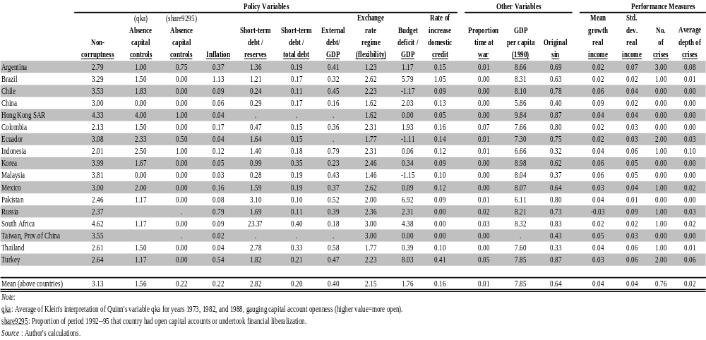

The view that wins the most support from table 1 is that countries that are not open to capital flows are more likely to have stable economies. It should perhaps not be surprising that countries that do not incur debt in the first place do not have debt crises. Still, it should be disturbing, from the viewpoint of pro-globalizers, that the two countries that show up as most closed to capital flows, China and Malaysia, are also the two with the fastest average growth over the period since 1990.

The answer in life is almost always that more than one factor is important in determining performance. A systematic analysis, to evaluate any one effect, must control for others. The strongest message to emerge from table 1 is that a dozen highly visible cases is not a large enough sample to answer most of the questions we wish to answer. As soon as we start considering alternative variables, or hypotheses regarding nonlinearities, or interaction terms, we have used up our degrees of freedom, to say nothing of significance levels. Accordingly, the remainder of this study turns to econometrics on larger samples, generally consisting of all developing countries for which sufficient data are available. (Most of the members on the former Soviet Union and other transition economies are excluded, mostly for lack of data and noncomparability before and after the fall of the Soviet Union.) We turn now to probit models to search for robust correlates of crises.

Probit Analysis of Crisis Probability

In this section of the paper, we describe possible correlates of currency crisis using standard probit models on a panel data set for the set of developing economies in the sample from 1974--2001. In the subsequent section, we use a regression tree technique to search for possible non-linear threshold effects and interactive effects.

We try a large number of different probit specifications. The variations are:
(a) including the year dummies, or not; (b) including the country fixed effects, or not; (c) measuring institutional quality by control of corruption versus constraint on executive branch of the government; (d) including the ratio of short-term external debt to reserve ratio, or not (since this variable is not available for a number of countries/years, its exclusion enlarges the sample size); and (e) defining currency crisis using three different thresholds for a “crisis month”: 15 percent, 25 percent, and 35 percent. This gives a total of 48 regressions (2⁴ X 3 = 48).

To simplify the presentation, table 2 reports a summary of these 48 regressions. Column 1 reports a sample regression with all the regressors, plus year and country fixed effects. Column 2 is a similar regression, this time replacing the variable “control of corruption” by “constraint on executive branch of the government.” (Other individual Probit regression results are reported in appendix E.)

Table 2. Summary of the Probit Regressions

 | Sample Regressions |  |  | Summary of Results
Variable |  |  |  | Pos Significant |  | Neg Significant |  |  | Contributor to  crisis?
Variable |  |  |  | 10% | 20% | 10% | 20% |  | Contributor to  crisis?
 | (1) | (2) |  | (3) | (4) | (5) | (6) |  | (7)
Trade openness | 0.006 | -0.003 |  | 1/48 | 5/48 | 2/48 | 4/48 |  | Not important
 | (0.006) | (0.009)
Financial | 0.001 | -0.029 |  | 3/48 | 5/48 | 2/48 | 6/48 |  | Not important
openness | (0.003) | (0.019)
Low corruption | 0.056 |  |  | 0/24 | 0/24 | 0/24 | 0/24 |  | Not important
 | (0.103)
Contraint on |  | -0.005 |  | 0/24 | 0/24 | 1/24 | 2/24 |  | Not important
executives |  | (0.093)
Stdebt/Reserve | 0.539 | 1.913 |  | 23/48 | 37/48 | 0/48 | 0/48 |  | Very likely +
 | (0.796) | (1.91)
Debt/GDP | -2.52E-04 | 0.008 |  | 9/48 | 10/48 | 0/48 | 0/48 |  | Not important
 | (0.001) | (0.004)
(FDI+ptf) | -0.008 | -0.010 |  | 0/24 | 0/24 | 9/24 | 13/24 |  | Likely -
/Gross liability | (0.003) | (0.005)
inflation | 2.06E-04 | 3.01E-04 |  | 15/48 | 28/48 | 0/48 | 0/48 |  | Very likely +
 | (1.57E-04) | (1.88E-04)
Fixed exchange | -0.246 | 0.350 |  | 0/48 | 1/48 | 1/48 | 4/48 |  | Not important
rate regime | (0.256) | (0.421)
Intermediate | -0.377 | -0.188 |  | 0/48 | 1/48 | 13/48 | 16/48 |  | Likely -
ex. rate regime | (0.223) | (0.344)
Country dummy | yes | yes
Year dummy | yes | yes
No. observations | 635 | 269
Source: Authors’ calculations

Column 3 of table 2 reports, for each regressor, in how many cases the coefficient is positive and statistically significant at the 10 percent level, relative to the total number of regressions in which the variable appears. For example, the first number in Column 3, 1/48, means that the regressor, “trade openness,” appears in 48 Probit regressions, out of which, one is positive and statistically significantly different from zero at the 10 percent level. Column 4 reports, for each regressor, how many times it is positive and significant at the 20 percent level, relative to the total number of regressions it appears. Similarly, Columns 5 and 6 report, for each regressor, how many cases it is negative and significant at the 10 percent and 20 percent levels, respectively, relative to the total number of regressions it appears.

The last column in table 2 presents our judgment on how likely a given variable is associated with a currency crisis. We label a variable as a “very likely” contributor to crisis if it is statistically significant at the 20 percent level more than half of the time and has a consistent sign in most regressions. We label a variable as a “likely” contributor to crisis if it is statistically significant at the 20 percent level for between 20 percent and 50 percent of the regressions and have a consistent sign in most cases. We label a variable as “not important” for crisis in all other cases.

The labels of “very likely” and “likely” contributors to crisis are generous, not only because of the definition used above but also because we look only at correlates within the sample (that is, no cross-sample validation is used to further reduce significant variables). Even so, only two variables qualify as “very likely” contributors to crisis. They are the ratio of short-term external debt to foreign exchange reserve, and expansionary monetary policy (inflation). Both of them are likely to be positively related to the probability of crisis.

Two variables satisfy the generous definition for a “likely” contributor to crisis. The first is the ratio of FDI and equity inflows to gross foreign liabilities. This is likely to decrease the chance of a crisis. The second is the intermediate exchange rate regime. This is less likely to be associated with crisis than the floating exchange rate regime.

According to these results, the remaining variables are not likely to be important for currency crises---even judged by the generous criteria above. It may be particularly worth highlighting two such variables. First, financial openness is not robustly associated with crisis, one way or the other. Second, a fixed exchange rate regime is no more likely to be in crisis than a flexible exchange rate regime.

The recent literature on financial crisis has proposed a number of possible non-linear “threshold” effects. For example, the financial openness on crisis probability may be hump-shaped. Some intermediate range of financial openness may be more crisis-prone than either low or high levels of financial openness. As another example, a combination of fixed exchange rate and high financial openness may be particularly prone to currency crisis. Or a combination of weak institutions (high corruption) and financial openness may make a country particularly vulnerable to speculative attacks on its currency. One could add quadratic terms or interactive terms to the above probit specification to capture some of these “threshold” effects. However, such terms are likely to be arbitrary and inflexible. The discussion that follows turns to the technique of regression tree analysis. This approach potentially can nest all such threshold and interactive effects and identify them in a relatively flexible way.

The Use of Regression Tree Analysis of Crisis Probability to Search for Threshold/Interactive Relationships

A regression tree is a data classification tool that performs a function analogous to factor analysis, but in a much more flexible way. While it is less familiar to economists, it has been used in statistical analysis of medical data to identify non-linear, interactive, or threshold patterns. We first illustrate the basic idea with an example, and then explain how we can apply the technique to our context.

The regression tree technique has three main advantages over linear regression that makes it suitable for our purpose. First, the same regressor does not have to have the same effect on the dependent variable in different ranges of value. In particular, the regression tree technique permits one or multiple threshold effects for any given regressor. Second, it identifies complex interactive relationships–how different combinations of variables in different data ranges could affect the dependent variable–in a relatively flexible way. Third, the classification result by the regression tree technique is invariant to monotonic transformations (such as logarithmic or quadratic transformations) of the explanatory variables.

Illustration of the basic idea. To illustrate the idea, we use a simplified version of a real-world medical example reported by Leo Breiman and his colleagues (Breiman and others 1984): how to classify heart attack patients into a high-risk group (those who would not survive in the next 30 days after testing) and a low-risk group (those who would live longer), using a small number of variables, so that they can be treated accordingly. The medical study has collected information on 19 different potentially relevant variables from a sample of patients. The regression tree technique searches for a data classification rule (splitting data into different branches and nodes) so that the difference between the predicted and actual values (sum of residual squared) is sufficiently small. The classification also identifies which subset of explanatory variables is most important, and how they can be used to classify the data into different terminal nodes.

In this example, the final classification rule identified three variables as most important: minimum systolic blood pressure over the initial 24 hour period, age, and presence of sinus tachycardia. But they exhibit thresholds and interact with one another non-linearly. More precisely, if a single variable–minimum systolic blood pressure–exceeds a threshold (91), then the patient should be in the high-risk group. No need to look at other variables. Otherwise, it depends on the interaction of two other variables. In particular, a combination of high age (>62.5) and presence of sinus tachycardia would again classify the patient to the high-risk group. In all other cases, the patient should be classified into the low-risk group. This statistical result can be described by a tree-like graph; hence the name of the statistical technique (see figure 1.)

Figure 1. Example of Regression Tree Analysis on Heart Attack Patients
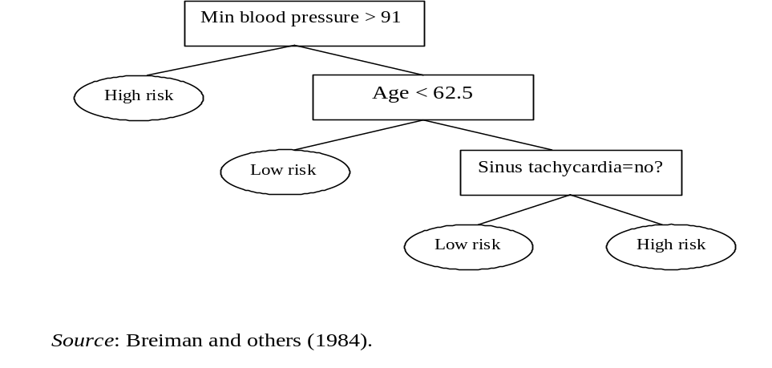

If the number and nature of thresholds, the needed transformation of the variables, and the pattern of variable interactions are known, one can modify a linear regression specification by adding suitably transformed variables, higher-order polynomial terms, interactive terms, and the like, to capture these relationships. If they are not known, then the regression tree is a more flexible approach to identify data patterns.

Applying the technique to the problem of currency crises. To implement the regression tree technique, one must decide on three parameters (similar to deciding on the size of a t-test or F-test, or choosing the convergence criteria in a maximum likelihood estimation of a regression). In addition, one must choose a list of candidate explanatory variables. The first parameter is mincut, the minimum number of observations needed before a first cut on a variable. The second parameter is minsize, the minimum number of observations before the last split. The statistical package we use (S-plus) requires minsize to be equal to at least twice the value of mincut. The third parameter is deviance, the tolerable level of sum of the square of the residuals for the variables at a given node. It is the amount of heterogeneity that can be tolerated without further splitting. Each of the three parameters could be a sufficient condition to stop splitting the data further.

The statistical literature does not provide definite guidance on how to choose these parameters. If one picks numbers for these parameters that are too small, then the sample may be split into too many branches and terminal nodes. In this case, sample variations and noises would clutter the reported data pattern. If one picks too big values for these parameters, the sample classification may be too coarse to be useful.

In the context of the currency crisis data, we have experimented with various possible values and discovered the following regularities. To err on the side of too fine a classification, we choose mincut = 1 percent of the sample, minsize =2 x mincut, and deviance = 0.01. In this case, there would be a large number of combinations of variables that would generate a high crisis probability. These cases are not easily ranked in terms of the values of variables, reflecting in part the noise created by sample variation. This set of values (mincut = 1 percent of the sample) can be regarded as the lower bound for the three parameters that we wish to consider.

At the other end, we choose mincut = 5 percent of the sample, minsize = 2 x mincut, and deviance = 0.01. In this case, there will often be only one combination of variables that will generate a crisis probability of 50 percent or higher. Any higher values for mincut or minsize would typically not generate any combination of explanatory variables that are associated with a crisis probability of 50 percent or higher. This set of values therefore may be the upper bound of the parameters that we wish to consider.

Deviance = 0.01 is small enough that it is almost never used as a stopping rule. Thus how fine the sample/“tree” is split is essentially determined by the choice of mincut (and minsize).

The results of the regression tree analysis. We now turn to the actual statistical results. The list of the potential explanatory variables is similar to before, including:
- Trade openness, as measured by the ratio of total trade to GDP
- De facto financial openness, as measured by the ratio of gross foreign assets plus liabilities to GDP
- Institutional quality, as measured by constraint on executive branch of the government
- Ratio of short-term debt to GDP
- Ratio of external debt to GDP
- Ratio of the sum of FDI and equity inflows to gross foreign liabilities
- Expansionary monetary policies, as measured by inflation rate
- Exchange rate regimes, as captured by a dummy for fixed exchange rate regime and another dummy for intermediate exchange rate regimes.
In addition, we also add decade dummies to allow for the possibility that crises are more frequent in one decade than in another, even if the values of other variables are held constant.

In the first case, there are 456 observations in total. We choose mincut = 5 percent of the sample size, minsize = 10 percent of the sample size, and deviance = 0.01. The results can be reported in two ways: a visually intuitive tree-graph (with less information); and a somewhat cumbersome long form of description (with more information). In this case, we report both in the upper and lower panels of figure 2, respectively. Out of the long list of possible variables, two variables are determined by the regression tree technique to be most important: ratio of short-term external debt to foreign reserve, and rate of inflation. When the ratio of short-term debt to reserve exceeds 157 percent and rate of inflation exceeds 17.2 percent, then there is a 50 percent probability of a crisis. (The long description in the lower panel of figure 2 reveals that 26 country-years fall into the bin in which short-term debt to reserve ratio exceeding 157 percent and inflation exceeding 17.2 percent. Of the 26 cases, half of them are crisis episodes.) Other than this combination of variables, there does not exist any other combination of variables (from the universe of all variables specified above) that would generate a crisis probability of 50 percent or higher (for any sub-sample of observations that satisfy the parameters specified). Therefore, the regression tree analysis suggests the combination of a high short-term debt to reserve ratio and a high inflation rate is likely to be lethal in terms of a proclivity for a currency crisis.

Figure 2. Crisis Classification, Relatively Broad Cuts

(mincut = 5% of sample size, minsize = 10% of sample, deviance = 0.01)

Panel 1. Regression Tree Graph
STdebt/Res < 1.57
Inflation < 17.22
0.1
0.3
0.5

Panel 2. Long Description
Total number of observations = 456
Pseudo R-squared = 1-51/441 = 88%
Average crisis probability = 20%

Reporting convention:
Split rule, #observation, deviance(X100), crisis probability

Stdebt/RES < 1.57 347 30 0.10

Stdebt/RES > 1.57 109 20 0.30

inflation<17.2% 83 20 0.30
inflation>17.2% 26 7 0.50 *

Source: Authors’ calculations.

In the second case, we have the same list of variables and the same sample, but choose smaller values for the key parameters. In particular, we let mincut = 3 percent of the sample size, minsize = twice of the mincut, and deviance = 0.01. The results (both the tree-graph and long descriptive form) are reported in figure 3. When the minimum permissible node size is made smaller, more nodes (and more tree branches) would be generated. As before, a combination of high short-term debt to reserve ratio (exceeding 157 percent) and a high inflation rate (exceeding 17.2 percent) would still generate a high crisis probability. In addition, even in scenarios in which short-term debt to reserve ratio is below the threshold of 157 percent, a combination of a high inflation rate (exceeding 24.5 percent per year) and a high ratio of external debt to GDP (exceeding 80.1 percent) would also land a country into a situation of high crisis probability. (The long form reveals that 15 observations are in that bin, of which 9 are crisis episodes.)

Figure 3. Crisis Classification, Intermediate Cuts

(mincut = 3% of sample size, minsize = 6% of sample, deviance = 0.01)

Panel 1. Regression Tree Graph
STdebt/RES < 1.57
Inflation < 17.22
0.3
0.5
Inflation < 24.53
0.08
Debt/GDP < 80.09
0.1
0.6

Panel 2. Long description

Total number of observations = 456
Pseudo R-squared = 1-48/436 = 89%
Average crisis probability = 20%

Reporting convention:
Split rule, #observation, deviance(X100), crisis probability

Stdebt/RES < 1.57 347 30.0 0.10

Inflation < 24.5% 268 20.0 0.08
Inflation > 24.5% 79 10.0 0.20

External Debt/GDP < 80.1% 64 7.0 0.10
External Debt/GDP > 80.1% 15 4.0 0.60 *

STdebt/RES > 1.57 109 20.0 0.30

inflation<17.2% 83 20.0 0.30
inflation>17.2% 26 7.0 0.50 *

Source: Authors’ calculations.
Other than these two combinations of variables, there does not exist any other combination of variables in the sample that could generate a crisis probability of 50 percent or higher (for any sub-set of observations that satisfy the parameters specified). Therefore, the regression tree analysis identifies three variables---ratio of external debt to GDP, in addition to ratio of short-term external debt to reserve and inflation---as the most important variables that can help classify country-years into high versus low probabilities of crisis. Note that the effect of these variables on the crisis probability is not linear, and depends on how they are combined.

Perhaps as telling as what has been chosen by the regression tree is what has not been chosen. For example, financial openness and institutional quality are not chosen. If there is a hump-shaped relationship between financial openness and currency crisis, or if there is a particular combination of weak institutions and high financial openness that would make a country vulnerable to crisis, the analysis suggests that these relationships are either not robust or are quantitatively unimportant (assuming that these variables are well-measured in the sample). Similarly, no decade dummies are selected by the regression tree, implying a lack of strong evidence that one decade is more crisis-prone than any other, once one takes into account the values of the other variables.

We could generate even finer classifications by letting mincut = 1 percent of the sample, minsize = 2 percent of the sample, and deviance = 0.01. This would naturally generate even more tree branches and even more cases of high crisis probability (with fewer observations in each of the node). Because the tree-graph becomes too messy, we choose to report only the long descriptive form in figure 4. While the result is reported for completeness, we think that the increase in the number of variable combinations that can generate crisis involves terminal nodes with too few observations. The influence of sample variation (noise) is likely to have increased in this case. So the resulting classification is likely much less robust to out-of-sample validation than the previous two cases. Consequently, we would not wish to generalize too much from this particular result.

Figure 4. Crisis Classification, Relatively Fine Cuts

(mincut = 1% of sample size, minsize = 2% of sample, deviance = 0.01)

Long Description
Total number of observations=456, Pseudo R-squared=1-32/415 = 92%
Average crisis probability = 20%

Reporting convention: Node), Split rule, #observation, deviance(X100), crisis probability

1)Root
2)STdebt/RES<157% 347 30.0 0.10
4) inflation<24.5% 268 20.0 0.08
8) cfdiequ<73% 17 4.0 0.30
16) cfdiequ<46% 11 0.9 0.09
17) cfdiequ>46% 6 1.0 0.70 *
9) cfdiequ>74% 251 20.0 0.07
18) debt/gdp<240% 6 1.0 0.30 *
19) debt/gdp>240% 245 10.0 0.06
38) tradeopen<50% 131 10.0 0.09
76) tradeopen<49% 125 7.0 0.06
77) tradeopen>49% 6 1.0 0.70 *
39) tradeopen>50% 114 3.0 0.03
5) inflation>24.5% 79 10.0 0.20
10) tradeopen<74% 67 8.0 0.10
20) debtgdp<86% 62 5.0 0.10
21) debtgdp>86% 5 1.0 0.60 *
11) tradeopen>74% 12 3.0 0.70
22) tradeopen<101% 5 0.0 1.00 *
23) tradeopen>101% 7 2.0 0.40 *
3)STdebtRES>157% 109 20.0 0.30
6) inflation<17% 83 20.0 0.30
12) finopen<6.84 40 9.0 0.30
24) debt/gdp<28.5% 8 0.0 0.00 *
25) debt/gdp>28.5% 32 8.0 0.40
50) cfdiequ<8% 7 1.0 0.70 *
51) cfdiequ>8% 25 6.0 0.40
102) STdebt/RES<250% 6 1.0 0.70 *
103) STdebt/RES>250% 19 4.0 0.30
13) finopen>6.84 43 6.0 0.20
26) debt/gdp<368% 38 4.0 0.10
27) debt/gdp>368% 5 1.0 0.60 *
7) inflation>17.2222 26 7.0 0.50
14) inflation<28.0874 6 0.0 1.00 *
15) inflation>28.0874 20 5.0 0.30
30) STdebtRES<0.0235644 11 3.0 0.50
60) cfdiequ<18.2002 5 0.8 0.80 *
61) cfdiequ>18.2002 6 1.0 0.30 *
31) STdebt/RES>0.0235644 9 0.9 0.10 *

Source: Authors’ calculations.

As a robustness check, we have also varied the crisis definition using the 35 percent (and 15 percent) threshold to identify crisis month (and hence the crisis year). The results are not reported to save space. The qualitative results are broadly similar to what is described above.

We have also conducted similar regression tree analyses using control of corruption instead of constraint on executives as a measure of institutional quality. The results are similar in spirit; to save space, they are not reported.

Next Steps

The findings of this section are consistent with the previous literature on leading indicators of currency crises: high levels of external debt do not necessarily lead to crises on their own, but they do significantly raise the probability of crisis if capital inflow is tilted to the short term and is not used (in part) to build up reserves. Accordingly, we will want to pay special attention to the composition of capital and use of inflows in the next section of the study. At the same time, we must recognize that identifying a variable such as the ratio of short-term debt to reserves as a significant predictor of currency crises does not mean that we can necessarily distinguish among competing theories or choose the best policies for crisis prevention or crisis management. Debt and inflation are certainly endogenous, with respect to fiscal and monetary policy.

The composition of capital inflows can be endogenous, as well. It is not necessarily a deliberate policy decision to borrow short term, to borrow in dollars, or to borrow through bank loans rather than FDI. It may be the result of some deep structural cause, such as crony capitalism or original sin. Or a shift in composition could be a consequence of suddenly reduced foreign willingness to hold domestic assets, together with the authorities’ determination not to devalue. That is, it could be a symptom of the sudden stop, rather than a cause.

The procrastination interpretation, for example, fits the shift in capital flows to Mexico during the course of 1994 toward the short term and toward the dollar-denominated, as the government substituted tesobonos (short-term dollar-linked bonds) for Cetes (peso bonds) as a stop-gap measure. The aim was to delay a painful choice between devaluing and continuing to lose reserves. In other words, the change in composition was a stalling tactic, analogous to a financially troubled household that starts charging its mortgage payments on its credit card.

Delayed adjustment---the lag from the date that reserves peak after a sudden stop to the date of a devaluation, restructuring, or an IMF program---may raise the ratio of short-term debt to reserves so much that an eventual crisis becomes more likely. Furthermore, if, as a result of delayed adjustment, the country goes into the crisis with a high proportion of dollar-denominated and short-term debt, then it may be more likely that the subsequent recession will be steep, whatever changes in macro policies are then adopted. At that point, there may be no optimal combination of expenditure reduction and devaluation that avoids a sharp loss in output. The lesson would be a more subtle story than simple admonitions to developing country policymakers to avoid borrowing short-term. The crisis Probit models cannot answer such questions, because they are not designed to do so, either with respect to their explanatory variables or with respect to what is being explained. Clearly more hypothesis testing is required.

Testing Hypotheses Regarding Economic Performance

We test, first, if there are any policies of crisis prevention that seem consistently to have given countries better economic performance on average since 1990. Subsequently, we look at crisis management policies.

Seven Measures of Crisis Prevention Policies

As noted, this study constructed a measure of output lost in crisis---crisisloss (or Compcrisis)--- intended to be a composite measure of a country’s proneness to severe crises. To see the effects of the seven “crisis prevention” policy variables, our first base-case regression, is equation 1. We condition on initial income per capita, and also include a variable for war (with the scored severity of each conflict weighted by the number of years). The two macroeconomic variables are taken to be external debt/GDP and inflation, in light of the empirical success of the latter in the preceding section.

(1)
Crisisloss = a + b1 Noncorruptness + b2 opencapital +b3 gdpcap90 +b4 inflatn +b5 external debt/gdp + b6 compshort + b7 origsin + b8 war +b9 exrateflex + u

The results are reported in table 3. Neither of the macroeconomic variables is highly significant. But the composition of capital inflows is more important. The coefficient of original sin (that is, the currency mismatch) is significant at low levels, with the hypothesized sign. Noncorruptness has the expected effect, and is significant. The open capital markets variable has a negative sign, suggesting that liberalization actually reduces the frequency or severity of crises. This is the same result found, for example, by Reuven Glick and Michael Hutchison (2002). The effect appears to be significant at the 95 percent level when we use the Klein (2003) measure of capital account liberalization (which is based on data for 1973--85), though not when the updated Quinn (1997) measure is used (1992--95). Exchange rate flexibility---if anything---appears to make crises worse, rather than better. Fans of currency boards and other institutional fixes should like this result, but the effect is not statistically significant. War and initial income have no discernible effect.

Table 3. Explaining Output Lost in Crises: Base Case Regression

 | Using qka ª |  | Using share ^{b}
Variable | Coefficient  (Std. Error) | Number of obs = 67  F(10,56) = 1.02  Prob>F = 0.4370  R-sqd = 0.1977 | Coefficient  (Std. Error) | Number of obs = 68  F(10,57) = 0.72  Prob>F = 0.7048  R-sqd = 0.1620
Noncorruptness | -.049 *  (.029) |  | -.044 #  (.029)
Absence of capital controls | -.038 **  (.018) |  | -.010  (.038)
Inflation | .141  (.114) |  | .160 #  (.120)
External debt/GDP | .002  (.017) |  | -.010  (.019)
Short-term debt/Total debt | -.138  (.202) |  | -.166  (.199)
FDI/GDP | -.008  (.008) |  | -.005  (.008)
Currency mismatch | .093  (.088) |  | .146 #  (.098)
War | .277  (.372) |  | .318  (.395)
GDP per capita (1990) | .023 #  (.017) |  | .007  (.013)
Exchange rate regime (flexibility) | .052  (.058) |  | .037  (.054)
Constant | -.104  (.137) |  | -.049  (.123)
Note:
Macro variables are inflation and external debt.
a. Regression uses average of Klein’s interpretation of Quinn’s variables qka73, qka82, qka85 as gauge for “absence of capital controls.”
b. Regression uses Klein’s “share9295” variable as gauge for “absence of capital controls.”

Source: Authors’ calculations.

Equation 2 replaces debt/GDP and inflation, which seem too endogenous to call policy variables, with budget deficit/GDP and the rate of credit creation (growth in net domestic assets). At the same time, it drops the war variable. Credit creation shows up with the right sign, but not with statistical significance. One possible interpretation of its weak effect is that, while the first generation speculative attack models give it a starring role as villain, the growth literature considers it just the opposite, viewing increases in the ratio of domestic credit to GDP a reflection of financial development--- and thus beneficial. The budget deficit effect shows up better (particularly in those regressions where the 1990s measure of capital account liberalization is used in place of the 1980s measure). Two other variables do show up (at moderate levels of statistical significance): noncorruptness and original sin (currency mismatch). Countries tend to have fewer crises or less severe ones if they are free from corruption, and tilt the composition of their capital inflows away from dollar-denomination. Open capital markets are again marginally significant, and in a direction that suggests that liberalization actually reduces the frequency or severity of crises.

(2)
Crisisloss = a + b1 Noncorruptness + b2 opencapital +b3 gdpcap90 +b4 credit +b5 bdgdp
+ b6 compshort + b7 origsin + b8 war +b9 exrateflex + u

There are two obvious problems with the specification for the exchange rate regime variable. One is that the move from a fixed exchange rate regime to a flexible one sometime during the decade may be the result of a currency crisis, rather than the cause. This is an argument for being more precise about the timing. The other possible objection would come from proponents of either the hard peg school of thought, or the corners hypothesis: that the exchange rate flexibility variable does not allow a test of their point of view.

Accordingly, we tested for each of these hypotheses. For the hard peg option, we defined a dummy variable that is equal to 1 only for currency boards, dollarization, and monetary unions---not for conventional pegs. The sign is as often negative as positive, and is not at all significant. Thus there is no evidence to support the claims for the hard peg. The estimated coefficient on the hard peg dummy points to amelioration of crises, but it is not at all statistically significant.

Next we tested the corners hypothesis, with a dummy variable that is equal to 1 for either a hard peg or a float. In both cases, the dummy variable countries that had a corner regime during only part of the sample period receive the corresponding proportional weight on that regime. The results are not reported, to save space. The coefficient on the corner regimes–either hard peg or float---often attains low or moderate levels of significance. But it is of the opposite sign from the corners hypothesis. In other words, it rejects the popular hypothesis that the corner regimes are less crisis-prone than the intermediate regimes. This is consistent with the results regarding intermediate regimes in the probit analysis above. Perhaps intermediate regimes are better, after all.

Before testing for some other combinations of policy variables, we checked the effects of the base-case list of variables on other more familiar measures of country performance. We tried defining the dependent variable, the measure of performance, to be the standard deviation of growth. This measure of performance is correlated with the crisis measure, as one would expect. (The correlation is 0.2101.) We add the standard deviation of the terms of trade as an obvious, and largely exogenous, determinant of volatility. It rarely shows significance, however (as is also true when the dependent variable is one of the crisis measures, in results not reported.) The only variable to show even marginal levels of significance in determining volatility is noncorruptness, which reduces the standard deviation of growth, as one would hope.

Next we tried the average growth rate over the 1990--2002 period as the dependent variable. This equation is intended as a bridge to the large literature on the determinants of economic growth. Drawing on some of the conclusions from that literature, the list of variables include initial income, size of the country (population), tropical location, and two measures of factor accumulation: investment/GDP, and a measure of education or human capital. The coefficient on education is of only marginal significance, and that on investment is of no significance. Other authors have found measurement problems as being very important in the performance of these variables. Population is highly significant, confirming that larger countries have an advantage. A high ratio of short-term debt to equity and FDI shows a negative effect on growth that is statistically significant. The same is true of exchange rate flexibility. Noncorruptness also shows a beneficial effect on growth, if again of marginal significance. This estimation could be refined by use of some of the measures that the most recent growth research has found to be relatively less prone to error.

Interactive Effects

Many of the interesting claims in the recent literature concern the effects of combinations of our variables. To test for interaction effects, we return to the composite crisis variable (total output lost in crises) as the measure of performance.

The proposed hypotheses of interactive effects involving capital account openness did not receive much support here. When the capital account variables is interacted with noncorruptness, or with the measure of monetary policy (domestic credit creation, NDA), the estimates are insignificant. In the case of fiscal policy, the finding is worse: we can reject, at least at low significance levels, the hypothesis that the combination of open capital markets and a high budget deficit worsens the crisis problem. This does not mean that the two variables considered individually do not increase the frequency or severity of crises in an additive way; it is just that we have found nothing particularly noteworthy about the combination of the two.

In the cases regarding the composition of capital inflows, the answer is worse still: the coefficient appears to be statistically significant, but again of a sign that is the opposite of the proposed direction. We reject the hypothesized deadliness of the combination of open capital markets and short-tilted composition, and also reject the hypothesis regarding the deadliness of the combination of open capital markets and currency mismatch. The view that the combination of open capital markets and fixed exchange rates causes crises also receives no support. This is not an encouraging result for most of the interaction effects.

Table 4.1. Explaining Output Lost in Crises: Interaction of Absence of Capital Controls and 1990 Per Capita GDP

 | Using qka
Variable | Coefficient  (std. error) | Number of obs = 67  F(10,56) = 0.85  Prob>F = 0.5854  R-sqd = 0.1675
Noncorruptness | -.055 #  (.034)
Absence of capital controls | -.184 *  (.098)
Growth of domestic credit | .042  (.104)
Budget deficit/GDP | .005  (.004)
Short-term debt/Total debt | -.132  (.192)
FDI/GDP | -.012 #  (.009)
Currency mismatch | .145 #  (.104)
GDP per capita (1990) | .001  (.013)
Exchange rate (flexibility) | .048  (.053)
Absence of capital controls * GDP per capita (1990) | .022 *  (.012)
Constant | .051  (.125)
Source: Authors’ calculations.

Table 4.2. Explaining Output Lost in Crises: Interaction of Absence of Capital Controls and 1990 Per Capita GDP

 | Using qka
Variable | Coefficient  (std. error) | Number of obs = 66  F(8,57) = 0.86  Prob>F = 0.5513  R-sqd = 0.1387
Noncorruptness | -.056 #  (.039)
Absence of capital controls | -.287 **  (.134)
Growth of domestic credit | .044  (.113)
Budget deficit/GDP | .005  (.004)
Short-term debt/Reserves | .284 *  (.166)
Currency mismatch | .168 #  (.110)
GDP per capita (1990) | -.007  (.015)
Exchange rate (flexibility) | .054  (.054)
Absence of capital controls * GDP per capita (1990) | .035 **  (.017)
Constant | .036  (.122)

Source: Authors’ calculations.

The one interactive effect that shows up highly significant is reported in tables 4.1 and 4.2. The variable that interacts open capital markets and income shows a positive sign and is significant at the 95 percent level. This is the opposite of the finding of Javier Gomez Biscarri, Sebastian Edwards, and Fernando Perez de Gracia (2003). It might be rationalized by a Kuznets-style U-shaped relationship: open capital markets can lead to heavy borrowing and thereby to crises in middle-income countries, but are less dangerous in poor countries and rich (the latter not being present in our sample).

A few other variables here are statistically significant, as well. Countries with more open capital markets again show up here as having reduced frequency or severity of crises, now significant at the 95 percent level. An increase in the ratio of short-term debt to reserves increases the frequency or severity of crises. Noncorruptness and currency mismatch have the hypothesized effects, but at fairly low levels of significance. In this regression, the rate of growth of domestic credit, the budget deficit, and the exchange rate regime variable do not attain statistically significance.

Crisis Management Policies

We now turn to the merits of differing approaches to managing crises after they happen. This is rather different from analyzing policies to prevent crises--- notwithstanding the importance of realizing that crisis prevention policies carry important implications forcrisis management policies, particularly in the form of moral hazard generated by bailouts.

The approach begins by looking at the month-by-month statistical profile of reserves in crisis episodes. We retain our previous definition of what constitutes a crisis: an increase in exchange market pressure that exceeds the threshold in absolute terms (although to focus on the larger crises, we raise the threshold in this section to 45 percent) and also exceeds a threshold for acceleration relative to the preceding month (still 10 percent).

The period of sudden stop: From reserve peak to crisis. We define the period of sudden stop as the span of time that ends with the crisis itself and begins with the preceding peak in reserves. It marks the end of a period of inflow, and the beginning of the period of outflow. We use a 7-month centered moving average of reserves to identify the peak that precedes each crisis. In our calculations, the average length of the period of sudden stop is 6.3 months. Much of the literature, both theoretical and academic, essentially assumes that this period is collapsed to a single instance, thereby losing sight of some important questions.

Figures 5.1--5.5 are bar graphs showing the time-profile of reserves for some prominent crises of the last eight years (Mexico, 1994; Indonesia, 1998; Russia, 1998; Brazil, 1999, Turkey, 2001). Vertical lines also indicate the date of the crisis (by the exchange market pressure index) and the date that adjustment began (devaluation or IMF program). The average reserve loss, across countries, during the period of sudden stop, is 35 percent (computed relative to the peak, not logarithmically). This does not count the reserves lost in the month of speculative attack, which we have identified as the month when the overall exchange market pressure index exceeds its threshold.

Figure 5.1. Mexico Reserves Profile: 94M12 Crisis
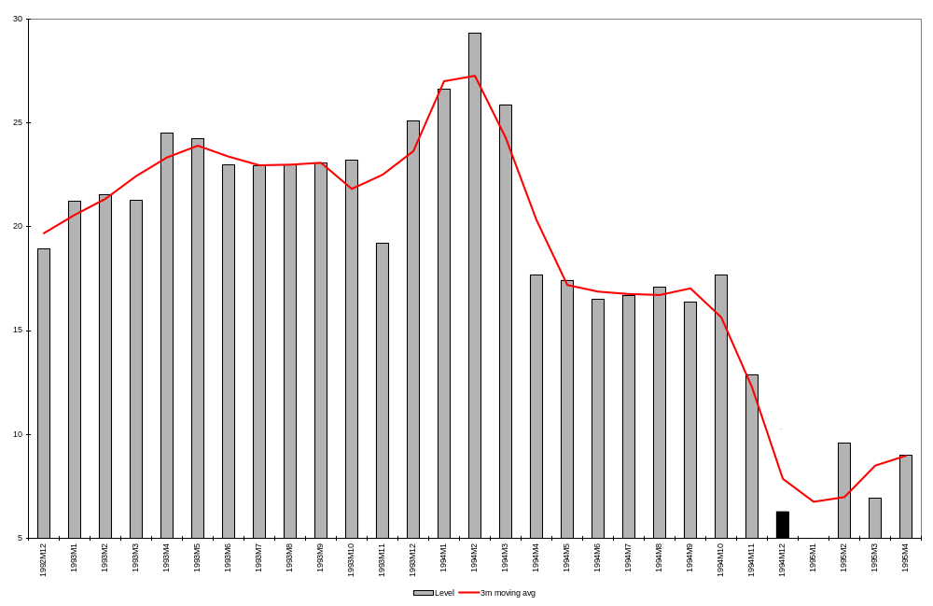

Source: IMF International Financial Statistics.

Figure 5.2. Indonesia Reserves Profile: 98M1 Crisis
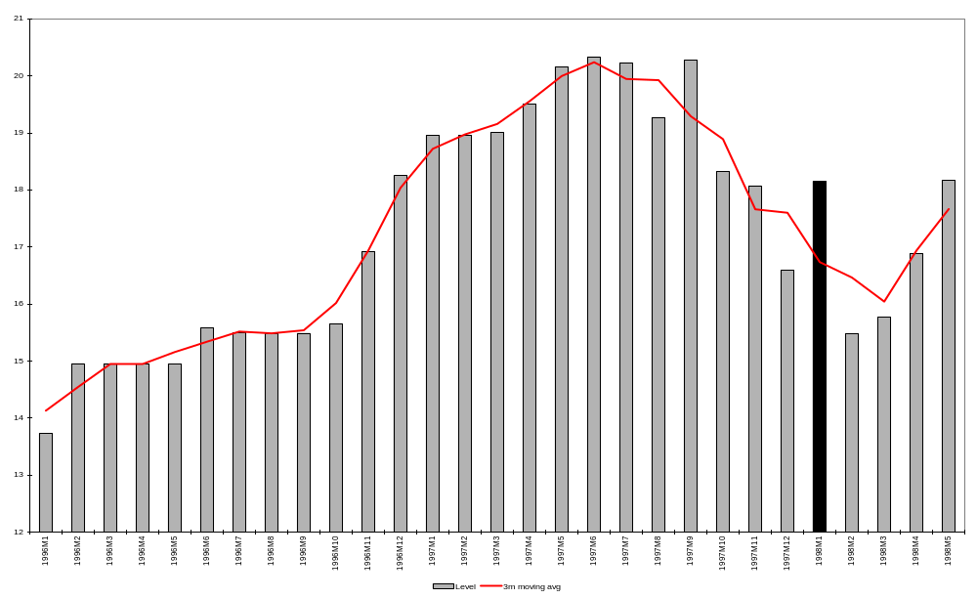
Source: IMF International Financial Statistics

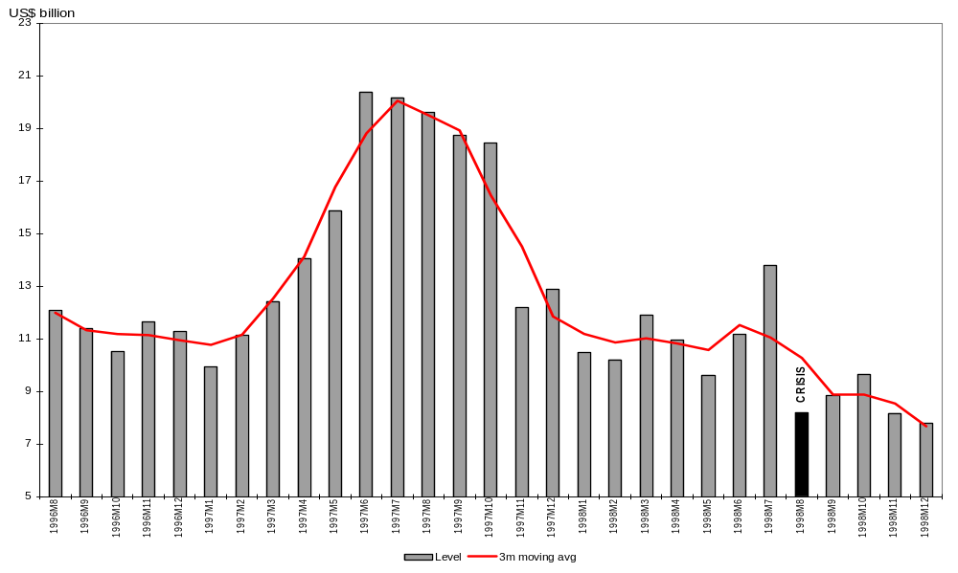
Figure 5.3. Russia Reserves Profile: 98M8 Crisis

Source: IMF International Financial Statistics.

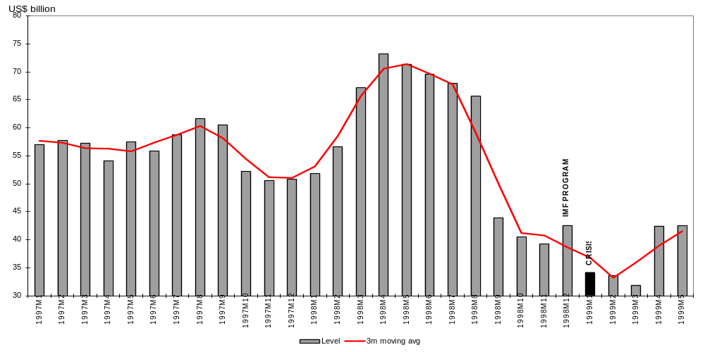
Figure 5.4. Brazil Reserves Profile: 99M1 Crisis
Source: IMF International Financial Statistics.
Figure 5.5. Turkey Reserves Profile: 01M2 Crisis
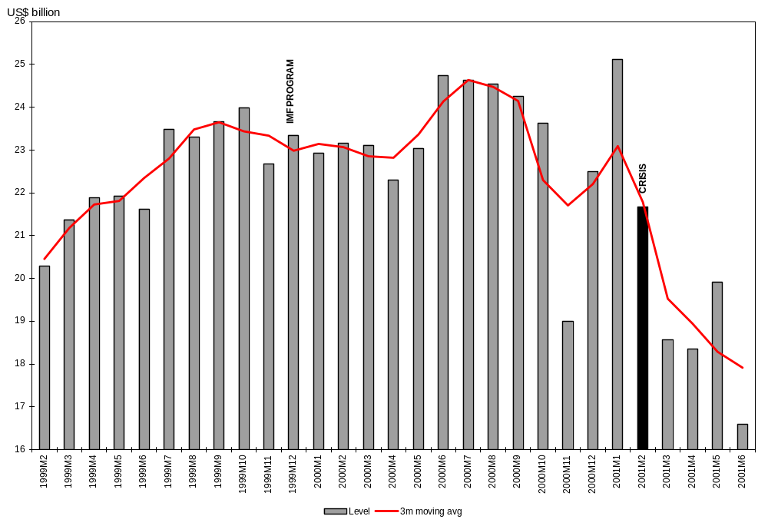
Source: IMF International Financial Statistics.

Figure 6 shows the average experience, over the last 12 years, among 87 country crises. Here, each country’s reserves are expressed as a ratio to the level in the peak month, and the moving average is computed over three months. The peak of the average comes about 13 months before the crisis.

Figure 6. Average Pre-Crisis Reserves Profile

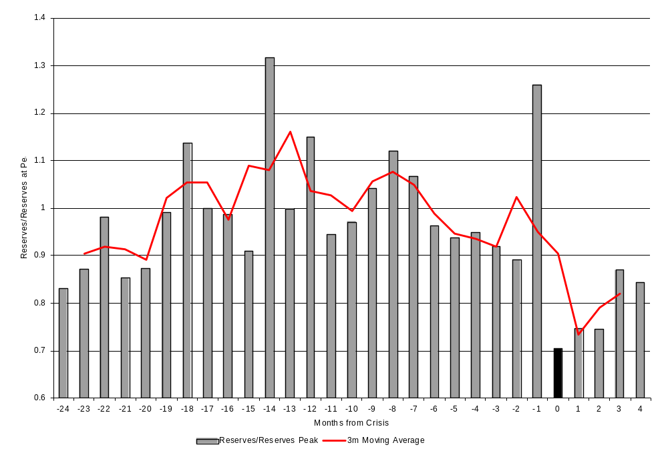
Note: Reserves level is normalized against each country’s pre-crisis peak before averaging for all crises.

Source: IMF International Financial Statistics.

Delaying adjustment. One key question is whether delaying adjustment, after the sudden stop has begun, makes crises more severe, or more likely to happen at all. The answer may well be “No,” since the correct economics is to “finance” a deficit---provided it is temporary---by drawing down reserves, rather than necessarily to “adjust.”

We could define the month when adjustment begins as the month of devaluation or of a substantial fiscal contraction, or as the month that an agreement on an IMF program is signed. But here we simply assume that adjustment begins at the same time as the crisis itself. A relevant metric for measuring the length of delay is what percentage of reserves the country has lost by the time of the crisis, relative to the peak. Does it affect the severity of the crisis?

We regressed output loss in the year of a crisis against a number of our “crisis management” policy variables: change in maturity composition during the sudden stop period, a dummy representing whether the country signed an agreement with the IMF, and a measure of the mix of adjustment policies. The fraction of reserves lost (during the interval from reserve peak to crisis) enters with the hypothesized positive sign, but is not significant at the 80 percent or 90 percent level of significance.

Shifting composition of debt during the sudden stop period. The exploration in previous sections of the importance of the composition of inward foreign investment, and the realization that the composition changes substantially over time, inspire us to consider a new hypothesis. That is, that during the period of sudden stop, the authorities sometimes delay adjustment, not just by drawing down reserves, but also by shifting the composition of capital inflows toward short-term and dollar-denominated debt. This strategy helps sustain the willingness of foreign residents to continue lending, in the short term, but magnifies the fragility of the economy rapidly over time. In particular, the strategy worsens the balance sheet problems that have been identified in the literature as the major explanation for the severe losses in output that have followed recent crises (an identification that is consistent with our own results and beliefs). Whatever the composition of the capital inflows a year or two earlier, if on the day when the crisis occurs the debt is substantially dollar-denominated and short-term, then the country is in trouble---regardless of what mix of policies it chooses as the means of adjustment. Either a short-term increase in interest rates or a devaluation, or any combination of the two, will sharply worsen the balance sheets of debtor firms and banks, and thereby contribute to bankruptcies and contraction in output and employment.

A prime example is Mexico during the course of 1994. International enthusiasm for investing in Mexico began to decline after the beginning of the year, due to some combination of the uprising in Chiapas, the assassination of presidential candidate Colosio, a new upward trend in U.S. interest rates, and the sexennial fiscal laxity of the Mexican election year. The authorities clung to the exchange rate target and delayed adjustment, in the hopes circumstances would turn around. Most obviously, during much of the year they ran down reserves. But an important alternative mechanism of delay was to placate nervous investors by offering them tesobonos (short-term dollar linked bonds) in place of the peso bonds (Cetes) that they had previously held. Between the first and second halves of the year, the share of foreign borrowing that was of maturity less than 1 year rose from 0.48 to 0.55 an increase of 7 percentage points. Figure 7a shows the dramatic increase in dollar-linked debt during the year leading up to the peso crisis of December 1994, and figure 7b shows the shift toward shorter maturities. It seems likely that the magnitude of the Mexican recession in 1995 stemmed in part not just from the adverse balance sheet effects that have been so frequently noted since then, but particularly from the adverse shift in balance sheets that took place during the course of 1994.

Figure 7a. Evolution of Mexican Debt According to Currency
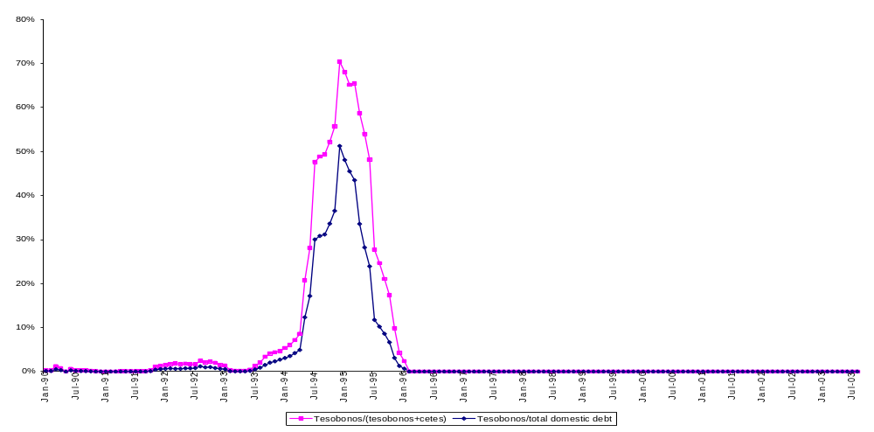
Source: Mexican Ministry of Finance and Public Credit.

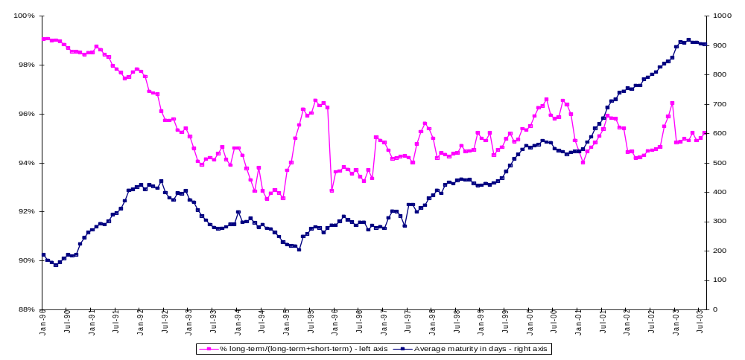
Figure 7b. Evolution of Mexican Debt According to Maturity
Source: Mexican Ministry of Finance and Public Credit.

Brazil may offer a more positive example: the exception that proves the rule. Reserves peaked in May 1998. Subsequently, contagion from the Russian devaluation and default leapt across the Atlantic to Brazil. As in Mexico in 1994 (or Korea in 1997), Brazil faced an important presidential election toward the end of the year, which added to the authorities’ incentives to delay adjustment and to rely instead on hopes that capital inflows would resume on their own. When Brazil was finally forced to devalue in January 1999, some observers predicted disaster, based on the analogies of recessions in Mexico in 1995 and East Asia in 1998. Indeed, reserves had been run down to similarly low levels. Yet Brazil suffered no output loss in 1999. What explains the difference? The most common answer from knowledgeable participants and observers is that during the intervening eight months, the authorities had used their reserves to allow the private sector to hedge or unwind short-term dollar liabilities. According to our data, the share of foreign borrowing that was short-term fell during the second half of the year from 0.68 to 0.62 or by 6 percentage points. By the end of the year, just before the devaluation, balance sheets were stronger, not weaker.

Is the shift toward dollar-denominated debt during the period of sudden stop a general phenomenon? Many countries were never able to borrow much in domestic currency in the first place, so that there is little scope for shifting the composition to dollars. But are there more Mexico’s than Brazil’s? Unfortunately data on the currency composition of debt are not available at a sufficiently high frequency to do the test. The “original sin” data on currency mismatch that we have been using are available only on an annual basis.

It is more feasible to test the proposition that the composition shifts in an undesirable direction with respect to the maturity structure, than it is to test with respect to currency denomination. Data on the maturity of bank loans are available from the BIS on a quarterly basis for the period since 2000, and on a biannual basis before that. Table 5 reports the change during the period of sudden stop for 74 crises. On average, the fraction of loans that were short-term increased by 0.6 percentage points after the peak in reserves (over a period of one or two quarters, depending on data availability). When we ran regressions of the subsequent output loss against our various crisis management policy measures, changes in maturity composition and the loss in reserves were both of the hypothesized sign, although not statistically significant.

Table 5. Shift Toward Short-term Debt during Period of Sudden Stop, 74 Crises,

1990—2002

 | Date of | ST/total in | ST/total in |  |  |  | Date of | ST/total in | ST/total in
 | reserve | quarter | comparison |  |  |  | reserve | quarter | comparison
Crisis | peak | of crisis | quarter ^{(a)} | Change |  | Crisis | peak | of crisis | quarter ⁽¹⁾ | Change
ALG90M7 | 90M3 | 0.395 | 0.369 | 0.026 |  | MAUR93M1 | 92M9 | 0.771 | 0.736 | 0.035
ALG94M3 | 93M10 | 0.351 | 0.399 | -0.048 |  | MEX94M12 | 93M12 | 0.554 | 0.485 | 0.069
ANG02M12 | 02M5 | 0.460 | 0.475 | -0.016 |  | MOLD98M11 | 97M10 | 0.543 | 0.438 | 0.106
ANG99M5 | 97M10 | 0.491 | 0.499 | -0.009 |  | MYAN96M6 | 95M7 | 0.945 | 0.629 | 0.316
AZER95M9 | 95M6 | 0.667 | 0.643 | -0.024 |  | NIC92M10 | 92M6 | 0.814 | 0.801 | 0.013
BEL99M2 | 99M1 | 0.267 | 0.192 | 0.076 |  | NIGA92M3 | 91M11 | 0.381 | 0.347 | 0.034
BRAZ99M1 | 98M5 | 0.623 | 0.680 | -0.057 |  | NIGA99M1 | 98M5 | 0.550 | 0.531 | 0.019
CAM93M4 | 93M3 | 0.482 | 0.431 | 0.052 |  | NIGR94M1 | 92M11 | 0.407 | 0.500 | -0.093
CAM97M11 | 97M10 | 0.650 | 0.522 | 0.128 |  | NIGR98M8 | 97M6 | 0.262 | 0.538 | -0.277
CHIN92M7 | 92M3 | 0.402 | 0.446 | -0.043 |  | PAK90M10 | 90M3 | 0.710 | 0.675 | 0.036
CONG01M5 | 01M1 | 0.606 | 0.447 | 0.159 |  | PAK96M10 | 96M3 | 0.488 | 0.658 | -0.170
CONG90M6 | 90M4 | 0.576 | 0.671 | 0.095 |  | PAN97M6 | 97M5 | 0.439 | 0.416 | -0.023
CONG94M1 | 93M3 | 0.522 | 0.591 | -0.069 |  | ROM97M1 | 96M9 | 0.395 | 0.495 | -0.100
CONG97M8 | 97M6 | 0.372 | 0.380 | 0.008 |  | RUSS98M8 | 98M4 | 0.476 | 0.470 | 0.006
COT90M5 | 90M1 | 0.678 | 0.641 | 0.037 |  | RWA90M11 | 90M10 | 0.667 | 0.706 | -0.039
COT93M11 | 93M4 | 0.797 | 0.830 | -0.033 |  | SEN93M11 | 93M11 | 0.843 | 0.876 | -0.033
DOM90M12 | 90M1 | 0.440 | 0.405 | 0.034 |  | SOAF94M3 | 94M1 | 0.564 | 0.598 | -0.034
DOM94M8 | 93M10 | 0.530 | 0.523 | 0.007 |  | SRI98M7 | 97M11 | 0.541 | 0.542 | -0.001
ECU92M5 | 92M1 | 0.518 | 0.475 | 0.044 |  | SUD90M5 | 90M1 | 0.837 | 0.791 | 0.047
ETH92M10 | 91M9 | 0.187 | 0.261 | -0.074 |  | TANZ97M7 | 97M3 | 0.864 | 0.777 | 0.087
GAB01M9 | 01M1 | 0.593 | 0.622 | -0.029 |  | TOGO94M1 | 92M6 | 0.733 | 0.607 | 0.127
GAB97M2 | 96M6 | 0.454 | 0.583 | -0.130 |  | TT92M1 | 91M3 | 0.301 | 0.292 | 0.008
GHA00M7 | 00M2 | 0.613 | 0.552 | 0.061 |  | TUN91M4 | 90M9 | 0.563 | 0.519 | 0.044
GHA90M10 | 90M6 | 0.749 | 0.636 | -0.114 |  | TURK01M2 | 00M10 | 0.676 | 0.664 | 0.012
GUI97M6 | 97M2 | 0.849 | 0.794 | 0.055 |  | TURK94M3 | 93M8 | 0.626 | 0.554 | 0.073
INDI91M4 | 90M3 | 0.297 | 0.305 | -0.007 |  | UAE95M9 | 95M7 | 0.920 | 0.886 | 0.034
INDO98M1 | 97M6 | 0.626 | 0.628 | -0.002 |  | UGA90M5 | 90M4 | 0.861 | 0.785 | 0.076
JAM91M9 | 91M2 | 0.374 | 0.379 | -0.006 |  | UKR98M9 | 97M9 | 0.489 | 0.427 | 0.062
JOR91M8 | 91M7 | 0.414 | 0.456 | -0.042 |  | URG02M7 | 01M9 | 0.605 | 0.652 | -0.047
KEN94M11 | 94M7 | 0.619 | 0.597 | 0.022 |  | VENZ02M2 | 00M11 | 0.341 | 0.387 | -0.046
KOR97M12 | 97M7 | 0.728 | 0.775 | -0.047 |  | VENZ94M5 | 93M9 | 0.297 | 0.315 | -0.018
LEB90M8 | 90M7 | 0.813 | 0.823 | -0.010 |  | ZAMB01M12 | 01M8 | 0.908 | 0.938 | -0.030
LIBR93M3 | 93M1 | 0.405 | 0.397 | 0.007 |  | ZAMB91M4 | 90M12 | 0.654 | 0.661 | -0.007
LIBR96M12 | 96M10 | 0.362 | 0.396 | -0.034 |  | ZAMB94M11 | 94M11 | 0.542 | 0.577 | -0.035
LIBY02M1 | 01M12 | 0.966 | 0.952 | -0.015 |  | ZIMB90M11 | 90M11 | 0.715 | 0.574 | 0.141
MALAW92M3 | 91M10 | 0.393 | 0.371 | 0.022 |  | ZIMB97M9 | 96M8 | 0.740 | 0.753 | -0.013
AVERAGE ACROSS CRISES |  |  |  |  |  |  |  |  |  | 0.006
Note:
a. Quarter of preceding reserve peak is used in comparison to crisis quarter. In cases where reserve peak and crisis fall in same quarter, that quarter is compared against the following quarter if crisis and/or reserve peak fall in June or December. If crisis and/or reserve peak fall in any other month, that quarter is compared against the preceding quarter. Data are available from BIS in semi-annual frequency (Q2 and Q4). In cases where reserve peak or crisis fall in Q1 or Q3, the preceding quarter's data are used. For data after 2000, quarterly data is available. If crisis or reserve peak falls in first month of quarter, the preceding quarter's data are used; otherwise, that quarter's data are used.

Source: World Bank World Development Indicators; IMF World Economic Outlook and International Financial Statistics.

Going to the IMF. Whether IMF programs help or hurt, relative to the relevant alternative, is an important and controversial question. Of course one does not necessarily want to blame the surgeon because his patients die more often than do the chiropractor’s; the former is likely to get the more serious cases. Even those studies that have tried to do a careful job of constructing the relevant counterfactual have had a difficult time of it. One of the problems for statistical differentiation is that so few countries choose the Malaysian option of not going to the Fund. But, for what it is worth, we looked for a statistical relationship between a country’s signing a program with the IMF and the magnitude of the output loss in the year of the crisis. We found no relationship, whether conditioning on other policy variables or not. (We tried counting only countries that had gone to the Fund within a 6-month period, or within a 12-month period.)

The Mix: Spending Contraction versus Devaluation

Perhaps the most interesting question of crisis management is the question of the mix between adjustment by real devaluation versus expenditure reduction–assuming a fixed quantity of adjustment given by the balance of payments constraint. When we think of expenditure reduction as fiscal policy, our measure is the change in the budget relative to the increase in the trade balance. We found that countries where the fall in government consumption constituted a large share of the adjustment in the trade balance suffered a smaller output loss, other things being equal. The effect, however, was not generally significant at the 95 percent level.

When we think of expenditure reduction as monetary policy, our measure of the mix is the increase in the real interest rate relative to the increase in the real exchange rate. We found that countries that relied heavily on high interest real rates (either absolutely or relatively to the preceding year) suffered larger output losses than those that relied on big real depreciation of the currency. The difference was very significant statistically, as reported in table 6.

Table 6. Crisis Management Policies
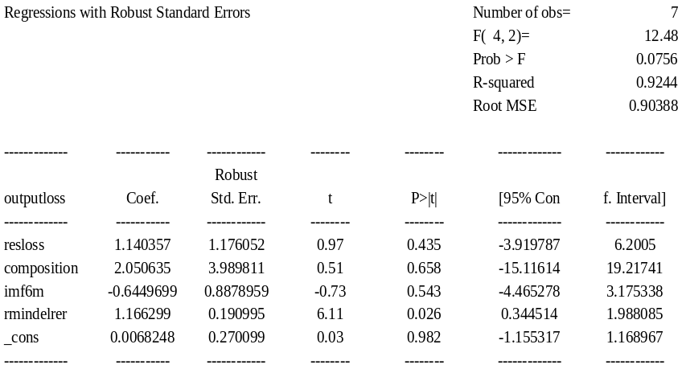

Source: Authors’ calculations.
It is useful to note that the regressions reported here do not include initial economy-wide corporate or bank balance sheet information due to lack of data. Those economies that started with a more serious currency-mismatch in their balance sheets before the crisis could fare less well with a depreciation approach as a crisis management tool.

Summary of Conclusions

Our results are consistent with much of the previous empirical literature in that we do not find that crises are necessarily the outcome of high current account deficits or high indebtedness per se, nor even of domestic credit creation. Nor does exchange rate flexibility necessarily mean that crises will be avoided. There is stronger evidence that poor institutional quality (corruption) is a fundamental problem.

But some of the new conventional wisdoms do not appear to be borne out by our tests. The corner exchange rate regimes are, if anything, more prone to serious crises, not less. If emerging market countries liberalize their capital controls, they are less prone to crises, not more. An extensive search for interactive effects that have been claimed by others does not uncover much evidence that capital account openness is particularly dangerous in combination with low income, expansionary policies, or corruption.

Countries are likely to have more frequent and more severe crises if their capital inflows are tilted toward short-term dollar borrowing and away from FDI and equity inflows, and if they hold a low level of reserves. The ratio of short-term debt to reserves is a particularly important indicator. We find evidence with the regression tree technique that high levels of inflation significantly raise the probability of crisis when coming in combination with a low level of reserves and a composition of capital inflow that is tilted to the short-term.

This chapter has sought to draw greater attention to policy decisions that are made during the phase when capital inflows come to a sudden stop. All of the theoretical literature, and most of the empirical literature, treats the “sudden stop” phase as taking place in a single instant: the country goes directly from a period of capital inflows and strong reserves to a crisis of capital outflows and plunging reserves. In reality there is often an interim period, when international investors have begun to lose enthusiasm, but the crisis has not yet hit. Think of the lag between the beginning of 1994, when investors began to pull out of Mexico, and the December peso crisis. (It does not matter for our purposes why investors pulled out, whether it was U.S. interest rates, domestic instability, election year macroeconomics, or even investor fickleness.) We find, across a broad sample of developing countries (1990--2002), that the typical lag between the peak in reserves and a currency crisis was six months to a year, depending on the calculation. The average loss in reserves during the sudden stop phase was 35 percent. Some countries had lost almost all of their reserves by the time they decided to abandon the exchange rate target.

Procrastination---the period of “financing a balance of payments deficit rather than adjusting”--had serious consequences in some cases. Typically, by the time the crisis hit, the level of reserves was so low that confidence could not be restored without beginning to rebuild them. As a result, reserves could not play their designated role of cushioning the contraction. In addition, the composition of liabilities tended to shift adversely during the period of sudden stop.

In the example of Mexico during the course of 1994, when the authorities were not stalling for time by running down reserves, they were instead placating nervous investors by offering them tesobonos (short-term dollar linked bonds) in place of the peso bonds (Cetes) that they had previously held. We find that on average across country crises, the fraction of loans that were short-term increased by 0.6 percentage points after the peak in reserves (over a period of one or two quarters, depending on data availability).

Others have correctly pointed out that crises are more frequent and more severe when short-term borrowing is high, dollar denomination is high, FDI is low, and reserves are low---in large part because balance sheets are then very sensitive to increases in exchange rates and short-term interest rates. Our point is that these compositional measures are strongly affected by decisions made by policymakers in the period immediately after capital inflows have begun to dry up but before the speculative attack itself has hit. These crisis management policies merit more attention. If countries that are faced with a fall in inflows had adjusted more promptly, rather than stalling for time by running down reserves or shifting to loans that are shorter-termed and dollar-denominated, they might be able to adjust on more attractive terms.

Our conclusions can be succinctly summarized in ten points.

- There is as yet no clear evidence of a general tendency for the removal of capital controls to be harmful. If anything, in our results, financial liberalization appears to reduce crises.

- There is also no evidence in favor of the conventional wisdom of the corners hypothesis: that the superior exchange rate regimes are hard pegs and floating. . If anything, in our results, intermediate regimes seem to do better.

- Our results regarding corruption are consistent with the trend in recentemphasis on issues of governance, the rule of law, and institutions, as key determinants of economic performance in developing countries. Indonesia is an example where corruption must be listed as an important contributing cause of the crisis.

- Our probit model found inflation to be an important predictor of currency crises, as in the first generation models of speculative attack. But inflation is endogenous, and we did not have any success tracing the problem back to domestic credit creation. We had slightly more success in identifying high budget deficits as a root cause, as in Brazil and Turkey.

- Consistent with earlier research, the level of current account deficits or debt is not as useful a predictor as the composition of capital inflows. If inflows take the form of short-term dollar-denominated debt, they are more likely to lead to trouble. If the flows take the form of foreign direct investment or equity, crises are less likely. These composition variables are relevant not just for the probability of crisis, but also the severity. As the balance sheet literature points out, a country that suffers from maturity and currency mismatch is likely to experience bankruptcies and sharp contraction when a crisis comes.

- The level of reserves plays a key role as well, as in all three generations of models of speculative attacks. The ratio of short-term debt to reserves is a particularly useful indicator. High levels of reserves helped China, Taiwan, Province of China, and Hong Kong SAR ride out the 1997--98 crises, and the otherwise puzzling propensity of these economies to continue running up ever-higher levels of reserves subsequently makes some sense in this light.

- This study has sought to draw added attention to some aspects of the management of crises, particularly policy during the period that begins when capital flows turn around and reserves peak and that ends with the outright speculative attack and devaluation (or, in the case of a successfully defended hard peg, that ends with a discrete large loss of reserves). Across the average of the sample, this period lasts 6 to 13 months, depending on the method of estimation. In other words, the “sudden stop” typically lasts for the better part of a year; it is not the same as the speculative attack. Our claim is that delaying adjustment during this sudden stop period can have severe consequences when the attack finally comes, even when the shock appears to be temporary---and thus to merit financing under the usual textbook rules.

- The significance of indicators such as reserves and the composition of debt may lie less in long-term tendencies that vary across countries than as key aspects of crisis management that vary over time within the same country Mexico in 1994 and Thailand and Korea in 1997 had run down the level of reserves sharply by the time they went to the IMF and began adjustment programs. In the months leading up to the Mexican attack, the composition of the debt had shifted from peso-denominated to dollar-linked, and from longer-term to shorter. These were decisions by the policymakers to delay adjustment. The pattern is typical.

- We were unable to find evidence of a significant relationship between the severity of crises and whether the country had an IMF program or whether adjustment took the form of devaluation rather than fiscal contraction.

- It is instructive to combine the balance sheet effects---wherein a country that enters a crisis with short-term dollar-denominated debt is likely to suffer a more severe crisis---with the tendency of countries to experience an adverse shift in composition during the period of sudden stop, as captured by an increase in the ratio of short-term debt to reserves. The implication is that it is precisely the decision to delay adjustment that leaves crisis victims with few good options, because balance sheets have deteriorated in the meantime. It is possible that, at this point, no combination of expenditure-reduction and expenditure-switching policies will, without a recession, satisfy the new external financing constraint.

Appendix A. Brief Review of Literature Relevant to Crisis Prevention Policies

Deep Determinants from the Growth Literature

Recent research recognizes that macroeconomic and trade policies, although important influences on economic performance, may themselves reflect deeper determinants. The growth literature now emphasizes three big influences: openness to trade, tropical geography, and especially, the quality of a country’s institutions, such as protection of property rights, efficacy of the legal system, and absence of corruption. Financial market institutions, such as protection of shareholder rights and the quality of regulation, receive particular emphasis. When a country is considered corrupt, foreign investors are skittish, for example.

This research ties in with some current trends in the practice of aid and development policy in Washington. The current trend is to say, not that such policies as macroeconomic discipline and openness are unimportant, but that countries cannot be artificially forced from the outside to agree to such policies, as under typical IMF or World Bank programs. Instead the country needs to “take ownership” of the reforms. If the political economy dictates transfers from rural farmers to urban workers, or if a federalist constitution gives provinces claim to income tax revenue, an agreement on paper with the IMF or World Bank to devalue the currency or reduce the budget deficit may be doomed to fail. This is the argument of a recent paper by Acemoglu, Johnson, Robinson, and Thaichaeron (2003). They find econometrically that institutions offer more explanatory power than policies. They also use the case study of Ghana to illustrate how an IMF-encouraged devaluation, with the aim of raising the real price of traded goods such as cocoa, can soon be offset by the governing elite, for example because the cocoa marketing board controls the price paid to the small inland farmers for cocoa.

Choice of Exchange Rate Regime

One major question remains what currency regime a country should choose: a fixed exchange rate, a floating exchange rate, or a regime with an intermediate degree of flexibility, such as a managed float, target zone, crawl, or adjustable peg. The debate is an old one, but it acquired some new features in the late 1990s.

One new development has been the decision of some countries to abandon their independent currency for a device to fix its value firmly, such as a currency board or dollarization. The motivation, to promote credibility, was similar to the motivation of those who had based stabilization programs on exchange targets in the preceding decade, but the logic was that the revealed impermanence of these targets in the 1990s argued for a firmer commitment device.

One of the arguments for a firm fix was that it would force domestic institutions to evolve in a favorable way, and would help prevent the chronic monetization of fiscal deficits that had undone so many previous attempts at macroeconomic stabilization. Argentina’s currency board, for example, appeared to work very well during most of the decade. It was believed that this “convertibility plan” had also encouraged reforms that by the late 1990s had turned Argentina’s banking system into one of the best among all emerging markets. But when the crisis came in 2001, neither the supposedly deep pockets of foreign parents that had been allowed local bank subsidiaries, nor any of the country’s other innovative reforms, was able to protect its banking system. This outcome cannot but have had a dampening effect on international enthusiasm for currency boards.

Another new argument for monetary union has been empirical findings by Andrew Rose and co-authors that the boost to bilateral trade is significant, and larger than had been previously assumed, as large as a threefold increase. While many others have advanced critiques of the Rose research, the basic finding has withstood perturbations and replications remarkably well, even if the estimated magnitudes are sometimes smaller. Most Central and Eastern Europeans now aspire to join the European Monetary Union. Some developing countries seeking enhanced regional integration---in South America, Africa, the Persian Gulf, or Southeast Asia---may try to follow Europe’s lead.

There are plenty of advantages to floating exchange rates as well, and most of the victims of crises in emerging markets over the last eight years have responded by increasing flexibility. One advantage that is beginning to receive renewed emphasis is that floaters are partially insulated against fluctuations in the world market for their exports.

Another new proposition of the 1990s was that countries are, or should be, moving away from the intermediate regimes, in favor of one corner or another (hard peg or float). Also relatively new is the realization that attempts in practice to categorize countries’ choice of regime (into fixed, floating, and intermediate) differ from the official categorization. Countries that say they are floating, for example, often in reality are not. Countries that say they are fixing often in reality are not. Indeed neat categorization may not be possible at all. While there are by now a number of attempts at de facto classification, the answers they yield show a surprisingly low correlation, not only with the de jure classification, but also with one another. This is probably the major reason why different attempts to measure economic performance by exchange rate regime give different answers.

That Argentina was in the end forced to abandon its currency board, in 2001, also dramatizes the lesson that the choice of exchange rate regime, including even the supposedly firm institutional fixes, is not so permanent or deep as had previously been thought. Even full monetary union need not be a truly permanent choice, as the Czech-Slovak divorce illustrated. The choice of exchange rate regime is more likely endogenous with respect to institutions, rather than the other way around. Furthermore, it may even be desirable that exchange rate regimes change along with circumstances. It has long been recognized, in the optimum currency area literature, that a single exchange rate regime does not suit all countries. (Fixed rates are more suitable for countries that are small and open to trade, for example.) It may also be true that, even for a given country, a single regime does not necessarily suit it at all points in its history. Criteria such as patterns of trade themselves evolve over time.

By now, all regimes–institutional fix, float, and intermediate regimes–have proven themselves to be something of a mirage. That is, when a country officially opts for one regime, first of all, it may not in fact be following it. Second, it may be impossible to verify quickly what regime it is indeed following. Third, different attempts at de facto classification may give different answers. Finally, the regime may change in the subsequent year. It may be more useful to think of what percentage of the time countries spend at various ends of the spectrum, rather than treating each new regime choice as a long-lasting one. The “corners hypothesis” is another possible casualty of the realization that no regime choice is in reality permanent, and that investors know that.

Choice of Capital Account Regime

The literature on capital controls and capital account liberalization is also very large.

Review of arguments on efficiency of financial markets. Financial integration between an emerging market country and the rest of the world has many advantages. Some of the potential gains from international trade in financial assets are analogous to the gains from international trade in goods. First, for a successfully developing country–that is, one that has not just a low capital labor ratio but also sound fundamentals---the rate of return to domestic capital is sufficiently high that investment can be financed more cheaply by borrowing from abroad than out of domestic saving alone. Second, investors in richer countries can earn a higher rate of return on their savings by investing in the emerging market than they could domestically. Third, everyone benefits from the opportunity to diversify away risks and smooth disturbances. Fourth, letting foreign financial institutions into the country can improve the efficiency of domestic financial markets. Over-regulated and potentially inefficient domestic institutions are subject to the harsh discipline of competition and the demonstration effect of having examples to emulate. At the same time, governments face the discipline of the international capital markets in the event they make policy mistakes (for example, in their domestic regulatory duties). The capital account liberalization can be a useful signal of commitment to market reform.

Recent crises, however, suggest that financial markets do not always work quite as perfectly as the happy view of the economic theorist suggests. It is difficult to argue that investors have punished countries when and only when the governments are following bad policies. First, large inflows often give way suddenly to large outflows, with little news appearing in between that might explain the change in sentiment. Second, contagion sometimes spreads to countries where fundamentals appear strong. Third, the recessions that have hit emerging market countries have been of such magnitude that it is difficult to argue that the system is working well. Beyond the specific issue of crises in emerging markets, international capital inflows do not appear to increase during temporary downturns nor fall during booms, as the smoothing theory says they should.

Evidence on liberalization. Do the advantages of open financial markets outweigh the disadvantages? Peter Henry and Anusha Chari, for example, have shown that when countries open up their stock markets, the cost of capital facing domestic firms falls (stock prices rise), with a positive effect on their investment and on economic growth. Some researchers, such as Reuven Glick and Michael Hutchison (2002), have found that countries that liberalize restrictions on capital flows are less prone to speculative attacks. But the evidence is mixed.

Capital account liberalization has often been implicated in the crises experienced by emerging markets over the last ten years. Certainly a country that does not borrow from abroad in the first place cannot have an international debt crisis. It has been widely alleged that developing countries in Asia and elsewhere were pressured to liberalize their financial markets prematurely, in the interest of U.S. banks but to the detriment of the countries.

Either a blanket indictment or a blanket vindication of capital controls would be too simplistic. One important point is that capital account liberalization may be good under some conditions and in some countries, and bad in other circumstances, much as is the case with the choice of exchange rate regime. A second important point is that both the proponents of controls and their opponents tend indiscriminately to lump together Chile-style controls on inflows, Malaysia-style control on outflows, a Tobin tax on all foreign exchange transactions, and other kinds of taxes and restrictions. But the precise nature of the restrictions matters a lot. Each of these two points is considered in turn below.

Some of the most interesting research examines under what circumstances capital account liberalization is more likely to be good or bad for economic performance. One claim is that only for rich countries does financial opening lower volatility and raise growth; capital account liberalization is more likely to lead to market crashes in lower-income countries. A second claim is that capital account liberalization raises growth only in the absence of macroeconomic imbalances, such as overly expansionary monetary and fiscal policy. A third important finding is that institutions such as shareholder protection and accounting standards determine whether liberalization leads to development of the financial sector, and in turn to long-run growth. A related finding is that corruption tilts the composition of capital inflows toward the form of banking flows, and toward dollar denomination, both of which have been associated with crises. The implication is that capital account liberalization can help if institutions are strong and other fundamentals are favorable, but can hurt if they are not.

All these findings are consistent with a conventional lesson regarding the sequencing of reforms: that countries will do better in the development process if they postpone opening of the capital account until after other institutional reforms. Of course, the observed positive correlation between the opening of capital markets and growth could be attributable to reverse causation–rich countries liberalize as a result of having developed, not as a cause. Hali Edison and colleagues (2002) conclude from their own tests that this is not the case.

Malaysia-style restrictions, and other controls on outflows. Controls on capital outflows have been common in the past. This alternative is often proposed by those who observe that modern financial markets do not seem to work as smoothly as the theory predicts. Many developing countries–most importantly, China and India–had not made much progress at removing them by 1997. When the East Asia crisis hit, many in these countries felt vindicated.

Reimposing capital controls that had earlier been removed is one policy option for coping with a crisis, though not likely to be sanctioned by the IMF. The goal is often to allow a lower domestic interest, and sustain growth, without accelerating a capital outflow that would threaten the currency. One disadvantage is that reimposed controls may not be very effective. Once markets have developed and have become familiar with derivatives and offshore banks, it may be difficult to turn the clock back, and attempts to do so are likely to have negative repercussions in a democratic society. Malaysia adopted controls to prevent investors from taking money offshore in 1998. Tight administrative control made this strategy more effective than it might have been in a more open society. Dani Rodrik and Ethan Kaplan (2002) find evidence that Malaysia’s decision to impose controls on outflows in 1998 helped it weather the Asia crisis.

Even when such controls are enforceable, a second disadvantage is that controls on outflows can weaken the discipline that international financial markets place on the quality of macroeconomic policy. Governments have all too often used controls to shield themselves temporarily from the implications of bad policies. A third disadvantage is that they are likely to scare investors away from the country in the future.

Chile-style penalties, and other controls on inflows. The usual motivation for controls on inflows is to prevent overvaluation and overindebtedness, and thereby prevent a crisis from occurring in the first place. The enforcement problem is not as great as with outflows: it is easier to keep capital out than to keep it in. Some countries appear to have had some success discouraging inflow, so as to limit real appreciation and aggregate debt. At times in the early 1990s, Chile, Colombia, Thailand, and Malaysia each imposed controls to discourage capital inflows.

The clearest disadvantage to controls on capital inflows is that the country passes up an opportunity to finance its development by borrowing abroad at a relatively lower interest rate. Instead, it has to finance investment out of higher-cost domestic funds. Controls designed to moderate capital inflows may impact small firms, in particular.

Chile’s controls have attracted the most attention, in part because they had the effect (if not the intention) of shifting the composition of capital inflows away from the short end of the maturity spectrum, and in part because Chile’s overall economic record has been so successful. As Sebastian Edwards (1999, 2000) has pointed out, the reforms undertaken by Chile were far too numerous and varied to allow one to attribute its overall economic performance specifically to those controls in place during the 1990s. But there is a more persuasive argument related to the composition of capital inflows.

This study emphasizes that the composition of inflow is statistically a leading indicator of the probability that severe currency crashes will occur. The higher the reliance on foreign-currency borrowing that is short-term or intermediated through banks, the higher the probability of crisis. Although statistical correlation need not imply causality, this conclusion is consistent with proposals for controls that would seek to change the composition of capital inflows, as opposed to the total magnitude. Taxes or restrictions on short-term inflows may shift the composition toward longer maturities.

Chile imposed its famous tax on inflows in 1991. It took the form of a requirement that a percentage of any foreign borrowing be left in a non-interest bearing deposit maintained at the central bank for up to one year. In addition, there was a longstanding requirement that all FDI stay in the country for at least one year. These controls apparently succeeded in changing the composition of the capital inflow to Chile in the 1990s, in the direction of longer-term maturities, even if having little effect on the total magnitude.

Some countries aim their restrictions specifically at banks. High reserve requirements on banks’ foreign borrowing fall well within the kind of enhanced prudential banking regulation that is widely recommended for emerging markets.

Chile removed its inflow penalties at the end of the decade. Some commentators saw this as a rejection of the usefulness of controls, or at least as confirmation that liberalization is appropriate as a country reaches a certain stage of development. But this move came during a period of capital drought for developing countries worldwide.

An alternative to the view that the immediate goal should be permanent liberalization deserves more consideration. That alternative is the view that Chile-style controls will remain as one possibly useful tool to be applied during a particular stage of the cycle. If one closes the umbrella when it stops raining, that does not mean one has changed one’s mind about the usefulness of umbrellas. Controls may have a role to play as a temporary measure when a country faces a large upsurge of inflows. They might help a government “play for time” until it can determine whether the funds are going to useful investments, which will generate the foreign exchange earnings needed in the future to service the debt, or whether they are instead going, for example, to consumption. After several years, policymakers may have a better idea whether their country is the next tiger, justifying the inflows, or merely the subject of a speculative bubble.

Choice of Trade Openness

The case in favor of free trade in goods and services is generally considered more certain than the case in favor of free trade in assets, at least when it comes to the average rate of growth. There is no necessary reason why openness to trade should reduce the volatility of real income, however. Indeed, for a country facing high variability in its terms of trade on world markets, it is entirely possible that higher levels of openness lead to larger cyclical swings. On the other hand, it has been observed that countries with a high ratio of trade to GDP, such as the East Asian tigers, tend to have an easier time adjusting to sudden stops, while those with a low ratio, like Argentina and other Latin American countries, tend to have a harder time.

One interpretation is that a higher ratio of trade to GDP (for a given debt/GDP ratio) means that in the aftermath of a cut-off of capital inflow of a given size, a smaller percentage increase in the output of traded goods is required to fill the gap (which in turn calls for a smaller devaluation or contraction in output). Another interpretation is that for countries that are highly dependent on trade, a cut-off of trade credit would be very costly. If the threatened loss of trade is the answer to the question why troubled debtors tend to pay their debts, and thus the explanation as to why creditors are willing to lend to them, then a higher ratio of trade is a form of “giving hostages” that makes a cut off of lending less likely. The implication is that openness to trade and openness to capital together is a good combination (analogously to the optimum currency area conclusion that openness to trade suits a country for a fixed exchange rate).

Composition and Use of Capital Inflows

As noted above, indicators that concern the composition of capital inflow, rather than the total amount, appear to be statistically useful at predicting the probability of currency crashes.

Bank loans versus other modes of finance. Banks, in particular, have been implicated in most crises. Foreign Direct Investment (FDI) is a less risky source of capital inflow than bank loans. The same is true of equity flows. FDI is thought to be relatively more stable. One theory is that bank flows, in particular, are more vulnerable to moral hazard problems created by the prospect of government bailouts than are other modes of finance. Another theory is that equities and FDI allow more efficient risk-sharing: in the event of adverse developments, the price of the asset falls automatically, without the need for the costly and protracted negotiations and restructuring of bank loans or bonds. Indexation of debt to variables such as the commodity export price would accomplish much of the same purpose, but for some reason this is rarely done.

The fraction of capital inflow that is short-term (the problem of maturity mismatch). Countries that borrow funds short-term are more likely to get into trouble, especially if those funds are intermediated through the banking system and denominated in dollars or other foreign currencies. Countries that borrow long-term are less likely to get into trouble, especially if the inflow takes the form of foreign direct investment rather than bank loans. A mismatch of short-term bank liabilities with longer-term bank assets (such as real estate) leaves a country vulnerable. One possibility is that a run-up of short-term bank credit is a symptom of coming problems, rather than the fundamental cause, much as an individual who tries to charge his mortgage payments on his credit card reveals that he is overextended. Either way, a concentration of short-term debt, especially relative to reserves, is a danger signal.

The fraction of debt that is dollar-denominated (the problem of currency mismatch). One prime culprit in explaining the apparent curse that follows developing countries in international financial markets is their inability to borrow internationally in their own currency. Ricardo Hausmann has called the problem “original sin,” by which he means that it is the fundamental root of the problem. If countries incur foreign liabilities despite the inability to borrow in their own currency---that is, if they borrow in foreign currency on net---that is the problem of “currency mismatch.”

We are not interested solely in predicting whether or not a crisis will occur. Another important question is why were the crises so severe---inflicting recession and bankruptcy on much of the economy---once they occurred. The composition of capital inflows is also relevant for the magnitude of output loss if there is a crisis. Firms or banks that incur liabilities in dollars (or other foreign currencies) while their revenues are primarily in domestic currency face the problem of currency mismatch. This, in turn, can lead to insolvency and contraction when the domestic currency devalues sharply. If most of the debt is denominated in dollars or other foreign currencies, as is the case for most developing countries, then a devaluation can be contractionary, as the adverse balance sheet effect renders otherwise-solvent debtor corporations and banks insolvent, and leads to plant closings and recession. These balance sheet effects are at the center of many analyses of why emerging markets seem prone to severe crises. (The balance sheet effect is only one of many ways in which devaluation can be contractionary.)

Reserves. The view that countries do not need reserves, because they can borrow them, has been thoroughly discredited. Reserves are important precisely because, in the event of a sudden stop, countries cannot borrow, at least not at regular world interest rates. And it may be that floating countries need reserves, not just countries with exchange rate targets as standard models imply.

Countries that accumulate a high level of international reserves are less likely to have problems. How high a level of reserves is enough? The traditional rule of thumb was phrased in terms of trade: a country needs a minimum level of reserves that is enough to pay for three months of imports. As the source of balance of payments crises has shifted from the trade account to the capital account, a new rule of thumb has been proposed, attributed to Pablo Guidotti (2003): a country should try to have enough reserves so that it could cover all debt coming due over the next year (short-term debt, as well as maturing longer-term debt), in the event that creditors suddenly lose willingness to roll it over or extend new loans. As already noted, one of the most useful summary indicators of danger is the ratio of short-term debt to reserves. The Guidotti rule says that as this ratio rises above 1, the danger of a crisis rises with it.
Appendix B. The Internal/External Balance Framework When Devaluation is Contractionary

In the traditional framework, there are two classes of policy instruments: expenditure-reducing policies, such as monetary contraction; and expenditure-switching policies, such as devaluation. The pair matches up nicely with the existence of two policy targets: internal balance and external balance.

Consider a graphical representation with the interest rate and exchange rate (price of foreign currency) on the axes. To satisfy external balance, there is an inverse tradeoff between the two instruments. A devaluation and an increase in the interest rate are each ways of improving the trade balance---the latter by reducing expenditure Thus the more you have of one, the less you need of the other. (If external balance is defined as equilibrium in the overall balance of payments, including the capital account along with the trade balance, the relationship is still downward-sloping, since a devaluation and an increase in the interest rate are both ways of making domestic assets more attractive to global investors.)

To satisfy internal balance, the tradeoff is traditionally considered to be upward-sloping. An increase in the interest rate reduces the domestic demand for domestic goods, while a devaluation increases the net foreign demand for domestic goods; if you have more of one, you also need more of the other, to prevent excess supply or excess demand for domestic goods. The existence of two independent instruments implies the possibility of attaining both targets simultaneously, at the intersection of the internal and external balance schedule. In the aftermath of an adverse shock in the foreign sector, for example, the right new combination of devaluation and monetary contraction will restore balance of payments equilibrium while maintaining real economic growth (as illustrated in figure B-1).

Figure B-1. Attaining Internal and External Balance: Traditional Version

Overheating
Internal
E balance

(Price of
foreign Recession
exchange)

Surplus

New external
balance
Deficit Original
external
balance

i (interest rate) or other expenditure-reducing policy
Source: Authors’ calculations.
This is not the way things actually work. By now we have had enough experience with crises in emerging markets that the traditional framework needs to be modified. The simple generalization seems to be that most developing countries that are hit by financial crises go into recession. The reduction in income is the only way of quickly generating the improvement in the trade balance that is the necessary counterpart to the increased reluctance of international investors to lend. External balance is a jealous mistress that can be satisfied only if internal balance is left to go wanting.

Some critics of the IMF say that the recessions are the result of Fund policies, specifically the insistence on monetary contraction. The argument is that the mix of a lower interest rate combined with a devaluation would successfully maintain internal balance. They often make the point that high interest rates are not in practice especially attractive to foreign investors when they carry increased probability of default (and associated recession). This is true. But in our view, it is not the most important correction in the traditional framework. Even if interest rates do not have as big a positive effect on the capital account as earlier models of high financial integration suggested---so that the graphical relationship may be flatter---we believe that the sign of the effect is still the same. One cannot normally attract many investors by lowering interest rates. Therefore the external balance line still slopes downward. Claims that high rates are damaging to the real economy willfully ignore the lack of an alternative, if the external balance constraint is to be met.

Where the traditional framework needs most to be modified is the relationship giving internal balance---not external balance. By now the evidence seems strong that devaluation is contractionary, at least in the first year, and perhaps in the second as well. We have long been aware of various potential contractionary effects of devaluation in developing countries. A total of ten such effects are identified in textbooks, of which the difficulty of servicing dollar debts has turned out to be by far the most important in recent crises (the balance sheet effect). But a mainstream view has been that any negative effects from a devaluation were eventually offset by the positive effect of stimulus to net exports, so that by the second year, when the latter had gathered strength, the overall effect on output had turned positive. Now however, one must judge the negative effects stronger than had been thought, and the positive effects weaker. Imports fall sharply; indeed crisis-impacted countries have for this reason experienced sharp increases in their trade balances beginning as soon as two or three months after the crisis. But this is clearly a response to the unavailability of finance and collapse of income and spending, not to relative prices. In other words, it is expenditure-reduction, not expenditure switching.

If devaluation is contractionary, then the internal balance line slopes down, not up (as illustrated in figure B-2). Moreover the slope is disturbingly similar to the slope of the external balance line. It is hard to see where the two intersect, if indeed they intersect at all. This means that it is hard to see what combination of policy instruments, if any, can simultaneously satisfy both internal and external balance, after an adverse shock has shifted the latter outward. The depressing conclusion is that there is no escape from recession. All policy instruments work through reduction in income in the short run: devaluation, fiscal contraction, and monetary contraction. Even structural policy reform, such as insisting that bad banks go under, is likely to have a negative effect on economic activity in the short run.

Figure B-2. Attaining Internal and External Balance: When Devaluation is Contractionary

E
(Price of
foreign
exchange)

New
external
balance

Recession

Internal
balance

i (interest rate) or other expenditure-reducing policy

Source: Authors’ calculations.

Is the financing-versus-adjustment framework then no longer useful? The framework may still be relevant during the (relatively brief) period after a terms-of-trade or other shock arises, but before the financial or currency crisis hits. It is hard to identify and date the former, even with the benefit of hindsight. But consider the interval of one to two years preceding December 2001 in Argentina, preceding July 1997 in East Asia, preceding December 1994 in Mexico, and preceding July 1982 in Latin America. In each case, policymakers responded to deterioration in their trade or capital accounts by running down foreign exchange reserves or shifting to short-term borrowing. They succeeded in this way in postponing macroeconomic adjustment and in postponing crisis. But when the crisis came, it was that much worse, requiring at that point the unfortunate response of turning all dials to contractionary settings---as the only way of satisfying the constraints imposed by finicky international investors.

It would have been better in these cases if the countries had spent these short intervals adjusting rather than financing, at a time when there was still a meaningful tradeoff between the two and the choice set had not yet been narrowed in such an unattractively constrained manner. The trick is thus having the economic acumen and political will to recognize that an adverse shock has occurred and to enact prompt adjustment. This element is even more crucial than calculating the right amount of adjustment or choosing among the available instruments to carry it out.

Appendix C. Data Appendix: Definitions and Sources of Variables

“Crisis Prevention” Policy Variables and Related Control Variables

Governance/Structure (noncorrupt). Source: ICRG, Corruption in Government. Scale ranges from 0 to 6; lower point totals indicate higher risk. Averaged over period 1990 to 2002.

Openness (opentrade). Source: IMF, International Financial Statistics. Ratio of (Exports + Imports)/GDP.

Capital Controls (qka). Source: From Klein's (2003) interpretation of Quinn (1997) data; appropriating qka7388r, which is mean of qka73, qka82, qka88 using rmean where qka is Capital Account Liberalism for years 1973, 1982, and 1988, respectively; range is 0-5, with higher values indicating less restrictive.

Capital Controls (share9295). Source: Klein's (2003) share9295 variable Proportion of period 1992--95 that country had open capital accounts or undertook financial liberalization.

Inflation (inflat). Source: IMF, World Economic Outlook. Annual inflation rates calculated from annual CPI data as [(CPIyear-CPIyear-1)/CPIyear-1]. Mean inflation levels determined for each country for period 1990 through 2002.

Log of Mean Inflation (loginflat). Source: Natural log of mean inflation levels calculated above.

Short-term Debt/Total Debt (shortotaldebt). Source: World Bank, World Development Indicators (WDI). Average for annual data for period 1990--2001. Short-term debt includes all debt having an original maturity of one year or less and interest in arrears on long-term debt.

FDI (net inflows)/GDP (fdigdp). Source: World Bank, WDI. Foreign direct investment, net inflows (percent of GDP).

External Debt/GDP (debtgdp). Source: World Bank, WDI. Ratio of total external debt to GDP, expressed as decimal. Averaged over period 1990 to 2002.

Exchange Rate Regime (Flexibility) (exrateflex). Source: IMF, Annual Report on Exchange Arrangements and Exchange Restrictions. Calculated as 1*(% time on regime 1)+2*(% time on regime 2)+3*(time on regime 3); 1=hard peg; 2=intermed; 3=float.

Short-term Debt/Reserves (stdebtres). Source: World Bank, WDI; IMF, World Economic Outlook. Calculated as annual ratio of short-term debt outstanding to stock of reserves at year-end. Short-term debt includes all debt having an original maturity of one year or less and interest in arrears on long-term debt. Variable represents mean of ratio for each country during period 1990 toto 2002, divided by 1000.

Reserves/GDP (resgdp). Source: World Bank, WDI. Ratio of reserves to GDP, expressed as decimal. Averaged over period 1990 to 2002.

Budget Deficit/GDP (bdgdp). Source: World Bank, WDI. Overall budget balance is current and capital revenue and official grants received, less total expenditure and lending minus repayments. Data are shown for central government only. Mean of annual data for period 1990 to 2002.

Expansion of Domestic Credit (ndagrowth). Source: World Bank, WDI. Calculated using “Net domestic credit (current LCU),” which the World Bank defines as “The sum of net credit to the nonfinancial public sector, credit to the private sector, and other accounts. Data are in current local currency.” The variable calculated as the mean of the series of values of ln(nda in year m) less ln(nda in 1990) for each year m, where 1990<m<=2002.

Standard Deviation of Terms of Trade (sdTOT). Source: World Bank, WDI. Standard deviation of annual Net Barter Terms of Trade data for period 1990 to 2002. Net barter terms of trade (1995 = 100). Net barter terms of trade is the ratio of the export price index to the corresponding import price index measured relative to the base year 1995.

FSU (fsu). Dummy variable registering 1 if country is Former Soviet Republic, 0 otherwise.

Population (pop). Source: University of Pennsylvania, Penn World Tables, in thousands. Mean of annual data for period 1990 to 2002.

War (war). (Intensity Level / pop) * Fraction of Period at War, summed over period 1990 to 2002. Source: War data from Gleditsch and others (2002).

Concessional Borrower (conces). Countries eligible for IMF Poverty Reduction and Growth Facility (PRFG) as of April 2003. Dummy variable for 1 if eligible, 0 if not. Source: http://www.imf.org/external/np/exr/facts/prgf.htm.

Tropical (tropical). Source: “tropical” variable from Gallup, Sachs, and Messenger (1998). The proportion of the country’s land area within the geographical tropics. Originally sourced from ArcWorld Supplement database (ESRI 1996).

GDP PPP-adjusted 1990 (gdp90). Source: World Bank, WDI. GDP, PPP current international US$, averaged over period 1990 to 2002. This variable represents the natural log of that figure.

GDP Per Capita 1990 (gdpcap90). GDP per capita is gross domestic product divided by midyear population. Data sourced from World Bank WDI. GDP is the sum of gross value added by all resident producers in the economy plus any product taxes and minus any subsidies not included in the value of the products. It is calculated without making deductions for depreciation of fabricated assets or for depletion and degradation of natural resources. The data are in constant 1995 U.S. dollars, and this variable is constructed by taking the natural log of that figure.

Investment (invest). Mean of annual values of ratio of Investment (current prices, billions of local currency) to GDP (current prices, billions of local currency) for period 1990 to 2002. Source: Variable constructed from Penn World Tables data.

Illiteracy (illiter). Source: World Bank, WDI. Illiteracy rate, adult total (percent of people ages 15 and above).

Original Sin (osin). Source: IADBtotloan, methodology adopted from Eichengreen, Hausmann, and Panizza (2003). This variable is constructed employing Eichengreen, Hausmann, and Panizza’s methodology for INDEXA, which is the ratio of securities plus loans in major currencies to total securities plus loans issued by the government. Mean of annual data for period 1990 to 2002.

Secondary Education, Percentage Completed (seced). Source: Data taken from Barro and Lee (2000). Average of lsc90, lsc95, and lsc99 which are percentage of "secondary school complete in the total population” for years 1990, 1995, and 1999, respectively.

Hard Peg, Variation 1 (hardpeg1). Source: Data from IMF’s Annual Report on Exchange Arrangements and Exchange Restrictions. Hardpeg generates a value between 0 and 1: 0 if the country never had a hard peg (that is, institutionally fixed by means of a currency board, dollarization, or monetary union); 1 if it did the entire period; and a fraction of that if it did so for only a portion of the period, where the time range extends from 1990 to 2002.

Hard Peg, Variation 2 (hardpeg2). Source: Data taken from Rose (2001). This variable is a dummy registering 1 for a country if it was classified by Rose as belonging to a common currency area, and 0 otherwise. Data extend only to 1996.

Corners, Variation 1 (corners1). Source: Data from IMF’s Annual Report on Exchange Arrangements and Exchange Restrictions. Corners generates a value between 0 and 1: 0 if the country always had an intermediate regime; 1 if it always had floating or fixed; and a fraction of that equal to the fraction of the period it spent on floating and/or fixed, where the time range extends from 1990 to 2002.

Corners, Variation 2 (corners2). Source: Data appropriated from Rose (2001). This variable is a dummy registering a 1 if hardpeg =1, a value between 0 and 1 for the fraction of the period the country had floating rates, and 0 if the country had an intermediate regime the entire period. Data extend only to 1996.

Interactive Variables

(Absence of Capital Controls) x [(GDP per capita (1990)]. opencapital * gdpcap90

(Absence of Capital Controls) x (Noncorruptness). opencapital * noncorrupt

(Absence of Capital Controls) x (Rate of Increase in Domestic Credit). opencapital * ndagrowth

(Absence of Capital Controls) x (Budget Deficit / GDP). opencapital * bdgdp

(Absence of Capital Controls) x (Short -term Debt / FDI+Equity). opencapital * composition

Performance Variables

Number of Crises (crises). Number of crises determined where:

For annual determination of crises, a year registers as a crisis if INDEX_{month} is greater than 0.25 and INDEX_{month}-INDEX_{month-12m} is greater than 0.10, where INDEX is the month-on-month change in the natural log of the exchange rate less the month-on-month change in the natural log of reserves. In the case where a year registers as a crisis year, and the subsequent year(s) do so as well, a single crisis is counted as beginning in the initial crisis year and continuing up to three years after that. Therefore, in the case of four consecutive years registering as crises, only the first and fourth years will be noted as discrete incidents of crisis, with the first crisis lasting three years.

For monthly determination of crises, a month registers as a crisis if is greater than 0.45 and INDEX_{month}-INDEX_{month-12m} is greater than 0.10. Similar to the methodology applied above, in the case of consecutive months registering as crises, a single crisis can extend up to 36 months. Therefore, in the case of 38 consecutive months registering as crisis, in actuality we will count two crisis: the first extending from month one through 36, the second occurring in months 37 and 38.

In both of the above cases, the period examined extends from January 1990 to December 2002. Exchange Rate and Reserves Level data are sourced from the IMF’s International Financial Statistics database employing Exchange Rate (line AE.ZF) for the former and Total Reserves minus Gold (line 1L.DZF) for the latter.

Mean Growth Real Income (avgrowth). Source: World Bank WDI, calculated for each country over period 1990 to 2002 as mean difference of annual values of ln(gdpr), where gdpr is Gross Domestic Product, constant prices in billions of local currency.

Standard Deviation of Growth Real Income (sdgrowth). Source: World Bank WDI, calculated for each country over period 1990 to 2002 as standard deviation of annual difference of ln(gdpr), where gdpr is Gross Domestic Product, constant prices in billions of local currency.

Output Loss in Crises (crisisloss [or compcris]). The sum of output lost during crises, excluding from that summation cases where crises were associated with output gain. Source: GDP, constant prices for each country from the World Bank’s World Economic Outlook.

Depth of Crises (depthofcrises). The average loss to crises, essentially calculated as Output Loss to Crises over Number of Crises (crisisloss/crises).

For Monthly Analysis

Length of “Sudden Stop” Interval (lag) is determined as the number of months between a crisis month and the preceding reserve peak.

Reserve Peaks (respeak) are determined using 7-month moving average. Monthly reserves data used are from IMF’s International Financial Statistics.

“Crisis Management Policy” Variables

Reserves Loss, percentage (resloss). Determined as the loss in reserves over the lag or length of sudden stop interval, as defined above. Source: Monthly reserves data used are from IMF’s International Financial Statistics. Calculated as the difference of the reserves level at the peak and the reserves level at crisis month, expressed as a ratio to the reserves level at peak.

First IMF Program Dummy (Imf6m). A dummy variable registering one if the lag in months between the crisis month and preceding institution of an IMF program is equal to or less than six months.

Second IMF Program Dummy (Imf12m). A dummy variable registering one if the lag in months between the crisis month and preceding institution of an IMF program is equal to or less than 12 months.

Adjustment Policy Mix. Fiscal contraction vs. expenditure-switching. (Δ Govt Cons / Δ TB ), over the period (Crisis Yr +1) – (Crisis Yr): Monthly data sourced from IMF’s International Financial Statistics. Line 91F used for Government Consumption and Trade Balance is constructed as Exports (line 98C) less Imports (line 90C). Calculated as difference in each variable from (Crisis + 1 year) versus (Crisis – 2 years).

Adjustment Policy Mix. Outcome of contraction vs expenditure-switching. (Δ GDP / Δ TB), Crisis Yr + 1 vs. Crisis Yr: Monthly data sourced from IMF’s International Financial Statistics, line 99B used for GDP and Trade Balance is constructed as Exports (line 98C) less Imports (line 90C). Calculated as difference in each variable from Crisis + 1 year versus Crisis – 2 years.

CPI sourced from IMF’s International Financial Statistics, “Consumer Prices.”

RER sourced from IMF’s International Financial Statistics, “REER BASED ON REL.CP.”

Real interest rate (r). Determined from monthly money market rates sourced from IMF’s International Financial Statistics. Calculated as the current month’s nominal interest rate, divided by 100, less the average of: the difference in the natural log of current CPI less the natural log of CPI for one year prior and the difference in the natural log of the CPI one year forward less the natural log of the current month’s CPI.

Adjustment Policy Mix: Monetary contraction (level) vs. devaluation (Rmindelrer). Calculated as r minus the difference in the natural log of that month’s RER less the natural log of the RER for one year prior.

Adjustment Policy Mix: Monetary contraction (change) vs. devaluation (delrmindelrer). Calculated as the difference in r for that month less r for one year prior minus the difference in the natural log of that month’s RER less the natural log of the RER for one year prior.

Change in Maturity Composition. Data are available from BIS in semi-annual frequency (Q2 and Q4) and constructed as ratio of short-term bank debt (maturity up to one-year) to bank debt of all maturities of consolidated claims of reporting banks on individual countries. Calculated as difference of this ratio; quarter of preceding reserve peak is used in comparison to crisis quarter. In cases where reserve peak and crisis fall in same quarter, that quarter is compared against following quarter if crisis and/or reserve peak fall in June or December. If crisis and/or reserve peak falls in any other month, that quarter is compared against preceding quarter. In cases where reserve peak or crisis falls in Q1 or Q3, preceding quarter's data are used. For data after 2000, quarterly data are available. If crisis or reserve peak falls in first month of quarter, preceding quarter's data are used; otherwise, that quarter's data are used.

Change in Currency Mismatch. Difference in osin ratio over time. Currency mismatch variable constructed from annual Q4 data. In cases where crisis occurred in the first six months of the calendar year, data were used from the preceding Q4. In cases where crisis occurred in the latter six months of the calendar year, data were used from the following Q4.
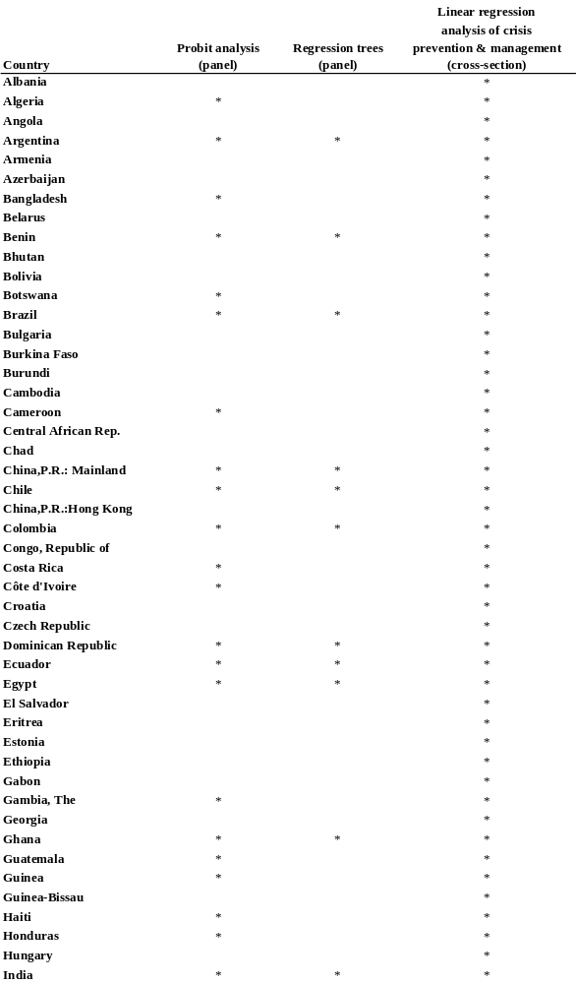
Appendix D. Dataset Country List
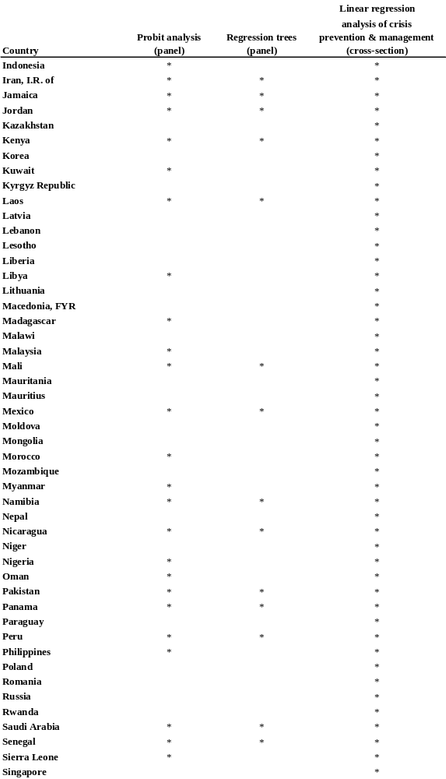
Appendix D. Dataset Country List (cont.)

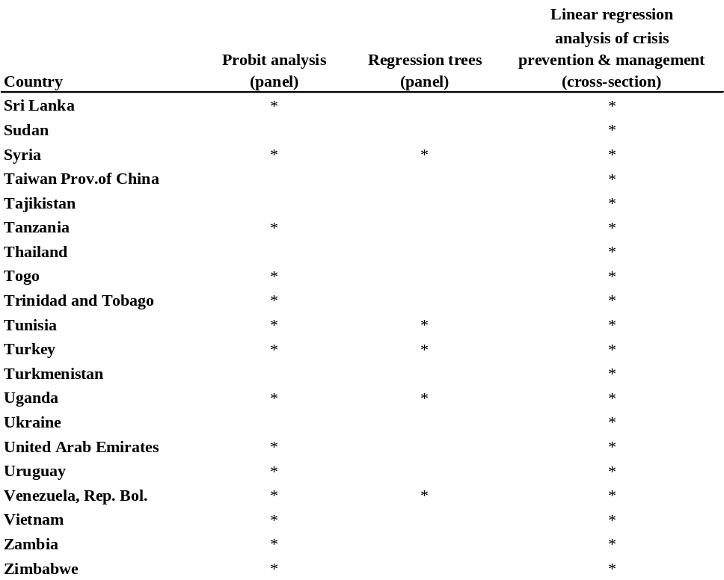
Source: Authors’ compilation.
Appendix E. Results of Probit Regressions, Different Thresholds for Crisis

Table E-1. Results of Probit Regressions (15%)
Variable | (1) | (2) | (3) | (4)
Trade openness | 0.003 | 0.005 | 0.007 | -0.001
 | (0.003) | (0.004) | (0.005) | (0.008)
Financial openness | 0.001 | -0.002 | 3.89E-04 | -0.004
 | (0.001) | (0.007) | (0.002) | (0.007)
Constraint on executives | -0.005 | 0.04 | -0.082 | -0.01
 | (0.036) | (0.047) | (0.059) | (0.08)
Stdebt/Reserve | 1.986 | 1.977 | 2.179 | 2.475
 | (1.067) | (1.24) | (1.429) | (1.646)
Debt/GDP | 0.001 | 0.001 | 0.003 | 0.005
 | (0.001) | (0.001) | (0.002) | (0.003)
(FDI+ptf)/Gross liability | -0.003 | -0.004 | -0.002 | -0.003
 | (0.003) | (0.004) | (0.003) | (0.005)
Inflation | 1.61E-04 | 1.57E-04 | 3.00E-04 | 3.11E-04
 | 1.20E-04 | 1.24E-04 | 1.59E-04 | 1.59E-04
Fixed ex. rate regime | -0.032 | -0.078 | 0.315 | 0.248
 | (0.205) | (0.257) | (0.278) | (0.391)
Intermediate ex. rate regime | -0.087 | -0.194 | 0.065 | -0.029
 | (0.194) | (0.229) | (0.246) | (0.309)
Country dummy | No | No | Yes | Yes
Year dummy | No | Yes | No | Yes
No. observations | 456 | 325 | 439 | 293
Source: Authors’ calculations.
Table E-2. Results of Probit Regressions (15%)
Variable | (1) | (2) | (3) | (4)
Trade openness | 0.002 | 0.005 | 0.004 | 0.004
 | (0.002) | (0.004) | (0.004) | (0.007)
Financial openness | 0.001 | 0.007 | 1.12E-03 | 0.005
 | (0.001) | (0.006) | (0.002) | (0.006)
Constraint on executives | 0.012 | 0.034 | -0.046 | 0.01
 | (0.029) | (0.041) | (0.05) | (0.075)
Stdebt/Reserve | 0.988 | 1.3 | 1.936 | 2.407
 | (0.678) | (0.842) | (0.935) | (1.215)
Debt/GDP | 1.09E-04 | -0.001 | 0.002 | 0.001
 | (0.001) | (0.001) | (0.001) | (0.002)
Inflation | 1.62E-05 | -1.58E-05 | -1.66E-07 | -3.76E-05
 | (7.91E-05) | (8.12E-05) | (9.57E-05) | (9.58E-05)
Fixed ex. rate regime | 0.069 | -0.05 | 0.315 | 0.264
 | (0.172) | (0.214) | (0.225) | (0.33)
Intermediate ex. rate regime | -0.133 | -0.217 | 0.065 | -0.004
 | (0.177) | (0.207) | (0.215) | (0.28)
Country dummy | No | No | Yes | Yes
Year dummy | No | Yes | No | Yes
No. observations | 640 | 401 | 629 | 374
Source: Authors’ calculations.
Table E-3. Results of Probit Regressions (15%)
Variable | (1) | (2) | (3) | (4)
Trade openness | -0.001 | -0.001 | 0.001 | 0.001
 | (0.002) | (0.002) | (0.004) | (0.005)
Financial openness | 0.001 | 0.001 | 2.01E-03 | 0.003
 | (0.002) | (0.003) | (0.002) | (0.003)
Low corruption | -3.77E-04 | 0.016 | 0.051 | 0.058
 | (0.056) | (0.058) | (0.088) | (0.097)
Stdebt/Reserve | 1.176 | 1.157 | 1.038 | 1.014
 | (0.498) | (0.523) | (0.676) | (0.727)
Debt/GDP | 1.57E-04 | 3.07E-04 | -4.15E-04 | -0.001
 | (4.68E-04) | (0.001) | (0.001) | (0.001)
(FDI+ptf)/Gross liability | -0.001 | 0.001 | -0.004 | -0.001
 | (0.002) | (0.002) | (0.003) | (0.003)
Inflation | 1.48E-04 | 1.58E-04 | 2.30E-04 | 2.49E-04
 | (1.13E-04) | (1.15E-04) | (1.52E-04) | (1.55E-04)
Fixed ex. rate regime | -0.149 | -0.171 | 0.007 | -0.143
 | (0.132) | (0.139) | (0.208) | (0.228)
Intermediate ex. rate regime | -0.253 | -0.289 | -0.225 | -0.358
 | (0.134) | (0.141) | (0.174) | (0.19)
Country dummy | No | No | Yes | Yes
Year dummy | No | Yes | No | Yes
No. observations | 810 | 751 | 741 | 673
Source: Authors’ calculations.
Table E-4. Results of Probit Regressions (15%)
Variable | (1) | (2) | (3) | (4)
Trade openness | -0.002 | -0.001 | -0.001 | 0.004
 | (0.002) | (0.002) | (0.004) | (0.005)
Financial openness | 0.002 | 0.002 | 0.003 | 0.005
 | (0.001) | (0.002) | (0.002) | (0.002)
Low corruption | -3.40E-02 | -0.01 | -0.004 | 2.28E-04
 | (0.05) | (0.052) | (0.081) | (0.088)
Stdebt/Reserve | 1.031 | 1.047 | 1.199 | 1.116
 | (0.394) | (0.446) | (0.601) | (0.665)
Debt/GDP | -4.96E-05 | -7.84E-05 | -7.07E-04 | -0.001
 | (4.05E-04) | (4.58E-04) | (0.001) | (0.001)
Inflation | 1.35E-05 | -6.31E-06 | 1.92E-06 | -1.83E-05
 | (7.46E-05) | (7.73E-05) | (9.55E-04) | (9.62E-04)
Fixed ex. rate regime | -0.098 | -0.154 | 0.047 | -0.133
 | (0.119) | (0.127) | (0.182) | (0.202)
Intermediate ex. rate regime | -0.27 | -0.32 | -0.2 | -0.36
 | (0.125) | (0.132) | (0.167) | (0.183)
Country dummy | No | No | Yes | Yes
Year dummy | No | Yes | No | Yes
No. observations | 959 | 865 | 906 | 817
Source: Authors’ calculations.

Table E-5. Results of Probit Regressions (25%)
Variable | (1) | (2) | (3) | (4)
Trade openness | 0.002 | 0.003 | -0.001 | -0.003
 | (0.003) | (0.005) | (0.005) | (0.009)
Financial openness | 0.001 | -0.009 | 4.20E-04 | -0.029
 | (0.001) | (0.013) | (0.002) | (0.019)
Constraint on executives | -0.005 | 0.002 | -0.062 | -0.005
 | (0.038) | (0.051) | (0.067) | (0.093)
Stdebt/Reserve | 1.476 | 0.946 | 1.011 | 1.913
 | (1.114) | (1.418) | (1.363) | (1.91)
Debt/GDP | 1.87E-04 | 0.001 | 0.006 | 0.008
 | (9.27E-04) | (0.002) | (0.002) | (0.004)
(FDI+ptf)/Gross liability | -0.004 | -0.005 | -0.005 | -0.01
 | (0.003) | (0.004) | (0.003) | (0.005)
Inflation | 1.94E-04 | 1.54E-04 | 3.30E-04 | 3.01E-04
 | (1.18E-04) | (1.34E-04) | (1.59E-04) | (1.88E-04)
Fixed ex. rate regime | 0.01 | -0.016 | 0.3 | 0.35
 | (0.215) | (0.283) | (0.292) | (0.421)
Intermediate ex. rate regime | -0.174 | -0.231 | -0.081 | -0.188
 | (0.206) | (0.249) | (0.267) | (0.344)
Country dummy | No | No | Yes | Yes
Year dummy | No | Yes | No | Yes
No. observations | 456 | 287 | 426 | 269
Source: Authors’ calculations.
Table E-6. Results of Probit Regressions (25%)
Variable | (1) | (2) | (3) | (4)
Trade openness | 0.001 | 0.002 | -0.001 | -0.004
 | (0.002) | (0.004) | (0.004) | (0.008)
Financial openness | 0.002 | 0.007 | 0.001 | -0.002
 | (0.001) | (0.005) | (0.002) | (0.012)
Constraint on executives | 0.002 | 0.007 | -0.04 | 0.022
 | (0.032) | (0.045) | (0.051) | (0.084)
Stdebt/Reserve | 1.234 | 1.352 | 1.51 | 2.426
 | (0.704) | (0.937) | (1.029) | (1.33)
Debt/GDP | -1.48E-04 | -0.001 | 0.003 | 0.002
 | (9.27E-04) | (0.001) | (0.002) | (0.002)
Inflation | 1.50E-04 | 8.05E-05 | 1.58E-04 | 7.22E-05
 | (7.26E-05) | (7.76E-05) | (9.19E-05) | (9.32E-05)
Fixed ex. rate regime | 0.074 | 0.033 | 0.236 | 0.222
 | (0.184) | (0.24) | (0.242) | (0.376)
Intermediate ex. rate regime | -0.169 | -0.274 | -0.026 | -0.155
 | (0.191) | (0.229) | (0.227) | (0.309)
Country dummy | No | No | Yes | Yes
Year dummy | No | Yes | No | Yes
No. observations | 640 | 373 | 572 | 332
Source: Authors’ calculations.

Table E-7. Results of Probit Regressions (25%)
Variable | (1) | (2) | (3) | (4)
Trade openness | -0.003 | -0.003 | 0.002 | 0.006
 | (0.002) | (0.002) | (0.005) | (0.006)
Financial openness | 0.001 | -3.85E-04 | 0.001 | 0.001
 | (0.002) | (0.003) | (0.002) | (0.003)
Low corruption | 0.016 | 0.03 | 0.06 | 0.056
 | (0.058) | (0.06) | (0.091) | (0.103)
Stdebt/Reserve | 1.061 | 1.092 | 0.525 | 0.539
 | (0.481) | (0.556) | (0.671) | (0.796)
Debt/GDP | 3.90E-05 | 4.25E-04 | -5.49E-04 | -2.52E-04
 | (4.92E-04) | (0.001) | (0.001) | (0.001)
(FDI+ptf)/Gross liability | -0.004 | -0.003 | -0.01 | -0.008
 | (0.002) | (0.002) | (0.003) | (0.003)
Inflation | 1.53E-04 | 1.44E-04 | 2.24E-04 | 2.06E-04
 | (1.12E-04) | (1.16E-04) | -0.000 | (1.57E-04)
Fixed ex. rate regime | -0.166 | -0.196 | -0.101 | -0.246
 | (0.141) | (0.149) | (0.225) | (0.256)
Intermediate ex. rate regime | -0.373 | -0.363 | -0.347 | -0.377
 | (0.144) | (0.15) | (0.192) | (0.223)
Country dummy | No | No | Yes | Yes
Year dummy | No | Yes | No | Yes
No. observations | 810 | 751 | 688 | 635
Source: Authors’ calculations.
Table E-8. Results of Probit Regressions (25%)
Variable | (1) | (2) | (3) | (4)
Trade openness | -0.003 | -0.003 | -0.003 | 0.004
 | (0.002) | (0.002) | (0.005) | (0.006)
Financial openness | 0.001 | 6.89E-04 | 0.002 | 0.001
 | (0.001) | (0.002) | (0.001) | (0.002)
Low corruption | -0.025 | 0.004 | 0.001 | -0.014
 | (0.052) | (0.052) | (0.084) | (0.094)
Stdebt/Reserve | 1.051 | 0.995 | 0.832 | 0.817
 | (0.396) | (0.491) | (0.608) | (0.746)
Debt/GDP | -2.13E-05 | 1.46E-04 | -5.91E-04 | -2.75E-04
 | (4.03E-04) | (0.001) | (0.001) | (0.001)
Inflation | 1.30E-04 | 8.56E-05 | 1.58E-04 | 1.08E-04
 | (6.43E-05) | (6.53E-05) | (8.51E-05) | (8.23E-05)
Fixed ex. rate regime | -0.184 | -0.243 | -0.192 | -0.374
 | (0.127) | (0.137) | (0.194) | (0.228)
Intermediate ex. rate regime | -0.375 | -0.383 | -0.293 | -0.37
 | (0.134) | (0.141) | (0.181) | (0.213)
Country dummy | No | No | Yes | Yes
Year dummy | No | Yes | No | Yes
No. observations  Source: Authors’ calculations. | 959 | 865 | 839 | 758
Table E-9. Results of Probit Regressions (35%)
Variable | (1) | (2) | (3) | (4)
Trade openness | 0.004 | 0.009 | -0.003 | 0.002
 | (0.003) | (0.005) | (0.006) | (0.011)
Financial openness | -0.001 | -0.031 | -0.003 | -0.084
 | (0.001) | (0.013) | (0.002) | (0.025)
Constraint on executives | -0.002 | 0.051 | -0.075 | 0.108
 | (0.041) | (0.051) | (0.074) | (0.094)
Stdebt/Reserve | 1.642 | 1.748 | 0.95 | 3.197
 | (1.17) | (1.576) | (1.517) | (2.314)
Debt/GDP | -3.24E-04 | 0.003 | 0.005 | 0.017
 | (0.001) | (0.002) | (0.002) | (0.005)
(FDI+ptf)/Gross liability | -0.006 | -0.006 | -0.007 | -0.013
 | (0.003) | (0.005) | (0.004) | (0.007)
Inflation | 3.23E-04 | 2.41E-04 | 5.64E-04 | 6.30E-04
 | (1.43E-04) | (1.58E-04) | (2.33E-04) | (2.72E-04)
Fixed ex. rate regime | 0.055 | -0.066 | 0.123 | 0.074
 | (0.236) | (0.313) | (0.303) | (0.464)
Intermediate ex. rate regime | 0.106 | -0.118 | 0.342 | 0.508
 | (0.217) | (0.258) | (0.273) | (0.388)
Country dummy | No | No | Yes | Yes
Year dummy | No | Yes | No | Yes
No. observations | 456 | 298 | 401 | 254
Source: Authors’ calculations.
Table E-10. Results of Probit Regressions (35%)
Variable | (1) | (2) | (3) | (4)
Trade openness | 0.003 | 0.007 | 1.77E-05 | 0.003
 | (0.002) | (0.004) | (0.005) | (0.009)
Financial openness | -3.97E-05 | -0.002 | -0.003 | -0.023
 | (0.001) | (0.006) | (0.002) | (0.018)
Constraint on executives | -0.004 | 0.051 | -0.097 | 0.101
 | (0.033) | (0.045) | (0.059) | (0.088)
Stdebt/Reserve | 0.974 | 0.85 | 0.655 | 1.599
 | (0.746) | (0.955) | (1.044) | (1.518)
Debt/GDP | -3.50E-04 | -2.24E-04 | 0.003 | 0.005
 | (0.001) | (0.001) | (0.001) | (0.003)
Inflation | 1.09E-04 | 7.24E-06 | 7.95E-05 | -3.56E-05
 | (8.12E-05) | (7.56E-05) | (9.71E-05) | (8.29E-05)
Fixed ex. rate regime | 0.027 | 0.047 | 0.101 | 0.016
 | (0.195) | (0.255) | (0.259) | (0.412)
Intermediate ex. rate regime | 0.006 | -0.131 | 0.294 | 0.313
 | (0.2) | (0.239) | (0.236) | (0.338)
Country dummy | No | No | Yes | Yes
Year dummy | No | Yes | No | Yes
No. observations | 640 | 365 | 540 | 294
Source: Authors’ calculations.

Table E-11. Results of Probit Regressions (35%)
Variable | (1) | (2) | (3) | (4)
Trade openness | -0.001 | -0.001 | 3.31E-04 | 0.005
 | (0.002) | (0.002) | (0.006) | (0.007)
Financial openness | -0.004 | -0.002 | -2.00E-03 | -0.001
 | (0.004) | (0.005) | (0.004) | (0.005)
Low corruption | -4.70E-02 | -0.035 | -0.042 | -0.035
 | (0.068) | (0.07) | (0.101) | (0.117)
Stdebt/Reserve | 1.471 | 1.557 | 1.6 | 1.744
 | (0.51) | (0.544) | (0.726) | (0.736)
Debt/GDP | 0.001 | 9.13E-04 | 7.22E-04 | 8.19E-04
 | (4.92E-04) | (0.001) | (0.001) | (0.002)
(FDI+ptf)/Gross liability | -0.005 | -0.002 | -0.011 | -0.006
 | (0.002) | (0.003) | (0.004) | (0.004)
Inflation | 3.09E-04 | 2.48E-04 | 4.66E-04 | 3.58E-04
 | (1.33E-04) | (1.20E-04) | (2.04E-04) | (1.70E-04)
Fixed ex. rate regime | -0.105 | -0.11 | -0.096 | -0.233
 | (0.156) | (0.165) | (0.245) | (0.268)
Intermediate ex. rate regime | -0.152 | -0.133 | -0.019 | -0.079
 | (0.153) | (0.165) | (0.204) | (0.243)
Country dummy | No | No | Yes | Yes
Year dummy | No | Yes | No | Yes
No. observations | 810 | 751 | 665 | 612
Source: Authors’ calculations.
Table E-12. Results of Probit Regressions (35%)
Variable | (1) | (2) | (3) | (4)
Trade openness | -0.002 | -0.001 | -0.003 | 0.006
 | (0.002) | (0.002) | (0.005) | (0.006)
Financial openness | -0.002 | -4.88E-04 | -0.001 | -4.40E-04
 | (0.002) | (0.003) | (0.003) | (0.003)
Low corruption | -0.069 | -0.041 | -0.1 | -0.118
 | (0.059) | (0.061) | (0.096) | (0.114)
Stdebt/Reserve | 1.117 | 1.092 | 1.639 | 1.787
 | (0.423) | (0.504) | (0.646) | (0.689)
Debt/GDP | 0.001 | 3.90E-04 | 5.77E-04 | 6.79E-04
 | (5.83E-04) | (0.001) | (0.001) | (0.001)
Inflation | 7.95E-05 | 2.52E-05 | 6.84E-05 | 3.17E-06
 | (7.79E-05) | (6.85E-05) | (9.42E-05) | (7.88E-05)
Fixed ex. rate regime | -0.158 | -0.181 | -0.172 | -0.287
 | (0.139) | (0.15) | (0.209) | (0.24)
Intermediate ex. rate regime | -0.199 | -0.18 | -0.04 | -0.068
 | (0.142) | (0.155) | (0.188) | (0.229)
Country dummy | No | No | Yes | Yes
Year dummy | No | Yes | No | Yes
No. observations | 959 | 865 | 797 | 716
Source: Authors’ calculations.
References

Acemoglu, Daron, Simon Johnson, and James Robinson. 2001. “The Colonial Origins of Comparative Development: An Empirical Investigation.” American Economic Review 91(5) :1369--1401.
Acemoglu, Daron, Simon Johnson, James Robinson, and Yunyong Thaicharoen. 2003. “Institutional Causes, Macroeconomic Symptoms: Volatility, Crises and Growth.” Journal of Monetary Economics 50 :49--123.
Agenor, Pierre Richard, and Joshua Aizenman. 1998. “Contagion and Volatility with Imperfect Credit Markets.” IMF Staff Papers, 45 (2) :207--35.
Aizenman, Joshua, and Reuven Glick. 2003. “Military Expenditure, Threats and Growth.” Federal Reserve Bank of San Francisco.
Aizenman, Joshua, and Andrew Powell. 2003. “Volatility and Financial Intermediation.” Journal of International Money and Finance 22 (5) :657--79.
Alesina, Alberto, and Alexander Wagner. 2003. “Choosing (and Reneging on) Exchange Rate Regimes.” NBER Working Paper 9809. National Bureau of Economic Research, Cambridge, Mass.
Alfaro, Laura, Sebnem Kalemli-Ozcan, and Vadym Volosovych. 2003. “Why Doesn’t Capital Flow from Rich Countries to Poor Countries? An Empirical Investigation.” Harvard Business School and University of Houston.
Alston, Lee J., and Andres Gallo. 2000. “Evolution and Revolution in the Argentine Banking System under Convertibility: The Roles of Crises and Path Dependence.” NBER Working Paper 8008. National Bureau of Economic Research, Cambridge, Mass.
Anderson, James, and Eric van Wincoop. 2003. “Gravity with Gravitas: A Solution to the Border Puzzle.” American Economic Review 93 (1): 170--92.
Arteta, Carlos, Barry Eichengreen, and Charles Wyplosz. 2003. “When Does Capital Account Liberalization Help More than It Hurts?” In Elhanan Helpman and Efraim Sadka, eds., Economic Policy in the International Economy. Cambridge University Press.
Barro, Robert. 1991. “Economic Growth in a Cross Section of Countries.” Quarterly Journal of Economics CVI (May) :407--44.
---------. 2001. “Economic Growth in East Asia Before and After the Financial Crisis.” NBER Working Paper 8330. National Bureau of Economic Research, Cambridge, Mass.
Barro, Robert, and Jong Wha Lee. 1993. “International Comparisons of Educational Attainment.” Journal of Monetary Economics 32 (3) :363--94.
--------. 2000. "International Data on Educational Attainment: Updates and Implications." Harvard University. Processed.

Bartolini, Leonardo, and Allan Drazen. 1997. “Capital Account Liberalization as a Signal.” American Economic Review 87 (1) :138--54.
Berg, Andrew, Eduardo Borensztein, Gian Maria Milesi-Ferreti, and Catherine Pattillo. 1999. “Anticipating Balance of Payments Crises: The Role of Early Warning Systems.” Occasional Paper 186. International Monetary Fund, Washington, D.C.
Bencivenga, Valerie, and Bruce Smith. 1991. “Financial Intermediation and Endogenous Growth.” Review of Economic Studies 58 (April) :195--209.
Bhagwati, Jagdish. 1998. “The Capital Myth.” Foreign Affairs 77 ( 3) :7--12. Reprinted in Jagdish Bhagwati, 2002. The Wind of the Hundred Days: How Washington Mismanaged Globalization. Cambridge, Mass.: MIT Press.
Biscarri, Javier Gomez, Sebastian Edwards, and Fernando Perez de Gracia. 2003. “Stock Market Cycles, Liberalization, and Volatility.” NBER Working Paper 9817. National Bureau of Economic Research, Cambridge, Mass.
Blanco, Herminio, and Peter Garber. 1986 "Recurrent Devaluations and Speculative Attacks on the Mexico Peso." Journal of Political Economy 94 :148--66
Blustein, Paul. 2002. The Chastening: Inside the Crisis that rocked the Global Financial System and humbled the IMF. New York: Public Affairs.
Bordo, Michael D., and Anna J. Schwartz. 1997. “Why Clashes Between Internal and External Stability Goals End in Currency Crises, 1797--1994.” NBER Working Paper 5710. National Bureau of Economic Research, Cambridge, Mass.
Bosworth, Barry, and Susan Collins. 2003. “The Empirics of Growth: An Update.” Brookings Papers on Economic Activity, 2:2003, 113--79 .
Breiman, Leo, Jerome H. Friedman, Richard A. Olshen, and Charles J. Stone. 1984. Classification and Regression Trees. New York: Chapman & Hall/CRC.
Burnside, Craig, Martin Eichenbaum, and Sergio Rebelo. 1998. “Prospective Deficits and the Asian Currency Crisis.” NBER Working Paper 6758. National Bureau of Economic Research, Cambridge, Mass.
---------. 1999. “Hedging and Financial Fragility in Fixed Exchange Rate Regimes.” NBER Working Paper 7143. National Bureau of Economic Research, Cambridge, Mass.
Caballero, Ricardo, and Arvind Krishnamurthy. 2001. “A ‘Vertical’ Analysis of Crises and Intervention: Fear of Floating and Ex Ante Problems.” NBER Working Paper 8428. National Bureau of Economic Research, Cambridge, Mass.
Calomiris, Charles W., and Andrew Powell. 2000. “Can Emerging Market Bank Regulators Establish Credible Discipline? The Case of Argentina, 1992-1999.” NBER Working Paper 7715. National Bureau of Economic Research, Cambridge, Mass.
Calvo, Guillermo A., and Frederic Mishkin. 2003. “The Mirage of Exchange Rate Regimes for Emerging Market Countries.” NBER Working Paper 9808. National Bureau of Economic Research, Cambridge, Mass.
Calvo, Guillermo A., and Carmen Reinhart. 2001. “When Capital Inflows Come to a Sudden Stop: Consequences and Policy Options.” In Peter Kenen and Alexander Swoboda, eds., Key Issues in Reform of the International Monetary System. Washington, D.C.: International Monetary Fund.
---------. 2002. “Fear of Floating.” Quarterly Journal of Economics 117 ( 2) :379--408.
Calvo, Guillermo A., and Carlos Vegh. 1994. "Inflation Stabilization and Nominal Anchors." Contemporary Economic Policy XII (April) :35--45. Reprinted in R. Barth and C. H. Wong, eds., 1994, Approaches to Exchange Rate Policy. Washington, D.C.: International Monetary Fund.
Calvo, Guillermo, Alejandro Izquierdo, and Ernesto Talvi. 2003. “Sudden Stops, The Real Exchange Rate, and Fiscal Sustainability: Argentina’s Lessons.” NBER Working Paper 9828. National Bureau of Economic Research, Cambridge, Mass.
Calvo, Guillermo, Leo Leiderman, and Carmen Reinhart. 1996. “Inflows of Capital to Developing Countries in the 1990s.” Journal of Economic Perspectives 10 (2) :123--39.
Cardenas, Mauricio, and Felipe Barrera. 1997. “On the Effectiveness of Capital Controls: The Experience of Colombia During the 1990s.” Journal of Development Economics 54 (1) :27--57.

Cardoso, Eliana, and Ann Helwege. 1999. “ Currency Crisis in the 1990s: The Case of Brazil.” World Bank, Washington, D.C.

Cavallo, Michele, Kate Schneider Kisselev, Fabrizio Perri, and Nouriel Roubini. 2002. “Overshooting of Exchange Rates in Currency Crises: A Theoretical and Empirical Analysis.” New York University.

Caves, Richard, Jeffrey Frankel, and Ronald Jones. 2002. World Trade and Payments: An Introduction. Boston: Addison Wesley Longman (ninth edition). http://www.ksg.harvard.edu/virtualbooktour/frankel.htm
Céspedes, Luis Felipe, Roberto Chang, and Andrés Velasco. 2002. “Dollarization of Liabilities, Net Worth Effects and Optimal Monetary Policy.” In J. Frankel and S. Edwards, eds., Preventing Crises in Emerging Markets. Chicago: University of Chicago Press.
Chang, Roberto, and Andres Velasco. . 2000a. “Liquidity Crises in Emerging Markets: Theory and Policy.” In Ben S. Bernanke and Julio Rotemberg, eds., NBER Macroeconomics Annual, 1999. Cambridge, Mass.: MIT Press.
---------. 2000b. “Banks, Debt Maturity and Crises.” Journal of International Economics 51 (1) :169--94.

--------- 2001. “A Model of Financial Crises in Emerging Markets.” Quarterly Journal of Economics 2 (116) :489--517. From NBER Working Paper 6606 (1998). National Bureau of Economic Research, Inc., Cambridge, Mass.
Chari, Anusha, and Peter Blair Henry. 2002a. “Capital Account Liberalization: Allocative Efficiency or Animal Spirits.” NBER Working Paper 8908. National Bureau of Economic Research, Cambridge, Mass.
---------. 2002b. “Risk Sharing and Asset Prices: Evidence from a Natural Experiment.” NBER Working Paper 8988. National Bureau of Economic Research, Cambridge, Mass.
Chinn, Menzie, and Hiro Ito. 2002. “Capital Account Liberalization, Institutions, and Financial Development: Cross-Country Evidence.” NBER Working Paper 8967. National Bureau of Economic Research, Cambridge, Mass.
Chinn, Menzie, and Kenneth Kletzer. 2000. “International Capital Inflows, Domestic Financial Intermediation and Financial Crises under Imperfect Information.” NBER Working Paper 7902. National Bureau of Economic Research, Cambridge, Mass.
Chinn, Menzie, Michael Dooley, and Sona Shrestha. 1999. “Latin America and East Asia in the Context of an Insurance Model of Currency Crises.” NBER Working Paper 7091. National Bureau of Economic Research, Cambridge, Mass.
Christiano, Lawrence J., Christopher Gust, and Jorge Roldos. 2002. “Monetary Policy in a Financial Crisis.” NBER Working Paper 9005. National Bureau of Economic Research, Cambridge, Mass
Chucamaro, R., R. Laban, and F. Larrain. 1996. “What Determines Capital Inflows: An Empirical Analysis for Chile.” Catholic University of Chile, Santiago.
Cole, David, and Betty Slade. 1992. “Indonesian Financial Development: A Different Sequencing?” In D. Vittas, ed., Financial Regulation: Changing the Rules of the Game. EDI Development Studies. Washington, D.C.: World Bank.
Corden, W. Max. 1993. “Absorption, the Budget, and Debt: The Wonderland of Possibilities.” In Horse Herberg and Ngo Van Long, eds., Trade, Welfare, and Economic Policies: Essays in Honor of Murray C. Kemp. Ann Arbor: University of Michigan Press.
---------. 1994. “A Model of Balance of Payments Policy.” In Corden, Max. Economic Policy, Exchange Rates and the International Monetary System. Oxford: Oxford University Press.
Corsetti, Giancarlo, Paolo Pesenti, and Nouriel Roubini. 1999a. “Paper Tigers? A Model of the Asian Crisis,” NBER Working Paper 6783. Also in European Economic Review 43 (7): 1211--36.
---------. 1999b. “What Caused the Asian Currency and Financial Crisis” Japan and the World Economy 11 (September): 305--73.
De Gregorio, Jose, and Pablo Guidotti. 1995. “Financial Development and Economic Growth.” World Development 23 (Sept.) :443--48.
De la Torre, Augusto, Eduardo Levy Yeyati, and Sergio Schmukler. 2003. “Living and Dying with Hard Pegs: The Rise and Fall of Argentina’s Currency Board.” Economia (Spring) :43--107. Reprinted in V. Alexander, J. Mélitz, and G. von Furstenberg, eds., Monetary Unions and Hard Pegs: Effects on Trade, Financial Development, and Stability. Oxford: Oxford University Press.
Dekle, Robert, and Kenneth Kletzer. 2001. “Domestic Bank Regulation and Financial Crises: Theory and Empirical Evidence from East Asia.” NBER Working Paper 8322. National Bureau of Economic Research, Cambridge, Mass. In Sebastian Edwards and Jeffrey Frankel, eds., 2002, Preventing Currency Crises in Emerging Markets. Chicago: University of Chicago Press.
Desai, Padma. 2003. Financial Crisis, Contagion and Containment: From Asia to Argentina. Princeton: Princeton University Press.
Diamond, Jared. 1997. Guns, Germs and Steel. New York: W.W. Norton and Co.
Diamond, Douglas, and Philip Dybvig. 1983. “Bank Runs, Deposit Insurance, and Liquidity.” Journal of Political Economy 91 (June) :401--19.
Diamond, Douglas, and Raghuram Rajan. 2000. “Banks, Short Term Debt and Financial Crises: Theory, Policy Implications and Applications.” NBER Working Paper 7764. National Bureau of Economic Research, Cambridge, Mass.
Diaz-Alejandro, Carlos. 1985. “Good-bye Financial Repression; Hello Financial Crash.” Journal of Development Economics 19 (Sept.):1--24.
Dooley, Michael. 1996. "A Survey of Literature on Controls over International Capital Transactions." IMF Staff Papers, 43 (4) :639--87.
---------. 1997. “A Model of Crises in Emerging Markets.” NBER Working Paper 6300. National Bureau of Economic Research, Cambridge, Mass. Also in Economic Journal 110 (460) (January 2000) :256--72.
Dornbusch, Rudiger. 1973. "Devaluation, Money and Nontraded Goods." American Economic Review 63 (December) :871--80.
---------. 2002. “Crises in Emerging Markets: A Primer.” In Sebastian Edwards and Jeffrey Frankel, eds., Preventing Currency Crises in Emerging Markets. Chicago: University of Chicago Press.
Dornbusch, Rudiger, and Alejandro Werner. 1994. “Mexico: Stabilization, Reform and No Growth.” Brookings Papers on Economic Activity, 1: 1994, 253--97
Dornbusch, Rudiger, Ilan Goldfajn, and Rodrigo Valdes. 1995. “Currency Crises and Collapses.” Brooking Papers on Economic Activity 2:1995, 219--93.
Drazen, Allan. 2003. “Interest Rate Defense against Speculative Attack as a Signal: A Primer.” In Michael Dooley and Jeffrey Frankel, eds., Managing Currency Crises in Emerging Markets. Chicago: University of Chicago Press.
Du Julan, and Shang-Jin Wei. 2003. “Does Insider Trading Raise Market Volatility?” NBER Working Paper 9541. National Bureau of Economic Research, Cambridge, Mass. Forthcoming in Economic Journal, October 2004.
Easterly and Levine. 1997. "Africa's Growth Tragedy: Policies and Ethnic Divisions." Quarterly Journal of Economics CXII (4) :1203--50.
Easterly, William, and Ross Levine. 2002. “Tropics, Germs, and Crops: How Endowments Influence Economic Development,” Center for Global Development Working Paper No. 15, Washington, D.C. Forthcoming in Carnegie-Rochester Conference Series on Public Policy.
Easterly, William, and Sergio Rebelo. 1994. “Fiscal Policy and Economic Growth: An Empirical Investigation.” Working Paper 885. Centre for Economic Policy Research, London.
Edison, Hali. 2000. “Do Indicators of Financial Crises Work? An Evaluation of an Early Warning System.” International Finance Discussion Papers No. 675. Federal Reserve Board, Washington, D.C.
Edison, Hali, Michael Klein, Luca Ricci, and Torsten Sloek. 2002. “Capital Account Liberalization and Economic Peformance: Survey and Synthesis.” NBER Working Paper 9100. National Bureau of Economic Research, Cambridge, Mass.
Edwards, Sebastian. 1984. “The Order of Liberalization of the External Sector in Developing Countries.” In Essays in International Finance, No. 156. Princeton University.
---------. 1986. “Are Devaluations Contractionary?” Review of Economics and Statistics 68 (3) : 501--08.
---------. 1999. “ Crisis Prevention: Lessons from Mexico and East Asia.” NBER Working Paper 7233. National Bureau of Economic Research, Cambridge, Mass.
---------. 2000. "Capital Flows, Real Exchange Rates, and Capital Controls: Some Latin American Experiences." In Sebastian Edwards, ed., Capital Flows and the Emerging Economies. Chicago: University of Chicago Press.
---------. 2001. “Capital Mobility and Economic Performance: Are Emerging Economies Different?” NBER Working Paper 8076. National Bureau of Economic Research, Cambridge, Mass.
---------. 2002. “The Great Exchange Rate Debate After Argentina.” NBER Working Paper 9257. National Bureau of Economic Research, Cambridge, Mass.
---------. 2003. “Exchange Rate Regimes.” In Martin Feldstein, ed., Economic and Financial Crises in Emerging Market Economies. Chicago: University of Chicago Press.
Edwards, Sebastian, and Jeffrey Frankel. 2002. Preventing Currency Crises in Emerging Markets. Chicago: University of Chicago Press.
Edwards, Sebastian, and Eduardo Levy-Yeyati. 2003. "Flexible Exchange Rates as Shock Absorbers." NBER Working Papers 9867. National Bureau of Economic Research, Cambridge, Mass.
Edwards, Sebastian, and Igal Magendzo. 2003a. “A Currency of One’s Own? An Empirical Investigation of Dollarization and Independent Currency Unions.” NBER Working Paper 9514. National Bureau of Economic Research, Cambridge, Mass.
---------. 2003b. “ Strict Dollarization and Economic Peformance: An Empirical Investigation.” NBER Working Paper 9820. National Bureau of Economic Research, Cambridge, Mass.
Edwards, Sebastian, and Miguel A. Savastano. 1999. “Exchange Rates in Emerging Economies: What Do We Know? What Do We Need to Know?” NBER Working Paper 7228. National Bureau of Economic Research, Cambridge, Mass.
Eichengreen, Barry. 1999. Toward a New International Financial Architecture: A Practical Post-Asia Agenda. Washington, D.C.: Institute for International Economics.
Eichengreen, Barry, and Tamim Bayoumi. 1999. “Is Asia an Optimum Currency Area? Can It Become One?” In Stefan Collignon, Jean Pisani-Ferry, and Yung Chul Park, eds., Exchange Rate Policies in Emerging Asian Countries. London: Routledge.
Eichengreen, Barry, and David Leblang. 2003. “Capital Account Liberalization and Growth: Was Mr. Mahatir Right?” NBER Working Paper 9427. National Bureau of Economic Research, Cambridge, Mass.
Eichengreen, Barry, and Ricardo Hausmann. 1999. “Exchange Rates and Financial Fragility.” NBER Working Paper 7418. National Bureau of Economic Research, Cambridge, Mass.
Eichengreen, Barry, and Ashoka Mody. 1999. “Lending Booms, Reserves, and the Sustainability of Short-Term Debt: Inferences from the Pricing of Syndicated Bank Loans.” NBER Working Paper 7113. National Bureau of Economic Research, Cambridge, Mass.
Eichengreen, Barry, and Michael Mussa. 1998. “Capital Account Liberalization: Theoretical and Practical Aspects.” Occasional Paper No. 172, International Monetary Fund, Washington, D.C.
Eichengreen, Barry, and Andy Rose. 2003. “Does it Pay to Defend against a Speculative Attack?” In Michael Dooley and Jeffrey Frankel, eds., Managing Currency Crises in Emerging Markets. Chicago: University of Chicago Press.
Eichengreen, Barry, and Alan Taylor. 2003. “The Monetary Consequences of a Free Trade Area of the Americas.” NBER Working Paper 9666. National Bureau of Economic Research, Cambridge, Mass.
Eichengreen, Barry, Ricardo Hausmann, and Ugo Panizza. 2003. “The Pain of Original Sin.” Inter-American Development Bank, Washington, D.C.
Eichengreen, Barry, Andy Rose, and Charles Wyplosz. 1995. "Exchange Market Mayhem: The Antecedents and Aftermath of Speculative Attacks." Economic Policy 21 :249--96.
Engerman, Stanley, and Kenneth Sokoloff. 1997. “Factor Endowments, Institutions, and Differential Paths of Growth among New World Economies: A View from Economic Historians of the United States.” In Stephen Haber, ed., How Latin America Fell Behind. Stanford, Calif.: Stanford University Press.
ESRI (Environmental Systems Research Institute Inc.) 1996. ArcWorld Supplement Database. Redlands, Calif.

Fischer, Stanley. 2001. “Exchange Rate Regimes: Is the Bipolar View Correct?” Journal of Economic Perspectives 15 (2) :3--24.
---------. 2004a. “Capital Account Liberalization and the Role of the IMF.” In Stanley Fischer, IMF Essays from a Time of Crisis: The International Financial System, Stabilization, and Development. Cambridge, Mass.: MIT Press.
---------. 2004b. IMF Essays. Cambridge, Mass.: MIT Press.
Flood, Robert, and Rebecca Coke. 2000. “Is ‘Predicted Currency Crisis’ an Oxymoron?” International Monetary Fund, Washington, D.C.
Flood, Robert, and Peter Garber. 1984. “Collapsing Exchange Rate Regimes: Some Linear Examples.” Journal of International Economics 17 (August) :1--14.
Flood, Robert, and Nancy Marion. 1996. “Speculative Attacks: Fundamentals and Self-Fulfilling Prophecies.” NBER Working Paper 5789. National Bureau of Economic Research, Cambridge, Mass.
---------. 1999. “Perspectives on the Recent Currency Crisis Literature.” IMF Working Paper 98/130. In International Journal of Finance and Economics 4 (1) :1-26. Also in Guillermo Calvo, Rudiger Dornbusch, and Maurice Obstfeld, eds., 2001, Money, Capital Mobility, and Trade: Essays in Honor of Robert Mundell. Cambridge, Mass.: MIT Press.
---------. 2002. “A Model of the Joint Distribution of Banking and Currency Crises.” International Monetary Fund, Washington, D.C.
Forbes, Kristin. 2003. “One Cost of the Chilean Capital Controls: Increased Financial Constraints for Smaller Firms,” NBER Working Paper 9777. National Bureau of Economic Research, Cambridge, Mass.
Frankel, Jeffrey. 1999a. “No Single Exchange Rate Regime is Right for All Countries or at All Times.” Essays in International Finance, No. 215. Princeton University.
---------. 1999b. “Proposals Regarding Restrictions on Capital Flows.” African Finance Journal Volume 1, Part 1: 92--104.
----------. 2001. “The Balance between Adjustment and Financing.” In P. Kenen and A. Swoboda, eds., Key Issues in Reform of the International Monetary System. Washington, D.C.: International Monetary Fund.
----------. 2004. “Experience of and Lessons from Exchange Rate Regimes in Emerging Economies.” In Takatoshi Ito and Yung Chul Park, eds., Monetary and Financial Cooperation in East Asia: The Way Ahead, Volume 2. New York: Palgrave Macmillan Press.
Frankel, Jeffrey, and David Romer. 1999. “Does Trade Cause Growth?”American Economic Review 89 (3) :379--99.
Frankel, Jeffrey, and Andrew Rose. 1996. “Currency Crashes in Emerging Markets: An Empirical Treatment.” Journal of International Economics 41(3/4) :351--66.
----------. 2002. “Estimating the Effects of Currency Unions on Trade and Output.” Quarterly Journal of Economics CXVII (2) :437--66.
Furman, Jason, and Joseph Stiglitz. 1998. “Economic Crisis: Evidence and Insights from East Asia.” Brookings Papers on Economic Activity 2:1998, 1--135.
Gallego, Francisco, Leonardo Hernandez, and Klaus Schmidt-Hebbel. 1999. “Capital Controls in Chile: Effective? Efficient?” Working Paper 59. Central Bank of Chile, Santiago.
Gallup, John, Jeffrey Sachs, and Andrew Messenger. 1998. “Geography and Economic Development.” NBER Working Paper 6849. National Bureau of Economic Research, Cambridge, Mass. In International Science Review 22 (2) (August 1999): 179--232.

Gelos, R. Gaston, and Shang-Jin Wei. 2002. “Transparency and International Investor Behavior.” NBER Working Paper 9260. National Bureau of Economic Research, Cambridge, Mass.
Ghosh, Atish, Anne-Marie Gulde, and Holger Wolf. 2000. “Currency Boards: More than a Quick Fix?” Economic Policy 31 (October) :270--335.
Gleditsch, Nil Peter, Peter Wallensteen, Mikael Eriksson, Margareta Sollenberg, and Håvard Strand. 2002. “Armed Conflict 1946–2001: A New Dataset.” Journal of Peace Research 39 (5) :615–37.
Glick, Reuven, and Michael Hutchison. 2002. “Capital Controls and Exchange Rate Instability in Developing Economies.” Federal Reserve Bank of San Francisco, Center for Pacific Basin Monetary and Economic Studies Working Paper PB00-05 (revised December 2002).
Glick, Reuven, and Andrew Rose. 2001. “Does a Currency Union Affect Trade? The Time Series Evidence.” NBER Working Paper 8396. National Bureau of Economic Research, Cambridge, Mass. In European Economic Review (June 2002) 46 (6) :1125--51.
Goldstein, Morris, and Philip Turner. 2004. Controlling Currency Mismatches in Emerging Economies: An Alternative to the Original Sin Hypothesis. Washington, D.C: Institute for International Economics.
Goldstein, Morris, Graciela Kaminsky, and Carmen Reinhart. 2000. Assessing Financial Vulnerability: An Early Warning System for Emerging Economies. Washington, D.C.: Institute for International Economics.
Gourinchas, Pierre-Olivier, and Olivier Jeanne. 2003. “The Elusive Gains from International Financial Integration.” NBER Working Paper 9684. National Bureau of Economic Research, Cambridge, Mass.
Guidotti, Pablo. 2003. In Jose Antonio Gonzalez, Vittorio Corbo, Anne Krueger, and Aaron Tornell, eds., Latin American Macroeconomic Reforms: The Second Stage. Chicago: University of Chicago Press.
Hall, Robert, and Chad Jones. 1999. “Why Do Some Countries Produce So Much More Output per Worker than Others?” Quarterly Journal of Economics 114 (1): 83--116.
Hausmann, Ricardo, Michael Gavin, Carmen Pages-Serra, and Ernesto Stein. 1999. “Why Do Countries Float the Way They Do?” Presented at conference on New Initiatives to Tackle International Financial Turmoil. Inter-American Development Bank Annual Meetings of the Board of Governors, Paris.
Henry, Peter Blair. 2003. “Capital Account Liberalization, the Cost of Capital, and Economic Growth, NBER Working Paper 9488. National Bureau of Economic Research, Cambridge, Mass.
Hutchison, Michael M. 2003. “A Cure Worse Than the Disease? Currency Crises and the Output Costs of IMF-Supported Stabilization Programs.” In Michael Dooley and Jeffrey Frankel, eds., Managing Currency Crises in Emerging Markets. Chicago: University of Chicago Press.
IMF (International Monetary Fund). 2003. Report on Capital Account Crises of the IMF Independent Evaluations Office. Washington, D.C.: IMF.
International Country Risk Group (ICRG). 1994-2003. Corruption Ratings. http://www.icrgonline.com/page.aspx?page=icrgmethods
Ito, Takatoshi. 2002. "Asian Currency Crises, Five Years Later: Retrospect of Thailand, Malaysia, Indonesia, Philippines and Korea." Presented at conference on Financial Sector Reform Across Asia, Center for Business and Government, December, Harvard University.
Jeanne, Olivier. 2000. “Currency Crises: A Perspective on Recent Theoretical Developments.” Special Papers in International Economics, No. 20. Princeton University.
Johnson, Simon, and Todd Mitton. 2003. “Cronyism and Capital Controls: Evidence from Malaysia.” Journal of Financial Economics 67 (2) :351--82.
Johnson, Simon, John McMillan, and Christopher Woodruff. 2002. “Property Rights and Finance.” American Economic Review 92 (5) :1335--56.
Johnson, Simon, Peter Boone, Alasdair Breach, and Eric Friedman. 2000. “Corporate Governance in the Asian Financial Crisis.” Journal of Financial Economics 58 (1) :141--84.
Kamin, Steven. 1988. “Devaluation, External Balance, and Macroeconomic Performance: A Look at the Numbers.” Studies in International Finance, No. 62. Princeton University.
Kaminsky, Graciela, and Sergio Schmukler. 2003. “Short-run Pain, Long-run Gain: The Effects of Financial Liberalization.” NBER Working Paper 9787. National Bureau of Economic Research, Cambridge, Mass.
Kaminsky, Graciela, S. Lizondo, and C. Reinhart. 1998. “Leading Indicators of Currency Crises.” IMF Staff Papers, 5 (1) :1--48.
Kharas, Homi, Brian Pinto, and Sergei Ulatov. 2001. “An Analysis of Russia’s 1998 Meltdown: Fundamentals and Market Signals.” Brookings Papers on Economic Activity 1:2001, 1--68.
King Robert, and Ross Levine. 1993. “Finance and Growth: Schumpeter Might be Right.” Quarterly Journal of Economics 108 (3) :717--37.
Klein, Michael. 2003. “Capital Account Openness and the Variety of Growth Experience.” NBER Working Paper 9500. National Bureau of Economic Research, Cambridge, Mass.
Klein, Michael, and Nancy Marion. 1997. “Explaining the Duration of Exchange-Rate Pegs.” Journal of Development Economics 54 (2) :387--404.
Klein, Michael, and Giovanni Olivei. 2000. “Capital Account Liberalization, Financial Development, and Economic Growth.” NBER Working Paper 7384. National Bureau of Economic Research, Cambridge, Mass.
Kose, M. Ayhan, Eswar Prasad, and Marco Terrones. 2002. "Financial Integration and Macroeconomic Volatility." Paper prepared for Annual Research Conference, International Monetary Fund.
Krugman, Paul. 1979. “A Model of Balance-of-Payments Crises.” Journal of Money, Credit & Banking 11 (3) :311--25. Reprinted in Paul Krugman, ed., 1992, Currencies and Crises. Cambridge and London: MIT Press.
---------. 1998a. "What Happened to Asia?” http://web.mit.edu/krugman/www/DISINTER.html
---------. 1998b. “Latin America’s Swan Song.” http://web.mit.edu/krugman/www/swansong.html
---------. 1999. “Balance Sheets, the Transfer Problem and Financial Crises.” In P. Isard, A. Razin, and A. Rose, eds., International Finance and Financial Crises: Essays in Honor of Robert Flood. Boston: Kluwer Academic Publishers.
Lahiri, Amartya, and Carlos A. Végh. 2000. “Delaying the Inevitable: Optimal Interest Rate Policy and BOP Crises.” NBER Working Paper 7734. National Bureau of Economic Research, Cambridge, Mass.
La Porta, Rafael, Florencio Lopez-de-Silanes, and Andrei Shleifer. 2003. “What Works in Securities Markets?” NBER Working Paper 9882. National Bureau of Economic Research, Cambridge, Mass.
La Porta, Rafael, Florencio Lopez-de-Silanes, Andrei Shleifer, and Robert Vishny. 1998. “Law and Finance.” Journal of Political Economy 106 (6) 1113--55.
---------. 1999. “Investor Protection: Origins, Consequences, and Reform.” NBER Working Paper 7428. National Bureau of Economic Research, Cambridge, Mass. In Journal of Financial Economics 58 (12) (October 2000): 3--27.
Larrain, Felipe, and Andres Velasco. 2001. “Exchange Rate Policy in Emerging Markets: The Case for Floating.” Studies in International Finance, No. 224. Princeton University.
Levine, Ross, and Sergio Schmukler. 2003. “Migration, Spillovers and Diversion: Impact of Internationalization on Stock Market Liquidity.” NBER Working Paper 9614. National Bureau of Economic Research, Cambridge, Mass.
Levy-Yeyati, Eduardo, and Federico Sturzenegger. 2003. “To Float or to Trail: Evidence on the Impact of Exchange Rate Regimes.” American Economic Review 93 (4) :41173--93.
Lipsey, Robert E. 2001. Foreign Direct Investors in Three Financial Crises. Working Paper 8084. National Bureau of Economic Research, Cambridge, Mass.
Lizondo, Saul, and Peter Montiel. 1989. "Contractionary Devaluation in Developing Countries: An Analytical Survey." IMF Staff Papers, 36 (March) :182--227.
Manasse, Paolo, Nouriel Roubini, and Axel Schimmelpfennig.2003. “Predicting Sovereign Debt Crises.” IMF Working Paper 03/221. International Monetary Fund, Washington, D.C.
Martin, Philippe, and Helene Rey. 2002. “Financial Globalization and Emerging Markets: With or Without Crash?” NBER Working Paper 9288. National Bureau of Economic Research, Cambridge, Mass.
Masson, Paul. 2001. “Exchange Rate Regime Transitions.” Journal of Development Economics 64 (2) :571--86.
McKinnon, Ronald. 1991. The Order of Economic Liberalization: Financial Control in the Transition to a Market Economy. Baltimore: Johns Hopkins University Press.
McKinnon, Ronald, and Huw Pill. 1997. “Credible Economic Liberalizations and Overborrowing.” American Economic Review 87 (2) :189--93.
McQuillan, Lawrence, and Peter Montgomery, eds. 1999. The International Monetary Fund: Financial Medic to the World? Stanford, Calif.: Hoover Institution Press.
Milesi-Ferretti, Gian Maria, and Assaf Razin. 1997. “Sharp Reductions in Current Account Deficits: An Empirical Analysis.” NBER Working Paper 6310. National Bureau of Economic Research, Cambridge, Mass. Also in European Economic Review 42 (3--5) (May 1998) :897--908.

---------. 1998. “Current Account Reversals and Currency Crises: Empirical Regularities.” NBER Working Paper 6620. . National Bureau of Economic Research, Cambridge, Mass. Reprinted in Paul Krugman, ed., 2000, Currency Crises. Chicago: University of Chicago Press.
Mendoza, Enrique. 2002. “Why Should Emerging Economies Give up National Currencies: A Case for 'Institutions Substitution.'” NBER Working Paper 8950. National Bureau of Economic Research, Cambridge, Mass.
Mishkin, Frederic S. 2001. “Financial Policies and the Prevention of Financial Crises in Emerging Market Countries.” NBER Working Paper 8087. National Bureau of Economic Research, Cambridge, Mass.
Morris, Stephen, and Hyun Song Shin. 1998. “Unique Equilibrium in a Model of Self-Fulfilling Crises.” American Economic Review 88 (3): 587--97.
Morris, Stephen, and Hyun Song Shin. 2001. “Rethinking Multiple Equilibria in Macroeconomic Modeling.” In Ben S. Bernanke and Kenneth Rogoff, eds., NBER Macroeconomics Annual, 2000. Cambridge, Mass.: MIT Press.
Mussa, Michael. 2002. Argentina and the Fund: From Triumph to Tragedy. Washington, D.C.: Institute for International Economics.
Noguer, Marta, and Marc Siscart. 2002. “Trade Raises Income: A Precise and Robust Result.” Department of Economics, New York University.
Obstfeld, Maurice. “The Logic of Currency Crises.” 1994. Cahiers Economiques et Monetaires 43 :189--213.
---------. 1996. “Models of Currency Crises with Self-Fulfilling Features.” European Economic Review 40 (April): 1037--47.
---------. 1998. “Destabilizing Effects of Exchange-Rate Escape Clauses.” NBER Working Paper 3603. National Bureau of Economic Research, Cambridge, Mass.
Obstfeld, Maurice, and Kenneth Rogoff. 1995. "The Mirage of Fixed Exchange Rates." Journal of Economic Perspectives 9 (Fall) :73--96.
Pinto, Brian, Evsey Gurvich, and Sergei Ulatov. 2004. “Lessons from the Russian Crisis of 1998 and Recovery” (chapter 10, this volume).
Prasad, Eswar, Kenneth Rogoff, Shang-Jin Wei, and M. Ayhan Kose. 2003. “Effects of Financial Globalization on Developing Countries: Some Empirical Evidence.” Occasional paper No. 220, International Monetary Fund, Washington, D.C. Downloadable at http://www.imf.org/external/pubs/nft/op/220/index.htm.
Prati, Alessandro, and Massimo Sbracia. 2002. “Currency Crises and Uncertainty About Fundamentals.” International Monetary Fund, Washington, D.C.
Quinn, Dennis, 1997 “The Correlates of Change in International Financial Regulation,” American Political Science Review 91 (September): 531--51.
Radelet, Steven, and Jeffrey Sachs. 1998. "The East Asian Financial Crisis: Diagnosis, Remedies, Prospects." Brookings Papers on Economic Activity 1:1998, 1--74 and 88--90.
Rajan, Ramkishen, 2001, “(Ir)relevance of ?Currency-Crisis Theory to the Devaluation and Collapse of the Thai Baht.” Princeton Studies in International Economics, No. 88. Princeton University.
Razin, Assaf, Efraim Sadka, Chi-Wa Yuen. 2001. “Why International Equity Flows to Emerging Markets are Inefficient and Small Relative to International Debt Flows.” NBER Working Paper 8659. National Bureau of Economic Research, Cambridge, Mass.
Reinhart, Carmen, and Vincent Reinhart. 2003. “Twin Fallacies about Exchange Rate Policy in Emerging Markets.” NBER Working Paper 9670. National Bureau of Economic Research, Cambridge, Mass.
Reinhart, Carmen M., and Kenneth S. Rogoff. 2002. “The Modern History of Exchange Rate Arrangements: A Reinterpretation.” NBER Working Paper 8963. National Bureau of Economic Research, Cambridge, Mass.
Reinhart, Carmen M., and R. Todd Smith. 2001. “Temporary Controls on Capital Inflows.” NBER Working Paper 8422. National Bureau of Economic Research, Cambridge, Mass.
Reinhart, Carmen, Kenneth Rogoff, and Miguel Savastano. 2003. “Debt Intolerance.” NBER Working Paper 9908. National Bureau of Economic Research, Cambridge, Mass.
Rodríguez, Francisco, and Dani Rodrik. 2001. “Trade Policy and Economic Growth: A Skeptic's Guide to the Cross-National Evidence.” In Ben Bernanke and Kenneth Rogoff, eds. NBER Macroeconomics Annual 2001. Cambridge, Mass.: MIT Press.
Rodrik, Dani. 1998. "Who Needs Capital-Account Convertibility?" In Essays in International Finance No. 207. Princeton University.
Rodrik, Dani, and Ethan Kaplan. 2002. “Did the Malaysian Capital Controls Work?” In Sebastian Edwards and Jeffrey Frankel, eds., Preventing Currency Crises in Emerging Markets. Chicago: University of Chicago Press.
Rodrik, Dani, and Andres Velasco. 2000. “Short-Term Capital Flows.” In Annual World Bank Conference on Development Economics 1999. Washington, D.C: World Bank.
Rodrik, Dani, Arvind Subramanian, and Francesco Trebbi. 2002. “Institutions Rule: The Primacy of Institutions over Geography and Integration in Economic Development.” NBER Working Paper 9305. National Bureau of Economic Research, Cambridge, Mass.
Rose, Andrew. 2000. “One Money, One Market: Estimating the Effect of Common Currencies on Trade.” Economic Policy 30 (April): 9--45.
---------. 2001. “Common Currency Areas in Practice.” In Revisiting the Case for Flexible Exchange Rates. Ottawa: Bank of Canada.
---------. 2002. “One Reason Countries Pay Their Debts: Renegotiation and International Trade.” NBER Working Paper 8853. National Bureau of Economic Research, Cambridge, Mass.
Roubini, Nouriel, Paolo Manasse, Richard Hemming, and Axel Schimmelpfennig. 2003. “An Early Warnings Model of Sovereign Debt Crises: A Panel Data Econometric Estimation for the 1970--2000 Period.” International Monetary Fund, Washington, D.C.
Sachs, Jeffrey. 1986 “Managing the LDC Debt Crisis.” Brookings Papers on Economic Activity 2:1986, 397--432.
---------. 1998. “The IMF and the Asian Flu.” The American Prospect 37 (March-April): 16--21.
---------. 2003. “Institutions Don’t Rule: Direct Effects of Geography on Per Capita Income.” NBER Working Paper 9490. National Bureau of Economic Research, Cambridge, Mass.
Sachs, Jeffrey, and Andrew Warner. 1995. "Economic Reform and the Process of Global Integration." Brookings Papers on Economic Activity 1:1995, 1--95.
Sachs, Jeffrey, Aaron Tornell, and Andres Velasco. 1996. “Financial Crises in Emerging Markets: The Lessons from 1995.” Brookings Papers on Economic Activity 1:1996, 147-216.
---------. 1996. “The Collapse of the Mexican Peso: What Have We Learned?” Economic Policy 22 (April): 13-63.
Salant, Stephen, and Dale Henderson. 1978. "Market Anticipation of Government Policies and the Price of Gold." Journal of Political Economy 86 (4) :627--48.
Salter, W. E. G. 1959. “Internal and External Balance–The Role of Price and Expenditure Effects.” Economic Record August :226--38 (Australia).
Schneider, Martin, and Aaron Tornell. 2000. “Balance Sheet Effects, Bailout Guarantees and Financial Crises,” NBER Working Paper 8060. National Bureau of Economic Research, Cambridge, Mass.
Servén, Luis, and Guillermo Perry. 2004. “Argentina’s Macroeconomic Collapse: Causes and Lessons ” (chapter 11, this volume).
Shleifer, Andrei, and Daniel Wolfenson. 2000. “Investor Protection and Equity Markets.” NBER Working Paper 7974. National Bureau of Economic Research, Cambridge, Mass.
Swan, Trevor. 1963. "Longer Run Problems of the Balance of Payments." In H. W. Arndt and W. M. Corden, eds., The Australian Economy. Melbourne: Cheshire.
Temple, Jonathan. 1999. “The New Growth Evidence.” Journal of Economic Literature 37 (1): 112--56.
Tenreyro, Silvana, and Robert J. Barro. 2003. “Economic Effects of Currency Unions.” NBER Working Paper 9435. National Bureau of Economic Research, Cambridge, Mass.
Ücer, Murat, and Caroline Van Rijckeghem. 2004. Murder on the Orient Express: The Turkish Currency Crises of 2000-01. Revised as A Chronicle of Sudden Death: The Turkish Financial Crises of 2000--01. Istanbul: Bogazici University Press.
Ul Haq, Mahbub, Inge Kaul, and Isabelle Grunberg, eds. 1996. The Tobin Tax: Coping with Financial Volatility. New York: Oxford University Press.
Valdes-Prieto, S., and M. Soto. 1996. “New Selective Capital Controls in Chile: Are They Efficient?” Catholic University of Chile, Santiago.
Velasco, Andres. 1996. “When Are Fixed Exchange Rates Really Fixed?” NBER Working Paper 5842. National Bureau of Economic Research, Cambridge, Mass. Also in Journal of Development Economics 54 (1) (1997): 5--25.
Wei, Shang-Jin, 2000a. "How Taxing is Corruption on International Investors?" Review of Economics and Statistics 82 (1) :1--11. Downloadable at www.nber.org/~wei.
---------. 2000b. "Domestic Crony Capitalism and International Fickle Capital: Is There a Connection?" World Bank - Country Economics Department Paper 2429. In International Finance 4 (Spring) (2001): 15--46. Downloadable at http://www.brook.edu/dybdocroot/views/articles/wei/20010409.pdf.
---------. 2000c. “Local Corruption and Global Capital Flows.” Brookings Papers on Economic Activity 2:2000, 303--54. Downloadable at www.nber.org/~wei.

Wei, Shang-Jin, and Yi Wu. 2002. “Negative Alchemy: Corruption, Composition of Capital Flows, and Currency Crises.” In Sebastian Edwards and Jeffrey Frankel, eds., Preventing Currency Crises in Emerging Markets. Chicago: University of Chicago Press.
Willett, Thomas. 2000. “International Financial Markets as Sources of Crises or Discipline: The Too Much, Too Late Hypothesis." Essays in International Finance, No. 218. Princeton University.
Williamson, John. 2001. “The Case for a Basket, Band and Crawl (BBC) Regime for East Asia.” In David Gruen and John Simon, eds., Future Directions for Monetary Policies in East Asia. Sydney: Reserve Bank of Australia.
Wyplosz, Charles. 2001. “How Risky is Financial Liberalization in the Developing Countries?" G-24 Discussion Paper Series No. 14, United Nations, New York and Geneva.
Endnotes

Krugman (1998b).
Caves, Frankel, and Jones (2002). For further exposition, see Corden (1993).
Edwards (1986) and Kamin (1988).
“Sudden stop” refers to any abrupt cut-off of foreign willingness to hold liabilities of the domestic country. The phrase originated with Rudiger Dornbusch (see, for example, Dornbusch, Goldfain, and Valdes 1995), but was further popularized by Guillermo Calvo (see, for example, Calvo and Reinhart 2001).
A note on semantics. The distinction between the first and second generation models of speculative attacks is widely agreed. See, for example, Flood and Marion (1999), which is a survey of the literature; Flood and Marion (1996); or Jeanne (2000). But there is less of a consensus as to what constitutes the third generation. This chapter uses the distinction that seems the most useful (multiple equilibria vs. structural flaws).
Even after 1995, some economists continued to attribute currency crises to macroeconomic fundamentals. See Bordo and Schwartz (1997) or Mishkin (2001).
Flood and Garber (1984); Flood and Marion (2002); Morris and Shin (1998, 2001).
Obstfeld (1994).
Diamond and Dybvig (1983). An international version is Chang and Velasco (2000a, b) and Velasco (1996).
Obstfeld (1996, 1998).
Even before the East Asia crises, this diagnosis was offered by a precious few far-sighted economists: Diaz-Alejandro (1985); McKinnon and Pill (1997); and Dooley (1997, 2000). As usual, Krugman (1998a, b) produced an influential analysis. Those writing after the crisis began also include Corsetti, Pesenti, and Roubini (1999a,b); Chinn, Dooley, and Shrestha (1999); and Burnside, Eichenbaum, and Rebelo (1998, 1999).
Diaz-Alejandro (1985). A “no bailout” declaration lacks credibility, particularly in the case of domestic banks. When the crisis comes, the pressure for the government to rescue insolvent banks will be irresistible for two reasons. First, most depositors are small savers, not sophisticated investors. Second, bank failures can have a devastating effect on the rest of the economy, particularly because banks constitute the payments system.
Empirical tests include Blanco and Garber (1986) and Prati and Sbracia (2002).
For example, Edwards (1999) found that current account ratios are of little use in predicting crisis.
Reinhart, Rogoff, and Savastano (2003) call these “debt intolerant” countries, and attribute the problem to histories of default and inflation.
Frankel and Rose (1996), writing before the East Asia crisis, found that the composition of capital inflow matters for currency crashes (more than the total). Short-term bank debt raises the probability of crash; FDI and reserves lower the probability.
Other important contributions include Rodrik and Velasco (2000); Edison (2000); Goldstein, Kaminsky, and Reinhart (2000); and Roubini, Manasse, Hemming, and Schimmelpfennig (2003). In the calculations of Berg and others (1999), the studies done before the Asian crisis did not perform very well post-sample. Flood and Coke (2000) criticize the exercise as inherently flawed.
Lahiri and Végh (2000); Christiano, Gust, and Roldos (2002); Caballero and Krishnamurthy (2001); Drazen (2003); Eichengreen and Rose (2003).
Barro (2001) estimates that the combined currency and banking crises in East Asia in 1997--98 reduced economic growth in the affected countries over a five-year period by 3 percent per year, compared to 2 percent per year for more typical crises.
Salter (1959); Swan (1963); Dornbusch (1973); Corden (1994).
For example, Furman and Stiglitz (1998) and Sachs (1998).
Fischer (2004b).
Krugman (1998b); Frankel (2001).
Who sought to explain, respectively, currency crises in European countries and in developing countries.
Wyplosz (2001), rather than simply adding the two components of this "exchange market pressure" index, assigns weights to their movements according to their inverse variability.
Some citation of background and evidence beyond an appeal to table 1 and the authors’ perceptions, is desirable. Overviews of the recent crises in emerging markets include Blustein (2002); Calvo, Leiderman, and Reinhart (1996); Desai (2003); Eichengreen (1999); Ito (2002); Radelet and Sachs (1998); and Willett (2000). Two retrospective exercises have been designed to shed light on competing propositions regarding the roles played by policy decisions. The Report on Capital Account Crises of the IMF Independent Evaluations Office (IMF 2003) sought to evaluate the many claims of errors on the part of the IMF, including claims of errors in the policies imposed on client countries, such as the critiques collected in McQuillan and Montgomery (1999). The NBER Project on Exchange Rate Crises in Emerging Market Countries [covered the roles of national policymakers and other players (http://www.nber.org/crisis/); it included eight meetings on the specifics of crises in eight of these countries. Both informed this section of this study. Selected further references to some individual country cases are given below.
In table 1, the column showing exchange rate flexibility offers some support for the hypothesis that exchange rate flexibility is useful. Taiwan, Province of China, was able largely to avoid the East Asian crisis by devaluing at the first sign of trouble in 1997, while Argentina, the most firmly fixed of the group, again had the worst recession. Thus in a later section, this study tests the effect of exchange rate flexibility as one of the base-case hypotheses.
Dornbusch and Werner (1994); Sachs, Tornell, and Velasco (1996).
Rajan (2001).
Kharas, Pinto, and Ulatov (2001). See also chapter 10 of this volume (Pinto, Gurvich, and Ulatov 2004).
Cardoso and Helwege (1999).
Ücer and Van Rijckeghem (2004) and http://www.nber.org/crisis/turkey_report.html.
2.8 for Argentina, as compared to 3.1 for the countries in the table or 3.0 for the full sample.
Mussa (2002); De la Torre, Levy Yeyati, and Schmukler (2003). See also chapter 11 of this volume (Servén and Perry 2004).
There is only one data point of a country that responded to a sudden stop by clearly opting to thumb its nose at the IMF and put on capital controls: Malaysia. As noted above, the case is controversial. Malaysia's economic performance by the various measures was quite good (it does not even show up in table 1 as having experienced a crisis). At the very least, the prediction that this choice would spell doom for Malaysia can be ruled out. Nevertheless, this case cannot be ruled as a definitive demonstration of the advantages of capital controls, in part because they were imposed after the worst of the Asian crisis.
The regression tree also generates branches that have no terminal nodes with crisis probability of 50 percent or higher. This study “prunes” the tree to leave out these branches, so the presentation is cleaner and more manageable.
For example, Wei and Wu (2002).
For example, Eichengreen and Hausmann (1999).
Krugman (1998b); Frankel (2001).
The War variable is in the equation largely to take into account the experience of many African countries. Easterly and Levine (1997), for example, find a large role for ethnic conflict. Aizenman and Glick (2003) point out that one needs to control for both military spending and threats.
Those carrying on the tradition of Goldsmith include Bencivenga and Smith (1991), De Gregorio and Guidotti (1995), and King and Levine (1993), among many others.
The intermediate regimes still have their supporters, such as Williamson (2001). Frankel (2004) includes a skeptical account of the “rise and fall of the corners hypothesis.”
For example, as surveyed in Bosworth and Collins (2003). Investment turns out to be an unreliable measure of additions to the capital stock, and the quantity of education turns out to be much less powerful than the quality. (This study also tried literacy, but it performed worse than years of secondary schooling.)
The data are from the BIS and refer only to bank loans. Nothing else is available at higher frequency than annual.
The expression “proves the rule” is used in its original and proper meaning of “puts the rule to a difficult test,” rather than the common modern usage of “seems to violate the rule, but we can’t know why.”
For example, comments by Arminio Fraga and Ilan Golfajn at a NBER conference in 2000 on Brazil http://www.nber.org/crisis/brazil_report.html. covered the roles of national policymakers and other players (http://www.nber.org/crisis/).
Other factors may also help explain why the Brazilian economy exceeded expectations after the devaluation, including worldwide reductions in interest rates in the interim, and the confidence-boosting appointment of Arminio Fraga as central bank governor.
Hutchison (2003) finds no difference.
For example, Sachs and Warner (1995), Frankel and Romer (1999), and Noguer and Siscart (2002). With a critique by Rodriguez and Rodrik (2001).
Diamond (1997); Gallup, Sachs, and Messenger (1998); Hall and Jones (1999); Sachs (2003).
Among the most important recent contributions are Acemoglu, Johnson, and Robinson (2001); Barro (1991); Easterly and Levine (2002); Engerman and Sokoloff, (1997); and Rodrik, Subramanian, and Trebbi (2002).
Johnson, McMillan, and Woodruff (2002). Examples for equity markets include La Porta, Lopez-de-Silanes, and Shleifer (2003); Shleifer and Wolfenson (2000); and La Porta, Lopez-de-Silanes, Shleifer, and Vishny (1999).
Wei (2000a, b, c) and Gelos and Wei (2002) find that investors respond negatively to corruption. Du and Wei (2003) find that countries with more insider trading have more variable stock markets. Alfaro, Kalemli-Ozcan, and Volosovych (2003) find that the explanation for the Lucas paradox---why so little capital flowed to “developing” countries during the period 1978--98---is low institutional quality, specifically weak protection of property rights, rather than low human capital. Johnson, Boone, Breach, and Friedman (2000) find that those East Asian countries with the least protection for investor rights suffered the greatest declines in currency values and stock markets in the crises of 1997--98.
Reviews of issues concerning the choice of currency regime, particularly for developing countries, include Edwards (2003); Frankel (1999a, 2004); Larrain and Velasco (2001); and Edwards and Savastano (1999).
Ghosh, Gulde, and Wolf (2000) find that currency board countries outperform others. Such findings have generally changed, however, with the collapse of Argentina’s convertibility arrangement in 2002.
Edwards and Magendzo (2003a, 2003b) find that dollarization and currency unions have delivered lower inflation, as promised, but with higher income volatility.
Guillermo Calvo and Carlos Vegh (1994) show that the end of stabilizations that rely on a pegged exchange rate has often led subsequently to dramatic balance of payment crises.
Mendoza (2002).
Alston and Gallo (2000); Calomiris and Powell (2000).
Edwards (2002).
Rose (2000); Glick and Rose (2001); Frankel and Rose (2002).
Tenreyro and Barro (2003); Anderson and van Wincoop (2003).
Monetary unions are more often adopted for political reasons than economic, as Eichengreen and Taylor (2003) point out.
Among peggers, terms of trade shocks are amplified and long-run growth is reduced, as compared to flexible-rate countries, according to Edwards and Levy-Yeyati (2003).
Fischer (2001).
Reinhart and Rogoff (2002); Levy-Yeyati and Sturzenegger (2001)
Calvo and Reinhart (2002).
Obstfeld and Rogoff (1995) report that only six major economies with open capital markets, in addition to a number of very small economies, had maintained a fixed exchange rate for five years or more, as of 1995. Klein and Marion (1997) report that the mean duration of pegs among Western Hemisphere countries is about 10 months.
To oversimplify a bit, Levy-Yeyati and Sturzenegger (2003) show floaters outperforming their competitors. Ghosh, Gulde, and Wolf (2000) show hard peggers performing the best. Reinhart and Rogoff (2002) show intermediate regimes in the lead.
All these issues are reviewed in Frankel (2004).
40 Alesina and Wagner (2003); Calvo and Mishkin (2003).
The reference is to the 1995 study by Obstfeld and Rogoff, "The Mirage of Fixed Exchange Rates." But Calvo and Reinhart’s “Fear of Floating” (2002) has done the same for floating, and the corners hypothesis did the same for the intermediate regimes (see, for example, Fischer 2001).
Masson (2001) shows that the corners are not in fact “absorbing states.”
Reinhart and Reinhart (2003)
Overviews include Dooley (1996); Edison, Klein, Ricci, and Sloek (2002); Eichengreen and Mussa (1998); Fischer (2004a); Frankel (1999b); Eichengreen and Leblang (2003); Rodrik (1998); and Prasad, Rogoff, Wei, and Kose (2003).
Bartolini and Drazen (1997).
Chari and Henry ( 2002a, 2002b); Henry (2003). Gourinchas and Jeanne (2003) estimate the gains from financial integration at about 1 percent (of consumption), which they consider small.
Prasad and others (2003) marks an important acknowledgement by the IMF that evidence on this question is mixed.
Among many such critiques are Bhagwati (1998), Furman and Stiglitz (1998), and Sachs (1998).
Some have sought to apply the Tobin tax idea to currency crises in developing countries, although it is not what Tobin had in mind. The chapters in ul Haq, Kaul, and Grunberg (1996) are among the few serious attempts to address the specific Tobin tax proposal.
Biscarri, Edwards, and Perez de Gracia (2003). Kose, Prasad, and Terrones (2002) find that increasing financial openness is associated with rising volatility, and that the smoothing benefits of financial integration begin to kick in only after a certain threshold is reached.
Klein and Olivei (2000); Edwards (2001).
Martin and Rey (2002).
Arteta, Eichengreen, and Wyplosz (2003). They reject the claim that it is the level of development per se that matters for the usefulness of financial opening. Wyplosz (2001) concludes that the reason financial liberalization seems to work for developed countries and not developing countries is that the latter are more likely to suffer from excessive growth of domestic credit.
Chinn and Ito (2002); La Porta, Lopes-de-Silanes, Shleifer, and Vishny (1998).
Klein’s (2003) finding that financial liberalization is more successful in countries with good institutions is not necessarily corroborated by others such as Arteta, Eichengreen, and Wyplosz (2003) and Edison and others (2002).
Wei and Wu (2002).
Edwards (1984) and McKinnon (1991), or, more recently, Kaminsky and Schmukler (2003). Indonesia tried early liberalization of international flows (see Cole and Slade 1992). The subsequent crisis is probably a good vindication of the early conventional wisdom.
Johnson and Mitton (2003) find that Malaysian capital controls mainly worked to provide a screen behind which politically favored firms could be supported.
Forbes (2003) finds that Chile’s famous controls on capital inflows raised the cost of capital for small firms, in particular. For Reinhart and Smith (2001), the main problem is being able to remove the controls at the right time. On the other hand, Levine and Schmukler (2003) find, for 55 countries, that when some firms are able to raise equity capital abroad, the remaining firms lose liquidity.
See also Sebastian Edwards, “Capital Controls Are Not the Reason for Chile’s Success.” Wall Street Journal, April 3, 1998, p. A19.
Chucamaro, Laban, and Larrain (1996); Valdes-Prieto and Soto (1996). A more recent study finds effects on both the level of net inflows and the currency composition (Gallego, Hernandez, and Schmidt-Hebbel 1999). Also, for the case of Colombia, see Cardenas and Barrera (1997).
That capital controls may come and go could as easily be the outcome of undesirable political constraints as of intelligent policymaking. Much as the choice of exchange rate regime, the choice of capital account regime is less permanent and more endogenous than economists usually consider.
Rose (2002) offers evidence in support of this proposition.
Sachs (1986). Many have argued that Argentina’s low trade/GDP ratio helps explain why it was such a victim of the global sudden stop after 1998 (see, for example, Calvo, Izquierdo, and Talvi 2003).
Among many other references, see Agenor and Aizenman (1998); Dekle and Kletzer (2001); Chinn and Kletzer (2000); Diamond and Rajan (2000); Aizenman and Powell (2003).
Lipsey (2001).
Razin, Sadka, and Yuen (2001).
Eichengreen and Mody (1999); Chang and Velasco (2000a, b).
For example, Eichengreen and Hausmann (1999). Hausmann’s terminology may overstate the degree of exogeneity of currency denomination, however. (As Tom Lehrer sang, “[only] the man who’s got religion’ll tell you if your sin’s original.”) Goldstein and Turner (2004), for example, argue that "national macroeconomic policies... matter a lot for generating and managing currency mismatches." They also strongly criticize the measure of mismatch that Eichengreen-Hausmann have constructed, and that this study tries out in the econometrics.
Schneider and Tornell (2000); Céspedes, Chang, and Velasco (2002); Cavallo, Kisselev, Perri, and Roubini (2002).
Krugman (1999), Chang and Velasco (2000a,b; 2001), and Dornbusch (2002) are some of those who have emphasized the post-devaluation burden of short-term dollar-denominated debt.
For the full list of ten contractionary effects, see Caves, Frankel, and Jones (2002). See also Lizondo and Montiel (1989). The empirical verdict of Edwards (1986) that devaluations on net may be contractionary at first, but turn expansionary after a couple of years, is probably still true today.

