Do Now
Directions: Complete all questions below. Answer in complete sentences when asked.
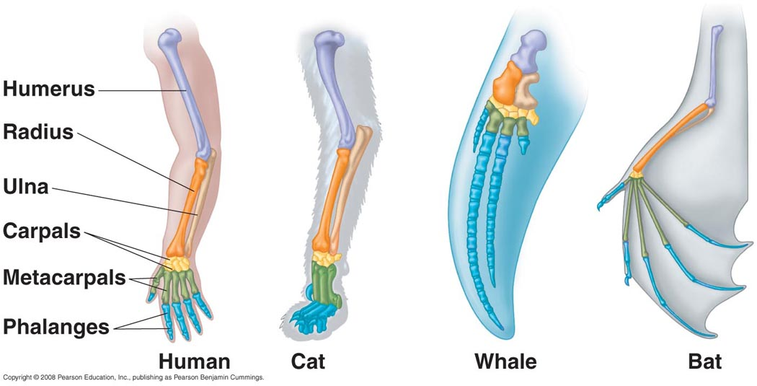
- Humans and have arms, cats have legs, bats have wings, and whales have fins. Still, many of the bones inside these structures are homologous traits. What does it mean that these bones are homologous traits? (complete sentences)

________________________________________________________________________________________________________________________________________________________________________________________________________________________________________________________________________________________________________________________________________

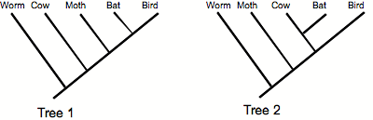

Image from www.biology.kenyon.edu

- Fill in the blanks: In Tree 1, bats are most closely related to _____________. In Tree 2, bats are most closely related to _____________.
- Only one of these trees is correct. Which tree do you think is correct, Tree 1 or Tree 2? Explain your answer. (complete sentences)
________________________________________________________________________________________________________________________________________________________________________________________________________________________________________________________________________________________________________________________________________

If you finish early:
- Check your work until the timer beeps.
- Have your pencil in the tape at the timer no matter what!

Objectives:
- SWBAT define convergent trait
- SWBAT describe the existence of convergent traits based on lineages that independently evolve similar adaptations, as illustrated by an evolutionary tree
- SWBAT identify potential convergent traits from anatomical images and specimens
- SWBAT identify whether shared traits are homologous traits or convergent traits, given an evolutionary tree

Example 1 – The evolution of wings

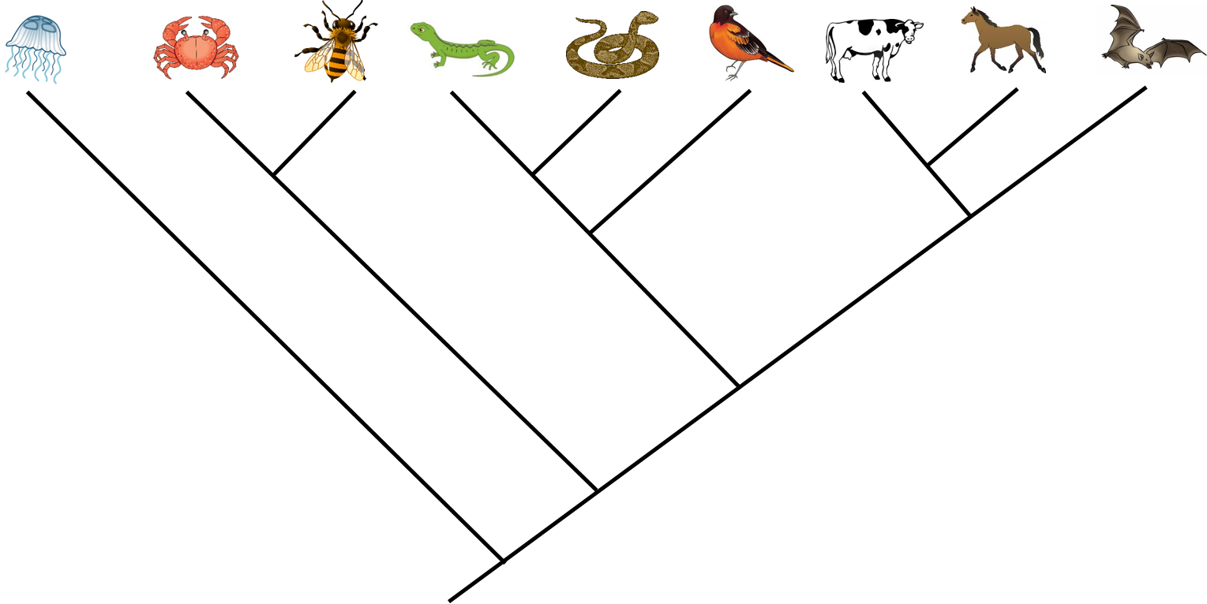

Convergent trait - ___________________________________________
__________________________________________________________

- Convergent traits are ______________ from homologous traits because homologous traits are inherited from a common ancestor and convergent traits are NOT.
- Instead, convergent traits often exist because different species have evolved similar _________________ to survive in similar environments.

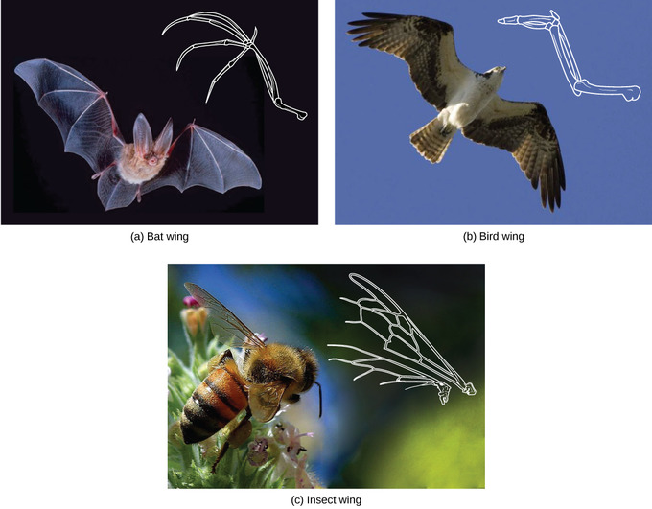
https://courses.lumenlearning.com/boundless-biology/chapter/determining-evolutionary-relationships/

Example 2 – The streamlined swimmer body shape
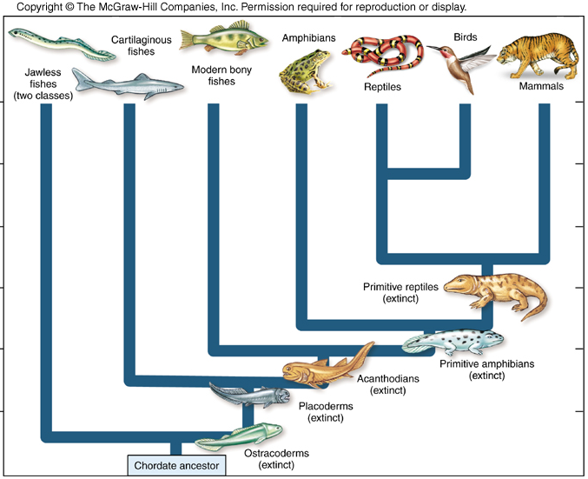
Sharks are here
Penguins are here
Dolphins are here

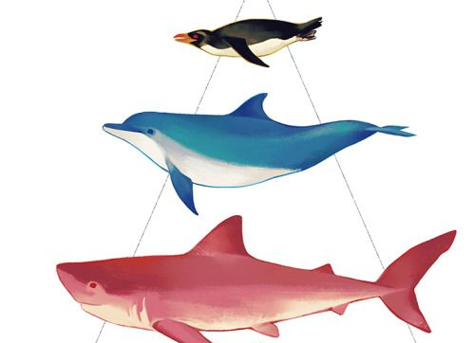

Image adapted from https://www.pinterest.com/pin/560276009877290552/

According to the evolutionary tree, is the swimmer body form observed in penguins, dolphins, and sharks probably a convergent trait or a homologous trait? How do you know? (complete sentences)

____The swimmer body form is probably a _________________________________ because________ ________________________________________________________________________________________________________________________________________________________________________________________________________________________________________________________________________________________________________________________________________
__________________________________________________________________________________

Example 3 – Convergent limbs vs. homologous limbs
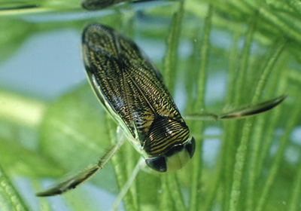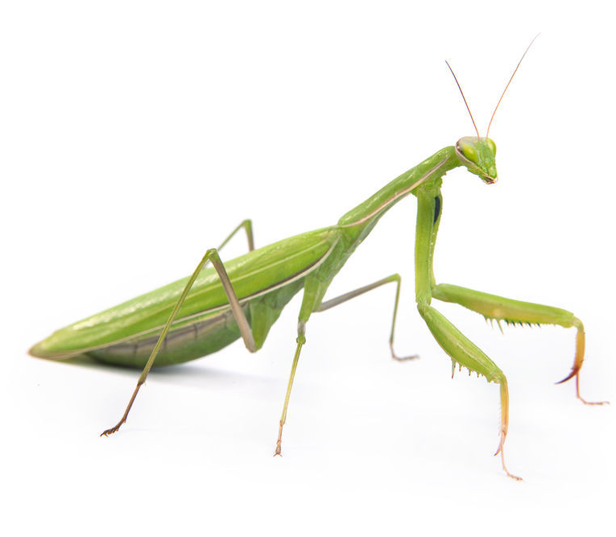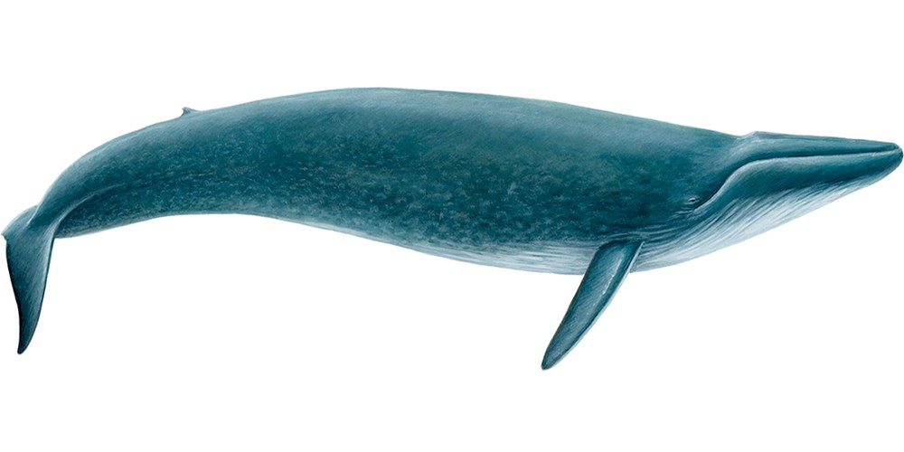

Left image from https://www.google.com/search?q=water+boatman&client=firefox-b-1-ab&source=lnms&tbm=isch&sa=X&ved=0ahUKEwjcnsX2oIDZAhUKLKwKHad_DzsQ_AUICigB&biw=1600&bih=736#imgrc=D5wenI1bA5OeyM:
Middle image from http://auburnpub.com/lifestyles/eco-talk-the-curiosity-that-is-the-praying-mantis/article_d802f0f6-356e-57c0-b05e-3d5d8e03fced.html
Right image from https://www.gentlegiants.is/whales/blue-whale

The images above show, from left to right, an aquatic diving beetle, a praying mantis, and a blue whale. The beetle and the mantis are insects, while the whale is a mammal. Label each statement below as true or false.
- The limbs of the diving beetle and the limbs of the mantis are convergent traits. _____
- The limbs of the diving beetle and the limbs of the mantis are homologous traits. _____
- The limbs of the diving beetle and the limbs of the whale are convergent traits. _____
- The limbs of the diving beetle and the limbs of the whale are homologous traits. _____
Independent Practice

Directions: Complete all questions below. Answer in complete sentences when asked.
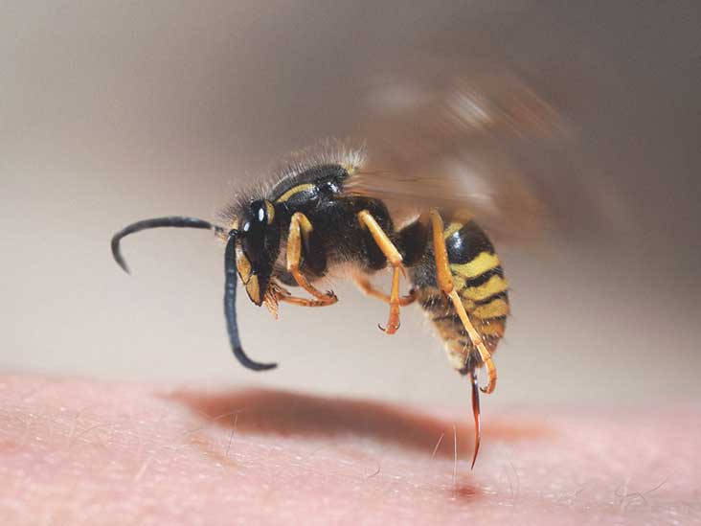
- The wasp pictured to the right has many of traits. When comparing these traits with other species, some of them are homologous (H), and others are convergent (C). Use the evolutionary tree from Example 1 in your notes to help label each trait below with H or C.
  - The wings of wasps and the wings of bats. ______
  - The eyes of wasps and the eyes of crabs. ______
  - The stinger of wasps and the stinger of jellyfish. __________
  - The stripes of wasps and the stripes of zebras (which are closely related to horses). _______
Image from https://www.healthline.com/health/wasp-sting

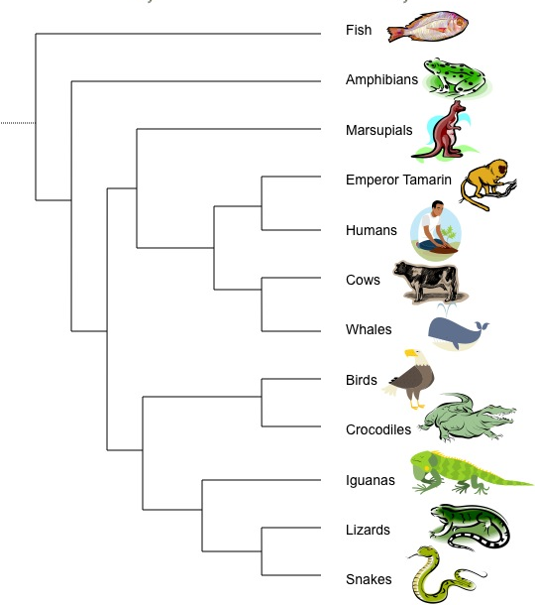
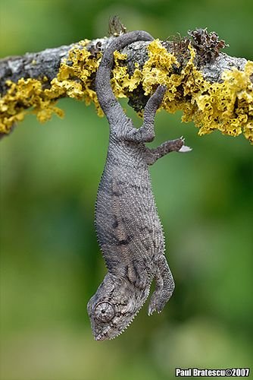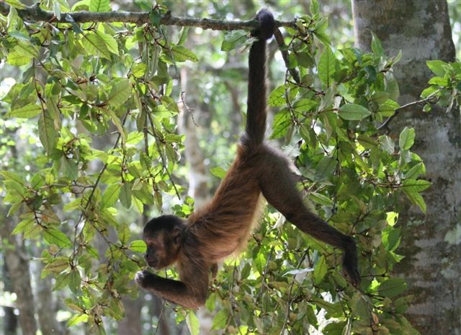

Left image from https://www.pinterest.com/whisperforest/chameleon/
Middle image from http://www.recessanytime.com/animals/prehensility/
Right image from https://www.macalester.edu/~montgomery/EmperorTamarinExtra.html

- The images above show a chameleon and a spider monkey using their prehensile tails to hang from branches. Many species have tails, but not many species can use to them to grab on like chameleons and spider monkeys. Consider each of the numbered statements below:

- The prehensile tail of the chameleon and the spider monkey are homologous traits.
- The prehensile tail of the chameleon and the spider monkey are convergent traits.
- The four legs of the chameleon and the spider monkey are homologous traits.

Which numbered statements are true?
- I only
- II only
- Both I and III
- Both II and III

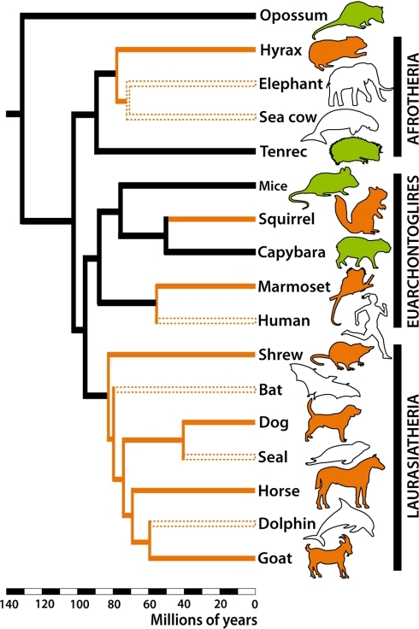
Left image from http://guardianlv.com/2013/09/bats-dolphins-and-the-genetic-evolution-of-echolocation
Right image from https://openi.nlm.nih.gov/detailedresult.php?img=PMC3198400_pone.0026436.g004&req=4

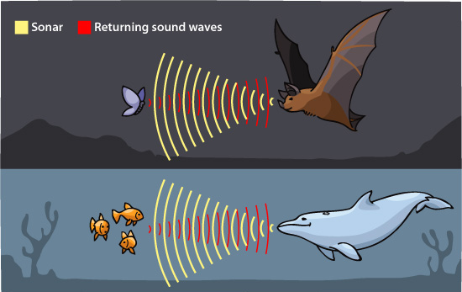

- Bats and dolphins have a special ability that no others species have which helps them investigate their surroundings using sound. These two species make noises, which echo back to them off objects and let them know is around them. This special trait is called echolocation. Is echolocation in bats and dolphins probably a convergent trait or a homologous trait? How do you know? (complete sentences)

________________________________________________________________________________________________________________________________________________________________________________________________________________________________________________________________________________________________________________________________________
____________________________________________________________________________________________________________________________________________________________________

- Horses and zebras are very relatively closely related and both have teeth that are shaped for chewing grass. Your friend says “Horse teeth and zebra teeth are convergent traits. I know because horse and zebras are two separate species and their teeth are adapted to eat the same thing.” DO you agree with your friend? Why or why not. Be specific and use scientific vocabulary in your answer. (complete sentences)

________________________________________________________________________________________________________________________________________________________________________________________________________________________________________________________________________________________________________________________________________
__________________________________________________________________________________
__________________________________________________________________________________
__________________________________________________________________________________

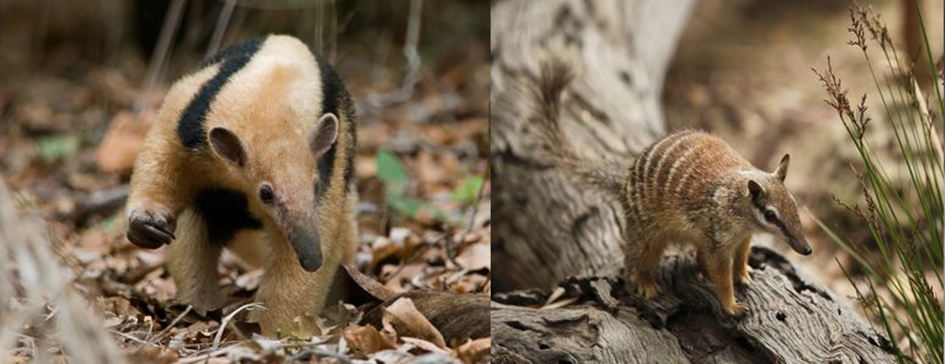

Image from https://www.thoughtco.com/amazing-examples-of-convergent-evolution-4108940

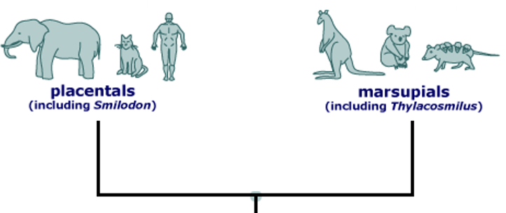

Imaged adapted from https://evolution.berkeley.edu/evolibrary/article/similarity_hs_07

- The pictures at the top of the page show a mammal anteater from South America (left) and a marsupial striped anteater from Australia (right). These two animals are not very closely related. For example, the mammal anteater is more closely related to cats than it is to the marsupial striped anteater. The striped anteater is more closely related to koala bears and kangaroos! Why do you think both these animals have long, skinny noses? In your answer, use scientific vocabulary from recent lessons. (complete sentences)

____________________________________________________________________________________________________________________________________________________________________________________________________________________________________________________________________________________________________________________________________________________________________________________________________________________________________________________________________________________________________________

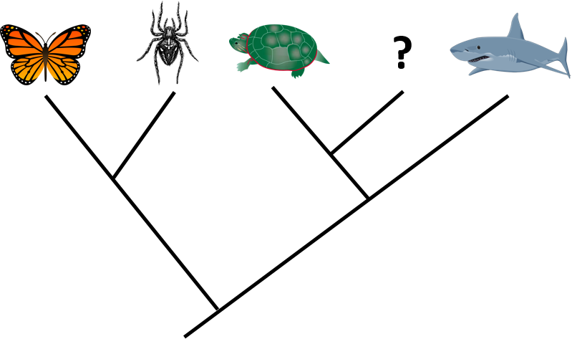

- You must create a new (imaginary) species to fit in the question mark on the evolutionary tree above. You will draw the species in the space below. You can make the new species look however you want, except that the species MUST have the following:
  - One trait that is homologous with a trait in turtles
  - One trait that is homologous with a trait in sharks
  - One trait that is homologous with a trait in both turtles and sharks
  - One trait that is convergent with a trait in spiders
  - One trait that is convergent with a trait in butterflies
You must LABEL each of these five traits in your drawing. To label the trait, draw an arrow to it and place the appropriate letter next to it (A through E).

If you finish early:
- Check your work until the timer beeps.
- Have your pencil in the tape at the timer no matter what!

